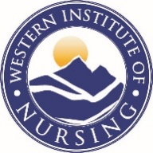

**Martha J. Lentz WIN/CANS Dissertation Grant**

**Eligibility Form**

NAME:

ELIGIBILITY:

* Registered Nurse;
* PhD student enrolled in a nursing PhD program within a WIN member organization;
* WIN student member;
* Proposed rigorous study in biobehavioral research with high impact and substantial direct research costs;
* Dissertation proposal approved by doctoral committee; and
* Institutional Review Board (IRB) or Institutional Animal Care and Use Committee (IACUC) approval/determination.
* I meet the eligibility requirements listed above.

Signature:

Date:

Please email this form, along with your proposal, to [perrybo@ohsu.edu](mailto:perrybo@ohsu.edu) by November 1.