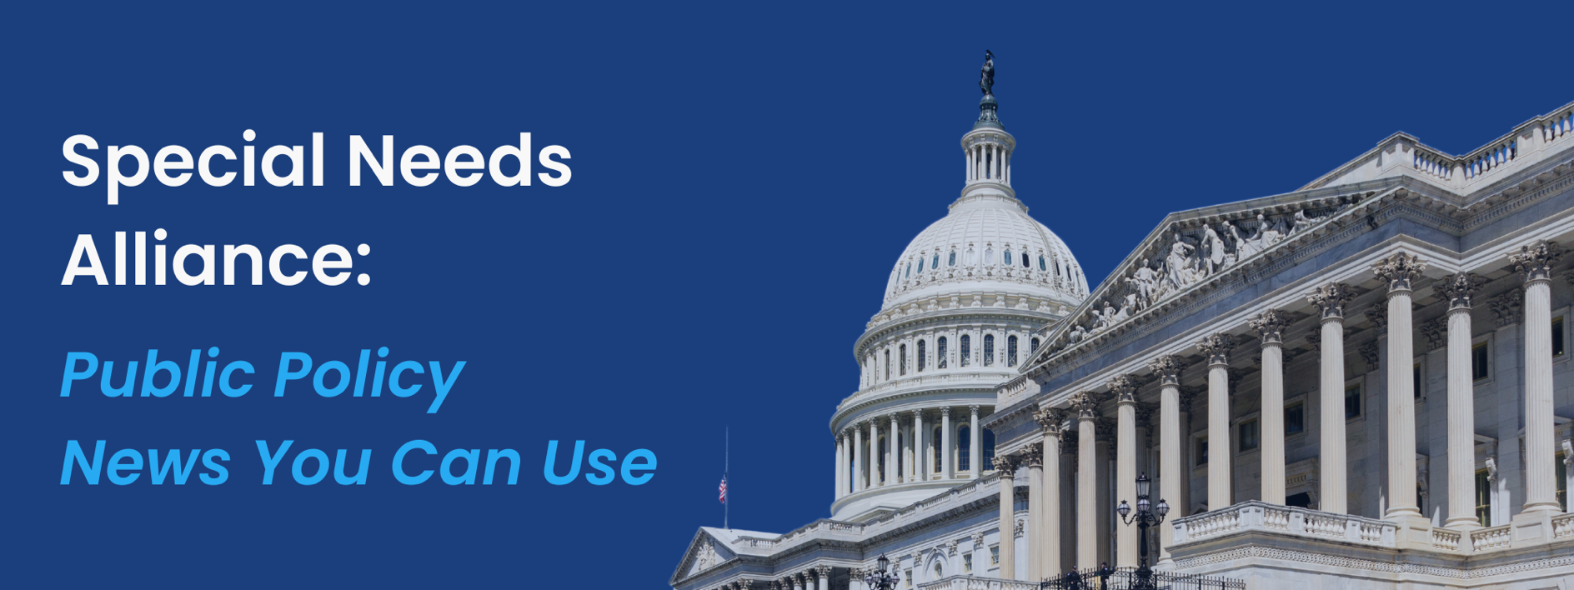
July 7, 2025
Reconciliation Bill Becomes Law
On Friday, President Trump signed into law H.R. 1, the One Big Beautiful Bill Act. The legislation marks the most sweeping package of healthcare reforms since the enactment of the Affordable Care Act (ACA) 15 years ago. The final legislation includes several consequential provisions, most notably changes to Medicaid eligibility and ACA marketplace enrollment requirements that are projected to result in millions of Americans losing healthcare coverage over the coming decade. Other significant changes include new restrictions on the use of provider taxes by states to finance Medicaid programs and a 2.5% increase in the Medicare Physician Fee Schedule for calendar year 2026. A full summary of H.R. 1’s healthcare provisions is available here, highlighting the most impactful elements of the bill.
16 States Sue Trump Administration Over Termination of School Mental Health Funds
On Monday, June 30th, sixteen democratically led states filed a lawsuit challenging the Trump administration’s decision to cut the Department of Education’s school mental health funding by $1 billion. The plaintiff states, which include California, Colorado, Connecticut, Delaware, Illinois, Maine, Maryland, Massachusetts, Michigan, Nevada, New Mexico, New York, Oregon, Rhode Island, Washington, and Wisconsin, argue that the contracts were illegally terminated under the Administrative Procedure Act, and that cancellation violates congressional mandates. The cut, initiated in April, cites concerns regarding diversity, equity, and inclusion (DEI) initiatives embedded within the mental health programs.
The Department of Education states that these programs are making problems worse due to the implementation of race-based actions by the Biden administration. Instead, the department insists on evidence-based practices to ensure that tax dollars go towards tangible improvements in the mental health of students. The plaintiff states argue that eliminating these programs will be detrimental to students who face increasing rates of depression, trauma, and anxiety.
CMS Proposes 2026 Payment and Policy Changes for Home Health and Dialysis Care
The Centers for Medicare and Medicaid Services (CMS) released a proposed rule to cut home health reimbursement by $1 billion in CY2026, marking the fourth consecutive year that CMS has imposed payment cuts to home health payments. While CMS claims that the cuts will effectively reduce the need for larger adjustments in the future, home health agencies argue that the cuts would threaten access, particularly for those in care deserts. The rule also proposes reclassifications of medical equipment, adjustments to face-to-face encounter policies, and improvements to the home health quality reporting program. CMS will accept comments on the proposed rule for 60 days following its forthcoming publication in the Federal Register.
CMS also released a proposed rule to update payment rates and policies under the End-Stage Renal Disease (ESRD) Prospective Payment System (PPS) for Calendar Year (CY) 2026. CMS proposed to increase the ERSD PPS base payment rates by approximately 1.9%. This also includes payment-adjusted costs for ERSD facilities in Alaska, Hawaii, and the U.S. Pacific Territories. CMS also proposed to eliminate several survey questions and equity reporting measures from the In-Center Hemodialysis Consumer Assessment of Healthcare Providers and Systems (ICH CAHPS). Similarly, CMS proposed to terminate use of the ESRD Treatment Choices Model by the end of 2025 due to the model’s limited impact. The agency is seeking public input on future quality measures, health IT use, and ways to reduce administrative burdens in Medicare. Comments are due by August 29, 2025.
CMMI Announces WISeR Model to Target Medicare Fraud, Waste, and Abuse Through AI and Prior Authorizations
The Centers for Medicare and Medicaid Services (CMS) through the CMS Innovation Center (CMMI) announced a new Innovation Center model called Wasteful and Inappropriate Service Reduction (WISeR). The WISeR model, which will launch January 1, 2026, aims to ensure people with Original Medicare receive safe, effective, and necessary care by leveraging enhanced technologies to conduct medical necessity reviews, including artificial intelligence (AI). The technologies will be deployed to expedite prior authorization or post-service/pre-payment reviews for services that are “particularly vulnerable to fraud, waste, and abuse, or inappropriate use,” such as skin substitutes and electrical nerve stimulators. The model will impact claims in New Jersey, Ohio, Oklahoma, Texas, Arizona, and Washington.
Participants in the WISeR model will be companies leveraging enhanced technology to provide recommendations on medical necessity of services, and they will be required to employ clinicians with expertise to conduct medical reviews. Participants will receive a percentage of the savings associated with averting wasteful care as a result of their reviews. Providers caring for people with Original Medicare in the selected regions will have the option of submitting a prior authorization request for the model’s selected services. If they do not submit a prior authorization request, their claim will be subject to a post-service/pre-payment review.
CMS estimates low-value health care comprises 25% of all spending and $5.8 million of Medicare spending. Potential model participants must reply to the Request for Applications by July 25, 2025.
What’s on Tap
On Friday, President Trump signed into law the Big Beautiful Bill Act following months of grueling negotiations within the Republican party. The bill arrived at the President’s desk after a tumultuous week of razor thin votes in both the House and the Senate. The upper chamber passed the bill by a vote of 51-50, with Vice President JD Vance casting the deciding vote on Tuesday of last week. The bill was then advanced to the House, where it passed along party lines Thursday before the self-imposed Fourth of July deadline. The bill reduces federal Medicaid spending by around $1 trillion, utilizing the savings to offset a partially permanent extension of the 2017 tax cuts that President Trump passed in his first term. As a result, the Congressional Budget Office estimates that the Medicaid provisions within the bill will increase the number of uninsured people by 11.8 million over the total budget window. The steep cuts to the Medicaid program are also expected to result in rural hospital closures across the country, despite a last-minute fix that provides $50 billion in emergency funding.
Democrats are expected to make the passage of the bill a focal point of the upcoming 2026 midterm elections. With 1 in 5 Americans enrolled in Medicaid, the most substantial cuts in program history could be a driving force in Democratic campaigns next year. On the other hand, prominent Republicans like House Majority Leader Steve Scalise (R-LA) have said the GOP is hopeful that the renewed tax cuts will generate strong support among their constituents. Elon Musk further complicated the upcoming election with an announcement over the weekend that he is establishing a third political party known as the America Party. The announcement comes on the heels of the public fallout between President Trump and Musk – the former leader of the Department of Government Efficiency (DOGE). It is unclear as to what steps Musk has taken to formally establish his party, but given his vast resources, he could make a serious impact on the 2026 midterms.
Chairman Brett Guthrie of the House Energy and Commerce Committee recently announced updates to the leadership and membership of several Subcommittees. Congressman Buddy Carter (R-GA) stepped down as Chairman of the Subcommittee on Health as he prepares to run for the U.S. Senate in Georgia. In response, Chairman Guthrie expressed his appreciation for Congressman Carter’s contributions and appointed Congressman Morgan Griffith (R-VA) to lead the Health Subcommittee. Guthrie also implemented leadership changes to the Subcommittee on Environment and the Subcommittee on Oversight and Investigations. Congressman Carter had been a leading voice in advancing bipartisan reforms aimed at increasing transparency among pharmacy benefit managers – efforts that now face uncertainty in the 119th Congress following their removal from the reconciliation package.
President Trump’s tariffs could pick back up this week as the 90-day pause on the steep tariffs imposed in April are set to expire on Wednesday. The President announced on his April 2nd “Liberation Day” speech that virtually every country would face sharp tariffs from the US, before pausing those rates a week later to allow countries to conduct negotiations in the interim. Over the weekend, Treasury Secretary Scott Bessent said that the U.S. will revert to the steep country by country rates at the beginning of August, almost a month after the pause is set to expire. The President announced he would be sending letters to some trade partners explaining that countries will revert back to the April 2nd tax levels on August 1st, unless a deal is reached ahead of time.
Upcoming Events
- Senate: In session – July 7th through July 10th
- House: In session - July 7th through July 11th
- Wednesday, July 9th at 10:00am | Senate Health, Education, Labor and Pensions Committee holds a hearing on Enhancing Cybersecurity and Protecting Americans’ Privacy in Health Care | 430 Dirksen Senate Office Building
- Wednesday, July 9th at 10:15am | House Committee on Energy and Commerce holds a hearing on Legislative Proposals to Maintain and Improve the Public Health Workforce, Rural Health, and Over-the-Counter Medicines | 2123 Rayburn House Office Building

