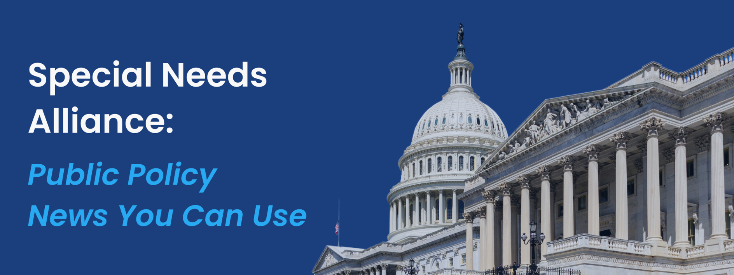
June 24, 2024
- CALDER Report Reveals Schools Failed to Identify Students with Disabilities During Pandemic, Delaying Access to Services
A new report from the National Center for Analysis of Longitudinal Data in Education Research (CALDER) found substantial drops in the number of children with disabilities who received crucial support during the Covid-19 pandemic. The report found that Washington State schools, for example, missed 8,500 children for special education referrals during the pandemic period. Compared to 2018-19, the identification rate of students with disabilities was 23% lower in 2019-20 and 20% lower in 2020-21. Identification rates have returned to pre-pandemic levels but do not indicate that children who were not evaluated during Covid have since been identified.
- HHS Ensures Individuals with Disabilities are Provided Services to Live at Homes
Last week, the U.S. Department of Health and Human Services (HHS) Office of Civil Rights (OCR) publicized an agreement with the State of Iowa to enforce Federal disability rights laws. Garret Frey, the individual who filed a complaint prompting an investigation, alleged that the State of Iowa violated his rights by failing to provide the 24-hour home-based support and services necessary for him to continue to live at home. The OCR’s actions were based on Section 504 of the Rehabilitation Act of 1973 (Section 504), Section 1557 of the Affordable Care Act (Section 1557), and Title II of the Americans with Disabilities Act. These laws require that services must be provided in the most integrated setting appropriate to the needs of a person with a disability. Iowa agreed to participate in an Expedited Complaint Resolution process with Frey to provide the support services necessary for Frey, ranging from raising the provider reimbursement rate to securing necessary providers for overnight and nursing services. OCR will monitor the State of Iowa’s actions for six months to ensure services are adequate for Frey to live at home.
- CBO Releases New Projections Related to Health Insurance Coverage for 2024 to 2034
The Congressional Budget Office (CBO) published updated baseline projections of federal subsidies for health insurance coverage. The release describes trends in health insurance coverage, projections of health insurance by age, and serves as a proxy for budgetary and coverage effects of proposed legislation. The CBO estimated that 92.3 percent of the US population, equivalent to 316 million Americans, have coverage in 2024. They report that 7.7 percent, or 26 million, are uninsured. The report projects that the uninsured rate of 7.2 percent in 2023 will rise to 8.9 percent in 2034, with the largest increase in those who are uninsured among adults ages 19-44. The projections expect employment-based coverage to be the predominant source of health insurance and that Medicare enrollment will grow significantly as the population ages. Additionally, after greater-than-expected enrollment in 2023, Marketplace enrollment is projected to reach an all-time high of 23 million people in 2025.
- CMS Announces Conclusion of CHOPD Payments
The Centers for Medicare & Medicaid Services (CMS) announced that payments under the Accelerated and Advance Payment (AAP) Program for the Change Healthcare/Optum Payment Disruption (CHOPD) will conclude on July 12, 2024. The CHOPD payments, initiated in early March, aimed to mitigate cash flow disruptions for Medicare providers and suppliers, including hospitals, physicians, and pharmacists, following a major cyberattack that disabled Change Healthcare in February. To date, over $2.55 billion has been issued to 4,200 Part A providers and more than $717.18 million to 4,722 Part B suppliers. CMS has already recovered over 96% of the CHOPD payments. After July 12, 2024, CMS will no longer accept new applications for CHOPD payments.

- NCHS Releases 2023 Health Insurance Coverage Estimates
The National Center for Health Statistics (NCHS) under the Centers for Disease Control and Prevention (CDC) released the “Health Insurance Coverage: Early Release of Estimates From the National Health Interview Survey, 2023.” The report uses National Health Interview Survey (NHIS) data from 2023 to estimate health insurance coverage for the non-institutionalized American civilians. A key highlight showed that 7.6 percent of all people were uninsured in 2023, which is lower than the 2022 rate of 8.4 percent.
- House Energy & Commerce Subcommittee on Health Holds Hearing on the Value of CMMI
The House Committee on Energy & Commerce Subcommittee on Health recently held a hearing “Checking-In On CMMI: Assessing The Transition To Value-Based Care.” Deputy Administrator and Director of the Center for Medicare and Medicaid Innovation (CMMI) Dr. Elizabeth Fowler testified to the successes of CMMI including continuous development of innovative programs that improve quality of care, reduce costs, and promote health equity. Subcommittee Chairman Guthrie (R-KY) and Subcommittee Ranking Member Eshoo (D-CA) were joined in their opening remarks by full committee Chairwoman Rodgers (R-WA) and Ranking Member Pallone (D-NJ). Generally, Republican Representatives focused their questioning on the limited cost savings CMMI has yielded, the few models that have been approved for broader implementation, and concerns about agency overreach. With their line of questioning, Democratic Representatives generally highlighted successes CMMI has brought including increased coverage, improved health equity, improved quality of care, and some models demonstrating moderate cost savings.
- Senate Finance Committee Holds Hearing on Work and Social Security Disability Benefits
On June 18th, the Senate Finance Committee held a hearing titled, “Work and Social Security Disability Benefits: Addressing Challenges and Creating Opportunities.” Witnesses included Willian R. Morton, Income Security Analyst at the Congressional Research Service, Susan B. Wilschke, Associate Commissioner of the Office of Research, Demonstration, and Employment Support at the Social Society Administration, Erin Godtland, Assistant Director of Education, Workforce, and Income Security at the United States Government Accountability Office, and Katherine Zuleger, President of the Chicago Social Security Management Association. A recording of the hearing can be found here.

- House Veterans’ Affairs Disability Assistance and Memorial Affairs Subcommittee Holds Hearing on TDIU
On June 12th, the House Veterans’ Affairs Disability Assistance and Memorial Affairs Subcommittee held a hearing titled, “Does a Total Disability Rating Based on Individual Unemployability (TDIU) Properly Compensate Today’s Veterans?” Witnesses included Ronald S. Burke, Jr., Deputy Under Secretary in the Office of Policy and Oversight at the Veterans Benefit Administration, Nick Pamperin, Executive Director of the Veteran Readiness and Employment Service, David J. Barrans, Chief Counsel for Benefits Law in the Office of the General Council of the VA, Marquis D. Marefield, Assistant National Legislative Director at the Disabled American Veterans (DAV), Mike Figlioli, Director of the Veterans of Foreign Wars (VFW) National Veterans Service, and Mike Stoddard, National Service Director for Wounded Warrior Project. A recording of the hearing can be found here.

- CDC Releases National Health Statistics Reports Outlining Declines in Telemedicine Use Among Adults
The Centers for Disease Control and Prevention (CDC) released a National Health Statistics Report examining changes in telemedicine use among U.S. adults between 2021 and 2022. The study found that the percentage of all adults who used telemedicine in the past 12 months decreased from 37.0 percent in 2021 to 30.1 percent in 2022. However, women, adults with a college degree or higher, and adults living in more urban areas were all more likely to use telemedicine in 2022. In 2021 and 2022, uninsured adults between the ages of 18 and 64 were less likely to utilize telemedicine compared with those who had private or public insurance, while Medicare beneficiaries 65 years and older were less likely to use telemedicine compared with those with other types of insurance. For both age groups, telemedicine use decreased from 2021 to 2022 for all insurance types except public coverage for adults ages 18–64.

What’s on Tap
- Last week, the 5th Circuit Court of Appeals sided in part with plaintiff groups challenging the Affordable Care Act’s (ACA) requirement that employer health plans cover preventive care. The Court also reversed the lower court ruling that blocked enforcement of the mandate nationwide, thereby maintaining access to no-cost preventive services ranging from depression screenings to the HIV prevention pre-exposure prophylaxis (PrEP) pills, except as applied to the plaintiffs. In siding in part with the plaintiff, the Court affirmed Texas-based company Braidwood Management Inc.’s religious objections to the mandate and agreed the company could not be forced to provide its workers with insurance covering preventive care services. The case will return to the Texas district court where Judge Reed O’Connor will hear arguments on if the U.S. Preventive Services Task Force (USPSTF) has the power to decide what insurers must cover and whether the panel’s decisions over the past decade can stand.

- This week, the bipartisan leadership of the House Energy and Commerce Committee will introduce a new American Privacy Rights Act after sponsors dropped earlier draft provisions to guard against harms from algorithmic discrimination. Sponsored by committee Chair Cathy McMorris Rodgers (R-WA) and ranking member Frank Pallone (D-NJ), the draft bill includes revised language regarding a data broker registry to be established by the Federal Trade Commission (FTC) and “mechanisms” by which individuals can thereby request that their covered data be deleted, or not collected by those entities, including by parents on behalf of their children, an issue that Pallone had expressed interest in addressing in earlier privacy bills. In light of a wave of cybersecurity challenges to health care systems, lawmakers from both parties have argued that a federal privacy law is essential to governing how data is handled by companies in the AI age.

Upcoming Events
Wednesday
- The House Ways and Means Committee will hold a hearing on “Strengthening Child Welfare and Protecting America’s Children,” at 10:00am.
- The House Ways and Means Committee hearing will hold a hearing on “Improving Value-Based Care for Patients and Providers,” at 3:00pm.
Thursday
- The House Education and the Workforce Committee will hold a hearing on “Examining the Policies and Priorities of the Employee Benefits Security Administration,” at 10:15am.



