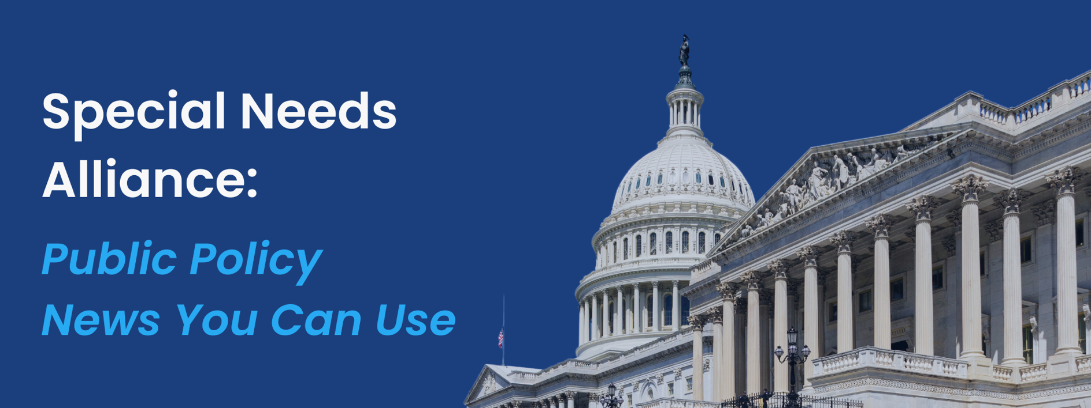
July 9, 2024
- Department of Education Issues 2024 Determinations for State Implementation of IDEA
Recently, the U.S. Department of Education released its 2024 determinations for States on their implementation of the Individuals with Disabilities Education Act (IDEA) for Part B and Part C. The IDEA requires the Department to issue an annual determination, based on the State Performance Plan (SPP) and Annual Performance Report (APR), which evaluates the State’s efforts to implement the requirements and purpose of the IDEA, and describes how the State will improve its implementation. As evidenced by this past year’s results based on a review of the 2022-2023 school year, states are increasingly struggling to meet their obligations under the IDEA. This year, only 20 states “meet requirements” for serving students with disabilities ages 3 to 21 under federal special education law. The agency deemed all other states “need assistance,” with most having earned that label for at least two years in a row. The Education Department will release more information about each state’s performance in August.

- Supreme Court Rules Against Regulators, Expands Grounds for Challenging Regulations Ensuring Rights of People with Disabilities
Last week, the U.S. Supreme Court ruled against regulators in a decision that will strengthen industries’ challenges of federal agencies and their regulations. The ruling, Corner Post, Inc. v. Board of Governors of the Federal Reserve System, involves a lawsuit in which a North Dakota truck stop challenged a 2011 Federal Reserve rule that capped “interchange fees” at 21 cents per transaction plus a small percentage of that transaction’s value, rejects the Justice Department’s argument that the statute of limitations runs from when a regulation is finalized. Now, old agency rules may be challenged so long as they produce present harm. Justice Amy Coney Barrett wrote the opinion for the 6-3 majority, with the liberal justices representing the dissenting opinion. This decision, combined with the Court’s recent overturning of Chevron v. Natural Resources Defense Council, has opened the door to new, broad challenges to regulations long after they take effect. In the past, statutes of limitation and other prohibitions prevented litigation of regulatory decisions made many years in the past. Now, it is reasonable to expect significant increase in judicial activism on many previous regulatory decisions. Countless federal regulations ensuring the rights of people with disabilities could now face legal challenges.
- HHS and CMS Take Action to Reinforce Commitment to EMTALA Enforcement
The U.S. Department of Health and Human Services (HHS) Secretary Xavier Becerra and Centers for Medicare & Medicaid Services (CMS) Administrator Chiquita Brooks-LaSure sent a joint letter to hospital and provider associations reminding all Medicare-participating hospitals that they are legally required to provide medically necessary stabilizing care to patients found with emergency conditions under the Emergency Medical Treatment & Labor Act (EMTALA). CMS also announced they will proceed to investigate EMTALA complaints in Idaho following the Supreme Court’s ruling on emergency abortions in the state. Additionally, HHS and CMS announced a Spanish-language version of the EMTALA complaint form which educates the public about their rights and allows complaints to be submitted in Spanish. This follows HHS and CMS’ release of an English-language EMTALA complaint form in May and CMS guidance affirming EMTALA from 2022.
- ASPE Releases Fact Sheets on Impacts of IRA and ACA on Healthcare Costs by State
Last week, the Office of the Assistant Secretary for Planning and Evaluation (ASPE) released fact sheets highlighting healthcare cost savings due to the Inflation Reduction Act (IRA) and Affordable Care Act (ACA). The fact sheets include information on enrollee savings from cost-sharing on Medicare Part D, insulin, and vaccines, Marketplace premiums, and enrollment data for Medicare, Medicaid, and Marketplace plans. Fact sheets are divided by state and include all 50 states and the District of Columbia.
- HRSA Invests Over $200 Million to Improve Care for Older Americans
The U.S. Department of Health and Human Services (HHS) through the Health Resources Services Administration (HRSA) announced a more than $200 million investment in 42 programs to improve care for older Americans. HRSA’s Geriatrics Workforce Enhancement Program will provide age-friendly and dementia-friendly care training to primary care physicians, nurse practitioners, and other clinicians. The program will also provide education on supporting caregivers and family members of aging Americans. This program supports Secretary Becerra’s Health Workforce Initiative to support, strengthen, and grow the health workforce.
- KFF Publishes Brief on Financial Performance of Health Insurers in 2023
The Kaiser Family Foundation (KFF) recently published a brief on private health insurance companies’ financial performance in 2023 across various markets, including Medicare Advantage, Medicaid managed care, individual, and group health insurance, with each market having distinct rules affecting their gross margins and medical loss ratios (MLRs). Private insurers increasingly participate in public programs, with over half of Medicare beneficiaries and nearly three-quarters of Medicaid enrollees in private plans. In 2023, Medicare Advantage had the highest per enrollee gross margins, while individual insurance had the lowest MLRs. Despite stable gross margins across markets, administrative costs and taxes likely impacted profitability. Market trends reveal stability in gross margins and MLRs, though specific factors like the end of continuous enrollment policies in Medicaid and the rise of consolidation affect performance metrics. Medicare Advantage plans show higher costs and premiums due to an older, sicker population, resulting in higher gross margins.
- FDA Approves New Treatment for Alzheimer’s Disease
The U.S. Food and Drug Administration (FDA) approved Kisunla (donanemab-azbt) injection for the treatment of Alzheimer’s disease in adults with mild cognitive impairment or mild dementia. Alzheimer’s affects over 6.5 million Americans and is characterized by brain changes leading to memory and thinking impairments. This is the third approval of an Alzheimer’s treatment that changes the underlying course of the disease. Administered intravenously every four weeks, Kisunla’s efficacy was demonstrated in a double-blind, placebo-controlled, parallel-group clinical trial showing significant reductions in clinical decline.
- CMS Announces Information Collection Requests for 2027 Drug Price Negotiation Data Elements and Drug Price Negotiation Process
The Centers for Medicare and Medicaid Services (CMS) announced an information collection request on Negotiation Data Elements and Drug Price Negotiation Process for Initial Price Applicability Year 2027 of the Medicare Drug Price Negotiation Program. The Negotiation Data Elements includes the data CMS would consider as the basis for determining offers and counteroffers throughout the negotiation process based on the submissions required from a participating drug company. The Drug Price Negotiation Process includes the data and information CMS would consider if a participating drug company submits a counteroffer for a selected drug during the negotiation process. CMS invites feedback on their burden estimates, the necessity and utility of the information collection, accuracy of the estimated burden, ways to improve the quality and clarity of the information, and the use of technology to minimize the burden. Comments are due by September 3, 2024.
- CMS Approves New 1115 Waiver to Support People Transitioning out of Incarceration
The U.S. Department of Health and Human Services (HHS), through the Centers for Medicare & Medicaid Services (CMS), announced approval of new Medicaid and Children’s Health Insurance Program (CHIP) demonstrations in Illinois, Kentucky, Oregon, Utah, and Vermont to provide coverage for adults and youth transitioning out of incarceration up to 90 days before their release. This initiative aims to ensure a seamless transition out of incarceration by avoiding coverage gaps and improving public health and safety. These states join others in expanding access to high-quality, affordable health care, particularly focusing on substance-use disorder (SUD) treatment and continuity of care. The Medicaid Reentry Section 1115 Demonstration Opportunity will enhance coordination among correctional facilities, Medicaid programs, and community providers, fostering better health outcomes and reducing emergency visits, hospitalizations, and deaths among recently incarcerated individuals. This initiative addresses the significant health coverage needs of justice-involved individuals and aims to streamline the approval process for similar future demonstrations under the Biden-Harris Administration.

What’s on Tap
- Congress is back in session this week, with the House meeting July 8th – 11th and the Senate July 8th – 12th.
- This Wednesday, the House Appropriations Committee will hold a markup of bills including the FY2025 Labor, Health and Human Services, Education, and Related Agencies bill. The markup follows the subcommittee’s June markup of the bill. The subcommittee’s bill reflects the Republican majority through its budgetary restraint, amounting to 11% cuts when compared to the FY2024 bill. While the subcommittee did not offer any amendments during the markup, passing the bill along strict party lines, the full committee hearing will likely include steps towards the discussion and negotiation necessary to create a bill with the chance of passing in the democrat-held Senate.

Upcoming Events
Tuesday
- The Senate Budget Committee will hold a hearing on “Examining CBO’s Updated 2024-2034 Budget and Economic Outlook” at 10:00am.
- The Senate Health, Education, Labor, and Pensions Subcommittee will hold a hearing on “Everyday Expenses and Everyday Americans: How High Costs Impact Children and Families” at 10:00am.
Wednesday
- The House Appropriations Committee will hold a markup of the FY2025 Labor, Health and Human Services, Education, and Related Agencies bill at 9:00am.
Thursday
- The Senate Health, Education, Labor, and Pensions Committee will hold a hearing on “What Can Congress DO to End the Medical Debt Crisis in America?” at 10:00am.
- The Senate Special Committee on Aging will hold a hearing on “Health Care Transparency: Lowering Costs and Empowering Patients” at 10:00am.
Friday
- The House Ways and Means Committee will hold a hearing on “Access to Health Care in America: Unleashing Medical Innovation and Economic Prosperity” at 12:00pm.
