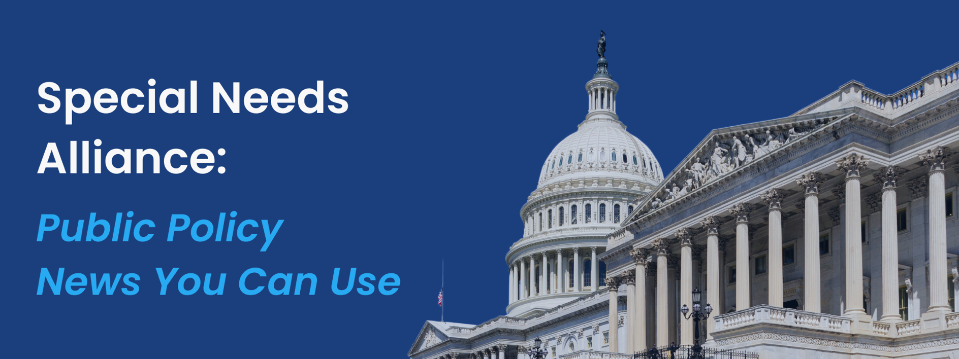
July 15, 2024
- House and Senate Advance Different FDA Appropriations Bills but Agree to Cut Language Blocking Ban of ESD Use on Patients with Disabilities
Last week, appropriators from the U.S. House of Representatives and Senate advanced fiscal year (FY) 2025 spending bills for the Food and Drug Administration (FDA) on party lines. The chambers’ bills are $44 million apart on discretionary funding, with the GOP-led House Appropriations Committee advancing a bill that would cut FDA funding by $22 million, and the Democratic-led Senate Appropriations Committee passing a bill to increase FDA discretionary funding by $22 million. However, republicans agreed to join democrats in cutting language that would have blocked the FDA from banning the use of electrical stimulation devices (ESDs) for behavior modification in patients with disabilities, a practice that has occurred at one controversial Massachusetts facility and has long been described as abusive to people with disabilities. The provision to block the renewed ban was removed in a bipartisan manager’s amendment to the bill after members heard outrage from numerous disability activists.
- SAMHSA Announces $27.5 Million in Funding for Women’s Behavioral Health
The Department of Health and Human Services (HHS) through the Substance Abuse and Mental Health Services Administration (SAMHSA) announced $27.5 million in funding aimed at improving women’s behavioral health across the United States. The funds will support expanding access to services and enhancing provider capacity to address mental health, substance abuse, and gender-based violence. Additionally, SAMHSA announced almost $1 million in grant awards as a part of the Services Program for Residential Treatment for Pregnant and Postpartum Women. These funds support the White House Initiative on Women’s Health Research, White House Blueprint for Addressing the Maternal Health Crisis, HHS’s Overdose Prevention Strategy, and Maternal Mental Health Task Force’s National Strategy to Improve Maternal Mental Health Care.
- ASPE Publishes Report on Potential Role of Nonprofit Pharmaceutical Companies in Increasing Access to Essential and Low-cost Medicines
The Office of the Assistant Secretary for Planning and Evaluation (ASPE) released a report outlining the potential role of nonprofit pharmaceutical companies in bridging gaps in the health care system, from addressing drug shortages to increasing access to essential and low-cost medicines. In the report, ASPE identified 11 nonprofit pharmaceutical companies with mission statements aimed to improve access to affordable and essential drugs or to address resiliency in the supply chains of medical products. Through an analysis of these nonprofit pharmaceutical companies, the report determined that the tax-exempt non-profit companies were comparable in scale to for-profit small businesses and start-up companies. Because of this small size, low production volumes, and inexperience navigating complex tax, regulatory, and reimbursement systems, ASPE concluded that while promising in potential, nonprofit pharmaceutical companies do not currently possess the capacity and sustainability necessary to bridge these industry gaps. The report suggested the need for more research to understand the available or potential tools that can reduce existing barriers and challenges in the pharmaceutical industry.
- FTC Interim Report Outlines Impact of PBMs on Accessibility and Affordability of Prescription Drugs
The Federal Trade Commission (FTC) released an interim staff report on the prescription drug middleman industry, focusing on the impact of pharmacy benefit managers (PBMs) on the affordability and accessibility of prescription drugs in America. A part of an ongoing inquiry launched in 2022 by the FTC, the report explains how an increase in vertical integration and concentration has enabled the six largest PBMs to oversee nearly 95 percent of all prescription fillings in the United States. It finds that this oligopolistic market allows PBMs to profit at the expense of independent pharmacists and patients through practices including self-preferencing, entering into unfair contract terms with smaller pharmacies, limiting access to low-cost competitors, and leveraging significant power and influence to control the market without transparency.
- AmeriCorps and CDC Award $76 Million in Funding to Support Public Health
AmeriCorps, in parentship with the Centers for Disease Control and Prevention (CDC), announced that they have awarded over $76 million, including $42 million in new funds, to enhance the public health workforce through service initiatives focused on mental health, chronic disease prevention, and public health readiness. The funding supports 89 Public Health AmeriCorps grantees, facilitating the involvement of more than 4,000 AmeriCorps members across nearly all states. These members gain practical experience by providing resources to community health clinics and supporting local public health organizations. Launched in 2021, Public Health AmeriCorps has significantly contributed to health departments, schools, and community-based organizations, addressing critical issues such as the opioid epidemic and the maternal health crisis. The initiative illustrates effective government collaboration and has established itself as a model for workforce development in public health.
- ONC for Health Information Technology Releases HTI-2 Proposed Rule for Public Comment
The Department of Health and Human Services (HHS) through the Office of the National Coordinator for Health Information Technology released the Health Data, Technology, and Interoperability: Patient Engagement, Information Sharing, and Public Health Interoperability (HTI-2) proposed rule. Portions of the rule were developed with the Centers for Disease Control and Prevention (CDC) and Centers for Medicare & Medicaid Services (CMS). ONC will host an information session on the proposed rule on July 17, 2024 at 2pm. The proposed rule will be uploaded to the Federal Register shortly with comments being accepted within 60 days of its posting on the Federal Register.
- CMS Releases 2025 Medicare Hospital Outpatient Prospective Payment System and Ambulatory Surgical Center Payment System Rule
The Centers for Medicare and Medicaid Services (CMS) released the Calendar Year 2025 Hospital Outpatient Prospective Payment System (OPPS) and Ambulatory Surgical Center (ASC) Payment System Proposed Rule. The proposed rule will have a 60-day comment period ending on September 9, 2024, with the final rule to be issued in early November. The 2025 rule addresses health disparities, expands access to behavioral health care, improves health system transparency, and promotes patient-centered care. The proposed policies and services outlined in the rule would impact about 3,500 hospitals and 6,100 ASCs.
- CMS Releases CY 2025 Medicare Physician Fee Schedule Proposed Rule
The Centers for Medicare and Medicaid Services (CMS) issued the calendar year (CY) 2025 Medicare Physician Fee Schedule (MPFS) proposed rule, which includes changes to the Shared Savings Program to promote Medicare’s vale-based care strategy of growth, alignment, and equity. Specifically, the MPFS proposed changes on Prepaid Shared Savings, Health Equity Benchmark Adjustment (HEBA), Alternative Payment Model (APM) Performance Pathway (APP) Plus Quality Measure Set, Mitigating the Impact of Significant, Anomalous, and Highly Suspect (SAHS) Billing Activity, Reopening ACO Payment Determinations, Higher Risk and Potential Reward under the ENHANCED Track, and Other Modifications to Medicare Shared Savings Program Policies Eligibility Requirements. Healthsperien’s detailed summary is forthcoming.
- New Study Finds Decreased Availability of Mental Health Telehealth Services After the COVID-19 PHE
The JAMA Network Open recently published an article exploring the availability of telehealth mental health care following the COVID-19 Public Health Emergency (PHE). Researchers from the RAND Corporation, Brigham Women’s Hospital, and Georgetown University found mental health treatment facilities were 0.84 times less likely to offer mental health via telehealth after the end of the public health emergency. Audio-only mental health and mental health with substance use disorder were 0.53 and 0.62 times less likely to be offered via telehealth. Additionally, mental health treatment facilities were 0.39 times less likely to report psychotherapy telehealth services and 0.59 times less likely to report medication management telehealth services post-pandemic. Public facilities were less likely to sustain mental health telehealth options (53.2%) compared to private for-profit (69.9%) and private not-for-profit (77.2%) facilities. Researchers suggest the need for policy interventions to sustain telehealth mental health services.
- Study Finds Medicare Eligibility Reduces Health Disparities Between LGB+ and Heterosexual Older Adults
A recently published article in JAMA Health Forum found Medicare eligibility increased self-reported health status, insurance coverage, and access to care across individuals regardless of sexual identity. The researchers from Yale University learned that lesbian, gay, bisexual, transgender and gender diverse individuals (LGB+) saw significantly higher rates of self-reported health status (2.6% increase) compared to their heterosexual peers (1.1% increase) with the greatest increases occurring in states with the highest preexisting disparities. Researchers report some increases in rates of insurance coverage and access to care for LGB+ folks in states with the highest preexisting disparities, however confidence intervals overlap.

What’s on Tap
- Both chambers of Congress are out of session this week, no hearings or markups will take place.
- CMS last week issued the calendar year (CY) 2025 Medicare Physician Fee Schedule (MPFS) proposed rule, which includes changes to the Shared Savings Program to promote Medicare’s vale-based care strategy of growth, alignment, and equity. Specifically, the MPFS proposed changes pertaining to Prepaid Shared Savings; Health Equity Benchmark Adjustments (HEBA); the Alternative Payment Model (APM) Performance Pathway (APP) Plus Quality Measure Set; Mitigating the Impact of Significant, Anomalous, and Highly Suspect (SAHS) Billing Activity; Reopening ACO Payment Determinations; Higher Risk and Potential Reward under the ENHANCED Track; and other modifications to Medicare Shared Savings Program Policies eligibility requirements. The Healthsperien team is currently creating a comprehensive summary of the proposed rule.
- With both chambers of Congress out of session, this week’s notable activity will likely emanate from the Republican National Convention (RNC) July 15th-18th. The Republican National Committee last week adopted a new abortion platform based on former President Donald Trump’s “leave-it-to-the-states” approach. Unlike the party’s 2016 platform, the text does not include a 20-week federal limit on abortions, instead stating that states are “free to pass laws protecting” the rights granted in the 14th Amendment. The RNC will provide Trump an opportunity to speak on a number of topics including abortion and healthcare after Saturday’s assassination attempt.
