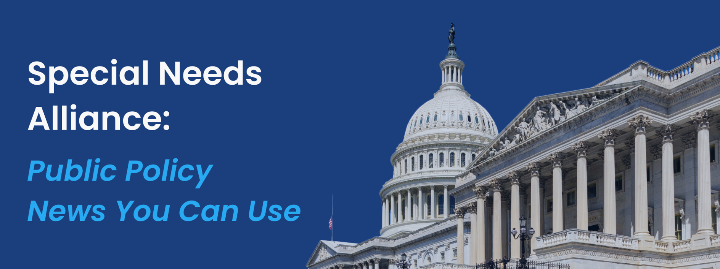
September 3, 2024
- Article Highlights States that Block People under Court-Approved Guardianship from Voting
In a recent article, the New York Times highlighted that at least seven states, including Missouri, have state laws in place that prohibit anyone under a guardianship agreement to cast a ballot. The Justice Department said earlier this year that such blanket policies are illegal under federal civil rights laws, but no further action to enforce this view has been taken. Some individuals under guardianship have gone to get their rights restored, yet this can be a long and difficult process. In addition to the seven states that prohibit anyone under a guardianship from casting a ballot, ore than two dozen other states have restrictions that vary by the type of guardianship or level of disability, and often require a judge to decide case by case on the right to vote.

- CMCS Issues Guidance for Timely Medicaid and CHIP Renewals Amid Backlogs
The Center for Medicaid and CHIP Services (CMCS) recently released new guidelines to assist states in meeting federal requirements for Medicaid and Children’s Health Insurance Program (CHIP) eligibility renewals. Due to challenges faced during the COVID-19 Public Health Emergency, many states have accumulated significant backlogs in processing these renewals. CMCS is granting states until December 31, 2025, to complete all “unwinding-related” renewals and return to regular compliance with federal renewal timelines. To help states manage the backlog and prevent coverage losses, CMCS has outlined several strategies related to redistribution of renewals, procedural flexibilities, full renewals for changes in circumstances, updated contact information, and re-initiation of pending renewals. CMCS strongly advises states to communicate any changes in renewal dates to beneficiaries and to provide timely notifications through multiple channels. States that fail to meet the extended deadlines or do not effectively implement these strategies may face formal compliance actions, including the requirement to submit corrective action plans.

- CMS Awards $100 Million in Grants to Navigators Helping Individuals Sign Up for Health Coverage in Underserved Communities
The Centers for Medicare and Medicaid Services (CMS) announced a new investment of $100 million to support organizations that help underserved communities, consumers, and small businesses enroll in affordable health coverage through HealthCare.gov and the Health Insurance Marketplace®. This funding, awarded to 44 Navigator grantees in states using HealthCare.gov, is part of a broader $500 million commitment over five years to improve access to health care coverage. The investment aims to bolster outreach to underserved groups and make health insurance more accessible and affordable. Navigators provide free assistance with plan selection, eligibility, enrollment, and support for Medicaid and CHIP coverage. The funding also includes streamlined application processes for smaller community organizations to become Navigators, with a focus on reaching key underserved populations, including racial and ethnic minorities, LGBTQIA+ communities, rural residents, immigrants, and low-income families. More information on this year’s Navigator grantees can be found here.

- SAMHSA Announces $65 Million in Funding to Support Mental Health and Substance Use Crises
The U.S. Department of Health and Human Services (HHS), through the Substance Abuse and Mental Health Services Administration (SAMHSA), announced $65 million in grant awards and notice of funding opportunity (NOFO) to support mental health and help tackle substance use crises. The funding opportunity includes $27.5 million allocated towards the Strategic Prevention Framework – Partnerships for Success (SPF-PFS), which has supported 40 million people across the nation through community-based interventions. The remainder of the funding will be awarded to programs that aim to support the needs of children with unmet behavioral health needs, increase access behavioral health care for individuals at risk of becoming unhoused, and enhance the behavioral health workforce. More specifically, the funding will be allocated to the Linking Actions for Unmet Needs in Children's Health (Project LAUNCH) – ($8 million), Treatment for Individuals Experiencing Homelessness – ($7.2 million), Provider’s Clinical Support System Universities – ($5.7 million), Coalitions Training Cooperative Agreement (CADCA) – ($675 thousand), Certified Community Behavioral Health Clinic (CCBHC) Planning Grants – ($15 million) and the Syndemic Approach to Preventing HIV and Substance Use Among Racial and Ethnic Minority Communities – ($1.6 million).

- HHS Awards Over $558 Million for Maternal Health Improvements
The U.S. Department of Health and Human Services (HHS) announced they will be investing over $558 million through the Health Resources and Services Administration (HRSA) and the Centers for Disease Control and Prevention (CDC) to improve care for new mothers, infants, and children. HRSA will award over $440 million to expand the maternal, infant, and early childhood home visiting services. The home visiting program funds states, local jurisdictions, and tribal entities to develop and implement evidence-based programs to meet the needs of their communities, providing services to families from pregnancy up to kindergarten. This is the first opportunity for states and local jurisdictions to receive federal matching funds in addition to their base grants for these programs.

- ACL Awards $5 Million to Volunteer Program Supporting Family Caregivers
The Administration for Community Living (ACL) awarded $5 million to the Oasis Institute for a new grant to support the continued development and refinement of the Community Care Corps model. The model is designed to increase the number of community-based volunteer programs to make caregivers more available for older adults and individuals with disabilities. The Oasis Institute received its first grant for this program in 2019 and will continue to carve out models with the established partnership agencies they have with the Caregiver Action Network, USAging, and the Altarum Institute. Additionally, this project aims to utilize the opportunities and further the principles of the 2022 National Strategy to Support Family Caregivers.

Surgeon General Releases Advisory on Parent Mental Health & Wellbeing
The U.S. Surgeon General issued a new advisory on the need to support parent mental health and wellbeing. The advisory stresses that parents and caregivers face a variety of stressors that impact their ability to care for their children across the lifespan, which have detrimental impact on the mental health and wellbeing of both the parents and their children. The advisory also notes these burdens disproportionately impact parents with fewer resources and who experience economic, social, political, and cultural marginalization. In response, the Surgeon General recommends creating a culture for parents and caregivers to thrive, by prioritizing resources, policies, and environments to better support caregivers. Examples of these changes include increasing access to paid leave, expanding childcare subsidies and other supportive programs, and investing in local social infrastructure to foster social connection among parents and caregivers

- HHS Awards $81.3 Million in Funding to Support Behavioral Health Integration
The Department of Health and Human Services (HHS), through the Substance Abuse and Mental Health Services Administration (SAMHSA), announced $81.3 million in grant awards, $16 million of which will be dedicated to supporting the integration of primary and behavioral health care. The integration of primary and behavioral health care is seen as the future of health care because it enhances the delivery of comprehensive, person-centered care by using evidence-based approaches. This integration improves access to preventive services, coordinates care for various needs, and reduces overall costs. The announcement also included over $24 million to expand drug treatment courts, which help reduce unnecessary incarceration of individuals with substance use disorders. Additional funding will support Tribal behavioral health, advance prevention science, and connect people to care, aligning with the Biden-Harris Administration's commitment to tackling mental health and overdose crises – two pillars of the President’s Unity Agenda for the Nation.

- CMS Suspends 450 Agents and Brokers from Selling through Healthcare.gov
The Centers for Medicare and Medicaid Services (CMS), through its Center for Consumer Information and Insurance Oversight (CCIIO) has suspended 450 agents and brokers from healthcare.gov due to an increase in illegal enrollments and unauthorized plan switches. CCIIO Director Ellen Montz emphasized improving the enrollment experience and ensuring consumers receive high-quality, affordable plans, especially those using agents and brokers, who have historically seen poorer outcomes and more complaints. To mitigate these issues, CMS has increased training for brokers, introduced stricter monitoring, and implemented new procedures for plan changes. In terms of furthering plan coverage, Montz highlighted upcoming regulations like the Mental Health Parity Final Rule, which aims to enhance access mental health services and substance use disorder treatments. CCIIO indicated that it will continue to identify agents and brokers engaging in illegal enrollments and will work to improve its transparency with states with regards to complaints that have been filed.

What’s on Tap
- Both the Senate and House have left for their summer recess and will return September 9th.

- The House and Senate will reconvene on Capitol Hill early next week, facing a pressing deadline of September 30th to pass legislation to avert a government funding lapse. There are indications of bipartisan support for a continuing resolution (CR) that would extend the current government funding levels beyond the November elections, allowing either party to gain leverage in funding negotiations depending on the outcome of the election. Uncertainty remains around when the CR will run through, with Republicans supporting a continuation through March and Democrats advocating for a continuation through December. Additionally, Congress still faces an approximately $3 billion budget shortfall for the Department of Veterans Affairs (VA), after failing to pass the necessary legislation before the August recess. Lawmakers from both parties are optimistic about passing a standalone bill to address the smaller funding gap by the September 20 deadline, just over a week before the potential funding lapse.

- If Congress succeeds in preventing a funding lapse, the focus will shift to the lame-duck session following the November elections. There are indications that a healthcare package might be advanced in the final weeks of 2024, given that several critical healthcare provisions, such as community health centers and telehealth flexibilities, are set to expire on December 31, 2024. Last year, telehealth services were extended under the Consolidated Appropriations Act of 2023. Many anticipate that similar legislative action will be taken to preserve these services at the end of this year and moving forward.

- The Medicare Payment Advisory Commission will resume its activities with a virtual meeting on Thursday, September 5. The commissioners will open the session with a discussion of their March report to Congress, focusing on Medicare’s overall financial situation. The mid-afternoon session will include a discussion on cost-sharing opportunities for outpatient services at critical access hospitals, aimed at addressing barriers to care in small and rural communities. The September meeting will conclude with a session on the quality of rural providers within the Medicare program.

