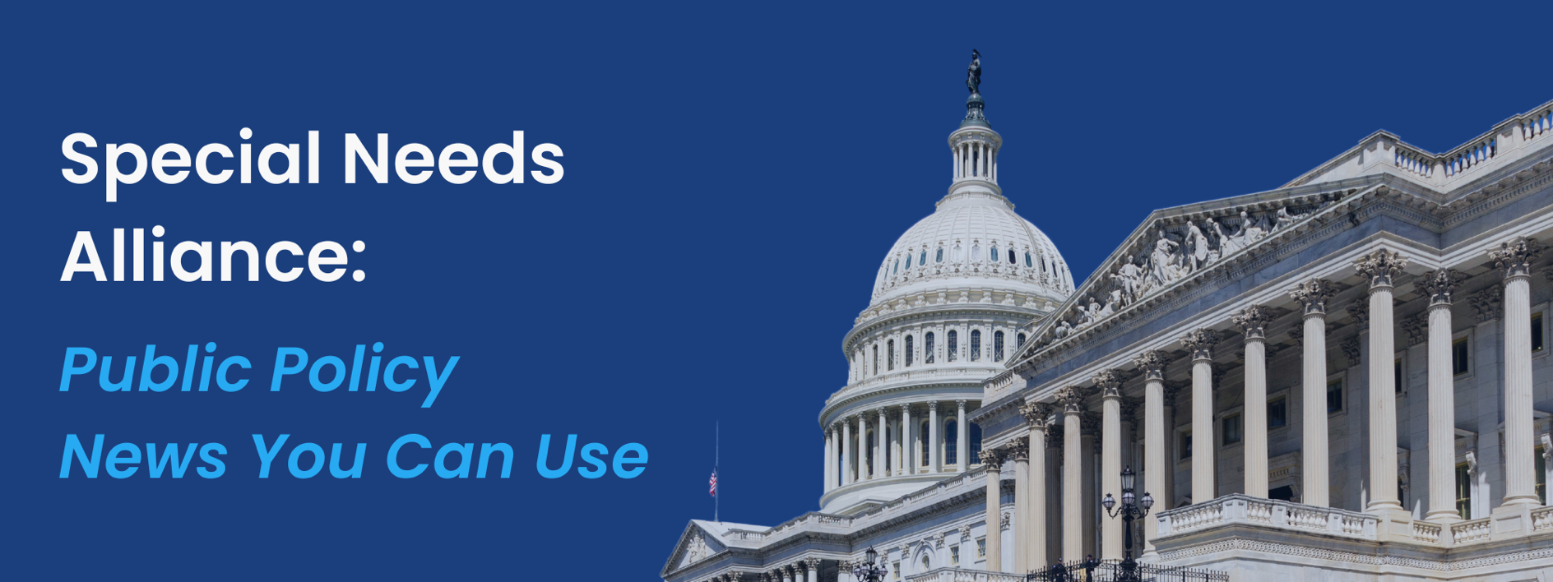
July 29, 2024
- HHS Affirms Commitment to Make Equal Opportunity a Reality on 34th Anniversary of the Americans with Disabilities Act
On the 34th anniversary of the signing of the Americans with Disabilities Act (ADA), Department of Health and Human Services (HHS) Secretary Xavier Becerra, along with other HHS Principals, affirmed their commitment to making inclusion and equal opportunity a reality for the more than 70 million Americans living with disabilities. In a statement, they emphasized that the fight for disability rights is far from over, highlighting that many people with disabilities still face significant barriers to accessing the services and supports they need to live fulfilling lives. Becerra assured that the Biden-Harris Administration remains dedicated to accelerating progress toward these goals.

- Committee on Oversight and Accountability Holds Hearing on PBMs’ Roles in Prescription Drug Markets, Focuses on Transparency and Accountability
The House of Representatives Committee on Oversight and Accountability recently held a full committee hearing titled “The Role of Pharmacy Benefit Managers (PBMs) in Prescription Drug Markets Part III: Transparency and Accountability.” This hearing, the third in a series, focused on the influence and practices of PBMs in the pharmaceutical market. The Committee was joined by the CEOs of the three largest PBMs—David Joyner of CVS Caremark, Adam Kautzner of Express Scripts, and Patrick Conway of OptumRx—who together control 80% of the PBM market. The hearing followed the release of the Federal Trade Commission (FTC) report earlier this month, titled “Pharmacy Benefit Managers: The Powerful Middlemen Inflating Drug Costs and Squeezing Main Street Pharmacies.” The report accused PBMs of engaging in anticompetitive and price raising practices that increase costs for both pharmacies and American consumers. Healthsperien covered the hearing, and detailed notes are available here.

- Committee on House Administration Holds Hearing on “Congress in a Post-Chevron World”
The Committee on House Administration held a hearing titled “Congress in a Post-Chevron World.” The hearing featured testimonies from Honorable Paul J. Ray from the Heritage Foundation, Mr. Satya Thallam from Americans for Responsible Innovation, Dr. Kevin Kosar from the American Enterprise Institute, Mr. Wayne Crews from the Competitive Enterprise Institute, and Professor Josh Chafetz from the Georgetown University Law Center. All witnesses agreed that Congress, in its current state, is ill-prepared to meet the increased regulatory demands of the legislative process. They collectively supported the creation of a Congressional Office of Regulatory Analysis (CORA), as proposed by the Government Accountability Office (GAO). However, there was disagreement among the witnesses regarding other actions Congress should take in response to the Loper Bright decision. Healthsperien covered the hearing, and detailed notes are available here.

- Study Analyzes Integrated Care for Dual-Eligible Population: Quality, Utilization, and Cost of Care
JAMA Health Forum recently published an article that evaluates the relationship between integrated care plans (IPCs) and quality, utilization, and spending among dual-eligible beneficiaries from 2010 through 2023. The study examined various integrated care models, including Programs of All-Inclusive Care for the Elderly (PACE) and Medicare-Medicaid Plans (MMPs), which demonstrated reductions in nursing-home says by 2-3 days and increases in outpatient care utilization. MMPs and Fully Integrated Dual Eligible Special Needs Plans (FIDE-SNPs) were associated with higher outpatient care utilization. Although data on Medicaid spending was limited, the study found that MMPs were linked with higher Medicare spending. Evidence on care coordination and hospitalizations was mixed or inconclusive. Due to insufficient data, patient satisfaction, overall health outcomes, and outcomes in beneficiary subgroups could not be fully evaluated. The researchers highlighted the need for further research to address evidence gaps and to guide future efforts for integrating care for dual-eligibles.
- HHS Reorganizes Technology, Cybersecurity, Data, and AI Strategy and Policy Functions
The U.S. Department of Health and Human Services (HHS) announced a reorganization aimed at optimizing and improving its technology, cybersecurity, data, and artificial intelligence (AI) strategy and policy functions. Previously, these responsibilities were distributed across the Office of the National Coordinator for Health Information Technology (ONC), the Assistant Secretary for Administration (ASA), and the Administration for Strategic Preparedness and Response (ASPR). Additionally, HHS will establish an Office of the Chief Technology Officer within ASTP/ONC and reinstitute the role of Chief Technology Officer. This position will oversee the Office of the Chief AI Officer, Office of the Chief Data Officer, and a new Office of Digital Services.
- SAMHSA Awards $45.1 Million to Expand Mental Health and Substance Use Services
The U.S. Department of Health and Human Services (HHS), through the Substance Abuse and Mental Health Services Administration (SAMHSA), announced $45.1 million in grant awards to address the mental health and overdose crises. The grants will fund a variety of behavioral health initiatives, including services for homeless individuals, school-based mental health programs, trauma, and grief treatment, supported employment for adults with mental health conditions, and HIV/AIDS substance use treatment for minority populations. These efforts align with SAMHSA’s mission to promote mental health, prevent substance misuse, and provide recovery supports, ensuring equitable access to services and better outcomes.
- Kids Online Safety Task Force Releases Recommendations and Best Practices for Safe Internet
The Kids Online Safety Task Force, co-led by the Department of Health and Human Services’ (HHS) Substance Abuse and Mental Health Services Administration (SAMHSA) and the Department of Commerce’s (DOC) National Telecommunications and Information Administration (NTIA), released a report outlining recommendations and best practices for social media and online platform safe use for youth. Convened to address the youth mental health crisis, the task force received input from youth advocates, civil society organizations, academic researchers, and other industry experts. The report provides a summary of the risks and benefits to social media, best practices to support parents and caregivers, recommended industry practices, a research agenda, and future work. Resources for parents and caregivers were developed in conjunction with the Center of Excellence on Social Media and Youth, led by the American Academy of Pediatrics.
- ASPR Awards Funding to Bolster American-Made Medicine Ingredient Production
The Administration for Strategic Preparedness and Response (ASPR), part of the U.S. Department of Health and Human Services (HHS), announced $18.5 million in awards for two American companies to strengthen the nation’s production of key materials and active ingredients necessary for manufacturing essential medicines. The awards are the first through ASPR’s Biopharmaceutical Manufacturing Preparedness (BioMaP)-Consortium, a public-private partnership established earlier this year. The funding aims to reduce the U.S.’s dependence on foreign-made ingredients, lower production costs, and increase reliability. Antheia, a California-based firm, will receive about $11 million to support U.S.-based production of pharmaceutical ingredients, while Virginia-based Capra Biosciences will receive about $7.5 million to leverage its bioreactor platform to manufacture three active pharmaceutical ingredients. Since 2019, ASPR has invested more than $325 million to develop domestic production capabilities for active pharmaceutical ingredients.
- Senate HELP Committee Votes to Investigate Bankruptcy of Steward Health Care
The Senate Health, Education, Labor, and Pensions (HELP) Committee voted 20-1 to investigate the bankruptcy of Steward Health Care and to issue a subpoena of Ralph de la Torre, CEO and Chairman of Steward. Senator Rand Paul (R-KY) was the only member to vote against. Ralph de la Torre will be expected at a hearing on September 12th, titled “Examining the Bankruptcy of Steward Health Care: How Management Decisions Have Impacted Patient Care.” Chairman Bernie Sanders (I-VT) and Ranking Member (R-LA) previously invited De la Torre to testify in front of the committee, but he declined. Steward Health Care is also reportedly under investigation by the Department of Justice and faces legal trouble in Malta for alleged fraud and corruption.
- Senate Democrats Introduce Bill to Codify the Chevron Doctrine
A group of Senate Democrats, led by Senator Elizabeth Warren (D-MA), introduced (press release) the Stop Corporate Capture Act (SCCA). This bill aims to codify the Chevron doctrine, which allows regulatory agencies to write rules to implement laws passed by Congress, a precedent that stood for forty years before a recent Supreme Court ruling. The SCCA seeks to strengthen the rulemaking process by protecting and codifying Chevron deference, modernizing and reforming the regulatory process, expanding public participation in rulemaking, and increasing transparency and independent expertise in the rulemaking process.
- Healthsperien Releases CY 2025 MPFS Proposed Rule Summary
On July 10, 2024, the Centers for Medicare and Medicaid Services (CMS) released the calendar year (CY) 2025 Medicare Physician Fee Schedule (MPFS) proposed rule and fact sheet. The proposed rule is one of several recently proposed rules by CMS that reflect a broader Administration-wide strategy to create a more equitable health care system that results in better access to care, quality, affordability, and innovation. Notably, the proposed rule includes a 2.93% reduction in overall payment rates in CY 2025 compared to CY 2024. The proposed CY 2025 MPFS conversion factor is $32.36, a decrease of $0.93, or 2.80%, from the current CY 2024 conversion factor of $33.29. Comments on the proposed rule are due by September 9th. Healthsperien's comprehensive summary of the main provisions of the proposed rule can be found here.
- KFF Holds Webinar on Overturning of Chevron
The Kaiser Family Foundation (KFF) hosted a webinar titled “The Health Wonk Shop: Beyond Chevron – How the Court’s Decision Will Change Health Policy Legislating and Rulemaking.” The discussion focused on the future of rulemaking, lawmaking, and role of congressional staff after the Loper Bright decision. The panelists evaluated potential impacts to Medicare, Medicaid, reproductive health care, and Employee Retirement Income Security Act (ERISA) among other topics. They expressed concern about increased litigation and administrative burden, noting that the Loper Bright decision did not establish a clear new doctrine, thereby making the outcome of future litigation uncertain and unpredictable. Panelists included Cindy Mann, Partner at Manatt Health and former Centers for Medicaid and Medicare Services Deputy Administrator, Kaye Pestaina, Vice President and Director of the Program on Patient and Consumer Protection at KFF, Dean A. Rosen, Partner at Mehlman Consulting and former Chief Healthcare Advisor to Senate Majority Leader Bill Frist, and Laurie Sobel, Associate Director of Women’s Health Policy at KFF. The webinar was moderated by Larry Levitt, Executive Vice President for Health Policy at KFF.

What’s on Tap
- While the Senate is in session this week, the House has left early for its August recess, only passing four of the 12 spending bills they had hoped to advance prior to departing due to disagreements that would have prevented passage.
- This week, the Senate HELP committee meets to consider three pieces of legislation: the Older Americans Act Reauthorization Act, the Autism CARES Act, and the Traumatic Brain Injury Program Reauthorization Act. The Senate Appropriations Committee will hold a markup of the FY 2025 Labor-HHS-Education appropriation bill, among others.

Upcoming Events
Wednesday
- The Senate HELP Committee will hold an executive session to consider the Older Americans Act Reauthorization Act (Sec. 4776), Autism CARES Act (S. 4762) and the Traumatic Brain Injury Program Reauthorization Act (Sec. 4755) at 10:00am.
Thursday
- The Senate Appropriations Committee will hold a markup of the fiscal 2025 Energy-Water, Defense, Labor-HHS-Education, Homeland Security and Financial Services appropriations bills at 9:30am.


