Student – Connecting Missing Scores
Go to www.chooserestaurants.org and log on to your account. Select ‘Certificate of Achievement’ from the ‘Programs and Scholarships’ dropdown. Then click on ‘Manage Exam Session’.
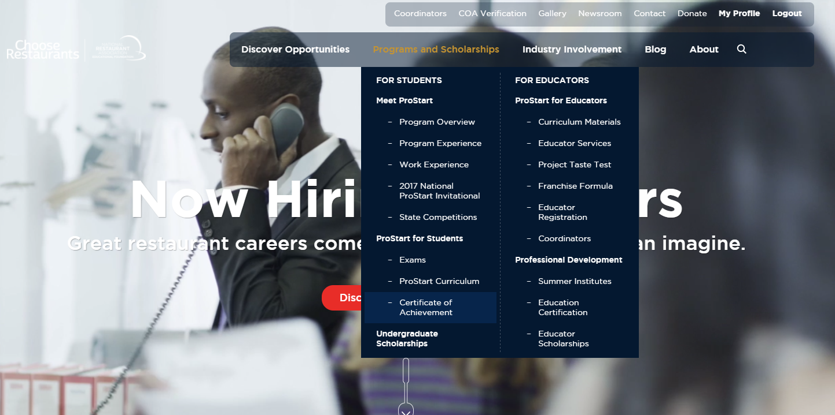
Click on the ‘Track your COA Progress Here’ link. You will receive the message below if you do not have at least one FRMCA exam connected with a 70% or higher.
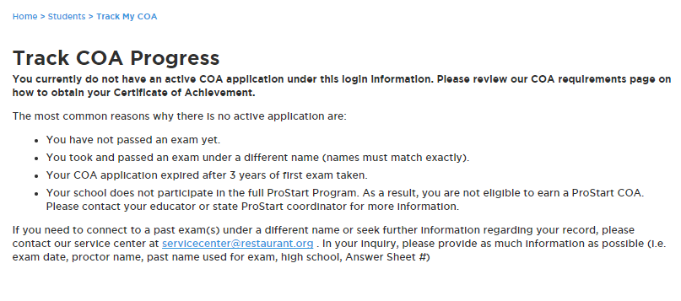

To confirm whether exams you have taken are connected to you profile select “Exams” from the “Programs and Scholarships” dropdown. Click the Check Scores button.
Possible reasons why your exam is not connected to your profile:
- Name on exam does not match name on registration.
  - Ex. Student registered as Benjamin Smith but took the exam as Benny Smith.
- Exam is already connected to a previous account. Service Center assistance will be required.
  - Ex. Student forgot their login from Level 1 so they created a new profile to take the Level 2 exam. Service Center assistance will be required.
- A self-merge is required.
  - Ex. Student has taken the exam however the Check Scores page is blank.
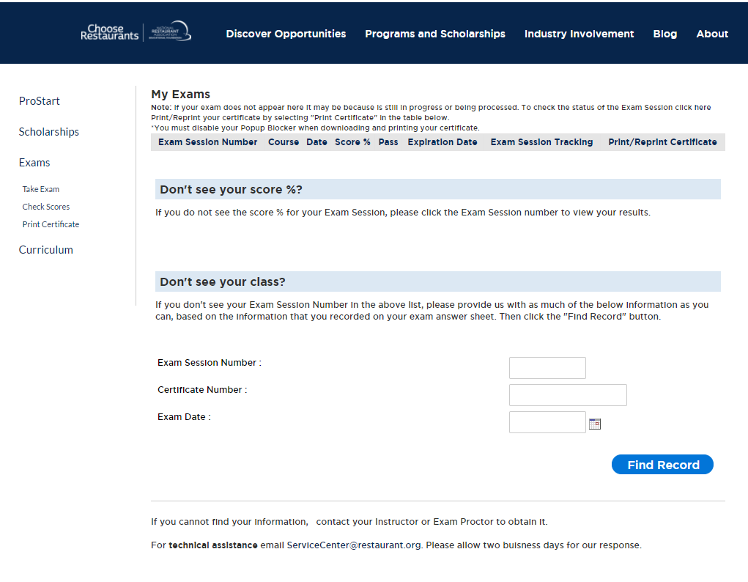

Enter the exam session number and click the Find Record button. The exam will immediately connect to your profile as long as the name matches and it’s not already tied to another profile.
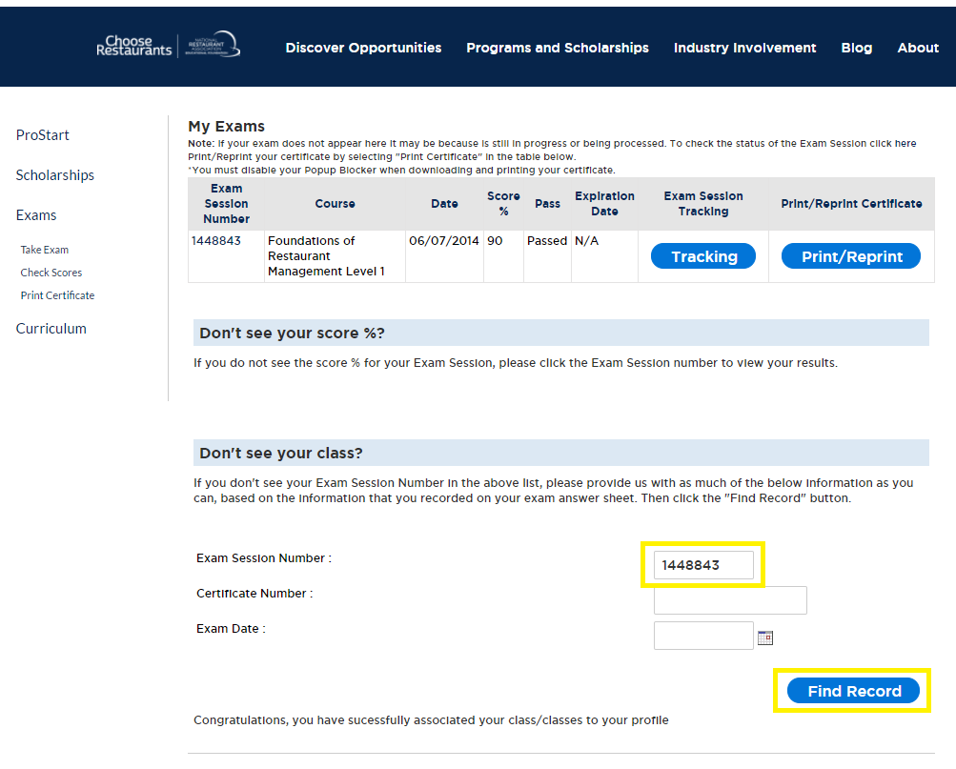

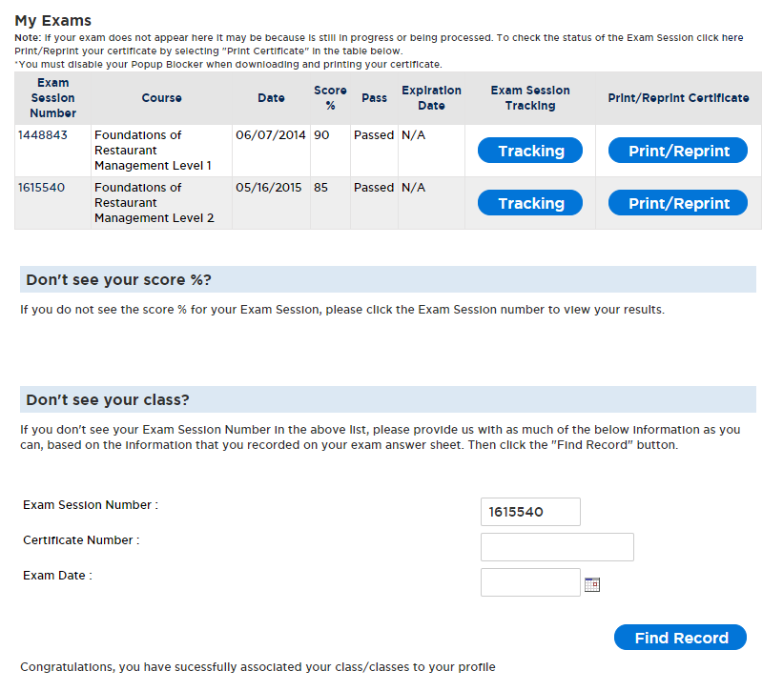
While the Check Scores page gets immediately updated, the COA Tracker may take a few minutes to reflect the change as the system updates.
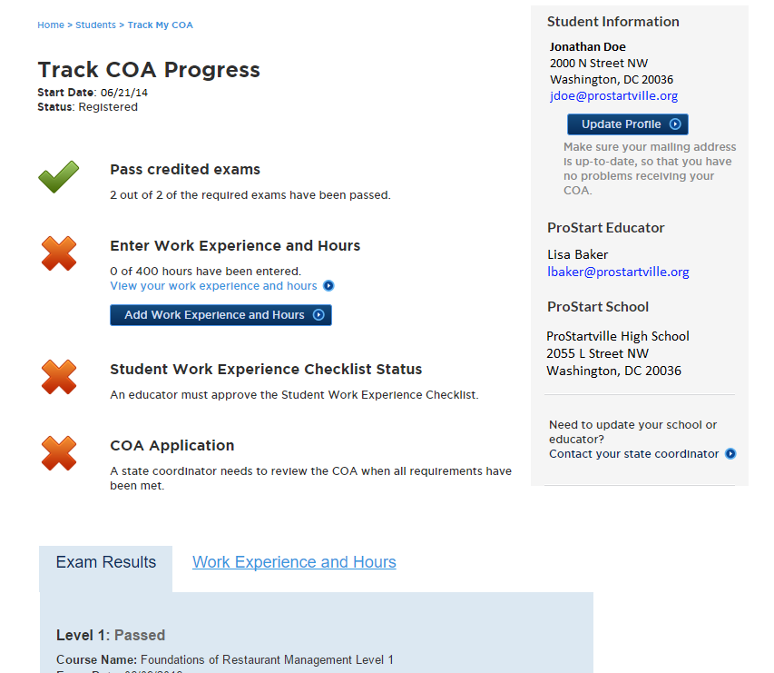

If these steps do not work it is possible that your name was entered differently or you have another account already connected to the record. Contact Megan Levy (mlevy@marylandrestaurants.com).

