C.O.A.
What is the C.O.A.?
- The Certificate of Achievement gives students a leg up in their job search and opens the door to collegiate opportunities such as; scholarships, class credits and credit towards work experience requirements.
How does a student earn the C.O.A.?
- Pass Level 1 and Level 2 Exams
- Work 400 hours in the industry
  - No more than 200 hours may be earned from class/school related activities such as catering, school events, school café…
- Complete 52/75 competencies on the Work Experience Checklist
My students has completed all of the requirements, what now?
- Send documentation of ALL work hours AND completed Work Experience Checklist to State Coordinator-
(Olivia Aberdeen- oaberdeen@marylandrestaurants.com)
- Make sure your student(s) are registered on the NRAEF website (www.chooserestaurants.org)
- Check that the student’s account has a GREEN CHECK next to:
  - “Pass Credited Exams”
  - “Enter Work Experience and Hours”
  - “Student Work Experience Checklist Status”
- There should be a RED X next to the last item, COA Application
  - This will turn into a GREEN CHECK once the state coordinator receives all necessary documents and approves the COA

Examples of the Track COA Progress Screen
Missing Items
If you see this, you either need to link exams, enter work hours and/or approve the Work Experience Checklist
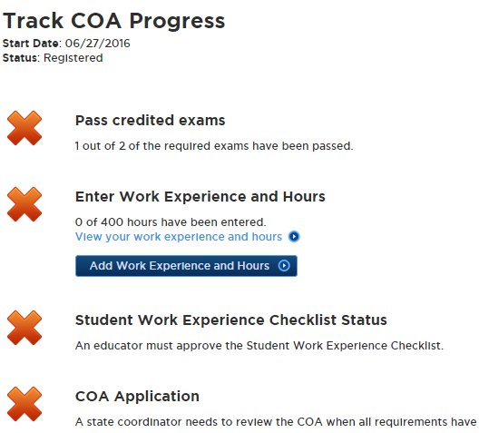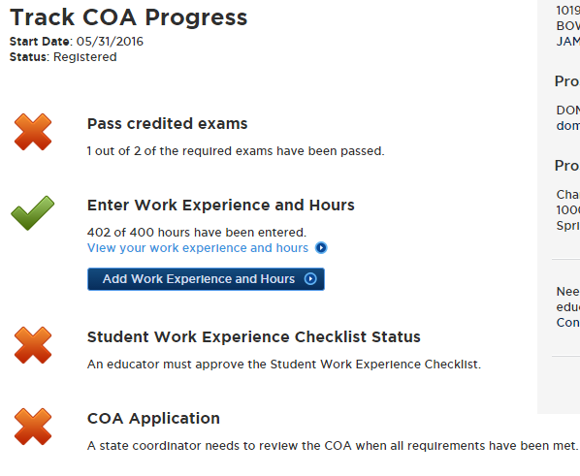
Complete Account
COA APPROVED!!
If you see this, you’re ready to
send me documents!
If you see this, your student now has their COA! Congratulations!
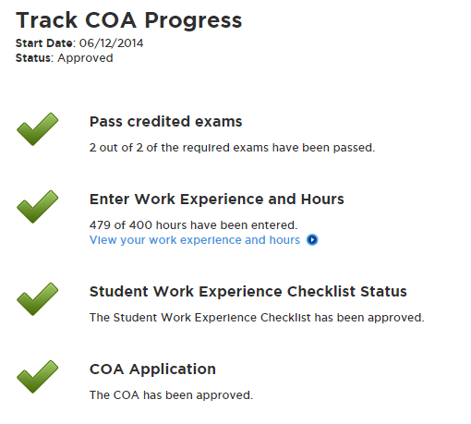
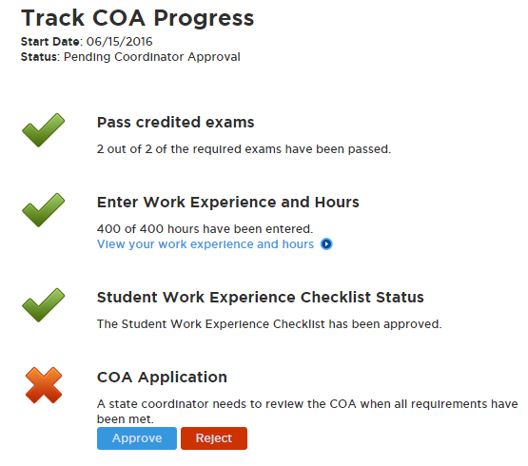

FAQ
- Can I use a student’s W-2 as proof of their work hours?
  - No, we will only accept pay stubs from the student’s place of work, notes on company letterhead signed by the students’ manager/boss documenting the number of hours worked, or school approved work hours signed and approved by the educator. If you are unsure, reach out and ask us!
- Can my students earn work hours at our school café, catering service, school related activities, etc…?
  - YES! But only up to 200 hours. We encourage students to work with their school to earn hours, but we want them to be well prepared for the industry as well! So we ask that only 200 of their hours be earned in a school related activity, and the remaining 200 be earned working in the industry.
- My student’s account is only showing one exam, even though they have taken and passed both. HELP!
Steps to add an exam to a student profile
- Go to ChooseRestaurants.org and log in. Go back up to the “Programs and Scholarships” and click on “Exams” under “ProStart for Students”. Here, click on “Check Scores”. On the next page, enter your Exam Session Number (don’t worry about the date or certificate number. Just the Exam Session Number is needed.
- The page will refresh and this should load the exam into the profile. On the Main Page, hover over “Programs and Scholarships”. In the drop down box that appears, click on “ Certificate of Achievement” (under “ProStart for Students”). On the next page, click on “Track Your COA Progress Here”.
- Go back to the Track COA Progress page and you should see a check mark for both exams. Sometimes it take 3-4 minutes for the information from the “Exams” page to populate over on the COA page so if it doesn’t show up immediately don’t panic 😊

