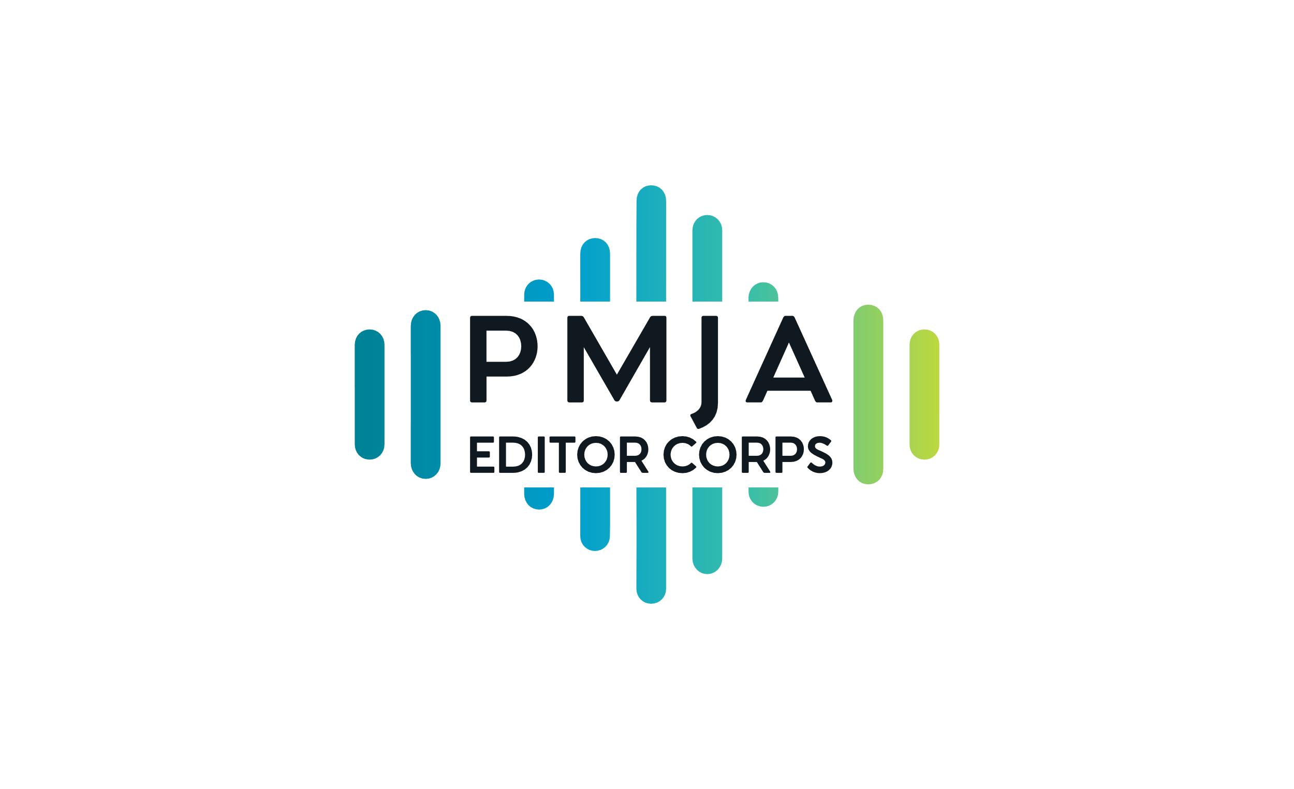
PMJA Editor Corps Editorial Guidelines
The following guidelines were developed for the PMJA Editor Corps. These are not intended to be comprehensive. They are some general terms to which editors and stations agree, meant to help facilitate quick-turn editing. We intend to update this document as we continue to draw on collective wisdom and experience.
Links to a number of useful style guides and handbooks are included below.
If you’re editing for audio, always do an ear edit – a timed read-through out loud by the reporter, with the audio (reporters/producers should email/Slack/etc. the audio files so you can hear what it actually sounds like).
How else can we make sure the audio is broadcast-quality? Or hear inflection, which can change meaning? Or notice if a cut unintentionally starts or ends abruptly, awkwardly, etc.? Does it need to be written into or out of differently? And what does the reporter sound like? Are they writing for their own voice? (More on that in a bit.) Are there read notes you can offer -- suggestions about marking up the scripts? That kind of thing. We also recommend listening to the first read-through without following along with the script. An editor only ever has one chance to listen to something from the perspective of a listener, something the reporter never has.
Digital
Before matching editors and stations, PMJA will find out if editing a web post or other digital presentation is part of the request, or perhaps the sole request, and will make the match accordingly, whenever available. If you are editing for digital, please ask the news director or news manager to find out what style the station uses – i.e. AP Style, etc.
Unnamed sources/not using full names
Reporters should know the full names of their sources for fact-checking and backgrounding. Decisions about when not to use names/full names should involve the station’s news director/news manager. If there’s an editorially-sound reason not to use a full name (i.e. someone is afraid of losing their job, privacy concerns about health conditions, undocumented immigrants, deadnames), make sure there is a line in the script explaining why a full name is not being used. If a source doesn’t want their name used but doesn’t give a reason why, the reason is not deemed editorially sound, or the reporter didn’t ask for a full name, that source should not be used. (This may be different in case of vox pop, montages, waterfalls, etc. Please check with the news director/news manager.)
Check implicit bias.
How Implicit Bias Works in Journalism from Nieman Reports offers a primer on avoiding some of the pitfalls of implicit bias. Also, think about how different audiences will experience the piece/spot/post/interview, etc. and ask - does this sound like it’s being presented as if it’s for an audience other than the people or group it’s about? Is something overly or unnecessarily explanatory? NPR once made the (wise) decision to edit: rapper Jay-Z, to just: Jay-Z. Think about whose voices we are hearing. Ask questions about representation. To answer such questions, some stations do audits of what they produce.
Maintain voice.
If something is going to be voiced by a reporter or has a reporter’s byline, maintain the reporter’s voice.
While there are of course tenets of good writing, and good writing for the ear, everyone sounding the same is a great way to make things sound really boring. Of course, no one’s expecting you to swoop in as a fill-in editor and know someone’s voice, but there are certain phrases and ways of presenting information that tend to get used a lot in public radio. See the Cliché Alert list we’ve included. Sometimes just asking a reporter to explain or describe what it is they’re reporting on yields more original language and allows you to hear how they actually talk, what they sound like as an individual.
Beware of buts.
This could probably go on the Clichés Alert list. “But” tends to be an overused word – especially in host intros. If you haven’t already thought about it, now you may notice how often a host intro hinges on that word when it really doesn’t need to. Beyond intros, ask if “but” really conveys the intended meaning, or even introduces implicit bias, such as in this sentence from an L.A. Times obituary a year or so ago: “Gary Stewart never married and had no kids. But he had an enormous community of friends.” (It was a lovely obit, and I love the L.A. Times; that line could have used an edit.)
Mix notes.
Please find out from the news director/news managers if you are expected to give notes on the mix – offering feedback/changes to the way a piece sounds, including levels, ambient sound, voicing, pacing, etc. Depending on the piece, we assume these things will be part of the discussion during the edit process, but find out if you are expected to listen to the mix.
Front-end editing
Depending on the type and scope of a report, story, interview, etc., communication between editors and reporters from conceptualization to the end of a process is the ideal scenario. For the purposes of short-term editing, we understand that this might not be possible. If you are in the position to talk with a reporter before they cover a story, or before they start writing/producing, we think there are elements of that kind of editing that could apply. Something to think about.
Other guidelines/style guides:
NPR Training Style Guide
NPR Accuracy Checklist
NPR Ethics Handbook
Diversity Style Guide includes links to handbooks and style guides from the AAJA, GLAAD, NABJ, National Center on Disability and Journalism, as well as links to NAHJ, Native American Journalists Association, Religion Newswriters Association and others.
GLAAD Media Reference Guide
Trans Journalists Association Style Guide (launched July 2020)
Much of SPJ’s Journalist’s Toolbox is now devoted to covering COVID-19.
David Candow's Yellow Flags (via PRPD, from the beloved late "host whisperer")
BBC Editorial Guidelines
BBC News Style Guidelines
Many thanks to the PMJA Editor Corps and other public media journalists who contributed ideas and suggestions for this document.

