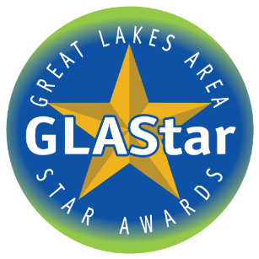
NOMINATION FORM
PROPERTY MANAGEMENT ASSOCIATION OF MICHIGAN
LIFETIME ACHIEVEMENT AWARD
The Property Management Association of Michigan is pleased to announce that it is accepting nominations for the 2023 Lifetime Achievement Award. PMAM established this award in 2011 to honor those who have made significant contributions to the apartment industry in Michigan. Please email entries to tracy@pmamhq.com. The deadline to enter is April 15th.

Name of Nominee: ____________________________________________________________________________________________

Agency or Organization:___________________________________________________________________________________________________

Job Title: _______________________________________________________________________________________________________

Address: ________________________________________________________________________________________________________

__________________________________________________________________________________________________________________

Business Phone: _______________________________________________________________________________________________

Home/Cell Phone: _____________________________________________________________________________________________

E-Mail: _________________________________________________________________________________________________________

NOMINATOR INFORMATION

Nominator's Name: ___________________________________________________________________________________________

Agency or Organization: _____________________________________________________________________________________

Address: _______________________________________________________________________________________________________

__________________________________________________________________________________________________________________

Business Phone: _______________________________________________________________________________________________

Home/Cell Phone: ____________________________________________________________________________________________
E-Mail: _________________________________________________________________________________________________________

RESUME
Please attach a copy of the Nominee's resume or biography.

LETTERS OF SUPPORT
Broad support for your Nominee is desirable. You may encourage other people or organizations to submit letters of support on behalf of your Nominee.
Lifetime Achievement Award
Entry Questionnaire

- Describe how the nominee through his or her life's endeavors has demonstrated noteworthy contributions to development and/or management of apartments.

- Please provide examples of the nominee's high integrity within the organization. (Leading by example, honesty, confidentiality, and treating others with respect)

- Describe the nominee's involvement with PMAM.

