Bankers in Schools Lesson Plans

Intended age K-2: “Silly Sally Saver” a MADLIB story that talks about safe places to keep your money.
Directions – call on students of the audience to provide noun, verbs, adjectives, ect. Once all blanks have been filled, read the story of Sally who saves (and loses) her money because it was not kept in a safe place.
Pre activity questions:
- Who has been to the bank?
- What do banks do?
- What does ‘save money' mean?
- What is a describing word? Give examples?
Post Story Questions
- What does it mean to save?
- Where are safe places to keep our money?
- Why would we want to save our money?

** If time allows have children to decorate a photo of a piggy bank or savings jar label. **

color-and-cut-savings-jar-wraps.pdf

Bankers in School Lesson Plans

Intended age 3-5 grade: “ Wants vs Needs Money Tree” a lesson that inspires discussions, and debates on wants vs needs. A look at budgeting and saving.

Directions: Using a faux tree, posterboard cut out, or similar fake bills of varying denominations on to the tree. On the back of each bill write an item that would be a ‘want’ (such as candy, concert tickets, tablet) and on others write compared ‘needs’ (water, shelter, medication) on a few remaining card list items that will inspire discussion and debate (bicycle, new shoes, Chic-fil-a)

Have students from the audience come up and select a bill from the tree, reading the card and denomination aloud to their peers.
Then have the class to vote on if that item is a want or a need. Depending on how the majority decides, keep a running $ amount on each – preferably on a visible classroom board – to see how much we are spending toward both want and needs. Be sure to encourage a little bit of debating with the discussion items. If bike is leaning toward want – ask would their opinions change, if they did not have a car? Or would their opinions change on new shoes, if their current shoes were too small?

After all ‘bills’ have been selected and recorded – have students to add together the total cost of their needs. Then the total cost of their wants. Turn the conversation to savings, and other alternatives. Reiterate times that wants become needs.

Continued :
Pre Activity Questions:
- What is a want?
- What is a need?
- What are some examples of a want? (1-2)
- What are some examples of a need? (1-2)
- Should there be a limit to spending money on things we want?

Post Activity Questions
-What is a want?
-What is a need?
-Are there times that wants become need? Give an example
-Are there better things we could do without money?
-Why should we save money?
-What / Where are safe places to save our money?

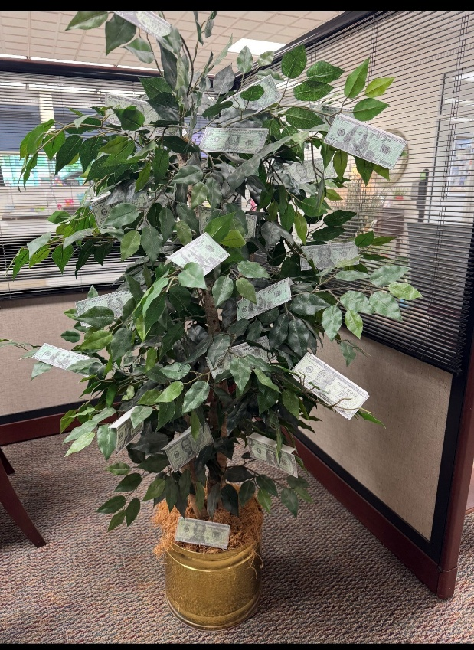
Bankers in Schools Lesson Plans
Intended age 6-8 grade: “Vacay on a Budget!” This lesson focuses on budgeting for a vacation from start to finish. Students will select travel, hotel accommodation, and an itinerary, while remaining in budget and avoiding the ‘uh-ohs!’ of life.
Directions: Divide students into groups of 3 or 4. Once each group is formed, you will present each group with an envelope. Each envelope will contain the destination for their vacation.
Example: “Congrats! You’re headed to New York City for 4 days! Your trip budget is $3600!”
The next paper in their envelope will be a list of differing items and prices from travel to experiences, as well as accommodations. You may make up these figures, or look them up if you like.
Example for travel:
Drive to New York - Cost: $240 in gas / Time: 16 hours roundtrip
Fly to New York – Cost: $312 PER PERSON / Time 3 hours roundtrip
Train to New York - Cost: $62 PER PERSON/ Time: 26 hours roundtrip

Students will have to weigh up the options and discuss whether they want to spend less on travel and have less time in the city or spend more on travel but have more time in the city.

This will be the same for hotels, where you have options for a room, room with breakfast or a room with breakfast and pool access. Dining as well, are you going to eat each meal at a restaurant? Purchase groceries for the duration of the stay?
This list should continue and include all options for travel, stay, food, and then activities. Be sure to throw in 1-2 free activities like site seeing, or visiting the park, etc.

While students are working on their trip and budgets you will walk around and drop an ‘uh-oh’ card. These cards include additional charges that the students were not expecting.
Examples include: Lost luggage, rebuy toiletries ($150) or parking ticket ($60) or flat tire ($200)

In total, the planning trips should take roughly 25-30 minutes for students to complete. Use the remaining class time to have students present their peers and discuss if they were able to stay in budget, and how they’ve planned their trip.

Pre Activity Questions:
-Who has ever been on vacation?
-Who has ever paid for a vacation all by themselves?
-What is a budget?
-Why would you need a budget?

Post Activity Questions?
- Why is budgeting important?
- What are some things you will need to budget for as you get older?
- Discuss saving money!

