MBIA Board of Directors Meeting prior to
Builder Mart Preview
September 16, 2026
3:30-5:00pm – Board Meeting

- Call to Order Matt Lefler
- Approval of Minutes from June Board Meeting Tom Baldwin
- President’s Remarks Matt Lefler
- Strategic Plan Update Lori Graf
- Financials Rob Kase
- Membership Tim Morris
  - Approval of new members
  - Recently terminated members
  - Membership Drive
- State Legislative Update Lori Graf
  - Housing Certainty Act
  - 2027 Legislation
  - Save the date:
    - October 21st- “Coffee with the Candidates” at Builder Mart
    - February 17th- State Advocacy Day
- Builder Mart Scott Bosse
- NAHB Update Marty Mitchell
- MBIA PAC Update Lori Graf
  - MBIA PAC Kick off- September 24th
- Home Builders Care Foundation Jeremy Rutter
- Builders Development Guaranty Group Scott Nicholson
- Association Report Lori Graf
  - Member feedback
  - Rest of 2026 Event Schedule
  - 2027 Planning

**Builder Mart Preview to follow**

Connect with MBIA!
Follow us @marylandbuilders




marylandbuilders.org

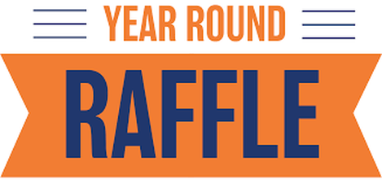

MBIA ADVOCACY RAFFLE
Drawing every week for a $250 prize. $100 per ticket.

‘Job

marylandbuilders.org/raffle

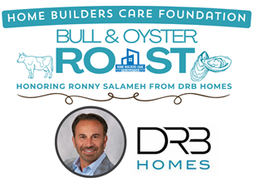

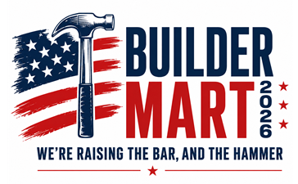

October 21, 2026
Howard Co. Fairgrounds



Nominations due October 1, 2026
Awards on November 18 at Laurel Park

‘Job

marylandbuilders.org/raffle

