MBIA Board of Directors Meeting prior to MAX+
feat. Guest Speaker, Senator Katie Fry Hester
June 16, 2026
3:30-5:00pm – Board Meeting

- Call to Order - 3:39pm Matt Lefler
- Approval of Minutes from April Board Meeting - Approved 3:39pm Tom Baldwin
- President’s Remarks Matt Lefler
- Strategic Plan Update Lori Graf
  - New Website rolled out May 2026: Please review our new website; create your new login
  - Revamped Social Media: Please send Lori feedback regarding social media campaign
  - Engagement: New website is now tracking engagement/New members will wear
stickers at their first event, kindly engage with them
  - Discord: Improves communication for councils/chapters; positive feedback thus far. Please encourage more usage at your meetings
- Financials Rob Kase
  - Currently working through transition from Atlas (old website/system) to Novi
  - Cash flow lower in summer; majority of dues collected in Sept
  - All financial documents presentedcan be reviewed at https://www.marylandbuilders.org/bodmaterials
- Membership Tim Morris
  - Approval of new members – Unanimously Approved; 4:01pm
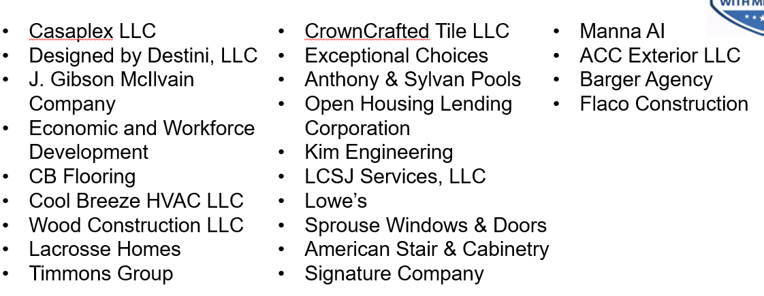

  - Recently terminated members
  - Membership Drive – June 26th at 9am; Goal 25 New Members
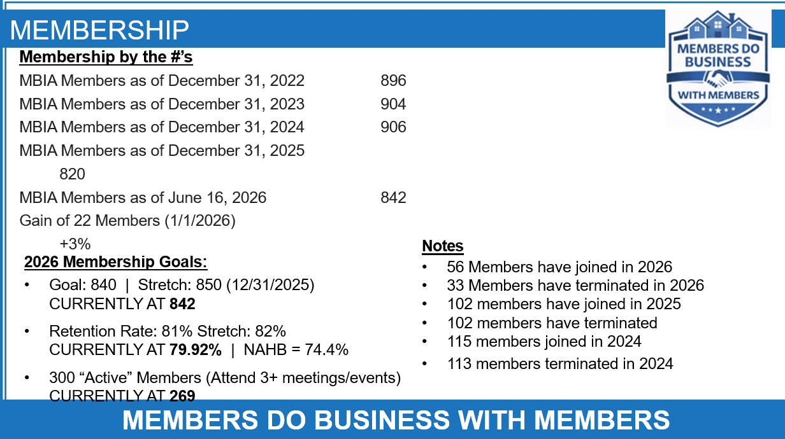

- State Legislative Update Lori Graf
  - Early voting until June 18th
- Builder Mart (October 21, 2026) Scott Bosse
  - Guinness Book of World Records Attempt – June 25th Meeting, 10am
  - Next Board Meeting – September 16th @ Howard County Fairgrounds
- NAHB Update Lori Graf in place of Marty Mitchell
  - Legislative day at the Capitol in DC went well; met with legislators June 10th
- MBIA PAC Update Lori Graf
- Home Builders Care Foundation Patti Kane in place of Jeremy Rutter
  - HBCF Report can be reviewed at https://www.marylandbuilders.org/bodmaterials
  - Bid Opportunities at HBCF.org
  - HBCF Bull Roast – Sept 22nd – CEO of DRB Group being honored
- Builders Development Guaranty Group Scott Nicholson
- Association Report (Skipped due to time) Lori Graf
- Guest Speaker, Senator Katie Fry Hester

