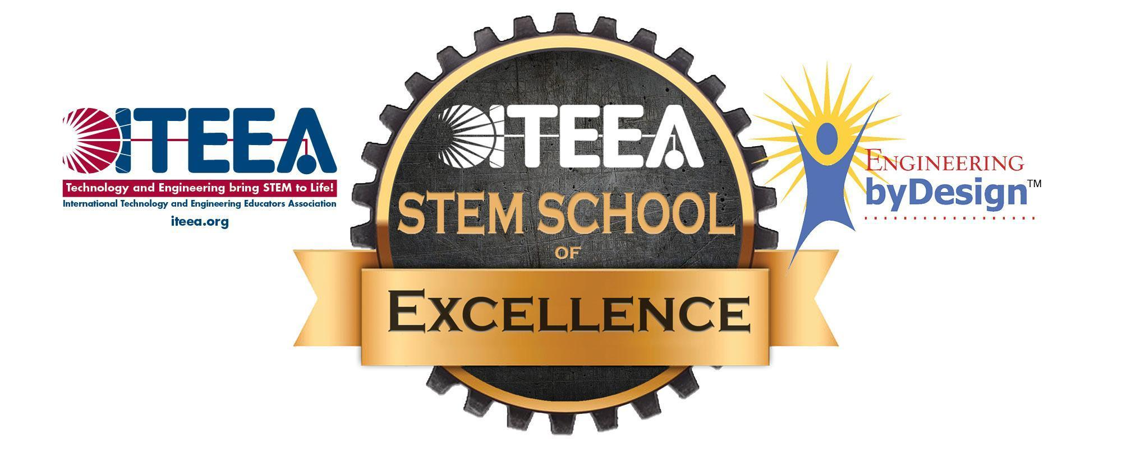
University STEM School of Excellence
Recognition Program

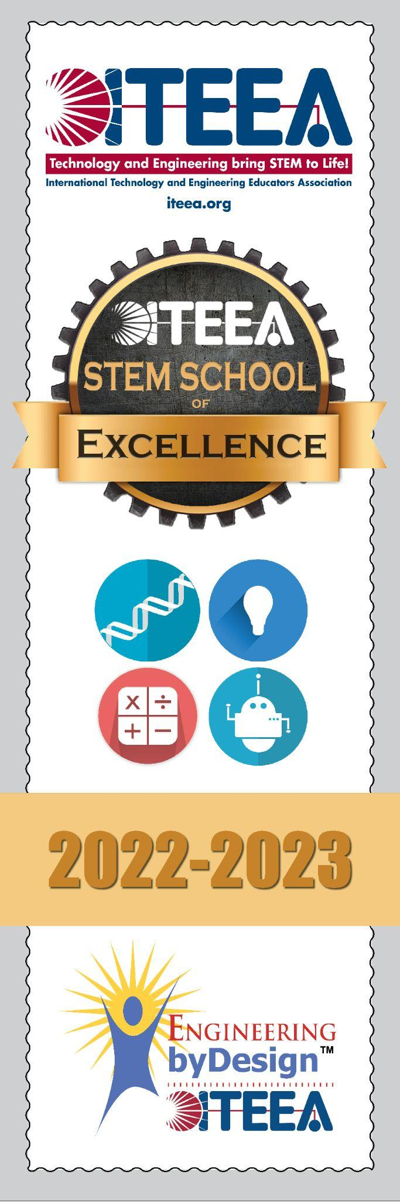
ITEEA’s STEM Center for Teaching and Learning™ annually recognizes outstanding colleges and universities for their commitment to providing a robust Integrative STEM education program. Recognized schools exemplify outstanding leadership in the field of STEM education. Recognized schools undergo a rigorous application process requiring detailed documentation to demonstrate a strong Integrative STEM program. A panel of reviewers work to reach consensus that the documented evidence represents excellence in Integrative STEM education.

ITEEA created the designation to officially recognize those schools whose teachers, administrators, and other stakeholders are providing a meaningful STEM education experience for students. By highlighting these schools, ITEEA hopes to help others learn effective best practices and continue sharing them more broadly into the larger STEM Education community.

Awards are made at two levels using a vetted application review process:
- ITEEA STEM School of Excellence (200+ points)
- ITEEA STEM School of Merit (170-199 points)
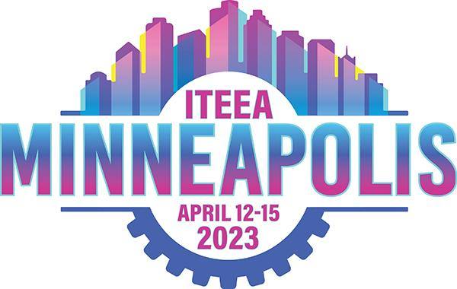
Award recipients will be recognized at the ITEEA International Conference in Minneapolis, MN, April 12-15, 2023:
- ITEEA University STEM School of Excellence schools will receive a banner and certificate for display in the school
- ITEEA University STEM School of Merit schools will receive a certificate for display in the school

Recognized colleges and universities will be posted on the ITEEA University STEM School of Excellence website page with school program description, pictures, video links, etc. To learn more about this program, please visit our ITEEA STEM School of Excellence website at www.iteea.org/STEMschoolofexcellence.aspx. Please send any questions about the application process to stemsoe@iteea.org or call ITEEA at 703-860-2100.

The application window for the 2022-23 school year is June 22, 2022–December 17, 2022.

Application Fees:
- ITEEA members: $195.00; non-ITEEA members: $295.00
- Previous SoE Recipients (ITEEA Members) $125.00; (non-ITEEA Members) $225.00
(previous recipients should contact iteea@iteea.org for a discount code).

To Apply:
DOWNLOAD this file to Microsoft Word and change the file name to your school’s name.
Complete the application that begins on the following pages.
Return to the Google Form Submission page at https://tinyurl.com/SoESubmit
Upload completed file.
Complete application fee.

2022-2023 STEM School of Excellence Application

- Supporting images can earn points and provide additional clarification of your provided descriptions.
- Point values that state “points per…” can earn you additional points either per person, event, etc.
- Multiple submissions for the same item will not earn additional points unless specifically stated.
- If you have any questions, please reach out prior to the application due date. Applications are reviewed by a committee and cannot be retracted after the due date.
_____________________________________________________________________________

School and Staff Information

Questions with * are required.

*STEM Instructor/Professor/Coordinator's Name:
Linda Paris
*STEM Instructor/Professor/Coordinator's Title:
Visiting Assistant Professor
* STEM Instructor/Professor/Coordinator's Email:
linda.paris@oswego.edu
*STEM Instructor/Professor/Coordinator's Phone Number:
315-312-2866
*Dean or Person overseeing nominated program’s Name:
Richard Bush
* Dean or Person overseeing nominated program’s Email:
Richard.bush@oswego.edu
Board President's Name:
Dr. Mary Toale (Officer in Charge)
College President's Email:
mary.toale@oswego.edu
*College/University State:
New York
*College/University Name:
SUNY Oswego
*College/University Address:
7060 State Route 104, Oswego, NY 13126

ITEEA Integrative STEM School Membership Number (if member): 12321
(Not sure of membership number? Email iteea@iteea.org)
(Not a member? Click here to join: www.iteea.org/membership.aspx)

______________________________________________________________________________

Qualifying Activities

Provide details and documentation for the activities and initiatives in which your school participates. Some activities require details such as specific titles to presentations and direct links to utilized resources.

In order to receive points for an activity, the required documentation should be fully documented within this form. Add as much space as needed.

- College/University produces completers in a STEM career pathway. Describe pathway requirements and numbers of completers in 2021-22. (30 pts)
Technology Education All Grades Major - B.S. Degree (85-95 cr)
Number of completers for 2021-2022:
- December 2021: 16
- May 2022: 16
- August 2022: 6
- Total: 38 students

- Core Requirements - Technical (39 cr)
  - TEL 101 - Engineering Graphics and Technical Illustration (3 cr)
  - TEL 110 - Design and Technology (3 cr)
  - TEL 120: Introduction to Materials Technologies (3 cr)
  - TEL 203: Materials Processing and Fabrication (3 cr)
  - TEL 204: Materials Molding and Forming (3 cr)
  - TEL 205: Materials Precision Production (3 cr)
  - TEL 240: Electronics Technology (3 cr)
  - TEL 323: Construction Systems (3 cr)
  - TEL 347: Computer-Assisted Design and Drafting (3 cr)
  - TEL 353: Transportation Systems (3 cr)
  - TEL 355: Energy and Power Technology (3 cr)
  - TEL 363: Communication and Multimedia Systems (3 cr)
  - TEL 393: Manufacturing Systems (3 cr)
- Core Requirements - Professional Education (26 cr)
  - TED 201: Introduction to Teaching Technology Education (3 cr)
  - TED 206: Introduction to Technology Education Curriculum (3 cr)
  - TED 211: Field Experience 1 - Observation and Participation in a Technology Education Environment (1 cr)
  - TED 216: Field Experience 2 - Assisting in a Technology Education Environment (1cr)
  - TED 306: Teaching Methods for Technology Education (3 cr)
  - TED 316: Field Experience 3 - Methods of Teaching (1 cr)
  - TED 410: Professional Field Experience (6 cr)
  - TED 411: Professional Field Experience (6 cr)
  - TED 414: Professional Topics and Problems (2 cr)
- Elective Requirements (3 cr)
  - TED 310: Technology and Civilization (3 cr)
  - TED 399: Independent Study (1-4 cr)
  - TED 400: Workshop in Technology Education (1-3 cr)
  - TED 499: Independent Study (1-4 cr)
  - TEL 396: Laboratory Management Practicum (3 cr)
  - TEL 397: Laboratory Instruction Practicum (3 cr)
  - TEL 401: Architectural Drawing (3 cr)
  - TEL 412: Design Probe (3 cr)
  - TEL 433: Metals Manufacturing Technology (3 cr)
- Cognate Requirements (15 cr)
  - CHE 101: Survey of Chemistry (3 cr)
  - COM 210: Critical Thinking and Public Speaking (3 cr)
  - PHY 101: Introductory Physics (3 cr)
  - TED 209: Technical Writing and Literacy (3 cr)
  - HDV 322: Child Development (3 cr) or HDV 323: Adolescent Development (3 cr)
- Other Arts and Sciences Requirements (3-12 cr)
  - PSY 100: Introduction to Psychology (3 cr)
  - TEL 130: Computing Technology and Information Systems for Technology Careers (3 cr) or competency exam
  - Foreign Language requirement (0-6 cr)
- Non-credit Requirements (0 cr)
  - SSHS 1020: Safe Schools, Healthy Students (0 cr)
  - DASA 1020: DASA Training (0 cr)

Technology Management Major - B.S. Degree (75 cr)
Number of completers for 2021-2022:
- December 2021: 1
- May 2022: 7
- August 2022: 5
- Total: 13 students

- Core Requirements (45 cr)
  - ACC 321: Accounting as a Management Tool (3 cr)
  - BLW 355: Legal and Regulatory Environment of Business (3 cr)
  - HRM 385: Organizational Behavior (3 cr)
  - MGT 261: Business Organization (3 cr)
  - MGT 460: Leadership (3 cr)
  - MKT 250: Marketing Principles (3 cr)
  - TED 209: Technical Writing and Literacy (3 cr)
  - TED 310: Technology and Civilization (3 cr)
  - TED 498: Professional Internship (3 cr)
  - TEL 101: Engineering Graphics and Technical Illustration (3 cr)
  - TEL 110: Design and Technology (3 cr)
  - TEL 120: Introduction to Materials Technologies (3 cr)
  - TEL 130: Computer Technology and Information Systems for Technology Careers or CSC 102: Business Information Systems and Computing Tools (3 cr)
  - TEL 355: Energy and Power Technology (3 cr)
- Elective Requirements (18 cr)
  - Manufacturing (select four courses)
    - TEL 203: Materials Processing and Fabrication (3 cr)
    - TEL 204: Materials Molding and Forming (3 cr)
    - TEL 205: Materials Precision Production (3 cr)
    - TEL 347: Computer-Assisted Design and Drafting (3 cr)
    - TEL 393: Manufacturing Systems (3 cr)
  - Facility Planning
    - TEL 323: Construction Systems (3 cr)
    - TEL 328: Computer-Aided Estimating and Site Management (3 cr)
    - TEL 347: Computer-Assisted Design and Drafting (3 cr)
    - TEL 401: Architectural Drawing (3 cr)
  - Select two Business courses from the following
    - HRM 386: Human Resource Management (3 cr)
    - MGT 305: Project Management (3 cr)
    - MGT 310: Operations Management (3 cr)
    - MGT 350: Entrepreneurship (3 cr)
    - MGT 469: Cultural Environment of International Business (3 cr)
    - MGT 486: Materials Management (3 cr)
- Cognate Requirements (12 cr)
  - MAT 158: Introduction to Statistics (3 cr)
  - MAT 104: College Algebra (3 cr)
  - Any GE Physics course (3 cr)
  - Any GE Chemistry course (3 cr)

Technology Minor (21 cr)
Number of completers for 2021-2022:
- December 2021: 0
- May 2022: 3
- August 2022: 2
- Total: 5 students

- Core Requirements (9 cr)
  - TEL 101: Engineering Graphics and Technical Illustration (3 cr)
  - TED 310: Technology and Civilization (3 cr)
  - TEL 120: Introduction to Materials Technologies (3 cr)
  - TEL 130: Computing Technology and Information Systems for Technology Careers (3 cr)
- Elective Requirements (12 cr)
  - TEL 203: Materials Processing and Fabrication (3 cr)
  - TEL 204: Materials Molding and Forming (3 cr)
  - TEL 205: Materials Precision Production (3 cr)
  - TEL 210: Design and Problem Solving (3 cr)
  - TEL 240: Electronics Technology (3 cr)
  - TEL 347: Computer-Assisted Design and Drafting (3 cr)
  - Select two courses from the following (6 cr)
    - TEL 323: Construction Systems (3 cr)
    - TEL 328: Computer-Aided Estimating and Site Management (3 cr)
    - TEL 343: Digital Electronics Systems (3 cr)
    - TEL 353: Transportation Systems (3 cr)
    - TEL 355: Energy and Power Technology (3 cr)
    - TEL 363: Communication and Multimedia Systems (3 cr)
    - TEL 393: Manufacturing Systems (3 cr)
    - TEL 401: Architecture Drawing (3 cr)
    - TEL 412: Design Probe (3 cr)
    - TEL 433: Metals Manufacturing Technology (3 cr)
    - TEL 442: Mechatronic Systems (3 cr)
    - TEL 457: CAD: Engineering and Analysis (3 cr)

Technology Education Grades K-12 (Professional Certification), M.S.Ed. (30 cr)
Number of completers for 2021-2022:
- December 2021: 1
- May 2022: 2
- August 2022: 3
- Total: 6 students

- Professional Core (18 cr)
  - TED 531: History and Philosophy of Technology Education (3 cr)
  - TED 532: Advanced Instructional Methodologies for Technology Education (3 cr)
  - TED 533: Curriculum Development for Technology Education (3 cr)
  - TED 534: Assessment in Technology Education (3 cr)
  - TED 535: Laboratory Instructional Environments in Technology Education (3 cr)
  - TED 536: Introduction to Research for Technology Education (3 cr)
- Options (must complete one option under advisement (12 cr)
  - Option A: Research Project Option: Directed Coursework
  - Option B: Thesis Option: Directed Coursework
    - TED 598: Thesis (3 cr)
  - Option C: Directed Coursework Option
    - Courses may be selected from the College of Liberal Arts and Science, School of Education, School of Communications, Media and the Arts, or departmental electives

- College/University participates in a STEM outreach or community service project during the 2021-22 academic year. Provide description of project and include (insert) photos. (30 pts)
KidsTech - Oswego KidsTech consists of two programs: STEM 4 Kids K - 3 and Young Inventors (4th - 6th grades) which are hosted by Oswego Technology Student Association (OTSA), Department of Technology, and preservice Technology Education teachers at SUNY Oswego. Each program includes exciting educational activities focused on the relationships among the different components of STEM. The children experience different problem-solving strategies as they learn about the designed world. The goals of KidsTech participants include recognizing the connection between the different components of STEM, utilizing STEM principles and concepts to solve problems, developing thought processes and motor skills necessary to design, construct and test models, and communicating ideas while working productively in a team. KidsTech is offered in person during the fall semester and remote and in-person during the spring semester.
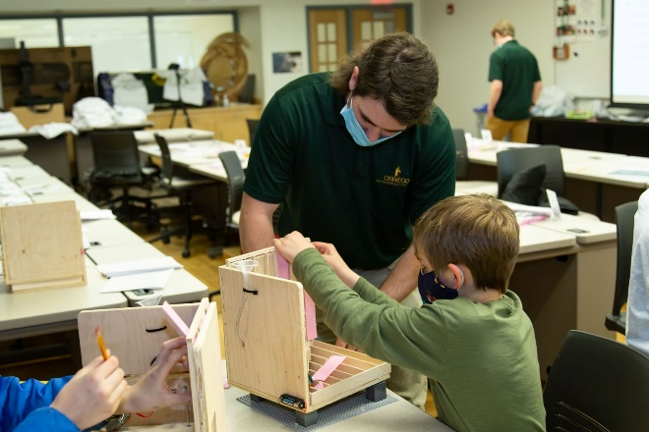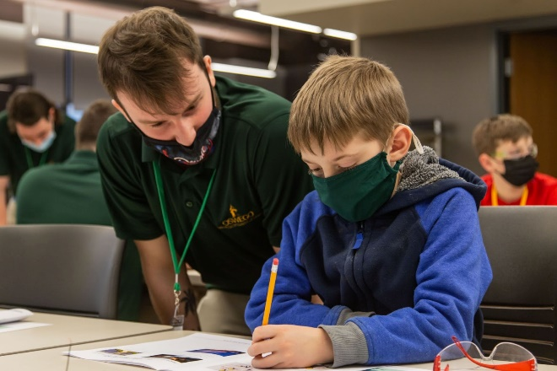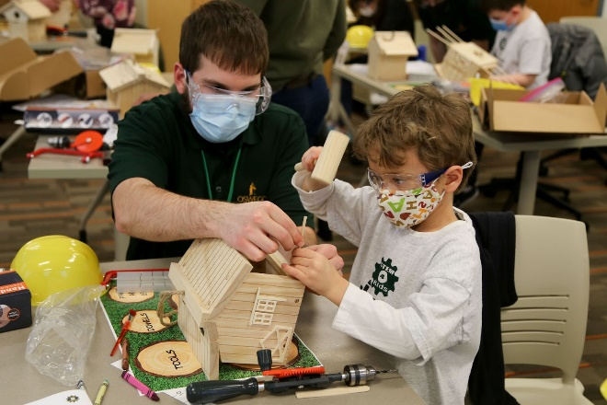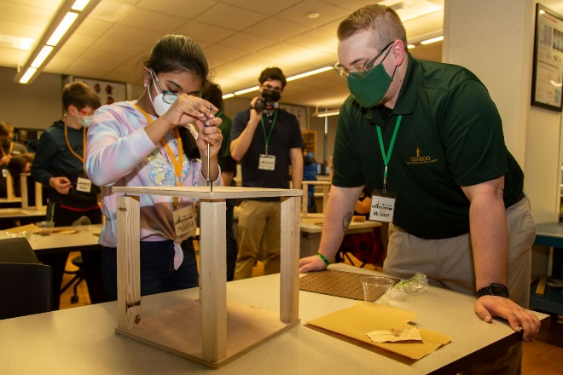

- Photo upload (insert) of STEM outreach or community service project (maximum 1 photo or 1 PDF containing up to 4 photos). (10 pts)
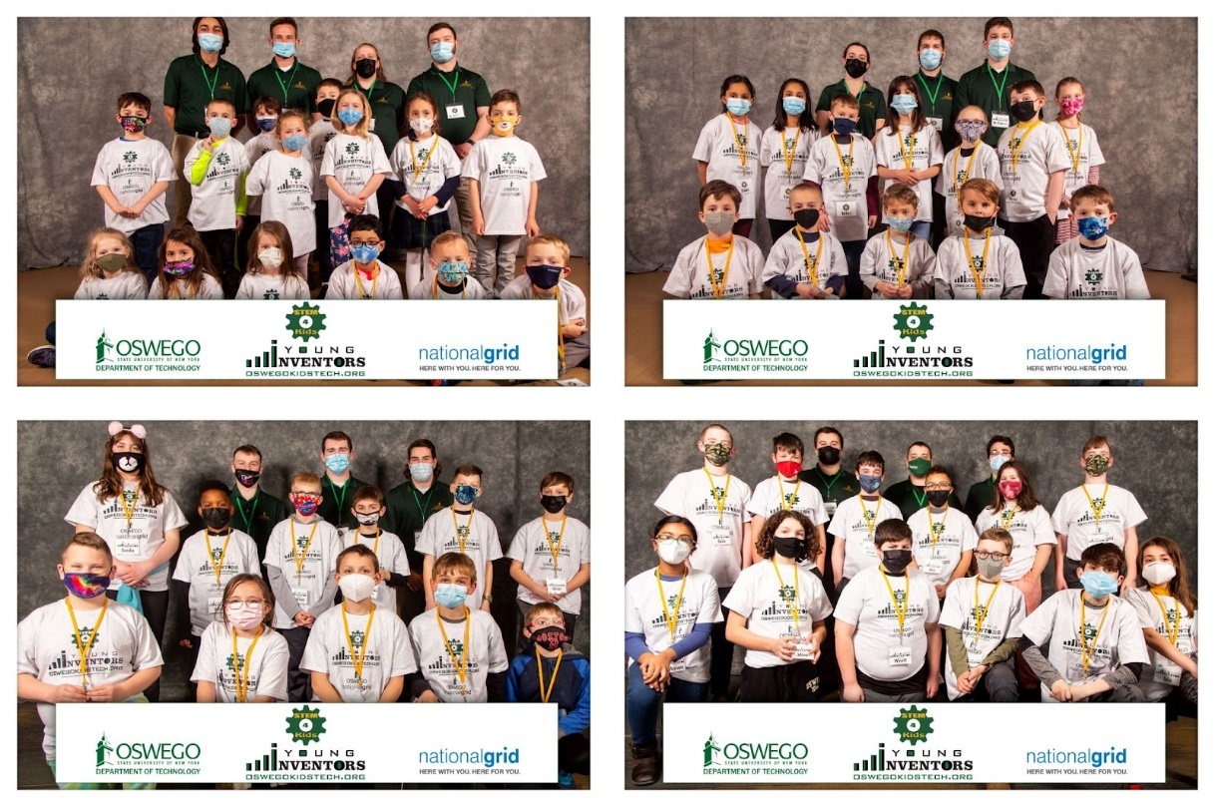
NOTE: Select Insert > Pictures > This Device for a picture on your PC.

- Two or more professors/instructors collaborated on an integrative STEM project during the 2021-22 academic year. Provide teachers’ names, subject areas, brief description of the project focusing on the integrative nature of the teaching and learning and include photos. (30 pts)
- Teachers’ names: Richard Bush and Benjamin Entner
- Subject areas: Technology Education and Studio Art
- Brief Description of Project: Sculpture and technology students come together to host Oswego’s annual Iron Pour. Raw iron is heated in an outdoor furnace to a toasty 2,500 degrees, liquefied, and poured into molds creating original sculptures and designs. The event is open to the campus and community. On the day of the event, attendees can create an artistic design in a sand mold to be cast in iron.

- Photo upload: collaborative, integrative STEM project (maximum 4 photos). (10 pts)
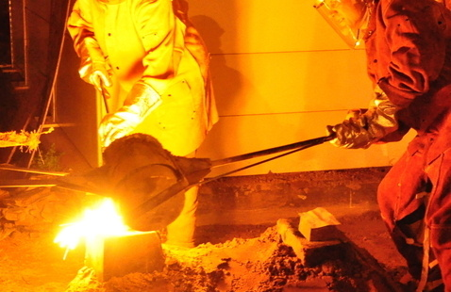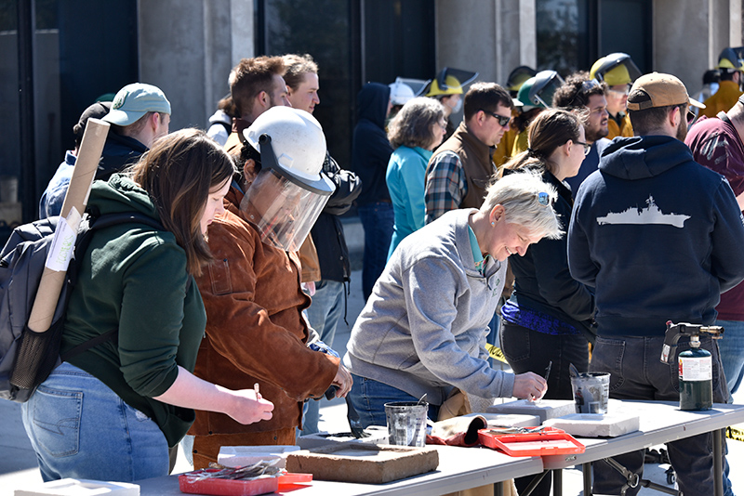
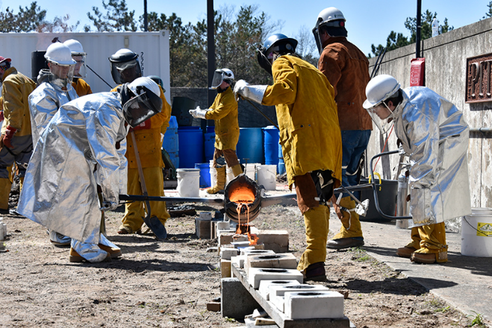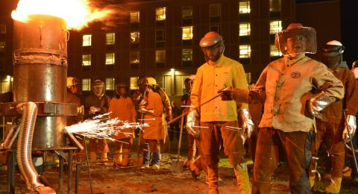

- College/University sponsored an initiative/project focused on diversity in STEM education during the 2021-22 academic year. Provide description of project and include photos. (30 pts)
Women in Technology meetings were started during the Fall 2021 semester. Meetings were held twice a month and were designed for the women in the technology department to build friendships and support each other. To help facilitate comradery, food was always provided and meetings were held in the design studio; a comfortable space for many of the technology students. Approximately ⅓ of the women in the technology department attended the meetings throughout the fall and spring semesters. One of the women who regularly attended said “I look forward to these meetings; they are fun and relaxing. I get to interact and bond with women in the department in a way I cannot do in the classroom.” The meetings are a success. Beyond the meetings designed to build comradery, other meetings include making networking connections with women alumni of the department, small group instruction on machines within the laboratories, educational field trips, and fun outings.

- Photo upload: initiative/project focused on diversity in STEM education (maximum 4 photos). (10 pts)
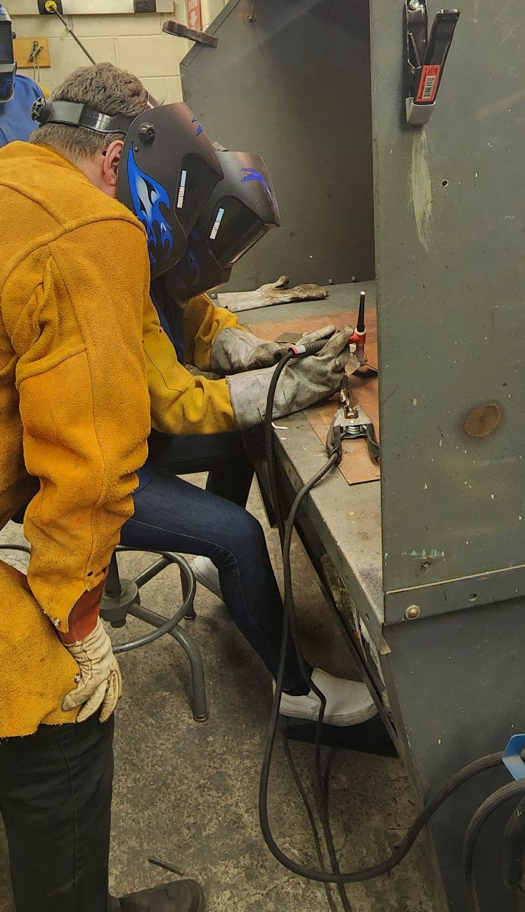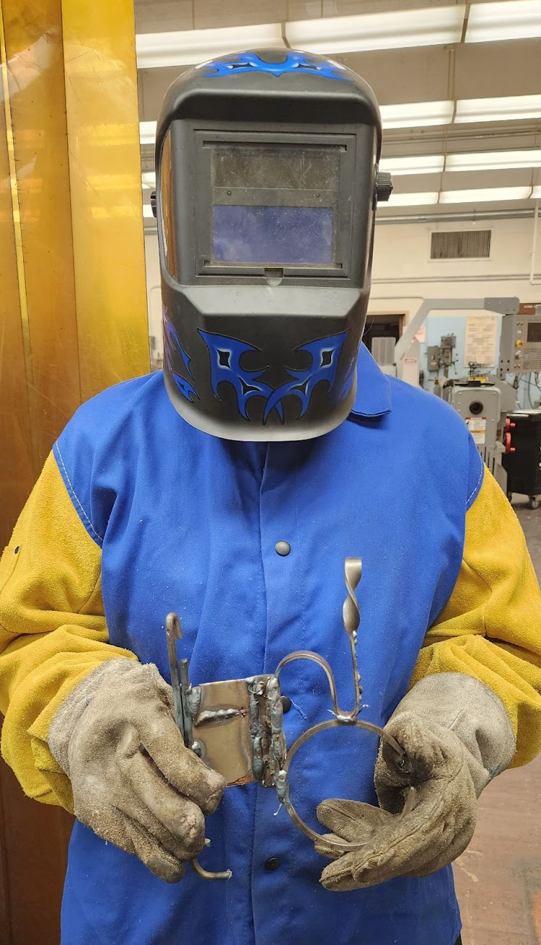
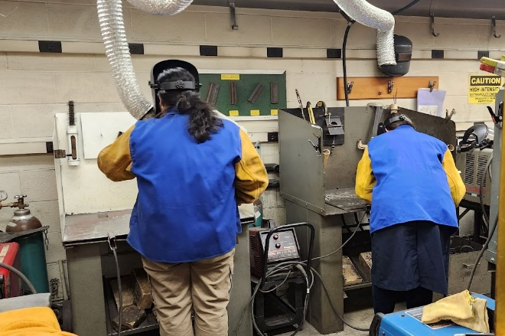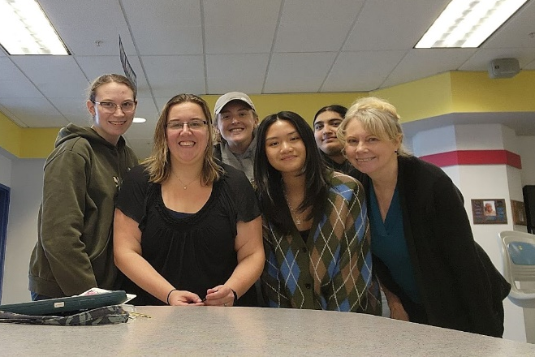

- College/University sponsored a family-oriented STEM event during the 2021-22 academic year. Provide description of project and upload photos. (30 pts)
Not applicable

- Photo upload: family-oriented STEM event (maximum 4 photos). (10 pts)
Not applicable

- College/University sponsored a STEM Career Fair or similar event during the 2021-22 academic year. Provide description of project and upload photos. (30 pts)
- The annual Technology Fall Conference is open to all K-16 educators/professionals from different school disciplines, who want to find out the latest developments in technology education and network with other educators and professionals. This year there were approximately 300 attendees and 50 presentations. Over 100 of our students attended the conference. Attendees share job opportunities with current students and other attendees. Many of our students have been invited for job interviews from their networking at the conference.
- The department manages an email ListServe with 182 members for job postings. In a typical week, 2-3 technology job listings are sent out.

- Photo upload: STEM Career Fair (maximum 4 photos). (10 pts)
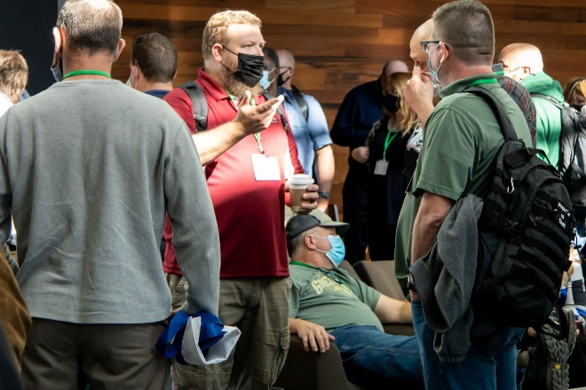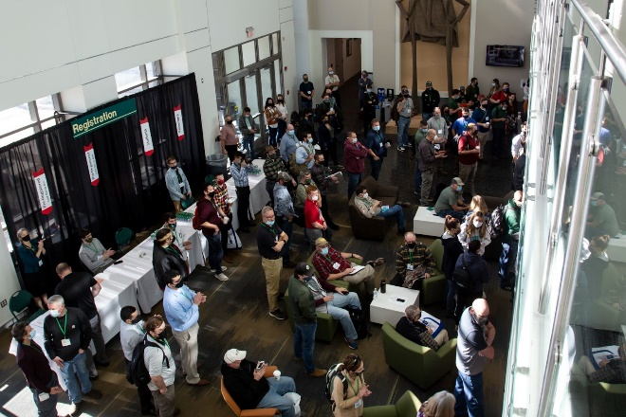
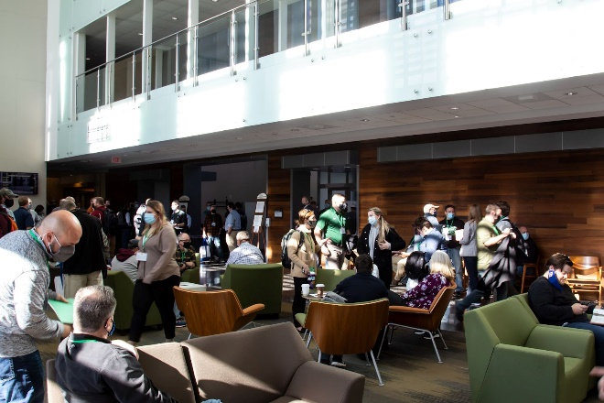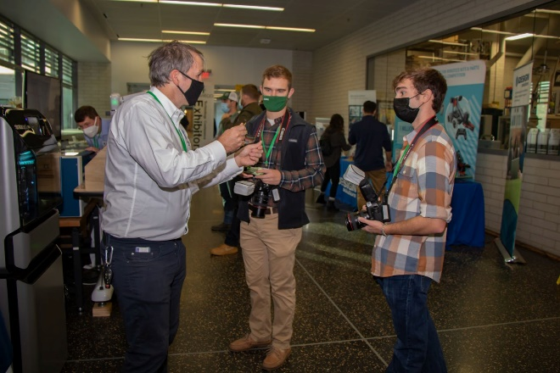

- College/University has active ITEEA Integrative STEM School Membership (20 pts) at time of application. (Provide membership number.) (20 pts)
Membership number: 12321

- College/University staff are ITEEA members. Active member status at time of application is required. Provide individuals' member name(s) and number(s). (5 pts per member on staff)
- Richard Bush: 32620
- Karin Dykeman: 54383
- Donna Matteson: 25329
- Mark Springston: 38859

- Professor/Instructor or administrator gave a STEM or STEAM Education conference presentation during the 2021-22 academic year at a national or international conference (e.g. ITEEA Annual Conference, NSTA STEM Forum, NSTA, ASCD, ASEE, NCTM, NAEA or other National/International Conference). Provide conference title, date of presentation, presentation title, and name(s) of presenter(s). (20 pts)
- Conference Title: 2022 ITEEA Conference
- Date of Presentation: March 10, 2022
- Presentation Title: Cracking the STEL Code - Adapt, Innovate, Implement
- Name(s) of Presenters: J. Bonds, Karin Dykeman, J. Egresitz, T. Isabell, D. Lecorchick, A. Richcreek, and D. Shapiro

- Conference Title: 2022 ITEEA Conference
- Date of Presentation: March 10, 2022
- Presentation Title: Inclusive Learning through Global Inquiry-Based STEM Projects
- Name(s) of Presenters: Donna Matteson

- Professor/Instructor(s) or administrator(s) attended the 2022 ITEEA International Conference. Provide name(s) of attendee(s). (15 pts per attendee)
Attendees: Richard Bush, Karin Dykeman, Donna Matteson

- Professor/Instructor(s) or administrator(s) participated in the STEM Showcase at 2022 ITEEA International Conference. Provide name(s) of presenter(s) and title of presentation. (20 pts)
- Name of Presenter(s): Not applicable
- Title of Presentation: Not applicable

- STEM or STEM-Related Education publication by staff member(s) in a peer-reviewed journal in the past three years. Provide complete article citation and provide article URL if available. (20 pts)
Matteson, D. (2019). Student Perceptions of Virtual Reality Technology for Computer Aided Design: A study to inform curriculum and add to the body of knowledge in an emerging field of technology in the learning environment. In K. Graziano (Ed.), Proceedings of Society for Information Technology & Teacher Education International Conference (pp. 1045-1053). Las Vegas, NV, United States: Association for the Advancement of Computing in Education (AACE). Retrieved December 13, 2022 from https://www.learntechlib.org/primary/p/207774/.

- Post school event in ITEEA’s STEM Connections newsletter. Provide member name, date, and title/description of post. (10 pts)
- Member name: Not applicable
- Title/Description of Post: Not applicable
- Date: Not applicable

- Active TEECA chapter (or another STEM-related organization) 2021-22 school year. Provide chapter advisor name and chapter number. (15 pts)
- Chapter advisor name: Richard Bush and Mark Springston
- Chapter number: Below is an email from Kevin Sutton regarding the chapter number. SUNY Oswego has a very active TEECA chapter and is regularly one of the top schools in the TEECA East competitions.
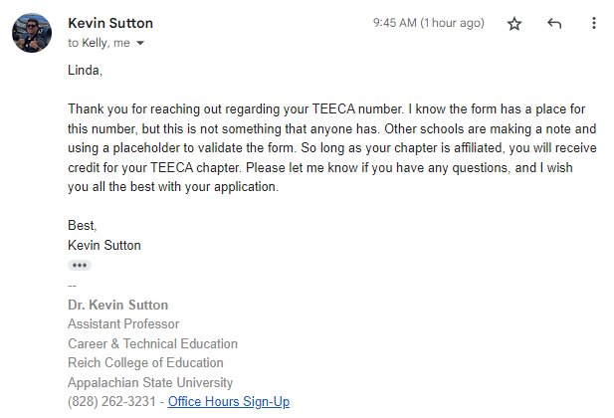

- Staff members participated in a Technology or Engineering Education Professional Development. Provide staff member's name, date(s), and title of PD event. (15 pts)
- Staff member’s name: Karin Dykeman
- Date: 2021-2022
- Title of PD Event: Twenty-First Century Leadership Academy

- Staff member’s name: Karin Dykeman and Richard Bush
- Date: March 28-29, 2022
- Title of PD Event: Through the Looking Glass: 59th Annual NYSTEEA Conference

- Staff STEM Spotlight participant during 2021-22 school year (15 pts). Provide link to your STEM Spotlight feature. (15 pts)
- Link: National Grid Grant Supports College’s KidsTech Programs
- Link: A Class at SUNY Oswego Changed Her Life

- Establish a safety protocol for your STEM lab and post it on your classroom or school website (15 pts.). Provide the link to your safety protocol document(s). A safety protocol is simply a standard operating procedure for the STEM lab that may include a safety manual, safety rules, HAZMAT sheets, procedures should an accident occur, equipment, tool and chemical inventory, etc. (15 pts)
- Link: Not applicable

- ITEEA Task Force participant on staff. Provide participant name and name of task force. (10 pts)
- Participant name: Not applicable
- Task Force name: Not applicable

- Staff member served as EbD™ course author, reviewer, or focus group participant during the 2021-22 academic year (15 pts). Provide name of participant and course. (15 pts)
- Name of participant: Not applicable
- Course name: Not applicable

- Participating staff to produce and submit a one-page written reflection that has embedded artifacts that directly relate, and show exemplary relevance to the STEL Standards listed below (e.g., link to a lesson plan relating to the standards with an explanation, an activity, etc.) (30 points)
Not applicable
- The Nature and Characteristics of Technology and Engineering
- Core Concepts of Technology and Engineering
- Integration of Knowledge, Technologies, and Practices
- Impacts of Technology
- Influence of Society on Technological Development
- History of Technology
- Design in Technology and Engineering
- Applying, Maintaining, and Assessing Technological Products and Systems

