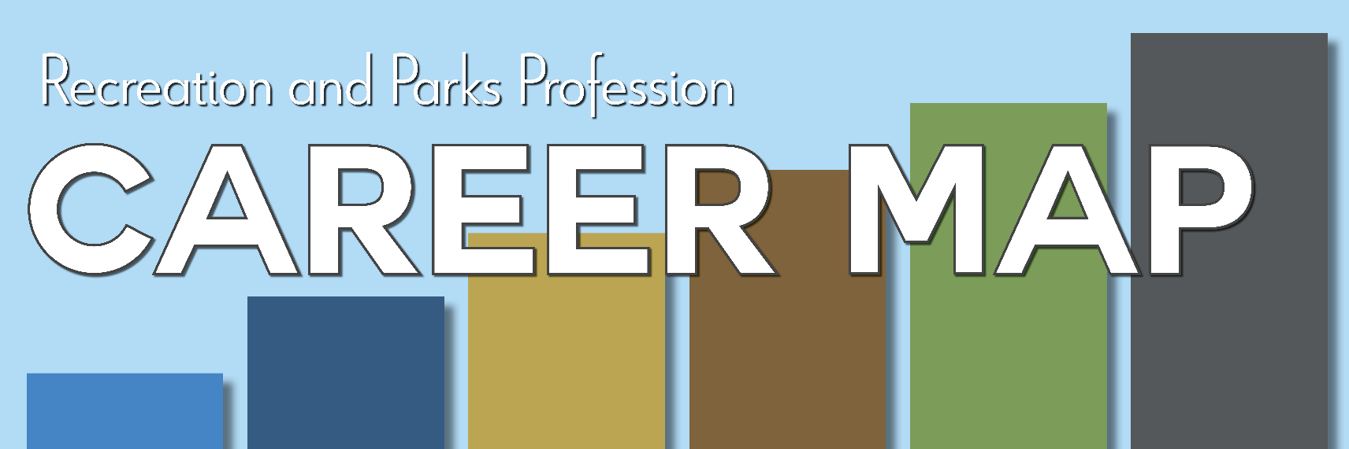

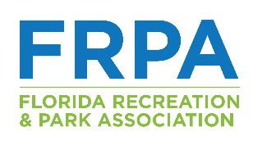
NAVIGATION GUIDE

A Resource Developed by the
Florida Recreation and Park Association Inc.
2528 Barrington Circle, Suite 1
Tallahassee, FL 32308
(850)878-3221
frpa.org
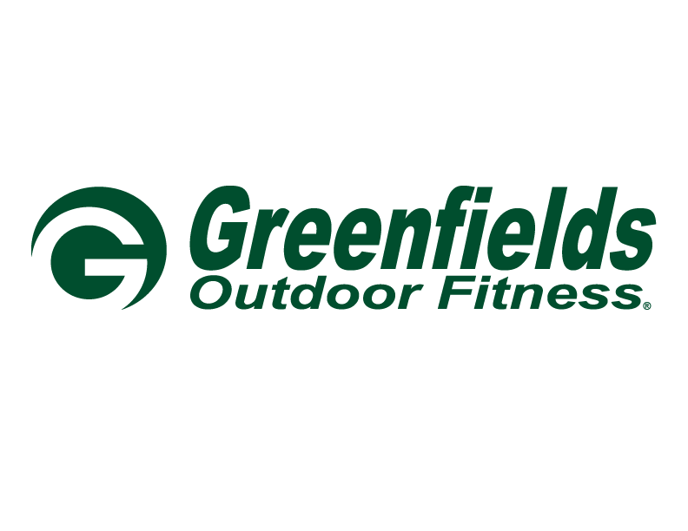

The FRPA Career Map is supported and sponsored by

Updated on: 2/27/2026
TABLE OF CONTENTS

3 Purpose and Background

3 Why Parks and Recreation Needs a Career Map

3 Foundational Principles and Assumptions
Education and Experience: A ‘Both/And’ Approach

Shift Toward Skills Over Degrees

5 The Structure of the Career Map
Scopes of Responsibility
Competency Areas
Skills and Application
Audience / Focus / Tools / Goal Framework
Development Guide

7 How to Use the Career Map
For the Individual Professional
For Agencies and Supervisors
For Mentors and Coaches

8 Making the Map Your Own

9 Thank you
A job is work you do now; a career is the journey
of your work life over time.
Purpose and Background
For more than two decades, workforce development has remained a central issue in discussions across Florida’s parks and recreation agencies. Recruiting, developing, and retaining skilled professionals continues to challenge agencies of all sizes and structures.

During the 2023 FRPA Strategic Plan review, two critical needs were identified:
- A clear, demonstrative model to guide professional growth across the field.
- A stronger pipeline of future workforce participants.

The Career Map addresses the first priority — providing a structured, skills-based framework to support career progression at every level of the profession.

From the outset, career development has been defined as the integration of:
- Formal education
- Knowledge acquisition
- Practical experience
- Implementation and Application
A well-rounded park and recreation professional requires all three.

Why a Skill-Based Career Map Matters
The parks and recreation profession continues to evolve — balancing community wellness, environmental stewardship, innovation, access, and operational excellence. Agencies require professionals who are adaptable, skilled, and prepared for increasing levels of responsibility.

A skill-based model:
- Bridges workforce gaps by clarifying core competencies.
- Supports career mobility by defining progression pathways.
- Strengthens recruitment and retention through transparency.
- Aligns training and development with real operational needs.
- Promotes equity by emphasizing demonstrated skills over titles alone.

This model shifts the conversation from “What is your title?” to “What is your scope of responsibility and demonstrated skill mastery?”

This Career Map is a framework — not a mandate.

Foundational Principles and Assumptions
The FRPA Career Map is built on several key assumptions:
- There is no single path into or through the profession.
- Advancement is not solely upward; growth can occur within roles.
- Mastery requires demonstrated application, not checklist completion.
- Individuals may enter the field at different responsibility levels.
- Agencies must tailor the Map to reflect their unique structure and needs.

Education and Experience: A ‘Both/And’ Approach
The professional landscape is shifting nationally toward skills-based hiring. While higher education remains a powerful pathway for knowledge development and long-term leadership preparation, lived experience and certifications provide equally meaningful contributions.

Shift Toward Skills Over Degrees - Skills-based hiring is on the rise. Many employers are dropping degree requirements in favor of competency-based evaluations, especially for mid-level roles.
Decline in College Enrollment - U.S. college enrollment has declined over the past decade, especially among men and students from lower-income backgrounds. Many young adults are questioning the ROI of a college degree and looking for faster, affordable paths to meaningful work. Industries must create alternative entry points that value lived experience, certifications, and practical skills.

Rise of Work-Based Learning and Certifications - Growth in apprenticeships, micro-credentials, and certification programs have aligned to industry needs. Employers and training providers are collaborating to build career pathways outside the traditional degree model. For example, recreation program leaders or park maintenance techs can gain targeted certifications (e.g., playground safety, lifeguarding) that prepare them directly for the role.

This is not intended to diminish the value of higher education, but rather to recognize and welcome multiple pathways for acquiring the knowledge necessary to thrive in the profession. It is critical that the industry evolve in how talent is recognized to reflect today’s workforce realities.

Data-Driven Hiring Practices - HR tech platforms and workforce systems are increasingly using skills taxonomies and career mapping tools to define job requirements, rather than relying solely on academic credentials.
This supports fairer and more accurate hiring, especially important in public service sectors aiming to reflect their communities.

Equity - Degree requirements can inadvertently exclude capable candidates, particularly from BIPOC and lower-income communities. Skills-based hiring promotes a more equitable, inclusive workforce—a key goal for many public-sector organizations.

The FRPA Career Map recognizes:
- Degrees offer theoretical depth and strategic preparation.
- Experience provides applied, operational skill.
- Certifications and credentials demonstrate competency validation.
- Organizations must evaluate role requirements individually.

This is not an either/or conversation. It is a both/and strategy.

The Structure of the Career Map
Scopes of Responsibility - Progression is defined by scope of responsibility rather than job title. Titles vary widely across agencies; scope provides consistency.

The six responsibility levels are:
Foundational
Task-based work under supervision; learning core operations.
Developmental
Growing responsibility; managing tasks or small teams.
Single-Focus / Multi-Function Management
Managing multiple functions within a discipline.
Area / Division Leadership
Leading multiple disciplines or locations.
Executive Level Operations
Overseeing large-scale operational strategy.
Organizational Executive
Setting vision, culture, governance, and legacy direction.
Each level reflects increasing autonomy, impact, and strategic responsibility.
It should be noted that the Career Map is dependent on individual and agency specific intricacies and frameworks. For instance, someone working in a small agency may have more opportunity to develop skills at multiple progression levels simply by virtue of fewer staff means broader responsibilities. Someone working in a larger agency may have more opportunity to develop deeper skill levels as they may occupy specific job responsibilities for longer periods of time by virtue of more staff may mean longer tenure before promotion or advancement, coupled with the general scope of responsibility for a county agency may be broader than a municipal agency.

Competency Areas
For the purposes of this Career Map, a Competency Area is a broad category that groups together related knowledge, skills, abilities, and behaviors required to perform a set of functions effectively. A competency area usually is focused on big-picture; what someone needs to be successful in a role or field; and often includes multiple skills, knowledge and behaviors. To be “competent” in an area requires not just the knowledge of that area, but the demonstration of one’s ability to apply and put into practice the specific set of skills toward achievement of a specified goal. The Career Map includes eighteen competency areas representing the breadth of the field:
- Communications, Public Relations, and Marketing
- Supervision and Oversight
- Program/Event Management
- Leadership
- Relationship Building
- Financial Management
- Technology
- Resource Management
- Natural and Cultural Resource Management
- Risk Management and Safety
- Policy Compliance
- Planning (Operational)
- Planning (Strategic, Master, Comprehensive, and Asset Management)
- Data Analysis and Research
- Project Coordination/Management
- Critical Thinking and Decision Making
- Interpersonal
- Organizational Design
Competencies are intentionally not ranked or categorized. Agencies should determine prioritization based on structure and mission.

Skills and Application
Each competency includes measurable skills. A skill is a learned ability — technical or interpersonal — that contributes to professional competence. Skills are the building blocks of competencies.
Some skills appear across multiple levels. The difference lies in:
- Scope of impact
- Audience
- Complexity of application
- Decision-making authority
Context defines mastery.

Audience / Focus / Tools / Goal Framework
To illustrate how skill application changes across responsibility levels, each competency includes:
Audience – Who the professional interacts with
Focus – What must occur in the interaction
Tools – Possible resources utilized
Goal – Intended outcome in relation to the audience
The Focus / Tools / Goals guide the user to understand the application of the skills, its purpose and how it is applied in the workplace relative to the specific competency area. They may not build on each other under each responsibility level, as they are independent of each by virtue of the intent (focus) of the application of that skill at the indicated level within the competency area. Attention should be given to assessing the individual skills under each responsibility level - because while one may be at a level by virtue of the responsibilities they have been assigned (especially for those entering the field at points other than the beginning of their career) they may not have mastered skills in the preceding responsibility level.
This structure allows agencies and individuals to tailor application to their environment.

Development Guide
Each competency and responsibility level includes a Development Guide, identifying opportunities to gain:
- Education
- Knowledge
- Experience
These are only a starting place, and we encourage users to add elements that are specific to the needs of your organization.

How to Use the Career Map
The Career Map is provided in an editable Excel format to allow customization.
Individuals working on development of the Career Map felt strongly that there had to be a mechanism for the Career Map to be tailored to an individual or an organization. It has been designed with that in mind. While there is work to be done in order to tailor the Map, the work of identifying competency areas and skills that have been identified as consistent across our industry has been done. The goal of the Career Map is to provide a solid foundation on which to build a Career Map outlining a pathway for advancement without being so prescriptive that the information is limiting and difficult to apply.

For the Individual Professional
Use the Career Map to:
- Identify your current scope of responsibility.
- Assess skill mastery within competencies.
- Identify development gaps.
- Build a professional development plan.
- Prepare for advancement conversations.
- Strengthen interview readiness.
Skill mastery requires demonstration through performance, outcomes, and consistent application.
Example Steps:
- Find what level you’re at now by comparing the skills you know you possess with the skills listed under the Scopes of Responsibility.
  - Read the definitions of the Scopes of Responsibility.
  - Begin thinking about the skills you use regularly in your job – refer to your job description or recent evaluations if needed. List these skills.
  - Study the skills associated with the Scopes of Responsibility you feel you would fall under and make note of skills that fall within the list you made in #2 (choose two so you can pivot if needed– we have found that employees tend to gravitate toward the level above where they are).
  - Once you determine where you align in the Map – consider where you’d like to go.
    - Ask yourself:
      - Are there skills under my current Scope of Responsibility that I can improve upon or do more to be excellent?
      - What skills in the Scope above mine should I start working on now to prepare myself for the future?
Work with a supervisor or mentor to clarify what mastery looks like in your agency.

For Agencies and Supervisors
The Career Map is designed to support performance management and workforce planning.
Supervisors should:
- Tailor competencies to role expectations.
- Define measurable indicators of mastery.
- Establish SMART performance goals.
- Align responsibilities with progression levels.
- Assess readiness for advancement based on demonstrated performance.
Skill mastery alone does not guarantee advancement; desire, capacity, and organizational need must also be evaluated.
Example Steps:
- The workgroup is currently working with a Beta testing group to help outline the steps for implementation of the Map in an agency setting. These details will be updated in this document as they are available.

For Mentors and Coaches
The Career Map provides a neutral, structured framework for mentoring conversations. It helps:
- Clarify career pathways.
- Identify development priorities.
- Interpret skill expectations across agency types.
- Encourage intentional professional growth.
Mentorship strengthens the profession by broadening perspective and sharing experience.

Making the Map Your Own
The FRPA Career Map provides a strong, industry-informed foundation. It is intentionally flexible and adaptable. The competencies reflect consistency across the field. The customization reflects your organization.
Use this tool to:
- Strengthen workforce planning.
- Clarify advancement expectations.
- Support professional growth.
- Build a resilient, future-ready profession.

The work of defining the framework has been done.
The next step is yours. Make the Map yours.

