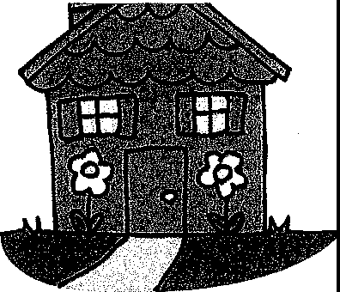
MY HOUSE IS MY HOME

Draw a picture of your house (or a house) and label the specific parts in the following manner:
- On the DOOR, write a quote that describes you.

- On the WINDOWS, write the things you know you want to accomplish before the end of the year.
- On the FOUNDATION, write the names of the people who support you.

- On the FRONT IAWN, write what you hear from the student body about what your school needs to do to improve.

- On the ROOF, list five accomplishments or areas of your personality of which you are most proud.

- On the SIDEWALK or DRIVEWAY, list two things you want to "walk out" or "drive out" of your school.

- On the CHIMNEY, what mark or legacy do you wish to leave behind at your school when you leave it? -How do you want to be remembered?

- On the WALLS, write some things you could do to make a difference in your relationships with others.

- On the SUN SHINING IN THE SKY, write what you love most about your school.

