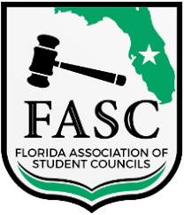
Florida Association of Student Councils
District 3 Meeting Agenda
Windermere High School
October 21st, 2023, at 10:00 AM

- Call to order
- National Anthem & Pledge of Allegiance
  - National Anthem
  - Pledge of Allegiance
  - Approval of Minutes
- Roll Call
- Welcomes from Windermere High School
  - Windermere High School Principal - A. Leftakis
  - Updates from District 3
- District 3 Officer Reports
  - President - Maggie Caprice
  - Vice President - Mira Patel
  - Secretary - McKenzie Linn
  - State Project Presentation
- Old Business
  - Southern Association of Student Councils at Chapin High School Oct. 14th-16th 2023
- New Business
  - Welcome D3 officers
  - FASC Candidate skit
  - FASC host candidate speeches
  - FASC host campaign voting/confirmation
  - FASC Kickoff at Gainesville High School
  - Constitution Review
- Announcements
  - FASC State Convention
  - District 3 VP Meeting at Lake Buena Vista High School, December 9th, 2023
  - District 3 Secretary meeting, at Horizon High School, January 20th, 2024
- Adjournment

