On Your Company Letterhead

DATE , 2022

The Honorable Name

District

Florida Senate

Address

The Honorable Name

District

Florida House of Representatives

Address

Senator Insert Last Name & Representative Insert Last Name:

I am writing in hopes that you will be able to help escalate concerns to leadership regarding the problematic proviso language in Line #217, General Appropriations Act relating to Medicaid Long Term Care. This text in question is as follows:

“*From the funds in Specific Appropriation 217, $136,616 from the General Revenue Fund and $207,505 from the Medical Care Trust Fund are provided to the Agency for Health Care Administration to adjust fee for service rates at the annual rate setting date for the sole purpose of raising wages of direct care employees of Medicaid providers including 1099 employees who provide services under the Florida Medicaid Program to at least $15.00 per hour. The agency shall enter into a supplemental wage agreement with each provider to include this minimum wage requirement to ensure compliance. The agreement must require the provider to agree to pay each of its employees at least $15.00 per hour. The agreement shall include an attestation under penalty of perjury under section 837.012, Florida Statutes, stating that every employee of the provider, as of October 1, 2022, will be paid at least $15.00 per hour.”*

I am the “insert your position” of a “insert number of licensed beds and type of facility” Assisted Living Facility or Adult Family Care Home with “insert the number of current Medicaid residents” residents. Our facility is a member of the Florida Assisted Living Association (FALA) which is the longest-established and largest assisted living association in the state. This organization collectively represents nearly 500 assisted living facility (ALF) members and nearly 300 associate members of FALA. Following FALA’s discussions with Secretary Marstiller and her staff at the Agency for Health Care Administration (AHCA), I am still very concerned about conflicting guidance between the budget proviso language and the agency website. It is of our utmost concern to be in compliance by the October 1, 2022 deadline, which will ensure that we are able to maintain high-quality jobs at our facility and continue to provide the best possible care to current and future seniors within the State of Florida.

Below is a list of specific questions and concerns that have been asked, their impact on our business, and examples of why we seeking further guidance.

1. **ALFs are being notified, but are not listed on the AHCA website for FAQs** [**https://ahca.myflorida.com/Medicaid/Finance/finance/enh_wage/ew_faq.shtml**](https://ahca.myflorida.com/Medicaid/Finance/finance/enh_wage/ew_faq.shtml) **:**

1. **ARE ALL EMPLOYEES AFFECTED?** Some language state “ALL” other language states “Direct Care”? (see portal agreement from AHCA).

**WHAT IS THE DEFINITION OF DIRECT CARE EMPLOYEE?** The budget proviso language states “direct care employees” in the first sentence but goes on to reference “each of its employees” and “every employee of the provider…” Does the minimum wage increase affect ALL employees and contract employees of an ALF or just those employees and contract employees who are direct care employees? Is there a definition of direct care employee? Does this include contracted staff such as janitorial or dining staff?

* 1. These textual discrepancies, coupled with our need to be in compliance in less than a month, is highly disconcerting.
  2. We are unable to calculate the financial implications of this law to our organization, nor are we able to plan accordingly.
  3. Media coverage has informed employees of this change, which may not actually effect them.

**From Home Page:**

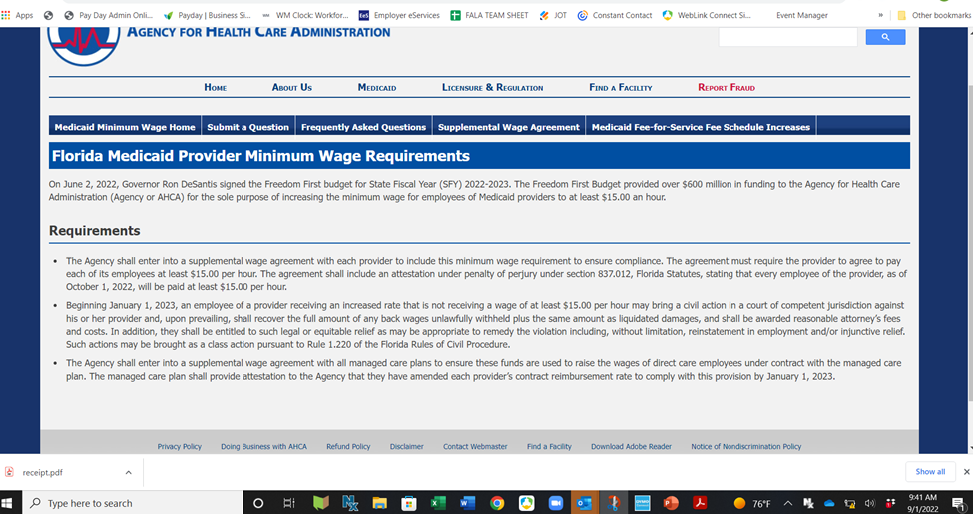

**From Medicaid Portal for attestation:**

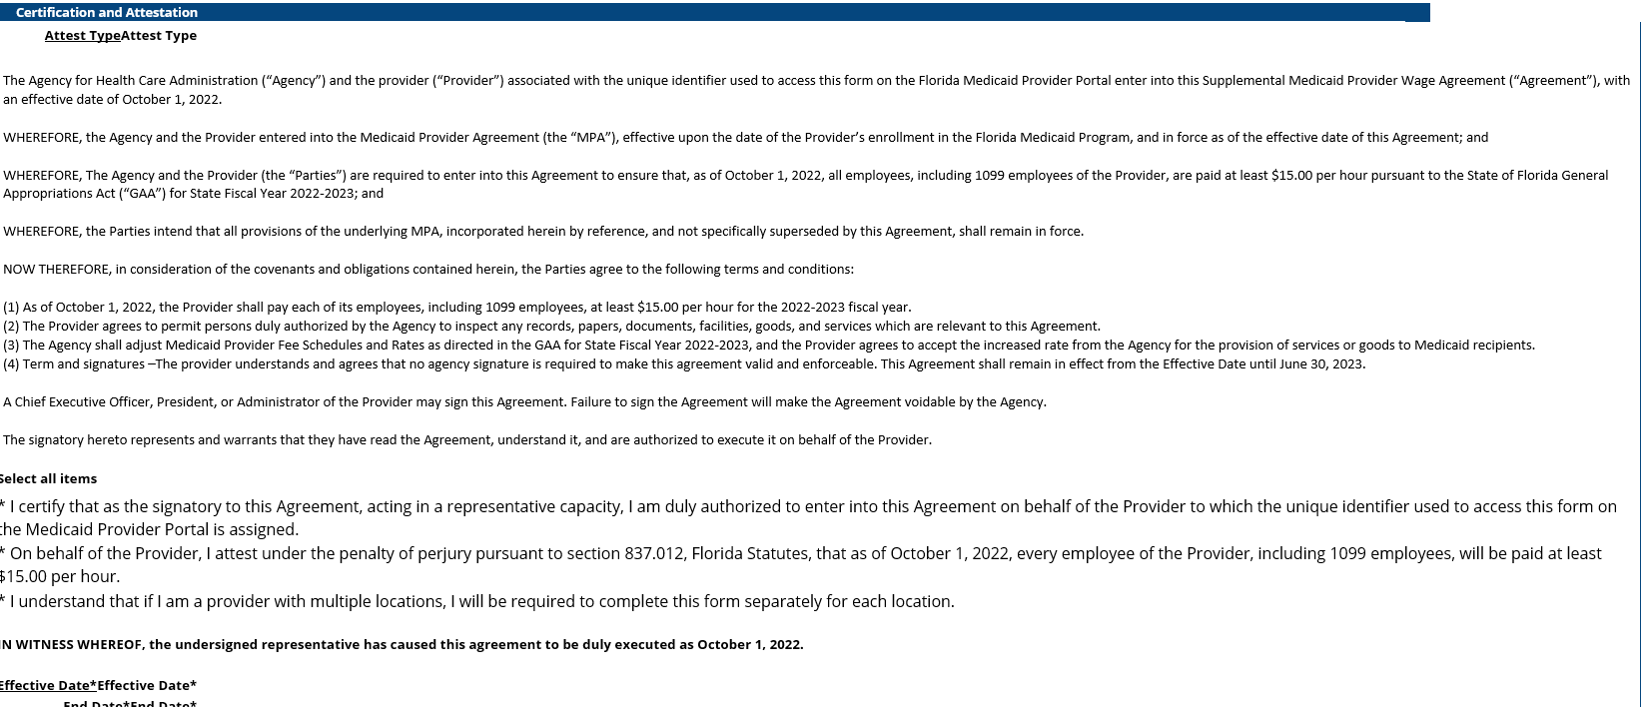

**From AHCA Website FAQs**

1. **WHEN IS THE $15 MINIMUM WAGE EFFECTIVE?** How can our facility implement this legislation on October 1, 2022, if the facility has not received the increased funding? The AHCA website indicates that necessary funding will be provided October 1, 2022.

1. **HOW CAN WE SIGN AN ATTESTATION FORM NOW IF WE DON’T KNOW IF THE INCREASED FUNDS WILL IN FACT BE PROVIDED FROM THE MANAGED CARE PLANS?** No information has been provided on what the increases will look like to the plan or to providers on a per life basis.
2. **HOW WILL WE BE ABLE TO ENSURE THE INCREASED MEDICAID FUNDING FOR THIS WAGE INCREASE WILL BE PROVIDED IN THE FORM OF REIMBURSEMENTS**? I understand that the Legislature was attempting to calculate the amount of funding needed to cover this wage increase and to increase the Medicaid Long Term Care budget to cover those costs. Based on the confusion about the definition of direct care employee and AHCA documents required to be signed by those providing Medicaid Long Term Care services to residents, this change appears to be premature if the contracts currently in place have not been amended to specify that the increased minimum wage cost is being passed on to the facility. Otherwise, we will be taking unanticipated funds from my “insert best answer” (savings, operating budgets) during a time at which operating funds and staffing is tight and limited.
3. **CAN FAQS OR AGENCY GUIDANCE BE CLARIFIED?** This clarification should not be general in form, but should apply by specific industry. Can ALFs be clearly listed as an affected party?

Should you need any additional information on this issue, please contact me directly or Veronica Catoe [veronica@fala.org](mailto:veronica@fala.org), FALA Lobbyist [lobbyist@libertypartnersfl.com](mailto:lobbyist@libertypartnersfl.com).

Sincerely,

Your Name and title

cc: FALA

Liberty Partners

Excerpt from the FY 2022-23 General Appropriations Act (HB 5001):

MEDICAID LONG TERM CARE

217        SPECIAL CATEGORIES

ASSISTIVE CARE SERVICES

FROM GENERAL REVENUE FUND . . . . . 1,279,935

FROM MEDICAL CARE TRUST FUND . . . . 1,944,082

From the funds in Specific Appropriation 217, $136,616 from the General Revenue Fund and $207,505 from the Medical Care Trust Fund are provided to the Agency for Health Care Administration to adjust fee for service rates at the annual rate setting date for the sole purpose of raising wages of direct care employees of Medicaid providers including 1099 employees who provide services under the Florida Medicaid Program to at least $15.00 per hour. The agency shall enter into a supplemental wage agreement with each provider to include this minimum wage requirement to ensure compliance. The agreement must require the provider to agree to pay each of its employees at least $15.00 per hour. The agreement shall include an attestation under penalty of perjury under section 837.012, Florida Statutes, stating that every employee of the provider, as of October 1, 2022, will be paid at least $15.00 per hour. Beginning January 1, 2023, an employee of a provider receiving an increased rate that is not receiving a wage of at least $15.00 per hour may bring a civil action in a court of competent jurisdiction against his or her provider and, upon prevailing, shall recover the full amount of any back wages unlawfully withheld plus the same amount as liquidated damages, and shall be awarded reasonable attorney’s fees and costs. In addition, they shall be entitled to such legal or equitable relief as may be appropriate to remedy the violation including, without limitation, reinstatement in employment and/or injunctive relief. Such actions may be brought as a class action pursuant to Rule 1.220 of the Florida Rules of Civil Procedure.