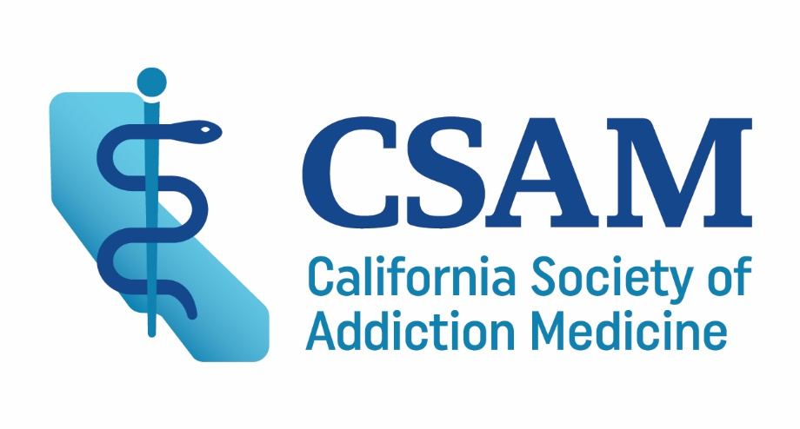

The California Society of Addiction Medicine certifies that

Has participated in the on-line webinar

The Challenge of Buprenorphine Induction: Overcoming the
Neuroadaptive Hurdle

(insert completion date here)

_______________________

PHYSICIANS
The California Society of Addiction Medicine is accredited by the California Medical Association (CMA) to provide continuing medical education for physicians. The California Society of Addiction Medicine takes responsibility for the content, quality and scientific integrity of this CME activity.

The California Society of Addiction Medicine designates this live activity for 1.5 AMA PRA Category 1 Credits™. Physicians should claim only the credit commensurate with the extent of their participation in the activity.

Total AMA PRA Category 1.5 Credit(s)™

California Society of Addiction Medicine
1540 River Park Drive, Suite 211, Sacramento, CA 95814 / 415-764-4855

