*(Please use this template for developing a proclamation for your community. Make sure to update text as necessary)*

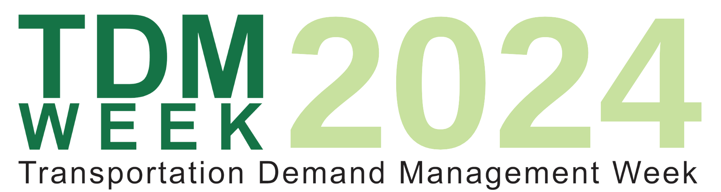

**Recognizing National TDM Week 2024**

**WHEREAS**, Transportation Demand Management (TDM) means the use of strategies to inform and encourage travelers to maximize the efficiency of a transportation system leading to improved mobility, reduced congestion, and lower vehicle emissions; and

**WHEREAS**, TDM programs and policies aim to provide all people with a mix of reliable and affordable transportation options; and

**WHEREAS**, supported with effective marketing and advanced technologies, people can make informed choices to meet each trip's unique needs while considering cost, time, and convenience; and

**WHEREAS**, with even a small reduction in the number of single occupancy vehicles on our nation’s roads, commuters can see significant reductions in congestion; and

**WHEREAS**, with reduced reliance on personal vehicles, our communities will see cleaner air leading to direct improvements in public health; and

**WHEREAS**, TDM initiatives that support increased levels of walking and cycling also enhance overall quality of life; and

**WHEREAS**, with more transportation options and less traffic, people will have better and more reliable access to jobs; and

**WHEREAS,** TDM professionals and organizations can support and advance community efforts; and

**WHEREAS**, through the use of TDM strategies, our communities can make strides in decarbonizing our transportation system, which is a significant contributor to climate change.

**NOW THEREFORE, I**, (NAME OF GOVERNOR/MAYOR/OR OTHER LEADER) proclaim September 16-20, 2024, as

**"TDM Week 2024"**

throughout (jurisdiction) and commends the efforts of local government agencies, businesses, and community members that are advancing TDM measures throughout our communities.