(Please use this template for developing a proclamation for your community. Make sure to update text as necessary)
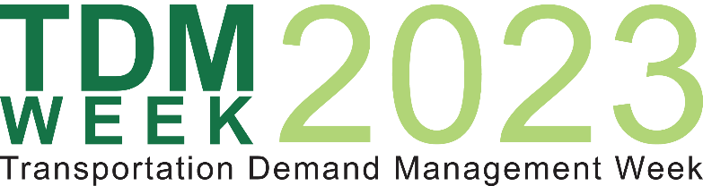
Recognizing National TDM Week 2023

WHEREAS, Transportation Demand Management (TDM) means the use of strategies to inform and encourage travelers to maximize the efficiency of a transportation system leading to improved mobility, reduced congestion, and lower vehicle emissions; and

WHEREAS, TDM programs and policies aim to provide all people with a mix of reliable and affordable transportation options; and

WHEREAS, supported with effective marketing and advanced technologies, people can make informed choices to meet each trips unique needs, while considering cost, time, and convenience; and

WHEREAS, with even a small reduction in the number of single occupancy vehicles on our nation’s roads, commuters can see significant reductions in congestion; and

WHEREAS, with reduced reliance on personal vehicles, our communities will see cleaner air leading to direct improvements in public health; and

WHEREAS, TDM initiatives that support increased levels of walking and cycling also enhance overall quality of life; and

WHEREAS, with more transportation options and less traffic, people will have better and more reliable access to jobs; and

WHEREAS, TDM professionals and organizations can support and advance community efforts; and

WHEREAS, through the use of TDM strategies, our communities can make strides in decarbonizing our transportation system, which is a significant contributor to climate change.

NOW THEREFORE, I, (NAME OF GOVERNOR/MAYOR/OR OTHER LEADER) proclaim September 18-22, 2023, as
"TDM Week 2023"

throughout (jurisdiction) and commends the efforts of local government agencies, businesses, and community members that are advancing TDM measures throughout our communities.

