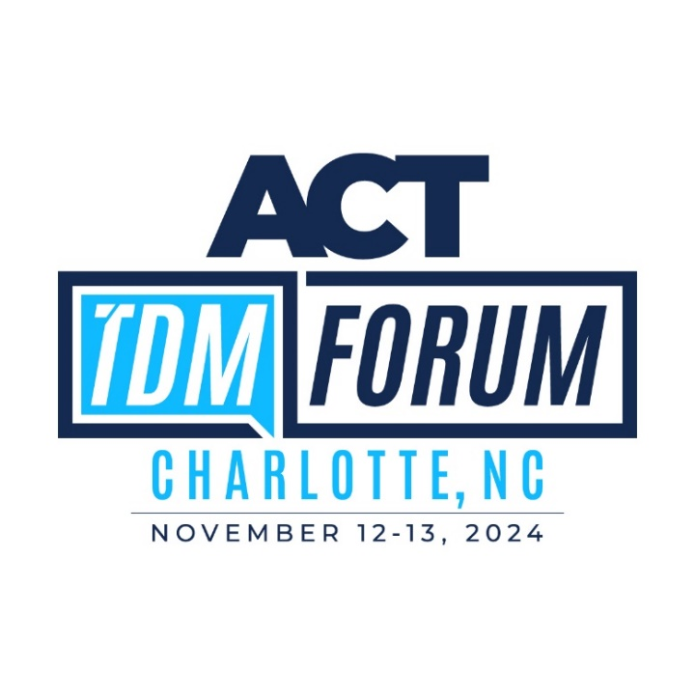

**ACT’s 2024 TDM Forum**Promotional Toolkit

We have prepared this toolkit to help you spread the word about ACT’s 2024 TDM Forum. It includes an elevator pitch, a sample invitation email, a newsletter blurb, social media posts, and additional resources that will help you expand awareness about the event to your colleagues and stakeholders.

Please note that some content includes highlighted fields. Be sure to customize them to tailor your outreach. Feel free to use the resources below as they are or use them as inspiration.

When posting to social media, we encourage you to use the hashtag **#TDMForum** and tag **Association for Commuter Transportation** (LinkedIn and Facebook) or **@actnational** (Instagram and X). Liking, sharing, and commenting on other TDM Forum posts will increase their visibility, so be sure to engage!

*Any questions or requests for additional information can be directed to* [*Allison Caravella*](mailto:acaravella@actweb.org)*, ACT’s Marketing & Communications Manager.*

**Elevator pitch**I’m attending ACT’s TDM Forum in Charlotte so I can learn more about responding to opportunities and challenges in transportation, mobility, and planning that come my way. I invite you to join me there, where I’ll be attending two days of focused learning about topics that directly affect the communities we work with. Each day, we’ll get to choose between two tracks built around different subjects. Along with about 200 other professionals from around the country, we’ll then spend the full day learning about them through debates, interactive discussions, panels, and other unique session types.

The event has been redesigned from the ground up, and its new programming offers something valuable for professionals with all levels of experience. If you’re interested in learning about real-world takeaways focused on transit, planning, equity, and mobility that you can put into action when you get home, join me there!

**Invitation email**

Dear/Hey/Hi [name],

I wanted to let you know about [ACT’s 2024 TDM Forum](https://www.actweb.org/events/tdm-forum-2024) coming up in Charlotte, NC, November 12-13. I will be attending, and I believe you would get a lot out of this event as well. Each day features two tracks on some key topics that I know you are interested in. Tracks include:

* [Creating the TDM City](https://www.actweb.org/tdm-forum-2024---creating-the-tdm-city) (November 12)
* [The Great Micromobility Experiment](https://www.actweb.org/tdm-forum-2024---the-great-micromobility-experiment) (November 12)
* [Ensuring TDM for Everyone](https://www.actweb.org/tdm-forum-2024---ensuring-tdm-for-everyone) (November 13)
* [Filling the Gaps](https://www.actweb.org/tdm-forum-2024---filling-the-gaps) (November 13)

Plue, there will be a [keynote from Mitchell Silver](https://www.actweb.org/tdm-forum-2024-keynotes), who I know I am looking forward to hearing from (again). If you check out the program, you’ll also see a fantastic group of speakers that will bring in fresh insights and new perspectives. Many will be speaking at an ACT event for the first time.

And there’s even a deal for you! **Once you register for the event, any additional registrant from your organization can receive a $100 discount.** Just [send an email to receive the code](mailto:cmurphy@actweb.org). Then, you both can learn on parallel tracks, and you won’t miss anything!

This is not your typical conference, and I hope you and others from your team will be able to join me and 200 others from across the country for a couple days of great networking and engaging learning. If you’re ready to join me, [you can register here](https://www.actweb.org/events/tdm-forum-2024/register).

If you have any questions, just let me know.

Best,

Your name

**Newsletter blurb**

[ACT’s 2024 TDM Forum](https://www.actweb.org/events/tdm-forum-2024) is coming to Charlotte, NC from November 12-13. This event has been completely transformed to offer track-based learning about transportation policies, equity, new mobility options, and key planning issues facing our communities. Each day, you’ll choose between two immersive tracks, each offering a variety of session formats designed to dive deep into crucial topics. Track options include:

* [Creating the TDM City](https://www.actweb.org/tdm-forum-2024---creating-the-tdm-city)
* [The Great Micromobility Experiment](https://www.actweb.org/tdm-forum-2024---the-great-micromobility-experiment)
* [Ensuring TDM for Everyone](https://www.actweb.org/tdm-forum-2024---ensuring-tdm-for-everyone)
* [Filling the Gaps](https://www.actweb.org/tdm-forum-2024---filling-the-gaps)

Spots are filling quickly at this unique and engaging event. Don’t miss your chance to be a part of this unforgettable TDM learning experience - [Register here](https://www.actweb.org/events/tdm-forum-2024/register)!

**Social media posts**

📢 ACT’s 2024 #TDMForum will take place in Charlotte, NC from November 12-13. If you’re passionate about making your community a more equitable, accessible, and sustainable place, this is the event for you!

✏️ Get ready for two days of immersive learning opportunities from subject matter experts on critical topics shaping our future. It’s a unique opportunity to make new connections, deepen your understanding, and join an event that’s the first of its kind.

Learn more and register here: [www.actweb.org/tdmforum](http://www.actweb.org/tdmforum)

📒 From November 12-13, I’ll be attending ACT’s #TDMForum, where I’ll be learning about emerging trends, new technology, and innovative TDM solutions. I’m especially excited to attend [session], where I’ll hear from [speaker] about [topic].

🤝 If you’ll also be in Charlotte, I look forward to connecting with you there! If you haven’t registered yet, you can do so here to join me: [www.actweb.org/tdmforum](http://www.actweb.org/tdmforum)

I am excited to attend the #TDMForum this fall! Whether you have years of experience or you’re new to the industry, this event offers something for everyone with unique issue focused tracks providing a transformative learning experience. I hope to see you in Charlotte from November 12-13!

Register here: [www.actweb.org/tdmforum](http://www.actweb.org/tdmforum)

I look forward to attending ACT’s #TDMForum for a reimagined learning, networking, and professional development experience this November. It’s not too late to join me and choose your tracks at this transformational industry event!

Register today at: [www.actweb.org/tdmforum](http://www.actweb.org/tdmforum)

*Additional social media content ideas*

* Shout out a speaker you’re excited to hear from
* Share something you’re hoping to learn at the event
* Highlight the two tracks you’ll be attending
* Pose a question to other attendees
* Snap a photo of you and another attendee
* Share a key takeaway from a session

**Additional resources**

You can find additional resources, event details, and key information on the [TDM Forum webpage](https://www.actweb.org/events/tdm-forum-2024). Check it out for:

* A downloadable TDM Forum logo
* Social media tiles
* FAQs
* And more resources as they become available