Marcus C. Erickson  - CLEAR Presidient Elect | 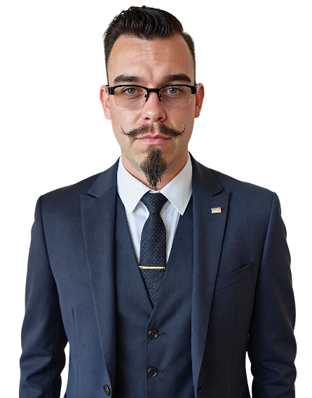  
TRANSFORMING REGULATORY EXCELLENCE  Throughout my tenure as a State Investigator/ Regulator for the State of New Mexico, I have been privileged to oversee the regulation of 98% of healthcare licensees within my state.  While healthcare regulation remains my primary specialty, my experience spans over 80 different professionals and occupations, providing me with comprehensive insight into the diverse regulatory landscape that defines modern professional oversight.  As a board member of HealthcareDiversion.org, an active participant in current offerings, and a graduate of CLEAR’S Basic/Advanced NCIT programs, I bring a multidisciplinary perspective to regulatory challenges. My recent hiring to serve as a CLEAR instructor for potential programs has further enhanced my understanding of both educational delivery and the evolving needs of regulatory professionals across all sectors.  VISION FOR CLEAR  Regulatory excellence requires leaders who understand that we operate in a world of grey areas where people's livelihoods hang in the balance. My experience across the vast amount professions has taught me that while each field has unique characteristics, the fundamental challenges of fair, effective regulation remain constant. We must modernize our approaches while never losing sight of the human impact of our decisions. |  | Strategic Objectives  PROCESS MODERNIZATION INITIATIVE  Systematically identify and update antiquated regulatory processes across all professional sectors, ensuring our approaches reflect current best practices while maintaining rigorous standards.  GREY AREA NAVIGATION FRAMEWORK  Develop comprehensive guidance for handling complex cases that don't fit traditional regulatory categories, recognizing that most real-world situations require nuanced analysis rather than binary decisions.  CROSS-PROFESSIONAL KNOWLEDGE INTEGRATION  Leverage experience regulating different professions to create educational programs that address common regulatory challenges while respecting the unique aspects of each professional discipline.  STRATEGIC OUTREACH AND ENGAGEMENT  Implement systematic approaches to identify and support regulatory agencies across all professional sectors, not just traditional areas of focus.  LIVELIHOOD-CONSCIOUS POLICY DEVELOPMENT  Ensure all regulatory initiatives consider both public protection and the profound impact on professional careers and livelihoods.
LEADERSHIP PHILOSOPHY: NAVIGATING THE GREY AREAS WITH PRECISION AND COMPASSION.
My leadership approach recognizes that regulatory work rarely operates in black and white scenarios where we live and work in the grey areas where nuanced decision-making determines outcomes, I understand that behind every case file is someone's livelihood, career, and often their life's work. The phrase "I'd rather go to jail than lose my license" resonates deeply with me because it captures the profound responsibility we bear as regulatory professionals. This reality shapes my leadership philosophy: evidence-based decision-making balanced with recognition of human impact, transparent communication that acknowledges complexity, and a commitment to updating antiquated processes that no longer serve the professionals we regulate or the public we protect.
COMMITMENT TO EXCELLENCE
As President Elect, I will bring leadership that values both public protection and professional fairness, recognizes the complexity of modern regulatory challenges, and commits to updating systems that no longer serve their intended purpose. Together, we will ensure CLEAR provides the tools and training necessary for regulatory professionals to navigate these grey areas with confidence, competence, and compassion.
Together, we will transform regulatory practice for the complex realities of professional oversight in the 21st century.

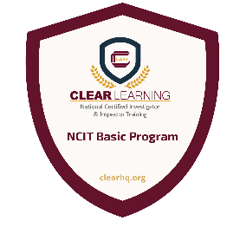

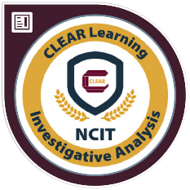
Thank you very much for considering voting for me, if you would like me to expand on anything please don’t hesitate to reach out at Marcuserickson@yahoo.com or 505-259-0051

