Reach top decision-makers at Georgia’s community banks

Community Bankers Association of Georgia (CBA) offers approximately 70 professional development programs, networking events, advocacy events, virtual programs, and of course, our annual convention – CONNECT. These opportunities bring together industry professionals and decision-makers from community banks across the state.

Targeted marketing with CBA provides associate members the exclusive opportunity to network, build business and brand recognition, and reinforce your support of Georgia’s community banking industry. 1-28-24

ADVOCACY/LEGISLATIVE/REGULATORY

2024 Advocacy Update – Weekly email during the 2024 Georgia Legislative Session - $2,000

2024 ICBA Capital Summit – Dinner for CBA Attendees | Spring 2024 | Washington, DC
- 4 sponsors @ $2,000 each - SOLD

2024 Town Hall Talk Tours | Spring 2024 | 3 Locations |
Meetings in 3 locations; Regional information, networking, refreshments, legislative updates; 1 representative per sponsor
- 3 sponsors @ $2,500 each - SOLD

2024 Topgolf Showdown | 2 Locations: Buford | April 25, 2024 and Atlanta | August 8, 2024
All levels include 3 hours of golf, food, unlimited non-alcoholic drinks, recognition at event and in CBA materials.
- Party of Fore - $1,000 – 4 players, 8 drink tickets, logo on monitors
- Par Partners - $500 – 2 players, 4 drink tickets, logo on monitors
- Player of the Year - $250 - 1 player, 2 drink tickets, logo on monitors

2024 Sporting Clay Shoots
South: Charlie Curry Memorial Clay Shoot - Wynfield Plantation, Albany | September 26, 2024
North: Chuck Harwell Memorial Clay Shoot – Burge Plantation, Mansfield | October 24, 2024

Pricing Per Clay Shoot:
- Premier Sponsor: $2,000 4 shooters, 2 station sponsor signs, table at registration
- Drink Sponsor: $500 Ride & deliver drinks
- Eye & Ear Protection: $500 Tabletop -distribute onsite
- 12 Gauge Sponsor: $750 4 shooters, 1 station sponsor sign
- 20 Gauge Sponsor: $500 2 shooters, 1 station sponsor sign
- 28 Gauge Sponsor: $250 1 shooter
- Morning Prize Sponsor: $750 1 shooter & prize presentation
- Afternoon Prize Sponsor: $750 1 shooter & prize presentation
- Cart Sponsor: $1,500 2 shooters & signs on carts

2nd Annual CBA Day at the Braves Outing | August 24, 2024
7:20 pm | Atlanta Braves vs Washington Nationals | Hank Aaron Terrace
Bring the family, entertain clients, and enjoy time at the home of the 2021 World Series Champions – the Atlanta Braves. Pre-game tailgate party for bankers and sponsors. Watch the game together in a private area at Truist Park. Over 140 tickets were sold for the first annual event in September 2023.
- 10 sponsors @ $2,000 each (9 of 10 sold)

ANNUAL CONVENTION & MINI-TRADE SHOW
SPECIAL PROGRAMS
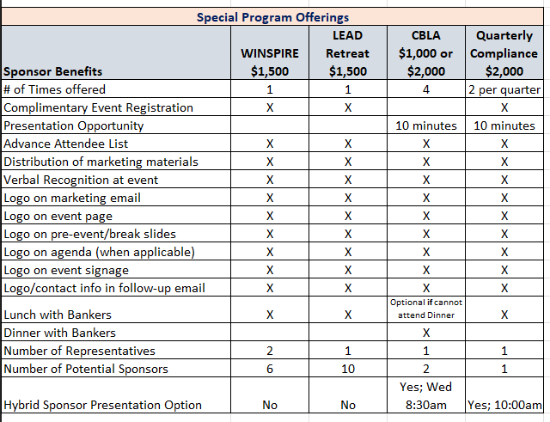

2024 Community Bankers Leadership Academy (CBLA)| 4 Sessions | Macon/Atlanta
- Q1 – March 2024 | Q2 – May 2024 | Q3 – August 2024 | Q4 – October 2024
- March 5-6, 2024 | April 30 – May 1, 2024 | August 13-14, 2024 | October 1 -2, 2024
- Network with 15-20 bankers over dinner/lunch - $1,000 co-sponsor or exclusive - $2,000

LEAD Retreat – Fall 2024 | Location TBD
- Engage with bankers advancing in their careers. This interactive session offers numerous networking opportunities.
- Limit 10 sponsors - $1,500 each; includes 1 registration

WINSPIRE | Date & Location TBD
- CBA’s popular Women in Banking program; Limit 6 sponsors - $1,500 each; includes 2 registrations

CBA’s Quarterly Compliance Program –Compliance Professionals Package
- 2 Sessions Each Quarter| Sponsorships per quarterly session - $2,000
- February 6 – 7, 2024 | May 15-16, 2024 | September 25-26, 2024 |December 10-11, 2024
- Limit 1 feature sponsor per quarter – eat lunch with students; includes 10-minute presentation

Banker Regulatory Forum | 2 In Person Sessions | Compliance; 2 Co-Sponsors – $3,000 each

PROFESSIONAL DEVELOPMENT

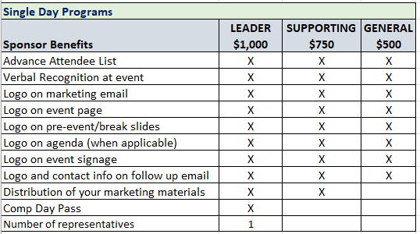
Single Day Programs Include:
- Safe Deposit Box Operations: February 21, 2024
- BSA/AML Forum: February 22, 2024
- Creating a Culture of Performance: April 9, 2024
- Loan Operations Manager – RAP: April 2024
- ISO Information Security RAP: May 21, 2024
- Loan Operations Manager RAP: August 8, 2024
- Retail Banking Leadership 1 & 2: September 17, 2024
- Retail Banking Leadership 3 & 4: October 3 & 4, 2024
- BSA Regulator Forum: December 5, 2024
- IT Management RAP: TBD

Essentials of Banking Series
$500 per session OR - $1,000 for all 4: Includes logo in marketing materials, verbal recognition, attendee list

- Essentials of Banking: Part 1 – February 8, 2024
- Essentials of Banking: Part 2 – March 7, 2024
- Essentials of Banking: Part 3 – April 11, 2024
- Essentials of Banking: Part 4 – May 16, 2024

HR/Talent Development RAP Sessions
$500 per session: Includes logo in marketing materials, verbal recognition, attendee list
- HR Rap Session: March 1, 2024 - HR Rap Session: July 19, 2024
- HR Rap Session: October 18, 2024 - HR Rap Session: December 6, 2024

** NEW ** Frontline Training Package: Virtual - 6 Topics
$1,000 per session: Includes logo in marketing materials, verbal recognition, attendee list.
Watch for more information!

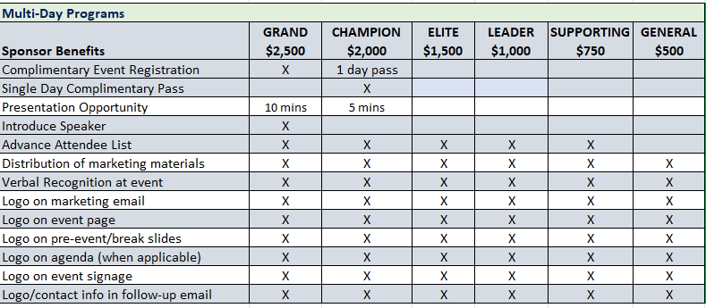
Schools and Multi-Day Programs Include:
- Credit Analysis, Part 1: February 13 & 14, 2024
- Credit Analysis, Part 2: March 12 & 13, 2024
- NEW: Compliance Deep Dive: March 19-20, 2024
- BSA/AML/CFT Fundamentals: April 9 – 11, 2024 (min sponsorship of $1,000)
- NEW: CRA Workshop: June 11 – 12, 2024
- Cyber Risk Summit: August 7 -9, 2024
  - Cyber Risk Summit Exhibits: Limit 10; $1,500 each – includes 1 registration
- Commercial Lending Bootcamp: October 22-24,2024
- Consumer/Retail School: October 1-4, 2024
- Human Resources & Talent Development Conference: May 6 – 8, 2024
  - HR/TD Exhibitors – Up to 5: $1,500; includes 1-day registration
- Advanced BSA/AML/CFT School: August 19 – 23, 2024 (min sponsorship of $1,000)

Fintech/Innovation Program | Date TBD:
  - Visionary $3,000 Exhibit and 2 registrations
  - Champion $2,000 Exhibit and 1 registration
  - Elite $1,500 1 registration

BSA Regulator Forum & Fundamentals Bundle:
- BSA Regulator Forum: February 22, 2024
- BSA Regulator Forum: December 5, 2024
- BSA Fundamentals: April 9 – 11, 2024
$1,500 sponsorship available for all 3
*** Sponsorships that include registrations must be registered 30 days prior to the event in order to participate. ***
** NEW THIS YEAR! Blue Ribbon Single Day Program Sponsorships**
Professional Development programs can be found on CBA’s website www.cbaofga.com. For single day programs, enjoy exposure to a variety of audiences by choosing a General Sponsorship for $500. This includes your logo on the CBA website, verbal recognition at event and logo/website distributed to attendees.

MORE WAYS TO SHOWCASE YOUR BUSINESS

** NEW **
Tracy Strozier Memorial Scholarship for CBA Leadership Academy
This scholarship is in memory of Tracy Strozier, a BankSouth employee and participant in the 2023 CBLA class, who passed away unexpectedly. The scholarship will be awarded to a deserving banker who wishes to further his or her career by participating in the 2024 CBA Leadership Academy. The 2024 scholarship will go to a BankSouth employee and beginning in 2025, the scholarship will be open to all CBA bank members. Investment of $2,000 includes logo on marketing materials, CBA website and to 2024 CBLA participants.

LinkedIn Sponsorship: This unique sponsorship works like this: The CBA CEO will call on banks throughout the year, dropping off a small gift (provided by sponsor). He will then take photos of the bank or CEO and tag your company on LinkedIn. Most posts range from 1,500 – 4,000 views. Exclusive sponsorship.
Available: January 1 – June 30, 2024: $2,500 | July 1 – December 31, 2024: $2,500

CBA Committee Meeting Sponsorships| In-Person or Virtual
Education, AG Committee, Marketing/Communications, LEAD, Innovation, Member Services
Current Opportunities:
- Innovation Committee Meeting Co-Sponsor - $1,000
- Marketing Committee/Roundtable Co-Sponsor - $1,500

Board Planning Session: Fall 2024 Virtual (limit 3 sponsors) - $5,000 each – includes 10-minute presentation during meeting.

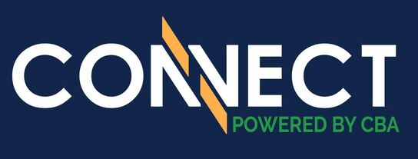
2024 SPONSORSHIP OPTIONS
Annual Convention & Mini-Trade Show
June 5 – 9, 2024 | The Ritz Carlton
Amelia Island, FL
CBA’s Annual Convention is a great opportunity to meet, visit and network with CEOs, senior managers and directors to promote your company’s services and image.

SPONSORSHIP BENEFITS

- Recognition commensurate with sponsorship level
- Advanced attendee roster
- Signage of sponsorship
- Listing in Georgia Communities First magazine as a sponsor
- Company listed as sponsor in CBA Today weekly e-newsletter
- Company listed in “Know Before You Go” email prior to the event
- Sponsor ribbon for name badge
- Recognition during General Session(s)
- Recognition on conference website pages, clickable to company’s URL
- Exposure on CBA social media

Premium • $10,000

Options include:
- Chairman’s Reception/Dinner Co-Sponsor (3)
- Premium Package includes 60-second commercial

Executive • $5,000

Options include:
- Thursday Night Event (2)
- Board Appreciation Dinner (3)

Deluxe • $3,000

Options include:
- Snack Bags at Registration Desk
- WiFi
- Convention Tote Bags
- Breakfast Buffet (2 of 3)
- Keynote Speaker Introduction (2 of 3)
- Saturday Night Entertainment Co-Sponsor (1 of 2)
- Thursday Night Dessert (2 of 3)
- Convention Swag Item (1)
- Thursday Night Hosted Beer & Wine (3 of 3)

Classic • $2,000

Options Include:

- Mid-Morning Refreshment Break (3)
- Continuous Morning Coffee (3)
- Name Tags
- Bottled Water
- Friday Beach Party (3 of 4)

General: • $1,000

Options Include:
- Standard General Sponsorship
- Cash Prizes (3)
- Daily Promo Items (3)
- Room Drop (2 of 2)

** Preference may be given to past sponsors. 2023 sponsors have first right of refusal for the 2024 sponsorship opportunities. See CBA’s Member Services department for questions.

Looking for a customized package?
Consider an advertising/sponsorship package to stretch your marketing dollars throughout the year.
Contact Lindsay Greene at lindsay@cbaofga.com or call (770) 541-0376.

2024 Sponsorship Commitment Form

Name:

Marketing Contact Name:
(Person for CBA to contact relative to marketing materials)

Company:
Address:
City, State, ZIP:

Phone: Email:
Authorized Signature: Date:
Please list your sponsorship(s):
□ ______________________________________________________________________________
□ ______________________________________________________________________________
□ ______________________________________________________________________________

A deposit of 50% of the total cost of your selected sponsorship(s) is required when submitting this sponsorship agreement. The total cost of all sponsorships must be paid in full 30 days prior to event date. All conference sponsorships are non-refundable as we will market the names of the sponsors prior to the conference.

PAYMENT METHOD: (please check the appropriate box)
□ Please send me invoice for all.
□ Please send me link to pay by credit card.

Please email this information form and payment to: Lindsay Greene - lindsay@cbaofga.com or call to discuss best options for your business - 770-541-0376.

