Reach top decision-makers at Georgia’s community banks

Community Bankers Association of Georgia (CBA) offers approximately 70 professional development programs, networking events, advocacy events, virtual programs, and of course, our annual convention – CONNECT. These opportunities bring together industry professionals and decision-makers from community banks across the state.

Targeted marketing with CBA provides associate members the exclusive opportunity to network, build business and brand recognition, and reinforce your support of Georgia’s community banking industry. 5-23-24

ADVOCACY/LEGISLATIVE/REGULATORY

2024 Town Hall Talk Tours | Spring 2024 | 3 Locations |
Meetings in 3 locations; Regional information, networking, refreshments, legislative updates; 1 representative per sponsor. 4 sponsors @ $2,000 each – SOLD

2024 Topgolf Showdown | Atlanta | August 8, 2024
All levels include 3 hours of golf, food, unlimited non-alcoholic drinks, recognition at event and in CBA materials.
- Party of Fore - $1,000 – 4 players, 8 drink tickets, logo on monitors
- Par Partners - $500 – 2 players, 4 drink tickets, logo on monitors
- Player of the Year - $250 - 1 player, 2 drink tickets, logo on monitors

2024 Sporting Clay Shoots
South: Charlie Curry Memorial Clay Shoot - Wynfield Plantation, Albany | September 26, 2024
North: Chuck Harwell Memorial Clay Shoot – Burge Plantation, Mansfield | October 24, 2024

Pricing Per Clay Shoot:
- Premier Sponsor: $2,000 4 shooters, 2 station sponsor signs, table at registration
- Drink Sponsor: $500 Ride & deliver drinks
- Eye & Ear Protection: $500 Tabletop -distribute onsite
- 12 Gauge Sponsor: $750 4 shooters, 1 station sponsor sign
- 20 Gauge Sponsor: $500 2 shooters, 1 station sponsor sign
- 28 Gauge Sponsor: $250 1 shooter
- Morning Prize Sponsor: $750 1 shooter & prize presentation
- Afternoon Prize Sponsor: $750 1 shooter & prize presentation
- Cart Sponsor: $1,500 2 shooters & signs on carts

ANAL CONVENTION & MINI-TRADE SHOW
SPECIAL PROGRAMS

2024 Community Bankers Leadership Academy (CBLA)| 4 Sessions | Macon/Atlanta
- Q1 – March 2024 | Q2 – May 2024 | Q3 – August 2024 | Q4 – October 2024
- August 13-14, 2024 | October 1 -2, 2024
- Network with 12-15 bankers over dinner/lunch - $1,000 co-sponsor or exclusive - $2,000

PROFESSIONAL DEVELOPMENT

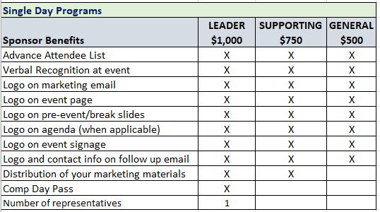
Single Day Programs Include:
- 2024 Small Business Loan Data: 1071: July 16, 2024
- Loan Operations Manager RAP: August 5, 2024
- Retail Banking Leadership 1 & 2: September 17, 2024
- Retail Banking Leadership 3 & 4: October 3 & 4, 2024
- HMDA: November 14, 2024
- BSA Regulator Forum: December 5, 2024
- ISO/IT Management RAP: TBD
- Deposit Ops RAP: TBD

HR/Talent Development RAP Session (Remaining Session): December 6, 2024
$500 per session: Includes logo in marketing materials, verbal recognition, attendee list

** NEW ** Frontline Training Package: Virtual – Remaining Opportunities
$1,000 per session: Includes logo in marketing materials, verbal recognition, attendee list.

- October 24, 2024 – Reg CC & Check Fraud
- November 7, 2024 – Security & Privacy

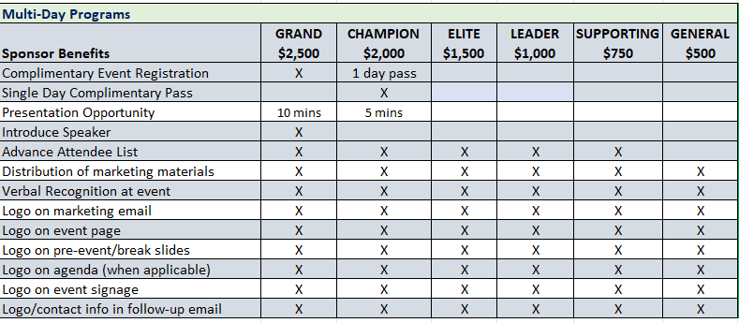
Schools and Multi-Day Programs Include:
- Cyber Risk Summit: August 7 -9, 2024
  - Cyber Risk Summit Exhibits: Limit 10; $1,500 each – includes 1 registration - SOLD
- Commercial Lending Bootcamp: October 22-24,2024
- Consumer/Retail School: October 1-4, 2024
- Advanced BSA/AML/CFT School: August 19 – 23, 2024 (min sponsorship of $1,000)

Fintech/Innovation Program | August 13, 2024 | Dublin – Tech Talk South
  - Visionary $3,000 5-Minute Pitch and 2 registrations
  - Champion $2,000 5-Minute Pitch and 1 registration
  - Elite $1,500 1 registration

Fintech/Innovation Program | November 6 & 7, 2024 | Atlanta – Tech Talk North
  - Visionary $3,000 5-Minute Pitch and 2 registrations
  - Champion $2,000 5-Minute Pitch and 1 registration
  - Elite $1,500 1 registration

*** Sponsorships that include registrations must be registered 30 days prior to the event in order to participate. ***
MORE WAYS TO SHOWCASE YOUR BUSINESS

LinkedIn Sponsorship: This unique sponsorship works like this: The CBA CEO will call on banks throughout the year, dropping off a small gift (provided by sponsor). He will then take photos of the bank or CEO and tag your company on LinkedIn. Most posts range from 1,500 – 4,000 views. Exclusive sponsorship.
Available: January 1 – June 30, 2024: $2,500 | July 1 – December 31, 2024: $2,500

CBA Committee Meeting Sponsorships| In-Person or Virtual
Education, AG Committee, Marketing/Communications, LEAD, Innovation, Member Services
Current Opportunities:
- Innovation Committee Meeting Co-Sponsor - $1,000
- Marketing Committee/Roundtable Co-Sponsor - $1,500

Board Planning Session: Fall 2024 Virtual (limit 3 sponsors) - $2,500 each – includes 10-minute presentation during meeting.

Looking for a customized package?
Consider an advertising/sponsorship package to stretch your marketing dollars throughout the year.
Contact Lindsay Greene at lindsay@cbaofga.com or call (770) 541-0376.

2024 Sponsorship Commitment Form

Name:

Marketing Contact Name:
(Person for CBA to contact relative to marketing materials)
Company:
Address:
City, State, ZIP:

Phone: Email:
Authorized Signature: Date:
Please list your sponsorship(s):
□ ______________________________________________________________________________
□ ______________________________________________________________________________
□ ______________________________________________________________________________
PAYMENT METHOD: (please check the appropriate box)
□ Please send me invoice for all. □ Please send me link to pay by credit card.

Please email this information form and payment to: Lindsay Greene - lindsay@cbaofga.com or call to discuss best options for your business - 770-541-0376.

