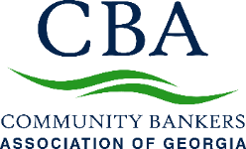

Sponsorships offer a tangible way to gain exposure to bankers across the state, through in-person or virtual professional development programs, our annual convention CONNECT, advocacy events, and special programs. CBA offers approximately 80 live professional development events, training programs, and peer-group forums annually.

ADVOCACY/LEGISLATIVE/REGULATORY

2023 Topgolf Showdown
- Thursday, April 20, 2023 Augusta
- Thursday, May 4, 2023 Chattanooga, TN

All levels include 3 hours of golf, food, unlimited non-alcoholic drinks, recognition at event and in CBA materials.
- Party of Fore - $900 – 4 players, 8 drink tickets, logo on monitors
- Par Partners - $500 – 2 players, 4 drink tickets, logo on monitors
- Prize Sponsor - $750 – 2 players, 4 drink tickets, logo on monitors, prize presentation
- Player of the Year - $250 - 1 player, 2 drink tickets, logo on monitors

2023 Town Hall Talk Tours | May, June, July | 6 Locations
Meetings in 6 locations; Regional information, networking, refreshments, legislative updates; 1 representative per sponsor.

- Waycross, May 18, 2023
- Cordele, May 24, 2023
- Greensboro, May 25, 2023
- Dalton, June 22, 2023
- Vidalia, July 13, 2023
- Bainbridge, July 20, 2023

2023 Sporting Clay Shoots
South: Charlie Curry Memorial Clay Shoot - Wynfield Plantation, Albany - September 21, 2023
North: Chuck Harwell Memorial Clay Shoot – Burge Plantation, Mansfield – October 19, 2023

Pricing Per Clay Shoot:
- Premier Sponsor: $2,000 4 shooters, 2 station sponsor signs, table at registration
- Drink Sponsor: $600 Limit 1 – includes 1 shooter
- 12 Gauge Sponsor: $800 4 shooters, 1 station sponsor sign
- 20 Gauge Sponsor: $550 2 shooters, 1 station sponsor sign
- 28 Gauge Sponsor: $350 1 shooter
- Prize Sponsor: $1,500 4 shooters, 1 station sign & prize presentation; OR
- Morning Prize Sponsor: $750 2 shooters & prize presentation
- Afternoon Prize Sponsor: $750 2 shooters & prize presentation
- Cart Sponsor: $1,500 4 shooters & signs on carts

Atlanta Braves Outing | Summer 2023 | Information Coming Soon
Bring the family, entertain clients and enjoy time at the home of the 2021 World Series Champions. Sponsorship opportunities coming soon.

ANNUAL CONVENTION & MINI-TRADE SHOW
SPECIAL PROGRAMS
2023 Executive Channel | 3 Sessions | Macon | May 3, 2023; TBD 2, TBD 3

2023 Community Bankers Leadership Academy (CBLA)| 4 Sessions | Macon
- March 28-29, 2023 | May 9-10, 2023 | August 8-9, 2023 | October 3-4, 2023

LEAD Retreat – Fall 2023 - SOLD

WINSPIRE – (formerly Women in Banking) - Spring 2023 | Date Location TBD – 1 of 6 available

CBA’s Quarterly Compliance Program –Compliance Professionals Package
- 3 Sessions Each Quarter| Sponsorships per quarterly session
- Compliance Program Q1: NSF/Overdrafts/Representments and UDAAP - SOLD
  - 2/7 – Macon/Live Virtual STREAM; 2/8 – Tifton; 2/9 – Statesboro/Live Virtual STREAM

- Compliance Program Q2: Appraisal Regulations & Flood Insurance - SOLD
  - 6/13 – Macon/Live Virtual STREAM; 6/20 – Tifton; 6/21 – Statesboro/Live Virtual STREAM

- Compliance Program Q3: Topic Being Selected using Survey Feedback - SOLD
  - Macon/Live Virtual STREAM; 8/29 – Macon; 8/30 - Tifton; 8/31- Adverse Action Notices with Small Creditors (Compliance Add-On) - Tifton
- Compliance Program Q4: 3rd Party Risk Management & ESG (Environmental Social Governance) - AVAILABLE
  - Macon/Live Virtual STREAM; 12/12 – Macon; 12/13 – Tifton; Retail Lending Compliance Add- On 10-12

- Banker Regulatory Forum | 4 sessions - 2 Virtual/2 In Person; 2 Co-Sponsors – $3,500 each- SOLD

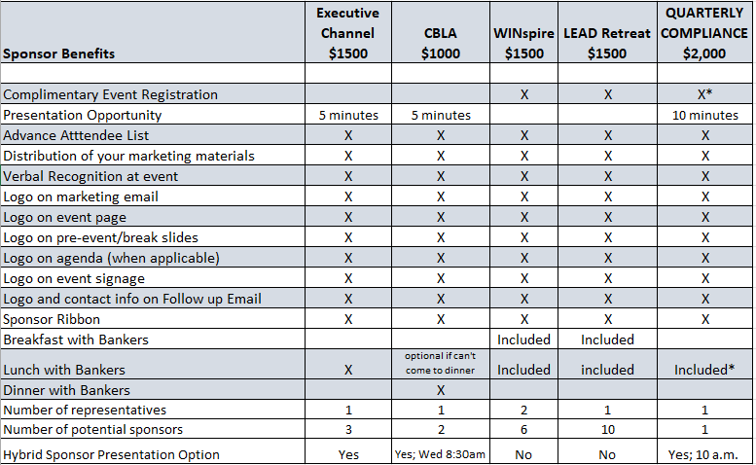

For Compliance program: Statesboro, Macon, Tifton (Tifton is in person only; others are hybrid); sponsors have 10-minute presentation at 10:00 a.m. EST. Sponsor may attend for lunch & present at lunch. May attend one full day.
CBA Committee Meeting Sponsorships| In-Person or Virtual – Range from $500 - $1,000
Education, AG Committee, Marketing/Communications, LEAD, Innovation, Member Services

Board Planning Session: Virtual – Summer 2023 (limited sponsorships)

PROFESSIONAL DEVELOPMENT

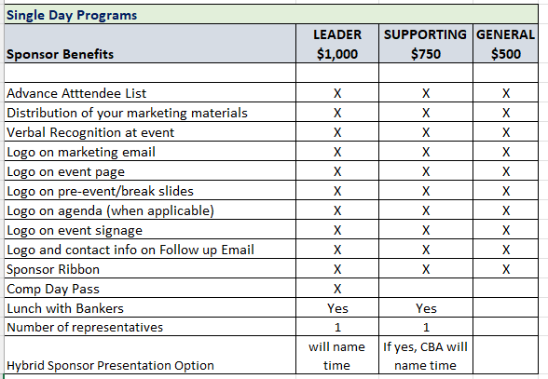
Single Day Programs Include:
Innovation Forum – Ag Technology: Tifton – TBD
Retail Banking Leadership 1: Macon – 4/18
Retail & Operations Banking Forum 1: Virtual– 4/19
Loan Portfolio Management & Review: Reviewing Your Loans and Mending Fences Before the Regulators Arrive – Macon - 4/28/23
Retail Banking Leadership 2: Macon – 5/23
Essentials of Banking: Part 3 - Live Virtual STREAM – 5/24
TRID – Advanced: Macon – 6/14
Essentials of Banking: Part 4 - Live Virtual STREAM – 6/20
HR/TD Rap Session 2: Macon – 7/21
Retail Banking Leadership 3: Macon – 8/29
Compliance Alphabet Soup – Deposits: STREAM – 9/12 & 9/26
Retail & Operations Banking Forum 2: Macon – 9/21
CRA Modernization Strategy: STREAM - 9/27
HR/TD Rap Session 3: Macon – 10/6
Retail Lending (NON-TRID) & E-sign Compliance: Virtual – 10/12
Retail Banking Leadership 4: Macon – 10/17
Mortgage Lending School: Atlanta – 12/14 – 11/18
HR/TD Rap Session 4: Macon – 12/1
BSA Forum: Macon – 12/5

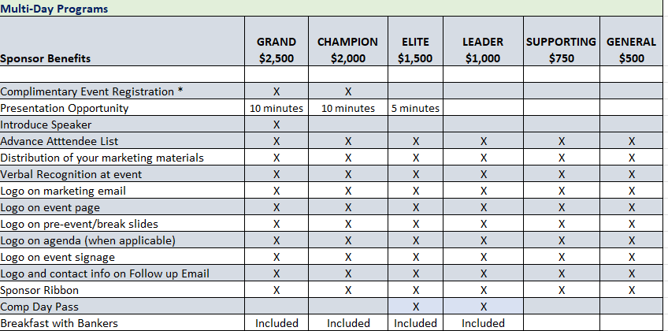

Schools and Multi-Day Programs Include:
BSA Fundamentals: Macon - 4/18-4/20
HR Conference: Jekyll Island – 5/15 – 5/17
Loan Documentation - Consumer & Commercial - Macon - 6/15-6/16
Cyber Risk Conference: Jekyll Island – 8/16 – 8/18
Advanced BSA School: St. Simons - 8/21 – 8/25
Retail Lending School: Macon – 10/2 – 10/5
Advanced Compliance School: 10/23 – 10/26
Advanced HMDA: Tifton – 11/8-11/9

Professional Development Exhibits:
- Cyber Risk Conference: 8/16 – 8/18 $1,100 Limit 10
- HR Conference: 5/15 – 5/17 $650 Limit 5 1-day pass
To be added:
- Bank Security
- Payments/Future of Banking
- Innovate Community Banking

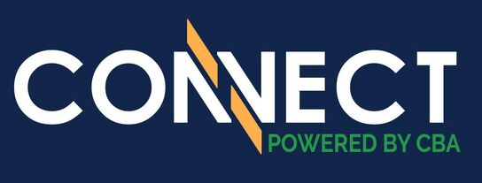
2023 SPONSORSHIP OPTIONS
Annual Convention & Mini-Trade Show
June 7-11, 2023 | The Charleston Place Charleston, SC

SPONSORSHIP BENEFITS

- Recognition commensurate with sponsorship level
- Advanced attendee roster
- Company logo on CBA website (for Deluxe packages and above)
- Signage of sponsorship
- Listing in Georgia Communities First magazine as a sponsor
- Company listed as sponsor in CBA Today weekly e-newsletter
- Company listed in “Know Before You Go” email prior to the event
- Sponsor ribbon for name badge
- Recognition during General Session(s)
- Recognition on conference website pages, clickable to company’s URL
- Exposure on CBA social media

SPONSORSHIP OPTIONS

Premium • $10,000

Options include:
- Board Appreciation Dinner (3)
- Chairman’s Reception/Dinner Co-Sponsor (3)
- Premium Package includes 60-second commercial

Executive • $5,000

Options include:
- Thursday Night Event (1 of 2)

Deluxe • $3,000

Options include:
- Snack Bags at Registration Desk
- WiFi
- Breakfast Buffet (3)
- Keynote Speaker Introduction (1 of 2)
- Saturday Night Entertainment Co-Sponsor (2)
- Thursday Night Dessert (1 of 2)
- Convention Swag Item (1)
- Thursday Night Hosted Beer & Wine (2)

Classic • $2,000

Options Include:
- Mid-Morning Refreshment Break (3)
- Breakout Session Speaker Introduction (6)
- Continuous Morning Coffee (0 of 3)
- Name Tags
- Bottled Water
- Convention Tote Bags

General: • $1,000

Options Include:
- Standard General Sponsorship
- Cash Prizes (3)
- Daily Promo Items (3)
- Room Drop (2)

*** Preference may be given to past sponsors. 2022 sponsors have first right of refusal for the 2023 sponsorship opportunities. See CBA’s Member Services department for questions.

Looking for a customized package?
Consider an advertising/sponsorship package to stretch your marketing dollars throughout the year.
Contact Lindsay Greene at lindsay@cbaofga.com or call (770) 541-0376.

2023 Sponsorship Commitment Form

Name:

Marketing Contact Name:
(Person for CBA to contact relative to marketing materials)

Company:
Address:
City, State, ZIP:

Phone: Fax: Email:
Authorized Signature: Date:
Please list your sponsorship(s):
□ ______________________________________________________________________________
□ ______________________________________________________________________________
□ ______________________________________________________________________________
A deposit of 50% of the total cost of your selected sponsorship(s) is required when submitting this sponsorship agreement. The total cost of all sponsorships must be paid in full 30 days prior to event date. All conference sponsorships are non-refundable as we will market the names of the sponsors prior to the conference.

PAYMENT METHOD: (please check the appropriate box)
□ Please send me invoice for all.
□ Please call or send me info to use credit card.

Please send this information form and payment to: Community Bankers Association of Georgia,
1640 Powers Ferry Road SE, Building 28, Suite 100, Marietta, GA 30067
770-541-0376 or email lindsay@cbaofga.com.

3-7-23

