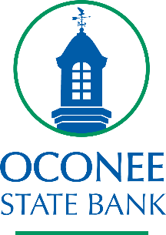

AZIZ NAMED VP & DIRECTOR, HUMAN RESOURCES
WATKINSVILLE, June 29, 2023 – Oconee State Bank (OTCQX: OSBK) announces the recent hiring of Sherry Aziz as Vice President and Director, Human Resources. Sherry’s 20-year Human Resource career has included positions at various organizations including FSG Bank, Atlantic Capital Bank and Transcard Payments, LLC. She also holds certification as a Society for Human Resource Management-Certified Professional (SHRM-CP). We are excited for the invaluable knowledge and experience she will bring to this role.

About Oconee State Bank

Oconee State Bank is a leading financial institution with a vision to be essential to the lives, businesses and communities we serve. With more than 60 years of service in the banking industry, we continuously strive to create remarkable experiences that significantly mark the lives of others. We are proud to provide an unparalleled commitment to personalized service, innovative products and solutions, and to bringing exceptional value to our customers through local ownership, involvement and decision-making.

