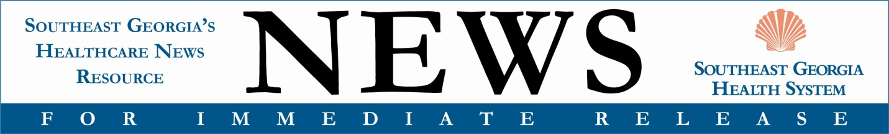
With attached photo: Southeastern Bank donated $100,000 to Southeast Georgia Health System Camden Campus through the 2023 Georgia HEART Hospital Program. L-R: Southeastern Bank Senior Vice President Jim Lomis and President and CEO Jay Torbert, Southeast Georgia Health System Vice President and Camden Campus Administrator Glenn Gann and President and CEO Scott Raynes.
Contact: Laura Young, director, Marketing & Public Relations; laura.young@sghs.org, 912-466-2148

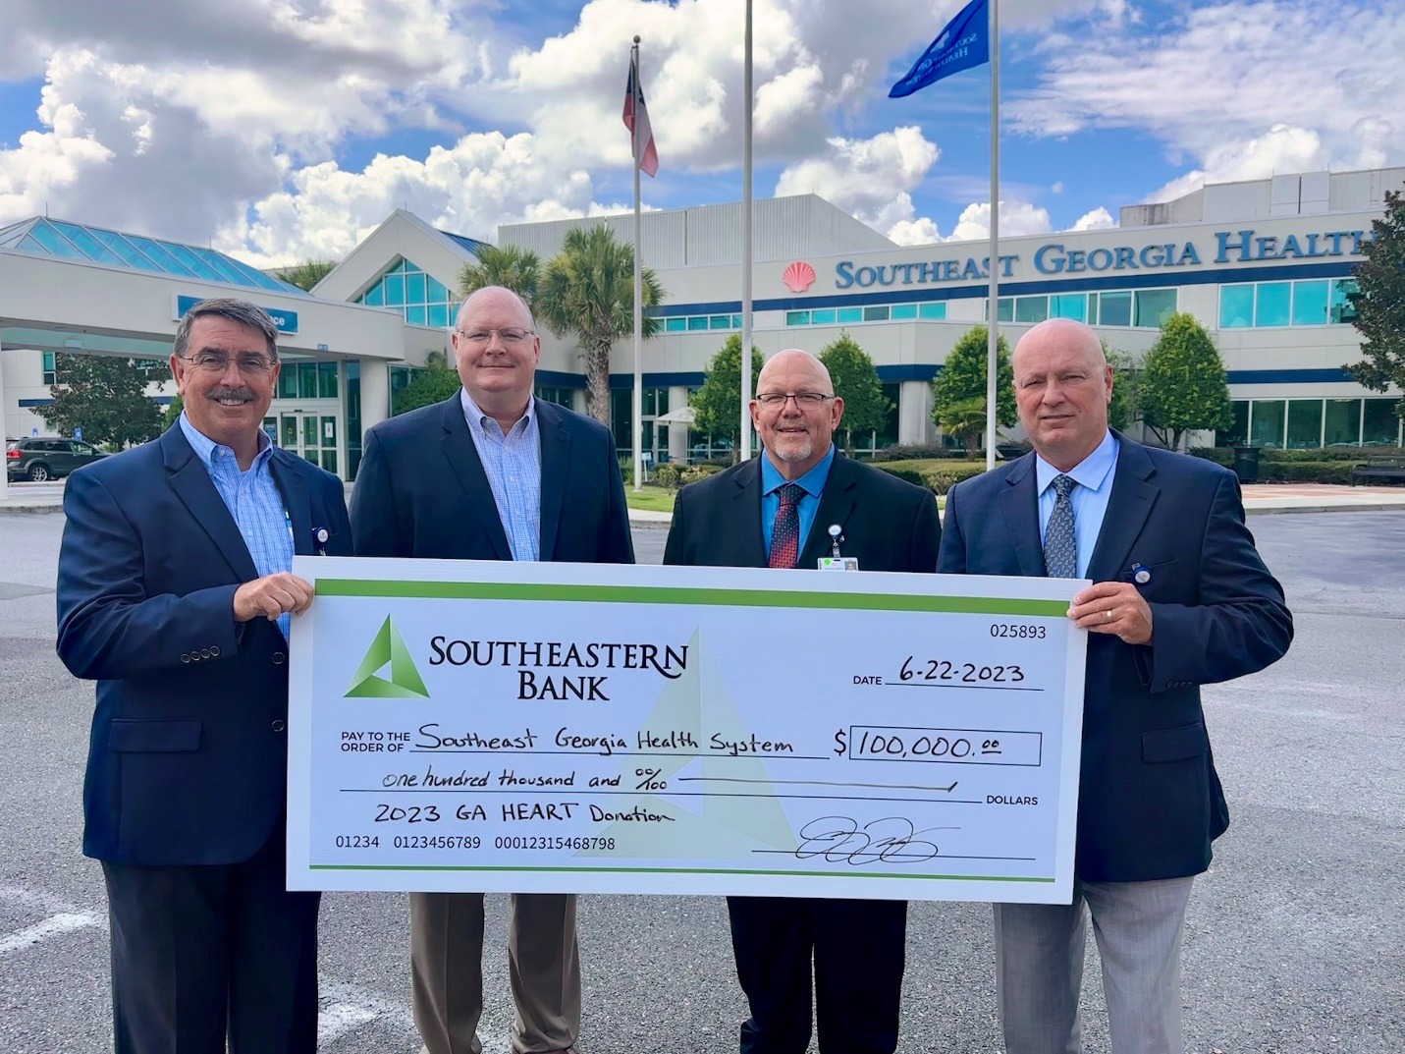

Southeastern Bank Contributes $100,000
To Southeast Georgia Health System Camden Campus

ST. MARYS, GA: August 3, 2023 – Southeastern Bank understands the importance of local, quality health care and, for the third year in a row, has chosen to redirect a portion of their 2023 tax dollars to the Southeast Georgia Health System Camden Campus through the Georgia HEART Hospital Program, helping to ensure the communities it serves have access to live-saving care.

“Southeastern Bank is very proud to support Southeast Georgia Health System’s mission to provide quality, compassionate healthcare with this $100,000 donation,” says Jay Torbert, president and CEO, Southeastern Bank. “Since 2021, Southeastern Bank has contributed $300,000 to the Camden Campus to assist with increasing their patient services.”

The Georgia HEART (Helping Enhance Access to Rural Treatment) Hospital Program allows taxpayers to make contributions in exchange for 100% state income tax credit, up to specified limits, to qualified rural hospitals of their choice. C-Corporations and Pass-thru-Entity business owners who participate may also qualify for an additional federal business expense deduction.

Torbert encourages all Georgia taxpayers, regardless of where they live, to learn more about the program and support qualifying rural hospitals. “Georgia HEART allows all Georgia citizens to participate in the program at no additional cost to the taxpayer. Both businesses and individuals can dedicate their state tax dollars toward a rural hospital of their choice. That means Georgians who live in cities where their hospital doesn’t qualify, such as Atlanta or Savannah, can help their friends and family who live in rural areas obtain excellent health care close to home.”

By redirecting what they would have paid toward state income tax to the Georgia HEART Hospital Program, taxpayers help rural hospitals, such as the Southeast Georgia Health System Camden Campus, add new services, purchase technology, recruit physicians and offer additional health programs and screenings. The Health System has used previous years’ Georgia HEART funds to help build a new Wound Care Center and purchase ROSA Knee robotic surgical technology. They also added 3D Mammography, the most effective screening method for breast cancer, to their radiology offerings.

“The health care services provided by Southeast Georgia Health System are vitally important to our community,” shares Torbert. “Through our annual participation in Georgia HEART, we are essentially redirecting tax dollars to support the health care needs of our families and neighbors.”
“We are very grateful for the individuals and businesses who participate in the Georgia HEART Hospital Program,” says Scott Raynes, MBA, MA, president and CEO, Southeast Georgia Health System. “Rural hospitals like the Camden Campus fill a vital need. The support we’ve received has been crucial in helping our hospital make important and necessary improvements so that we can offer the best care for our patients.”

Raynes adds, “The tax credit program is an excellent way for contributors to improve access to local medical care, where it benefits family, friends and themselves. It’s an easy way to feel better about paying taxes, knowing that your money helped improve health care.”

Southeastern Bank is among the more than 95 Georgia taxpayers to redirect a portion of their 2023 tax dollars to the Camden Campus. The process to participate in this program is easy and takes less than five minutes. Simply complete a brief application, found at sghs.org/ga-heart or at georgiaheart.org.

About Southeast Georgia Health System
Southeast Georgia Health System is a not-for-profit health system comprised of two acute care hospitals, two long term care facilities, two comprehensive Cancer Care Centers and multiple specialty care centers, including orthopaedic and spine care, joint replacement, breast care, maternity, outpatient rehabilitation, sleep management and wound care. The Brunswick Campus Cancer Care Center is accredited by the American College of Surgeons Commission on Cancer and is one of the few centers in Georgia to offer CyberKnife® M6 with MLC. Additionally, the Brunswick Campus is accredited by The Joint Commission as an Advanced Primary Stroke Center and the Camden Campus is accredited as an Acute Stroke Ready Hospital. The Southeast Georgia Physician Associates medical group includes more than 160 providers working in 20 different medical specialties at more than 50 locations. The Health System is part of Coastal Community Health, a regional affiliation between Baptist Health and Southeast Georgia Health System, a highly integrated hospital network focused on significant initiatives designed to enhance the quality and value of care provided to our contiguous communities. For more information, visit sghs.org.

###

