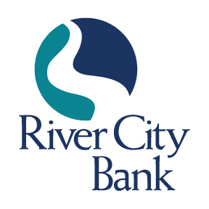
CONTACT: Jennifer M. Selman
(706) 236-3553
jennifer.selman@rivercity.bank

FOR IMMEDIATE RELEASE

Matthew Goldin Promoted to AVP, Senior Credit Analyst

ROME, GA, February 12, 2024 – River City Bank is pleased to announce the promotion of Matthew Goldin to Assistant Vice President, Senior Credit Analyst. Since joining River City Bank in 2015, Goldin’s outstanding work ethic and commitment to excellence have made a significant impact on the bank’s credit department.

“Matthew plays a vital role in our credit team, demonstrating remarkable growth in the last several years,” stated Jonathan Jones, SVP and Senior Credit Officer at River City Bank. “He is committed to his work, consistently delivering thorough and efficient results. This promotion reflects his dedication and the significant value he brings to our team.”

“We are thrilled to announce Matthew Goldin’s well-deserved promotion,” stated Jamie Tallent, President and CEO of River City Bank. “His strong comprehension of the credit analyst role and exceptional performance in all areas have been outstanding. This promotion is a testament to his skills and commitment to River City Bank, and I look forward to witnessing his continued growth and success.”

Goldin received his Bachelor of Science Degree in Finance and Economics from Berry College. “I have been with River City Bank for nearly a decade now, and I’m proud to be a part of this tight-knit team and community,” said Goldin. “We have an incredible group of bankers who drive us forward and cultivate a strong sense of community here. I’m thrilled to be a part of an ever-growing team and look forward to all the new challenges in this role and beyond.”

Goldin and his wife, Kelly, reside in Rome with their two-year-old son, Levi, and their dog, Molly. They are active members of Rome First United Methodist Church and look forward to welcoming a baby girl to their family this summer. In his free time, Goldin enjoys spending time outdoors with friends and family, taking on home improvement projects, attending Rome Little Theatre Shows, and cheering on the Atlanta Braves.

About River City Bank
River City Bank, founded in 2006, is a full-service community bank, offering financial solutions for personal and business clients including deposits, loans, treasury management, and brokerage services. We are headquartered at 228 North Second Avenue SW, Rome, Georgia. For more information, visit www.rivercity.bank. Member FDIC. Equal Housing Lender.
###

