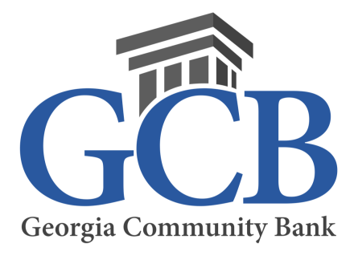

August 25, 2023
Contact: Shannon Turner 229-514-1760

PRESS RELEASE

Georgia Community Bank celebrates 10 years in Crawford County.

ALBANY, GA – Georgia Community Bank (formerly known as The Citizens State Bank of Crawford County) will be celebrating its Crawford County branch’s 10th anniversary on Friday September 1st from 9 am to 3 pm at its banking office at 300 N. Duggar Avenue, Roberta, Georgia.

Commenting on the milestone anniversary, Lucie Beeley, CEO and Chairman of the Board of Directors of Georgia Community Bank, said, “Roberta and Crawford County have a long history of community banking. We purchased the branch building from Certus Bank in 2013 with a plan to offer our version of local, hometown banking to the community. Over the past ten years, branch growth has exceeded our expectations and we look forward to serving the financing needs of Crawford County for many years to come.” Beeley also noted that Georgia Community Bank is the only financial institution in Crawford County. “While larger financial institutions are closing branches in smaller markets, we continue to focus on providing banking services to underserved markets.”

Market President Matt McDonald added, “I am excited to celebrate 10 years in Crawford County. The customer appreciation event on Friday September 1st is our way of thanking the community for their support and confidence in our bank.”

Georgia Community Bank, founded in 1922, is a locally owned Community Bank with branch offices in Albany, Blakely, Dawson, Donalsonville, Leesburg, Reynolds and Roberta, Georgia. Later this year, the bank will be opening a Loan Production Office in Warner Robins, Georgia.

For more information, visit www.gcb.bank

