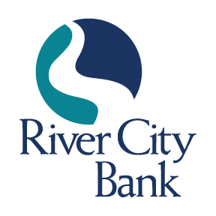
CONTACT: Jennifer M. Selman
(706) 236-3553
jennifer.selman@rivercity.bank

FOR IMMEDIATE RELEASE

Terri Ainsworth Joins River City Bank as Vice President, Mortgage Loan Officer

ROME, GA, October 17, 2023 – River City Bank is pleased to announce the addition of Terri Ainsworth as Vice President, Mortgage Loan Officer. In this role, she will be responsible for originating both conventional and government-sponsored residential mortgage loans for the secondary market.

Ms. Ainsworth joins the River City Bank team as a veteran banker, bringing over 20 years of mortgage lending experience to her role. She is a graduate of Model High School and attended Kennesaw State University. Ms. Ainsworth was voted by her peers as Best Mortgage Lender in the “Best of Rome” awards presented by the Rome News Tribune for three consecutive years in 2020, 2021, and 2022.
“I am proud to welcome Terri Ainsworth to the River City Bank team,” stated Jamie Tallent, President and CEO of River City Bank. “She is a highly experienced mortgage banker with years of experience in all facets of the mortgage industry. Terri’s commitment to consistently providing best-in-class customer service while offering sound advice for the right mortgage solution for customers aligns with our mission of helping our consumers throughout the region achieve their financial goals. I am confident that Terri will be an excellent addition to River City Bank.”

Ms. Ainsworth is a lifelong resident of Rome and Floyd County and remains active in the communities we serve. She is a member of the Greater Rome Board of Realtors, serving as the current Chairperson of Community involvement. Ms. Ainsworth is a board member of the Children's Museum of Rome and the North Broad Youth Center, the Chairperson of the Terrific Kids Program, and the past Director and Treasurer for the Rome Noon Optimist Club.

“I am excited to join the team of community bankers at River City Bank,” said Ms. Ainsworth. “I have lived in the Rome area my whole life, and I look forward to continuing to help my neighbors achieve their dreams of homeownership.” With a passion for volunteering her time, Ms. Ainsworth proudly supports Extra Special People Inc. (ESP), Keep Rome-Floyd Beautiful, the Sexual Assault Center, and Floyd Against Drugs.

Ms. Ainsworth and her husband, Edwin Ainsworth, reside in Rome and have been married for 39 years. Together, they have two daughters and five grandchildren. They are active members of Pleasant Valley South Baptist Church. In her free time, she enjoys traveling, music, and riding jet skis at the lake.

About River City Bank
River City Bank, founded in 2006, is a full-service community bank, offering financial solutions for personal and business clients including deposits, loans, treasury management, and brokerage services. We are headquartered at 228 North Second Avenue SW, Rome, Georgia. For more information, visit www.rivercity.bank. Member FDIC. Equal Housing Lender.
###

