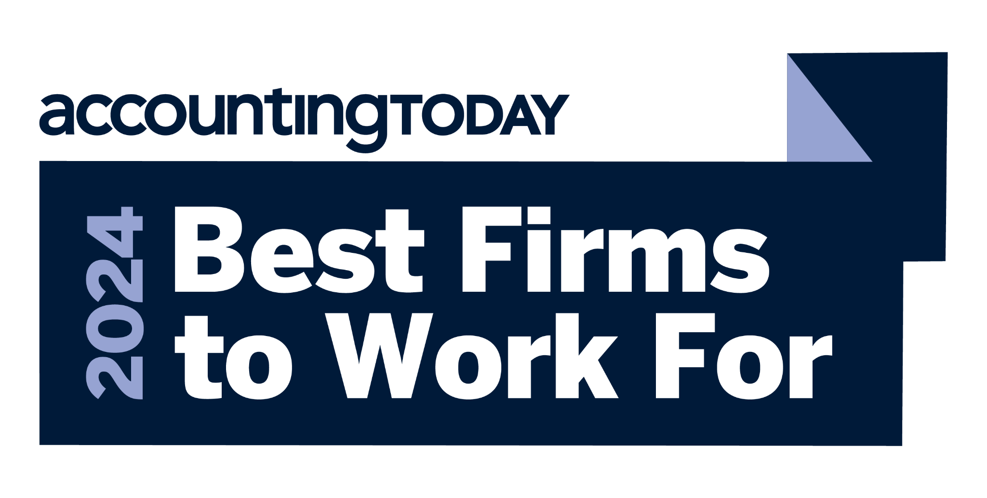

**Accounting Today Names Mauldin & Jenkins one of 2024’s “Best Firms to Work For”**

**ATLANTA**– Leading assurance, tax and advisory firm Mauldin & Jenkins is proud to announce that it has been named one of *Accounting Today's* Best Firms to Work For in 2024. This prestigious recognition highlights the Firm's commitment to fostering a positive and rewarding workplace culture, prioritizing employee well-being, and delivering exceptional client service.

*Accounting Today's* Best Firms to Work For program identifies and honors the best employers in the accounting profession nationwide, with almost 200 firms from across the United States entering the two-part survey in 2024. The first part of the survey consisted of evaluating each nominated company's workplace policies, practices, philosophy, systems and demographics, worth approximately 25% of the total evaluation. The second part of the survey consisted of an employee survey to measure the employee experience, worth approximately 75% of the total evaluation. The combined scores determined the top companies and the final ranking.

“Our people are our greatest asset, and we know that by fully supporting their needs, we not only enhance their professional and personal growth but also elevate the quality of services we provide to our clients,” shared Managing Partner Hanson Borders. “This honor is a testament to our employees’ dedication to our firm’s core values and their commitment to excellence.”

Human Resources and Marketing Partner Kelsie Deiter emphasized the importance of supporting employees in all aspects of their lives, stating, “We know that our employees perform at their best when they feel supported and valued in the workplace. By prioritizing employees’ professional and personal needs and goals, we can attract and retain top talent in our profession.”

Comprehensive year-round training, flexible work arrangements, and a supportive, inclusive culture drive employee satisfaction. A Firmwide commitment to community engagement, a dynamic work environment, and acknowledging hard work through various recognition and incentives ensures that employees thrive personally and professionally.

“This recognition from *Accounting Today* reinforces our dedication to creating an environment where our team can thrive," added Kelsie.

Mauldin & Jenkins would like to extend its gratitude to its employees for their hard work and dedication, which have made this achievement possible.

Accounting Today Subscribers can view the [full list of firms here.](https://www.accountingtoday.com/news/accounting-today-names-2024-best-accounting-firms-to-work-for)

###

**About Mauldin & Jenkins, LLC**

Mauldin & Jenkins is annually recognized as a Top 100 Certified Public Accounting firm by Inside Public Accounting and Accounting Today and provides assurance, tax, advisory and consulting services to clients. Founded in 1918, the Firm serves clients in a range of industries including agribusiness, government, banking, technology, healthcare, construction, manufacturing, not-for-profit, financial services, film & entertainment, private client services, and higher education. For additional information, please visit mjcpa.com.