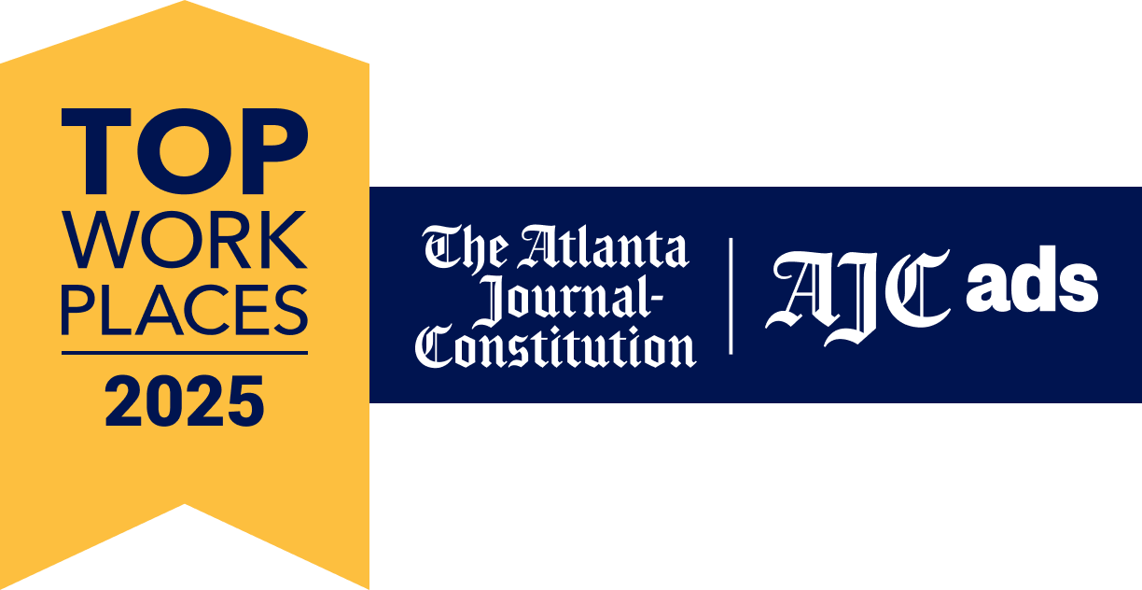

**Mauldin & Jenkins Named A Winner Of The Metro Atlanta Top Workplaces 2025 Award**

**ATLANTA**- Mauldin & Jenkins, a leading assurance, tax and advisory firm, is proud to announce its recognition as a Top Workplaces 2025 honoree by the Atlanta-Journal Constitution. This marks the sixth year in a row the firm has received this award, which is based entirely on [employee feedback](https://www.energage.com/survey/).

The Top Workplaces award is determined through an anonymous third-party survey conducted by employee engagement technology partner Energage LLC. The survey measures various aspects of the employee experience, including how respected and supported employees feel, their opportunities for growth, and their empowerment to do their work effectively.

“We are excited to receive the Top Workplace distinction for the sixth consecutive year,” shared Partner and Atlanta Market Leader Adam Fraley. “It shows that investing in our people and their professional development leads to a thriving workplace for both individuals and the firm.”

Mauldin & Jenkins is committed to fostering a positive work environment, offering policies that prioritize a healthy work-life balance. These include discretionary paid time off (PTO), a flexible 40-hour work week, support for continuing education, and remote work options, to name a few.

Energage CEO, Eric Rubino, noted, “Earning a Top Workplaces award is a badge of honor for companies, especially because it comes authentically from their employees. That's something to be proud of. In today's market, leaders must ensure they’re allowing employees to have a voice and be heard. That's paramount. Top Workplaces do this, and it pays dividends.”

Annually recognized as a "Top 100 Accounting Firm" by *Inside Public Accounting* and *Accounting Today,* Mauldin & Jenkins is one of the nation's fastest-growing CPA firms. In addition to providing accounting and advisory services, the firm is also committed to making a meaningful impact in local communities, engaging in numerous service projects across its 14 locations throughout the year. For more information, please visit [mjcpa.com](http://mjcpa.com).

###

**About Mauldin & Jenkins, LLC**

Mauldin & Jenkins is annually recognized as a Top 100 Certified Public Accounting firm by Inside Public Accounting and Accounting Today and provides assurance, tax and advisory services to clients. Founded in 1918, the Firm serves clients across a wide range of industries, including government, banking, technology, healthcare, construction, manufacturing, not-for-profit, financial services, private client services, and higher education. For additional information, please visit mjcpa.com.