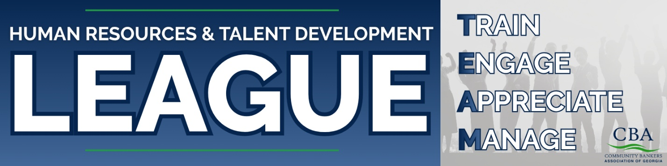
HR Legal Hotline:
*Disclaimer - This Hotline is intended for simple, straightforward questions such as "what is the general law in a particular area?" In the event your question is complex, fact specific, or requests the application of the law to a specific set of circumstances, we may suggest that you seek a legal opinion from independent counsel or engage our firm on a direct basis. ​More in-depth issues (i.e. reviewing or editing an employee handbook, drafting policies, drafting employment agreements, drafting separation agreements, or guiding your bank’s response to an employee lawsuit. . . etc.) will require a formal legal engagement and establishment of a direct attorney-client relationship.

HR Legal Hotline telephone number: 478-336-5525
HR Legal Hotline email address: cbahrhotline@jamesbatesllp.com

