Rates Update
As part of our commitment to keeping our customers informed, I am reaching out to let you know that PG&E’s electric rates prices are changing, effective September 1, 2024. This rate pricing change results in an increase in rates due the implementation of AB 1054 Securitization – Finance Order Three. The details can be found in Advice Letter 7366-E.
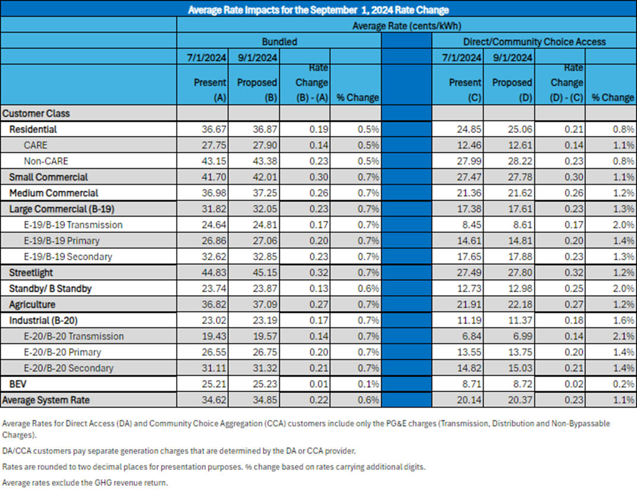
Please remember the forecasted amounts are based on future filings that the CA Public Utilities Commission (CPUC) would need to approve. Based on prior experience there is no guarantee that the amounts will be approved in their entirety.

ELRP
Emergency Load Reduction Program (ELRP)

Get financial incentives for reducing energy use during times of high grid stress and emergencies, with the goal of avoiding rotating power outages through participation in the Emergency Load Reduction Program. This is a five-year pilot program ordered by the California Public Utilities Commission in rulemaking 20-11-003 and administered by PG&E.

This program will run between May and October each year. Events can occur any day of the week between 4-9 p.m. and can last anywhere from 1 to 5 hours. You may be asked to participate on consecutive days if conditions warrant, but you will not be asked to participate for more than 60 hours per year. Also, this program can be automated through an Energy Management System to assist with load reduction. Participating customers will receive a day ahead and/or the day-of notice for the event.

The incentive for this program is $2/kWh for load reduction during program events.

To qualify for this program, you need to be:
- Able to reduce load by at least 1 kW during an event
- Not currently enrolled in the Peak Day Pricing rate plan
- Not currently enrolled in any other demand response program with the exception of PG&E’s Base
Interruptible Program

Your participation in events is voluntary and there is no penalty if you are not able to participate in an event. You will be compensated for your participation.

EV Rates
EV Rates eliminate demand charges and customer charges, instead using a monthly subscription pricing model! Customers choose subscription level based on charging needs.
Subscription charge remains consistent month-to-month
Energy usage is billed based on TOU pricing
- Peak Period: 4pm-9pm
- Off-Peak Period: 9pm-9am and 2pm-4pm
- Super Off-Peak Period: 9am-2pm

Two Rates: BEV1 (Bus. Low Use EV), BEV2(Bus. High Use EV)
BEV1
- Charging Installation up to 100kW
- Subscription in blocks of 10kW
- Smaller workplaces and multifamily sites
- Secondary voltage service
- Small and Medium SA type

BEV2
- 100kW and over
- Subscription blocks of 50kW
- Fleets, fast charging and larger sites
- Secondary and primary voltage services
- Large SA type

Requirements
- Must have Smartmeter or MV90 meter
- Must have Active Energy Alert email on file
- Must have Individually metered charging stations

Electric Vehicles (pge.com)

