Reflection Questions on professional development/ growth / goals

- What do you want? (goals, process, outcomes)

- What’s driving this want? (should, want to, have to)?
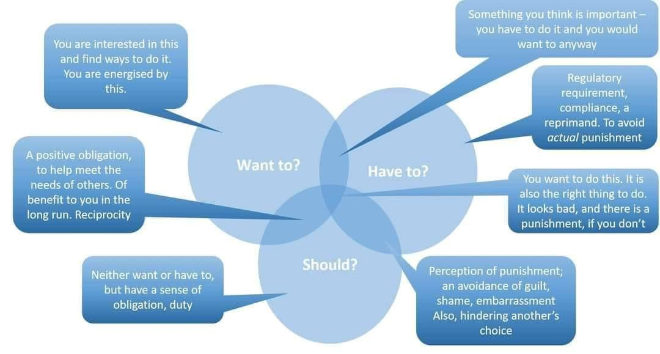

- What is hindering your process towards your goals?
  - Internal obstacles?

  - External obstacles?

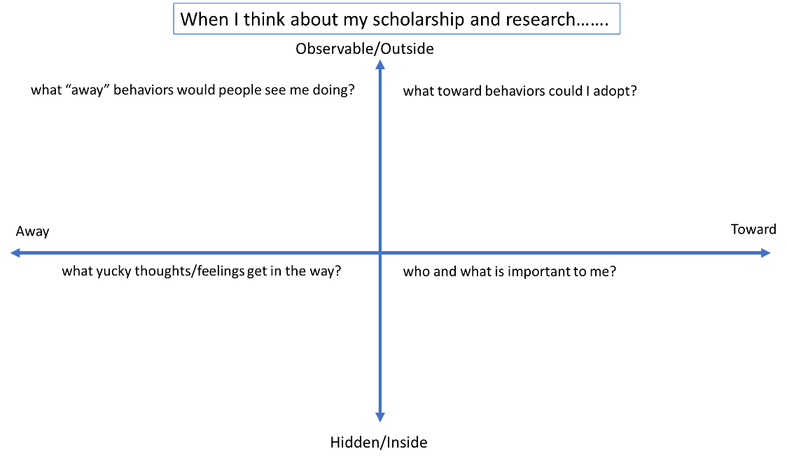

- What supports do you have?

- Can you write a specific goal (SMART goal)?
