RFESIG Executive Committee
Agenda

Date: March 10, 2023
Time Zone: 3:00 pm CT
Location: Zoom Meeting

Time | Topic |  |  |  |  | Purpose | Proponent(s)
3:00 pm | Intro |  |  |  |  | Introduction | All
3:05 pm | Officer Reports  - Chair – Darren Calley  - AOE Updates: Transition in leadership. Academy of Education has taken over fellowship. Webpage will be updated towards end of the year (Nov-Dec)  - CSM 2023: Well attended (60+). Q&A with Kendra and Matt from ABPTRFE and Ryan from RF-PTCAS  - AOE Clinical Instructors SIG Committee request  - Vice Chair – Christina Gomez  - Updates: none  - Membership Secretary – David Nolan: 389 members  - Just in Time Experts/Mentors  - Treasurer Secretary – Kristel Maes  - 2023 SIG Budget $2,500 |  |  |  |  | Update & Discussion | Officers
3:20 pm | Committee Reports  - Nominating Committee Chair – Laura Zajac  - Update on elections/nominations for 2023: April. New positions will be 3 year term  - Communications Chair – Kris Neelon  - Newsletter frequency: 3-4 newsletters  - Communications committee - Cameron Jadali  - Program Committee – Eric Monsch/Ryan Pontiff  - Scholarly Research Chair – Raine Osborne  - Research Collaborative: symposium dates Sep 12th 7-9pm EST and Sat 16th 11-2 EST. Working on marketing. |  |  |  |  | Update | Committee Chairs
3:30 pm | Key Discussion Items  - AOE SIG Committee request: Darren will ask for a blurb and David will send out to members.  - Just in Time Resources  - Mentor videos. Come up with criteria and an outline. Develop a review process.  - Faculty/mentor development  - Free Annual Mentor Training Webinars  - Use of RFESIG Budget Gift cards for members developing mentor videos.  - Collaboration with other residency SIGs: 3 meetings per year scheduled by Darren, Linda takes notes. Hoping to collaborate to not duplicate efforts. Work on list of different SIGs and contacts to post on our webpage. Work on adding link to our webpage on ABPTRFE’s site: might be a conflict of interest. Ask the practice area SIGs to link our info on their page and vice versa. |  |  |  |  | Discussion | Darren
3:45 pm | Upcoming meetings  - Executive Committee Meeting pattern: 2nd Friday of Jan, March, May, July, Sept, Nov @ 3:00 pm CT |  |  |  |  | Discussion | all
Initiatives
- Our one goal: Connecting with the individual practice residency SIGs to see if there is 1 common item we can support them with.
- Just in Time Experts: David will send out a survey to members. Create list of content experts to be posted on the website for members only.
- Mentoring and Education resources
- Think Tank Refresh: Available to non-members. 740 page views last year, not sure % of non-members (see below). Hosted a dozen webinars/podcasts free for all.

Upcoming Dates
Next RFE SIG Executive Committee Meeting: May 12, 2023, 3:00 pm CT
Action items:
Darren to share notes from meetings with Chairs of practice area residency SIGs
Darren to respond to Marisa and include David to request blurb so David can send this out to the members.
Darren to send residency content expert list to David
Come up with criteria and an outline for mentor videos. Develop a review process. Develop an example. Deadline: next meeting
Kris and Christina to reach out to Cameron for development of an example.

RFESIG Roles
- Darren Calley Chair
- Christina Gomez Vice Chair
- Kristel Maes Secretary/Treasurer
- David Nolan Membership Secretary
- Laura Zajac-Cox Nominating Committee Chair
- Casey Unverzagt Nominating Committee
- Kris Neelon Communications Committee Chair
- Eric Monsch & Ryan Pontiff Program Committee Chairs
- Raine Osborne Scholarly Research Committee Chair
Attendance
Darren Calley |  | x | Kristel Maes | x | Laura Zajac-Cox
Christina Gomez |  | x | David Nolan | x | Casey Unverzagt |  |  | NA
Kris Neelon |  | x | Eric Monsch |  | Ryan Pontiff
Raine Osborne
X = Attending; NA = Not Attending

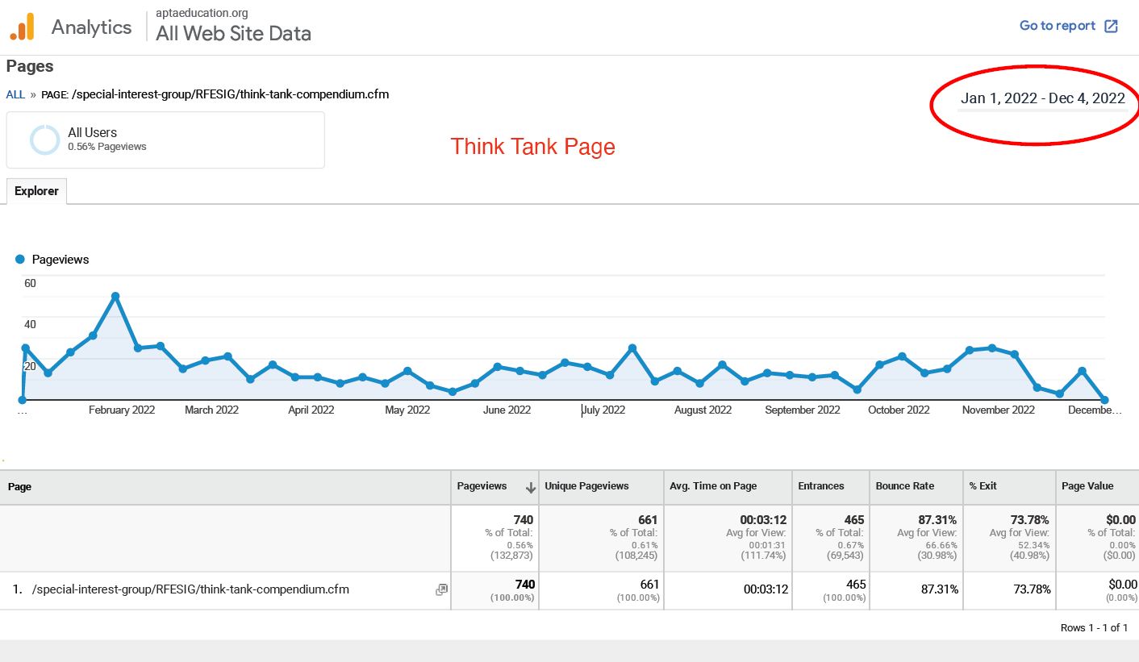

Additionally, below are the definitions that Google Analytics provides for all of the categories:
• Pageviews: Pageviews is the total number of pages viewed. Repeated views of a single page are counted.
• Unique Pageviews: Unique Pageviews is the number of sessions during which the specified page was viewed at least once. A unique pageview is counted for each page URL + page Title combination.
• Avg. Time on Page: The average amount of time users spent viewing a specified page or screen, or set of pages or screens.
• Entrances: Entrances is the number of times visitors entered your site through a specified page or set of pages.
• Bounce Rate: The percentage of single-page sessions in which there was no interaction with the page. A bounced session has a duration of 0 seconds. Learn more
• % Exit: %Exit is (number of exits) / (number of pageviews) for the page or set of pages. It indicates how often users exit from that page or set of pages when they view the page(s)
• Page Value: The average value of this page or set of pages. Page Value is ((Transaction Revenue + Total Goal Value) divided by Unique Pageviews for the page or set of pages)).
March 2023 CSM RFESIG Membership Meeting Responses

