RFESIG Executive Committee
Agenda

Date: February 23, 2023
Time Zone: 1:00 pm CT
Location: CSM San Diego

Time | Topic |  |  |  |  |  | Proponent(s)
3:00 pm | Slides: https://docs.google.com/presentation/d/1cA7F01kLW9hc10MUAQui-fYMuBVL8V7V/edit?usp=sharing&ouid=118415495289374602273&rtpof=true&sd=true |  |  |  |  |  | Darren
3:05 pm | AOE President Reports  Introduction from AOE President and President-Elect |  |  |  |  |  | Pam Levangie  and Chalee Engelhard
3:15 pm | Leadership reports  Chair of Res-Fel Education SIG meets 2-3 times a year with all Chairs of the various SIGs.  Request for better communication between SIGs as to avoid overlap in efforts.  Annual award: please nominate someone you know for 2023, needs to be a SIG member. |  |  |  |  |  | Officers
3:45 pm | ABPTRFE: presentation provided prior to meeting. https://www.dropbox.com/s/beezlkvg4fnrv0d/RFE%20Updates%20CSM%202023.mp4?dl=0  Aware of fellowship difficulties to recruit applicants.  Working on revamping the mentorship webinar/credentialed mentor training development  Can ABPTRFE promote the SIG resources? |  |  |  |  |  | Kendra Harrington  Matt Briggs
 | RF-PTCAS:  New pricing: $165 for 1st application, $65 for each subsequent. Payment at submission of application. Will go up by $5 each year for the next few years.  Residencies and Fellowships are encouraged to identify who they admitted into their program in RF-PTCAS. Going forward the platform will only be closed 2 weeks in September.  Currently not possible to send reminders to programs when an applicant has submitted an application. |  |  |  |  |  | Ryan Bannister
 | RFESIG Research Collaborative  Invitations to join contact list for research collaboration.  Upcoming Residency and Fellowship Research Virtual Symposium Tuesday Sept 5, 2023 7-9 pm ET; and Saturday Sept 9, 2023 11am to 2 pm ET. |  |  |  |  |  | Sara Kraft
 | Open items:  Discussion about how medical model receives funding from Medicare to support residency programs. PT residency-fellowships not approved through CHIA so funding currently not an option.  ChatGPT: https://openai.com/blog/chatgpt/ Concerns on the platforms ability to write letters of reference and giving fake citations.  Time allocated for program director, coordinator, PTO granted |  |  |  |  |  | All
3:30 pm | Poll results:  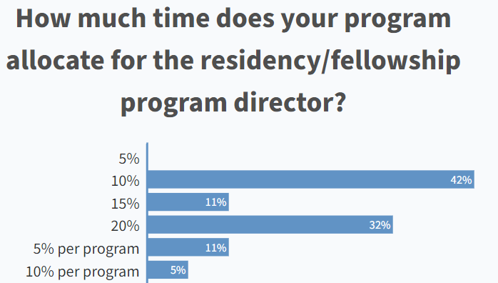  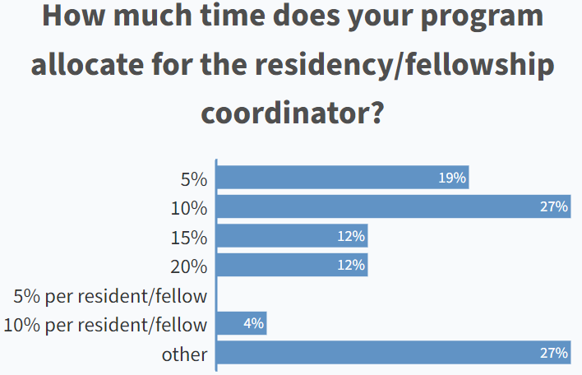  How many days of PTO (vacation days, sick days, holidays, trip days) does your residency/fellowship program grant in a year? 19.2 (4.3); range= 11.6-28; n=24  Ideas for the SIG:  - Development mentor resource videos. Concern was brought up that most mentors are clinicians and do not pay for the Education section so would not have access to these resources.  - Idea to put on a conference focused on residency-fellowship: discussion about making it virtual and maybe offering multiple sessions to maximize participation of clinicians. Get training resources for mentors approved for CEU’s.  - Change med ed website: https://www.ama-assn.org/topics/umegme-coaching . Coaching videos: https://www.youtube.com/playlist?list=PL7ZHBCvG4qsenM7OYXv9uHq6EUupLnWWC |  |  |  |  |  | Darren  All
3:45 pm | Raffle Winners  Jeff O’Laughlin  Stephanie Hessel  *Darren to mail these. |  |  |  |  |  | Darren
Initiatives/Action items
RF-PTCAS will communicate reminders to all Program Directors to identify those they have admitted. Will be posted on Hub.
Meeting decisions
Upcoming Dates
Next RFE SIG Executive Committee Meeting: March 10, 2023, 3:00 pm CT

RFESIG Roles
- Darren Calley Chair
- Christina Gomez Vice Chair
- Kristel Maes Secretary/Treasurer
- David Nolan Membership Secretary
- Laura Zajac-Cox Nominating Committee Chair
- Casey Unverzagt Nominating Committee
- Kris Neelon Communications Committee Chair
- Eric Monsch & Ryan Pontiff Program Committee Chairs
- Raine Osborne Scholarly Research Committee Chair
Attendance
Darren Calley |  | x | Kristel Maes |  | x | Laura Zajac-Cox
Christina Gomez |  |  | David Nolan |  | x | Casey Unverzagt
Kris Neelon |  | x | Eric Monsch |  |  | Ryan Pontiff
Raine Osborne |  |  | 60 members |  | x
X = Attending; NA = Not Attending

