**RFESIG Executive Committee**

**Agenda**

**Date: March 8, 2024**

**Time Zone: 3:00 pm CT**

**Location: Zoom Meeting**

|  |  |  |  |  |  |  |  |  |
| --- | --- | --- | --- | --- | --- | --- | --- | --- |
| **Time** | **Topic** | | | | | **Purpose** | **Proponent(s)** | |
| 3:00 pm | Welcome | | | | | Introduction | All | |
| 3:05 pm | Officer Reports   * Chair – Darren Calley   + CSM 2024 meeting recap: around 35 in attendance for meeting, see comments from poll at bottom of meeting notes   + Committee prefers morning or lunch for future meetings at ELC/CSM   + Discussion on recruiting efforts for residency-fellowship programs. Idea to make short videos from former residents-fellows who state why they did a residency-fellowship. Other idea of educational session with a panel of current and former residents at CSM and student conclaves or work with consortium where DCEs are well represented.   **Thursday 2/15/24**   * + 12-1 pm ON-19175 **Oncology** Residency SIG Meeting     - Darren Calley visited   + 6-8 pm ED-19187 **RFESIG** Business Meeting Academy of Education   **Friday 2/16/24**   * + 6:30-7:30 am **Neurology** NE-19019 Residency Breakfast     - Darren Calley visited   + 12-1 pm AC-19123 **Acute Care** Residency/Fellowship SIG     - Martha Bloyer visited: 50 people in attendance   + 1-1:50 pm SP-19236 **Sports** Specialization SIG Business Mtg     - Dave Nolan visited   + 1:30-2:30 pm OR-19288 **Orthopaedics** ORF-SIG Mtg     - Raine Osborne visited * Vice Chair – Dave Nolan   + Mentor Videos updates * Membership Secretary – Martha Bloyer   + Membership update: 337 * Treasurer Secretary – Kristel Maes   + 2024 Budget updates: $539/2500 spent for CSM 2024 budget. 10 gift certificates left at $50 each, 4 at $200 each. Only valid for 1 year. | | | | | Update & Discussion | Officers | |
| 3:20 pm | Committee Reports   * Nominating Committee Chair – Casey Unverzagt   + Updates 2024 election cycle: none at CSM. Elections starting in April. * Communications Chair – Kris Neelon   + Plans for next communication * Program Committee   + Laura Zajac-Cox (ELC)   + Christina Bentrewicz (CSM)     - ELC & CSM education submission due dates * Scholarly Research Chair – Raine Osborne   + Residency Fellowship Research Updates | | | | | Update | Committee Chairs | |
| 3:30 pm | Discussion Items   * Website ongoing updates   + Adding RF Specialty SIG Chairs to our website   + Website content Residency Resources editing plan * Mentor Training videos – [google document outline](https://docs.google.com/document/d/1y_L1HqlrcnGl2p-6a1zmdMBISnNNm0YCMthUZ5uVnXs/edit?usp=sharing) * Education content: Kristel developing resource for PDs | | | | | Discussion | all | |
| 3:50 pm | Upcoming meetings   * Executive Committee Meeting pattern: 2nd Friday of Jan, March, May, July, Sept, Nov @ 3:00 pm CT | | | | | Update | all | |
| **Initiatives** | | | | | | | | |
| * Collaboration & Networking with ResFel SIGs   + The RFESIG is engaged in connecting other residency and fellowship education SIGs and leaders by collaborating on projects, sharing resources, providing networking opportunities, and creating innovative strategies to promote excellence in RFE. * Mentoring and Education resources & videos   + The Collaborative Initiatives Among and Residency & Fellowship SIGs seeks to provide faculty and mentor development resources and build connections to support residency and fellowship SIG's * Research Collaborative * Rebranding Residency & Fellowship Resources | | | | | | | | |
| **Upcoming Dates** | | | | | | | | |
| **Next RFE SIG Executive Committee Meeting: Friday, May 10, 2024, 3:00 pm CT** | | | | | | | | |
| **Action items** | | | | | | | | |
| * **Darren to reach out to Kendra to see where they are with working on a packet for PT programs** * **Kristel, Martha and Christina will put proposal together for micro-session for ELC to promote residency training** * **Add names of SIG leaders and links to their sites on our website** * **Kris to send an email out to membership to recruit mentor videos and send out via hub** * **ALL: reach out to Christina if you want to be a reviewer for ELC and CSM submissions** * **Kristel to review website and ask items where there is no data to be removed** | | | | | | | | |
| **RFESIG Roles** | | | | | | | | |
| * Darren Calley Chair * David Nolan Vice Chair * Kristel Maes Secretary/Treasurer * Martha Bloyer Membership Secretary * Casey Unverzagt Nominating Committee Chair * Kristina Stein Nominating Committee * Kris Neelon Communications Committee Chair * Laura Zajac-Cox & Christina Bentrewicz Program Committee Chairs * Raine Osborne Scholarly Research Committee Chair | | | | | | | | |
| **Attendance** | | | | | | | | |
| Darren Calley | | x | Kris Neelon |  | Kristina Stein | | | x |
| Martha Bloyer | | x | Eric Monsch |  | Casey Unverzagt | | | x |
| Kristel Maes | | x | Raine Osborne |  | Laura Zajac-Cox | | |  |
| Dave Nolan | |  | Ryan Pontiff |  | Christina Bentrewicz | | | x |

X = Attending; NA = Not Attending

**2023-2024 RFESIG Goals**

|  |  |  |  |  |  |
| --- | --- | --- | --- | --- | --- |
| **AoE SIG** | **Board Position Goals** | **Strategic Plan Goal Being Addressed (Name and Letter)** | **Time Frame for Meeting Goal** | **Catalyst(s) to Achieving Goals** | **Barrier(s) to Achieving Goals** |
| RFESIG | Implement Residency/fellowship symposium. Take information from symposium to formulate research groups, plans, metrics. | Elevate AB; Lead A | 12 months | Symposium planning group; RFESIG leadership; connect with scholarship goal Scholarship of Education | Coordination and communication; follow-up action steps. |
| RFESIG | Add mentor training videos, rebrand THINK TANK, curate web-site content | Lead B; Advance B & C | 12 months | Residency & Fellowship Specialty SIG leaders; RFESIG leaders | Development of and vetting mentor video content. Defining new content branding. Disseminating, communication updates to members. |

**Academy Goals: 2022-2024**

**ADVANCE: Inspiring physical therapists and physical therapist assistants in their roles as educators.**

* A. Pathways – Creating pathways to inspire emerging educators.
* B. Advancing – Developing professionals through contemporary educational opportunities using innovative and accessible methods.
* C. Sharing - Disseminate best practices and resources to physical therapy educators.

**CONNECT: Leading physical therapy education through organizational collaboration and member engagement.**

* A. Partnerships - Create and strengthen interactive partnerships among education stakeholders.
* B. Members - Increase member involvement in the Academy to promote a diverse and inclusive environment.
* C. Representation - Ensure strategic representation of the Academy in every relevant forum

**ELEVATE: Elevating the profession by furthering physical therapy educational research.**

* A. Research Agenda – Prioritize research based on the gaps in evidence to support best practices in teaching and learning in physical therapy education.
* B. Collaboration – Support the development and collaboration of education researchers.
* C. Strengthen – Strengthen education research initiatives.

**LEAD: Exhibiting strong leadership to advance the Academy.**

* A. Members - Engage members to contribute to achieving the vision of the Academy.
* B. Communications – Maintain a strong Academy presence through branding, clear messaging, publications, and visibility.
* C. Leadership and Management – Maintain excellence in governance and management with a dedicated team and pipeline of future leaders.
* D. Resources – Supplement revenue streams to advance the mission and serve the membership.

**CSM 2024 Boston RFESIG Member Meeting Poll Questions**

Which state are you joining us from (n=25)?

Rank order any of your PT residency programs that are experiencing a shortage of applicants (n=7):

1. Neurology (3.6)
2. Orthopaedics (2.6)
3. Geriatrics (2.3)
4. Acute Care (2.1)

Are any of your PT fellowship programs experiencing a shortage of applicants (n=7):

* Faculty residency
* NICU fellowship

Do your residency/fellowship programs use RFPTCAS (n=21)?

* All our programs use RFPTCAS (90%)
* Some of our programs use RFPTCAS (10%)

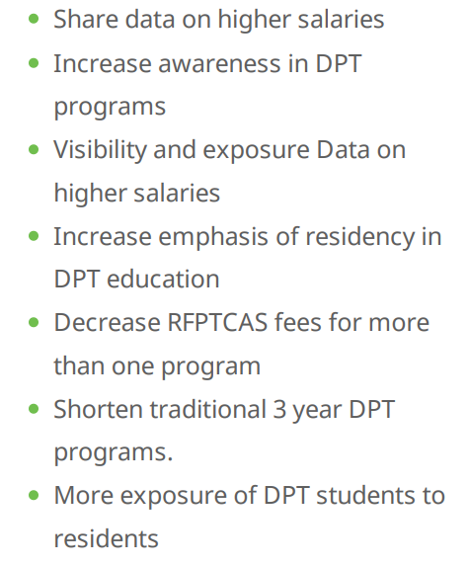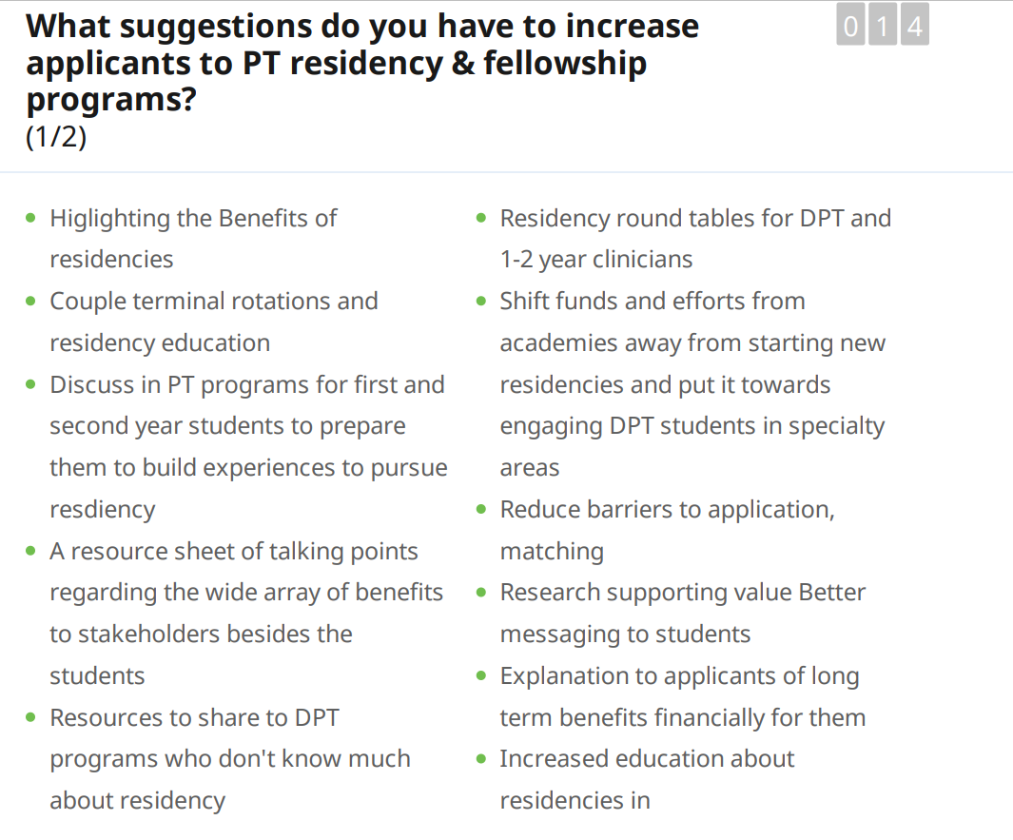

**Questions About Future ELC/CSM Planning**

