RFESIG Leadership Meeting
Minutes

Date: July 10, 2026
Time Zone: 3:00 pm CT
Location: Zoom Meeting
Time | Topic |  |  |  |  | Purpose | Proponent(s)
3:00 pm | Welcome  Introduce new nominating committee member Victoria Wilson Harris |  |  |  |  | Introduction | All
3:05 pm | Officer Reports  - Chair – Darren Calley  - Academy of Education (AoE) updates  - Excellence in Education Certificate progress  - Discussed APTA/AoE changes to CSM, including fiscal impact and SIG meeting opportunities. The RFESIG might consider holding a virtual SIG meeting instead of in-person CSM meeting (held in mid-March or pre-CSM, November/December to increase CSM awareness/ excitement)  - Feedback from 2026 RFESIG CSM meeting on Recruitment strategies (Slido poll)  - Discussion about Residency Value Tool Kit. Raine Osborne is leading a study gathering data around this topic and as part of the grant, is planning to develop a residency value tool kit. Raine thinks this could be a collaborative effort. He will visit with research team, and if in agreement, will reach out to Post-Professional Council to create a small group of individuals from RFESIG and other specialty areas to help give input to the tool. Also discussed getting social media marketing to students.  - Vice Chair – Dave Nolan  - Resident/Fellow/Student RFESIG Workgroup updates – plan to discuss updates at September meeting  - Membership Secretary – Martha Bloyer  - Membership updates  - Treasurer Secretary – Kristel Maes  - 2026 budget: CSM food $1,780  - Remaining 2026 budget: $720  - Earmark $25 to cover cost of resident workgroup liaison AoE membership in year 1 |  |  |  |  | Update & Discussion | Officers
3:30 pm | Committee Reports & Discussion  - Nominating Committee Chair – Caitlyn Lang  Open RFESIG Appointed Positions  - Communications Committee Chair  - Program Committee Chairs  - Create a flyer with these open positions – Darren to create. Ask Martha to share with RFESIG members.  - Communications  - Edusphere Online Community Engagement  - Everyone reminded about this communication tool, encouraged utilization.  - RFESIG Student & Resident Workgroup  - Create 1-2 student/resident liaison positions  - Dave & Martha serve as RFESIG Liaison Leaders  - Purpose statement: “This workgroup partners with RFESIG leadership to bridge the gap between student training and residency. It develops practical, trainee-informed resources that highlight the value of residency and fellowship as career pathways. By incorporating student and resident perspectives, the group increases interest in advanced training and equips peers with the tools and guidance to confidently navigate the application process.”  - Tasks:  - Create meaningful residency/fellowship content  - Build interest in the RFESIG & residencies  - Where are discussions happening? – Social Media  - Create description of responsibilities  - Attend RFESIG meetings 6 per year  - Potential staffing at PT Residency Booth at CSM  - Two year role for student, 1 year role for resident  - Cover the cost of resident’s Academy of Education membership in 1st year ($25). This should be free in future years.  - Scholarly Research Chair – Raine Osborne  - Future 2026 dates (2nd Tuesday): Raine has reached out to authors for these 2026 dates.  - Sept 8, 2026 – planning  - Dec 8, 2026 – planning  - Program Committee  - ELC Oct 16-18, 2026 Washington DC  - In-person ELC RFESIG meeting Friday 10/16/26 5:30-7 pm (time not yet confirmed)  - Christina Bentrewicz (CSM) – Feb 4-6, 2027 Philadelphia PA |  |  |  |  | Update | Committee Chairs
3:40 pm | Ongoing Items  - RFESIG Community Discussion board  - Develop content for students/residents:  - Road to Residency guide  - Why residency?  - How to prepare a competitive application  - Pathway to clinical education or academic teaching  - Road to Fellowship guide  - Collaborate with other residency/fellowship SIGs |  |  |  |  | Discussion | all
 | Upcoming meetings  - RFESIG Leadership Meeting pattern: 2nd Friday of Jan, March, May, July, Sept, Nov @ 3:00 pm CT |  |  |  |  | Information | all
Initiatives
- Collaboration & Networking with ResFel SIGs
  - The RFESIG is engaged in connecting other residency and fellowship education SIGs and leaders through the APTA Post-Professional Education Workgroup, including collaborating on projects, sharing resources, and creating innovative strategies to promote excellence in RFE.
- Mentoring, Recruiting, and Education resources
  - The collaborative initiatives among and Residency & Fellowship SIGs strive to provide faculty and mentor development resources and support recruitment and excellence in residency and fellowship education.
- RF Research Collaborative – ongoing research projects and RFESIG Journal Clubs
Action items and Upcoming Dates
Action items:
- Next RFESIG Executive Committee Meeting: Friday, September 11th, 2026 3:00 pm CT

RFESIG Roles
- Darren Calley Chair
- David Nolan Vice Chair
- Kristel Maes Secretary/Treasurer
- Martha Bloyer Membership Secretary
- Caitlyn Lang Nominating Committee Chair
- Jodie Rush Nominating Committee
- Victoria Wilson Harris Nominating Committee
- Kris Neelon Communications Committee Chair
- Laura Zajac-Cox & Christina Bentrewicz Program Committee Chairs
- Raine Osborne Scholarly Research Committee Chair
Attendance
Darren Calley |  |  | Kristel Maes |  | Jodie Rush
Christina Bentrewicz |  |  | Kris Neelon |  | Victoria Wilson Harris
Martha Bloyer |  |  | Dave Nolan |  | Laura Zajac-Cox
Caitlyn Lang |  |  | Raine Osborne
X = Attending; NA = Not Attending

RFESIG Membership Meeting Recruitment Slido Poll Question at 2026 CSM - Anaheim
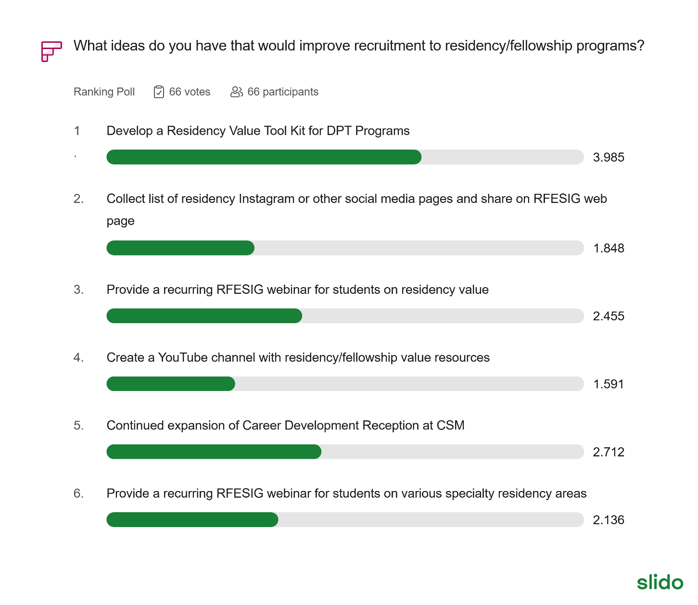
2026 RFESIG Goals
AoE SIG | Board Position Goals | Strategic Plan Goal Being Addressed (Name and Letter) | Time Frame for Meeting Goal | Catalyst(s) to Achieving Goals | Barrier(s) to Achieving Goals
RFESIG | Further develop research groups, plans, created from Residency/fellowship symposium. | Elevate AB; Lead A | 12 months | Symposium planning group; RFESIG leadership; connect with scholarship goal Scholarship of Education | Coordination and communication; follow-up action steps.
RFESIG | Futher curate web-site content, focus on recruitment, mentor training, educator training. | Lead B; Advance B & C | 12 months | Residency & Fellowship Specialty SIG leaders; RFESIG leaders | Development of and vetting recruitment and mentor training content. Disseminating, communication updates to members.

Academy of Education Goals
ADVANCE: Inspiring physical therapists and physical therapist assistants in their roles as educators.
- A. Pathways – Creating pathways to inspire emerging educators.
- B. Advancing – Developing professionals through contemporary educational opportunities using innovative and accessible methods.
- C. Sharing - Disseminate best practices and resources to physical therapy educators.
CONNECT: Leading physical therapy education through organizational collaboration and member engagement.
- A. Partnerships - Create and strengthen interactive partnerships among education stakeholders.
- B. Members - Increase member involvement in the Academy to promote a diverse and inclusive environment.
- C. Representation - Ensure strategic representation of the Academy in every relevant forum
ELEVATE: Elevating the profession by furthering physical therapy educational research.
- A. Research Agenda – Prioritize research based on the gaps in evidence to support best practices in teaching and learning in physical therapy education.
- B. Collaboration – Support the development and collaboration of education researchers.
- C. Strengthen – Strengthen education research initiatives.
LEAD: Exhibiting strong leadership to advance the Academy.
- A. Members - Engage members to contribute to achieving the vision of the Academy.
- B. Communications – Maintain a strong Academy presence through branding, clear messaging, publications, and visibility.
- C. Leadership and Management – Maintain excellence in governance and management with a dedicated team and pipeline of future leaders.
- D. Resources – Supplement revenue streams to advance the mission and serve the membership.

