RFESIG Leadership Meeting
Minutes

Date: May 8, 2026
Time Zone: 3:00 pm CT
Location: Zoom Meeting
Time | Topic |  |  |  |  | Purpose | Proponent(s)
3:00 pm | Welcome |  |  |  |  | Introduction | All
3:05 pm | Officer Reports  - Chair – Darren Calley  - 4/16/26 Post-Professional Council meeting  - APTA’s Residency and Fellowship Career Development Reception @ CSM will continue in 2027  - Requested RFPTCAS share specialty specific data at set intervals  - 9/15/26 is 2026 RFPTCAS application open date  - Recommended holding a residency/fellowship booth or student village area at CSM  - Recommended ABPTRFE/APTA provide guidance to programs on appropriate AI use  - Discussion clarifying residency/fellowship roles & process decisions  - Academy of Education BoD discussed how to include students/residents into the AoE & SIGs  - Resident/Fellow/Student RFESIG Liaison Positions  - Thanks to outgoing Nominating Committee Chair Kristina Stein for RFESIG service.  - Vice Chair – Dave Nolan  - Discussed providing a $500 gift certificate for Distinguished Mentor in Residency/Fellowship Education Award on an annual basis. Action approved.  - Membership Secretary – Martha Bloyer  - Membership updates  - Treasurer Secretary – Kristel Maes  - 2026 budget: CSM food $1,780  - Remaining 2026 budget: $720  - Need to earmark $100 out of the 2026 budget to pair with current gift certificates for Distinguished Mentor in Residency/Fellowship Education Award.  - May need to earmark cost for resident liaison AoE membership. |  |  |  |  | Update & Discussion | Officers
3:30 pm | Committee Reports & Discussion  - Nominating Committee Chair – Kristina Stein  Newly Elected Positions 2026  - Nominating Committee – Victoria Wilson  - Vice Chair – Dave Nolan  Outgoing 2026 Positions  - Nominating Committee Chair – Kristina Stein – Thank you!  - Communications Chair – Kris Neelon  - Edusphere Online Community Engagement  - S: Concern that the Online Community is not being used enough use to justify cost.  - B: Currently used as a calendar, not enough discussion. Recommendations from AoE that each SIG have 1 person responsible for posting monthly.  - Could ask questions from experts in the field  - Weekly monthly tip  - Member spotlight  - Program spotlight  - Polls yes/no  - Event attendance  - Stories/quotes  - Trivia contest with a prize  - A: Discussed barriers and challenges. Need to give dedicated effort to intentionally increase use in the next 3 months.  - R: Create plan to increase RFESIG use. RFESIG leadership to consider ways to post regularly.  - RFESIG Student & Resident Workgroup  - Create 1-2 student/resident liaison positions  - Dave & Martha serve as RFESIG Liaison Leaders  - Purpose statement: “This workgroup partners with RFESIG leadership to bridge the gap between student training and residency. It develops practical, trainee-informed resources that highlight the value of residency and fellowship as career pathways. By incorporating student and resident perspectives, the group increases interest in advanced training and equips peers with the tools and guidance to confidently navigate the application process.”  - Workgroup tasks:  - Create meaningful residency/fellowship content  - Build interest in the RFESIG & residencies  - Where are discussions happening? – Social Media communication?  - Next steps:  - Create description of responsibilities  - Create form for applications to the liaison positions  - Liaisons should attend the 6 RFESIG leadership meetings (part of the meeting).  - Potentially could be asked to help staff PT Residency Booth at CSM  - Two-year role for students  - RFESIG will cover the cost of resident’s Academy of Education membership in 1st year ($25). This should be free in future years, beginning 2027.  - Scholarly Research Chair – Raine Osborne  - Future 2026 dates (2nd Tuesday):  - Need to do better with advertising.  - June 9, 2026 – cancelled  - Sept 8, 2026 – planning  - Raine seeking recommendations for authors/speakers at these journal clubs. Send suggestions to Raine (all).  - Dec 8, 2026  - Foundations study going well.  - Number of other projects going well.  - Program Committee  - Laura Zajac-Cox (ELC) – Oct 16-18, 2026 Washington DC  - Christina Bentrewicz (CSM) – Feb 4-6, 2027 Philadelphia PA |  |  |  |  | Update | Committee Chairs
3:40 pm | Ongoing Items  - RFESIG Community Discussion board  - Develop content for students/residents:  - Road to Residency guide  - Why residency?  - How to prepare a competitive application  - Pathway to clinical education or academic teaching  - Road to Fellowship guide  - Collaborate with other residency/fellowship SIGs – Postprofessional Council Participation |  |  |  |  | Discussion | all
 | Upcoming meetings  - RFESIG Leadership Meeting pattern: 2nd Friday of Jan, March, May, July, Sept, Nov @ 3:00 pm CT |  |  |  |  | Information | all
Initiatives
- Collaboration & Networking with ResFel SIGs
  - The RFESIG is engaged in connecting other residency and fellowship education SIGs and leaders by collaborating on projects, sharing resources, providing networking opportunities, and creating innovative strategies to promote excellence in RFE.
- Mentoring, Recruiting, and Education resources & videos
  - The collaborative initiatives among and Residency & Fellowship SIGs strive to provide faculty and mentor development resources and build connections to support residency and fellowship SIG's
- RF Research Collaborative – ongoing research projects
Action items and Upcoming Dates
Action items:
- All RFESIG leaders to use suggestions above to post regularly/monthly on Online Community.
- All – send suggestions to Raine Osborne for presenters for September and December RFESIG journal clubs
- Dave/Martha – further develop RFESIG Student/Resident liaison roles, create application process.
- Krissy Stein to make hand off with Caitlyn Lang for Nominating Committee Chair

Next RFESIG Executive Committee Meeting: Friday, July 10th, 2026 3:00 pm CT

RFESIG Roles
- Darren Calley Chair
- David Nolan Vice Chair
- Kristel Maes Secretary/Treasurer
- Martha Bloyer Membership Secretary
- Kristina Stein Nominating Committee Chair
- Caitlyn Lang Nominating Committee
- Jodie Rush Nominating Committee
- Kris Neelon Communications Committee Chair
- Laura Zajac-Cox & Christina Bentrewicz Program Committee Chairs
- Raine Osborne Scholarly Research Committee Chair
Attendance
Darren Calley |  | x | Kristel Maes |  | Jodie Rush |  |  | x
Christina Bentrewicz |  |  | Kris Neelon |  | Kristina Stein |  |  | x
Martha Bloyer |  |  | Dave Nolan | x | Laura Zajac-Cox
Caitlyn Lang |  | x | Raine Osborne | x
X = Attending; NA = Not Attending

RFESIG Membership Meeting Slido Poll Questions at 2026 CSM - Anaheim

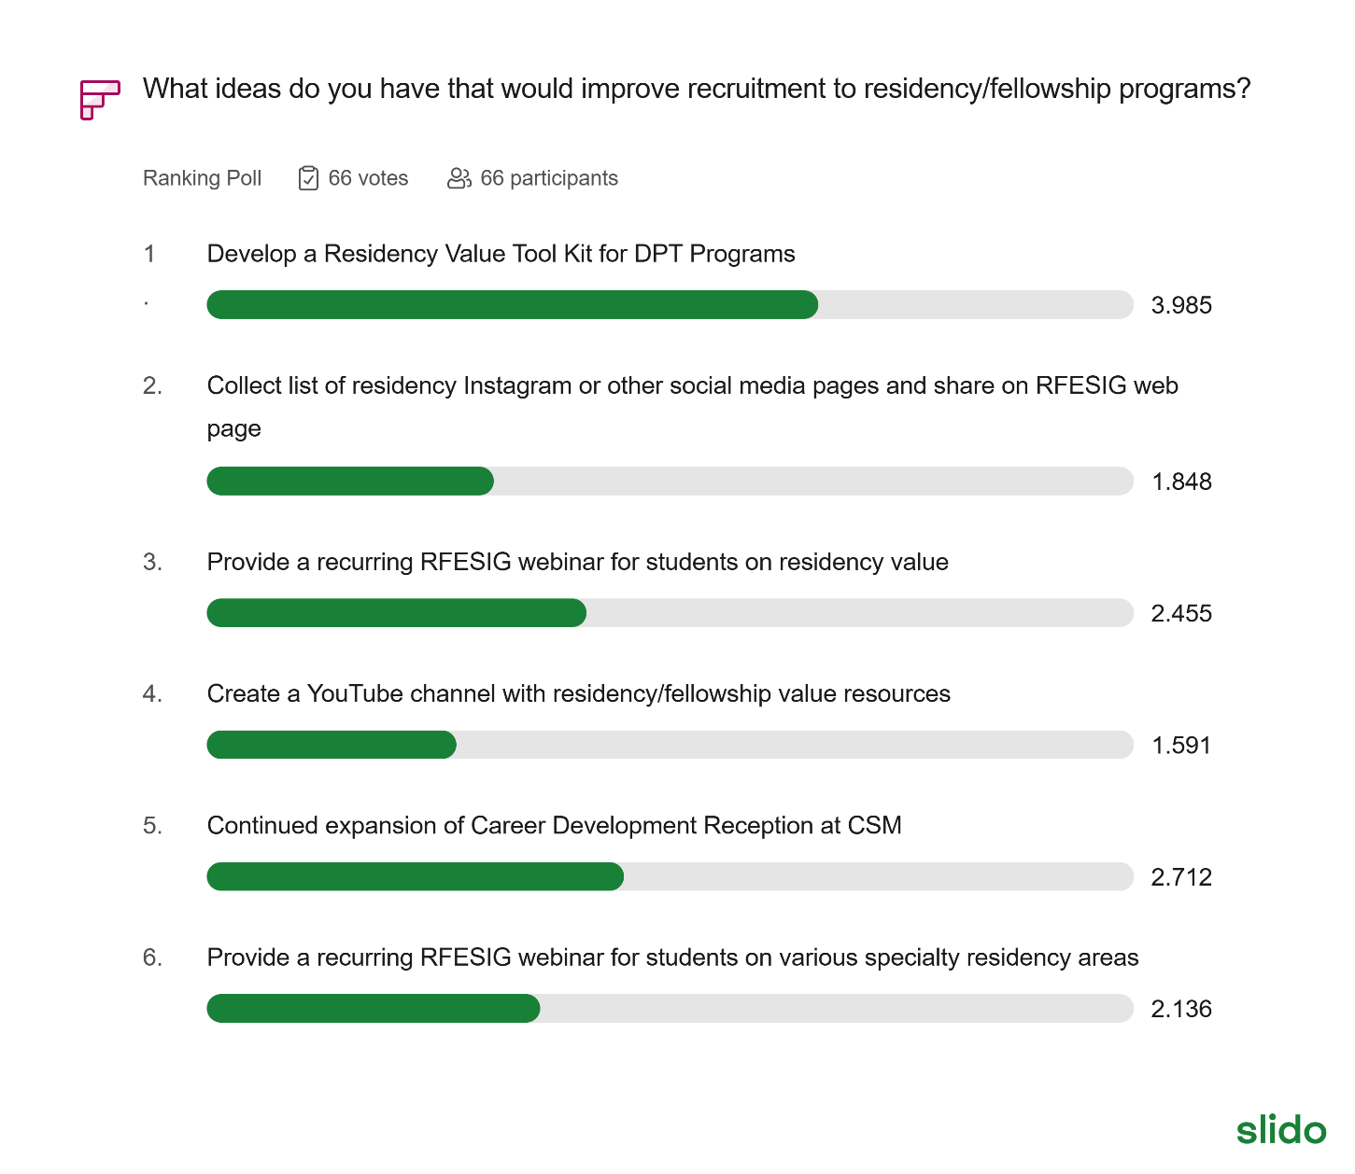

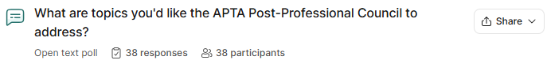

1. Recruitment & Marketing Strategy
This is the most prominent theme, with respondents seeking more aggressive and polished ways to attract DPT students to residency programs.
- Targeted Outreach: Getting in front of 2nd and 3rd-year DPT students to introduce residency early.
- Media & Content: Creating videos of recent graduates to showcase the value of residency and utilizing an "intro to residency" video to filter applicants before events like CSM.
- Unified Messaging: Collaborating with DPT programs to ensure consistent messaging and clear distinctions between the residency and fellowship continuum.

2. Standardization & Administrative Support
Many participants expressed a desire for a more streamlined, less fragmented experience for both programs and applicants.
- Admissions Reform: Suggestions include a "match" system for all specialty areas and a more standardized application/admissions process.
- Streamlining Accreditation: Simplifying annual reporting, accreditation processes, and form/assessment sharing.
- Consistent Quality: Developing a "best practices" framework for curriculum development and residency education consistency.

3. Resource Sharing & Development
There is a clear call for a centralized hub of information to help programs improve their offerings.
- Educational Repository: Compiling resources for mentoring development, lectures, and faculty modules.
- Peer-to-Peer Learning: Knowing what specific programs are doing well to allow for better resource sharing across institutions.
- Advocacy Groups: Creating a council of residency graduates to advocate for these programs and the profession.

4. Financial & Professional Incentives
Participants highlighted the need to address the "ROI" of residencies to remain competitive.
- Compensation: Quantifying program value and advocating for "PT equivalent" salaries for residents to attract higher-quality applicants.
- Funding: Finding funding opportunities for faculty seeking specialist certifications when institutional support is lacking.
- Specialty Growth: Specific mentions of addressing the Acute Care board certification and exam.

2026 RFESIG Goals
AoE SIG | Board Position Goals | Strategic Plan Goal Being Addressed (Name and Letter) | Time Frame for Meeting Goal | Catalyst(s) to Achieving Goals | Barrier(s) to Achieving Goals
RFESIG | Further develop research groups, plans, created from Residency/fellowship symposium. | Elevate AB; Lead A | 12 months | Symposium planning group; RFESIG leadership; connect with scholarship goal Scholarship of Education | Coordination and communication; follow-up action steps.
RFESIG | Futher curate web-site content, focus on recruitment, mentor training, educator training. | Lead B; Advance B & C | 12 months | Residency & Fellowship Specialty SIG leaders; RFESIG leaders | Development of and vetting recruitment and mentor training content. Disseminating, communication updates to members.

Academy of Education Goals
ADVANCE: Inspiring physical therapists and physical therapist assistants in their roles as educators.
- A. Pathways – Creating pathways to inspire emerging educators.
- B. Advancing – Developing professionals through contemporary educational opportunities using innovative and accessible methods.
- C. Sharing - Disseminate best practices and resources to physical therapy educators.
CONNECT: Leading physical therapy education through organizational collaboration and member engagement.
- A. Partnerships - Create and strengthen interactive partnerships among education stakeholders.
- B. Members - Increase member involvement in the Academy to promote a diverse and inclusive environment.
- C. Representation - Ensure strategic representation of the Academy in every relevant forum
ELEVATE: Elevating the profession by furthering physical therapy educational research.
- A. Research Agenda – Prioritize research based on the gaps in evidence to support best practices in teaching and learning in physical therapy education.
- B. Collaboration – Support the development and collaboration of education researchers.
- C. Strengthen – Strengthen education research initiatives.
LEAD: Exhibiting strong leadership to advance the Academy.
- A. Members - Engage members to contribute to achieving the vision of the Academy.
- B. Communications – Maintain a strong Academy presence through branding, clear messaging, publications, and visibility.
- C. Leadership and Management – Maintain excellence in governance and management with a dedicated team and pipeline of future leaders.
- D. Resources – Supplement revenue streams to advance the mission and serve the membership.

