RFESIG Leadership Meeting
Minutes

Date: March 13, 2026
Time Zone: 3:00 pm CT
Location: Zoom Meeting
Time | Topic |  |  |  |  | Purpose | Proponent(s)
3:00 pm | Welcome |  |  |  |  | Introduction | All
3:05 pm | Officer Reports  - Chair – Darren Calley  - CSM 2026 RFESIG Meeting 2/12/26  - 80 attended  - 10 gift cards raffled. Successful APTA residency Fair held.  - Meredith Chaput received Distinguished Mentor in Residency/Fellowship Education Award ($500 gift card)  - Survey completed during end of CSM 2026 RFESIG membership meeting  - Survey results at end of these minutes.  - Discussed timing of future RFESIG Meetings at CSM.  - Contact AoE to include R/F content at ELC in AoE newsletter – need improved advertising of R/F content.  - RF Fair at CSM a huge hit – encouraged to continue.  - Suggestion to create a virtual journal where R/F content could be stored – long term goal, need sponsors.  - Proposal from APTA Orthopedic to co-sponsor with AoE RFESIG a pre-con residency course for CSM 2027. Recommended to pursue co-sponsoring this pre-con, will want to include other specialty residencies.  - Suggestion for Post-Professional Council to consider creating a residency/fellowship booth at CSM  RFESIG leadership supports pursuing this idea.  - Resident/Fellow/Student RFESIG Liaison Positions  - Create Liaison roles to work with RFESIG member  - Focus on sharing resources how to be a strong applicant, why residency/fellowship, post-residency career pathways.  - Student/resident AoE membership cost should be free, however, AoE website currently showing there is a cost. Darren to check with AoE.  - Once approved, ask the Vice Chair & Membership Secretary to take RFESIG Liaison role.  - Martha created and shared rubric for application and position. Action item: leadership to review, seeking feedback/edits.  - Consider selecting two DPT students, or 1 DPT student and 1 resident for these Liaison positions.  - Need to clearly define the purpose of these roles.  - Will discuss at our next RFESIG meeting.  - Vice Chair – Dave Nolan  - Membership Secretary – Martha Bloyer  - Membership updates – decrease in RFESIG members listed in AoE reports, Martha will compare with AoE Communities.  - Treasurer Secretary – Kristel Maes  - 2026 budget: CSM food $1,780  - Remaining 2026 budget: $720 |  |  |  |  | Update & Discussion | Officers
3:30 pm | Committee Reports  - Nominating Committee Chair – Kristina Stein  Nominations slated for 2026:  - Vice Chair – Dave Nolan  - Nominating Committee  - Victoria Wilson  - Coral Gubler  - Carrie Schwoerer  - Communications Chair – Kris Neelon  - Program Committee  - Laura Zajac-Cox (ELC) –  - Christina Bentrewicz (CSM) –  - Scholarly Research Chair – Raine Osborne  - RFESIG Journal Club Webinar – March 10, 2026 8 pm ET Impact of PT Postprofessional Education Programs on Productivity - John DeWitt. Excellent content presented at this, recorded for future use.  - Need to use APTA Learning Center to Login – Darren to check about easier sign on and calender invite once registered.  - Future 2026 dates (2nd Tuesday):  - June 9, 2026  - Sept 8, 2026  - Dec 8, 2026  - Pre-con CSM or ELC for Symposium 2027 |  |  |  |  | Update | Committee Chairs
3:40 pm | Ongoing Items  - RFESIG Community Discussion board  - Recruiting resources – RFESIG website  - RFPTCAS Winter Newsletter email 3/6/26  - Develop content for students/residents:  - Why residency  - How to prepare a competitive application  - Pathway to clinical education or academic teaching  - Preparation for a fellowship  - Collaborate with other residency/fellowship SIGs |  |  |  |  | Discussion | all
 | Upcoming meetings  - RFESIG Leadership Meeting pattern: 2nd Friday of Jan, March, May, July, Sept, Nov @ 3:00 pm CT |  |  |  |  | Information | all
Initiatives
- Collaboration & Networking with ResFel SIGs
  - The RFESIG is engaged in connecting other residency and fellowship education SIGs and leaders by collaborating on projects, sharing resources, providing networking opportunities, and creating innovative strategies to promote excellence in RFE.
- Mentoring, Recruiting, and Education resources & videos
  - The collaborative initiatives among and Residency & Fellowship SIGs strive to provide faculty and mentor development resources and build connections to support residency and fellowship SIG's
- RF Research Collaborative – ongoing research projects
Action items and Upcoming Dates
Action items:

Next RFESIG Executive Committee Meeting: Friday, May 8th, 2026 3:00 pm CT

RFESIG Roles
- Darren Calley Chair
- David Nolan Vice Chair
- Kristel Maes Secretary/Treasurer
- Martha Bloyer Membership Secretary
- Kristina Stein Nominating Committee Chair
- Caitlyn Lang Nominating Committee
- Jodie Rush Nominating Committee
- Kris Neelon Communications Committee Chair
- Laura Zajac-Cox & Christina Bentrewicz Program Committee Chairs
- Raine Osborne Scholarly Research Committee Chair
Attendance
Darren Calley |  |  | Kristel Maes |  | Jodie Rush
Christina Bentrewicz |  |  | Kris Neelon |  | Kristina Stein
Martha Bloyer |  |  | Dave Nolan |  | Laura Zajac-Cox
Caitlyn Lang |  |  | Raine Osborne
X = Attending; NA = Not Attending

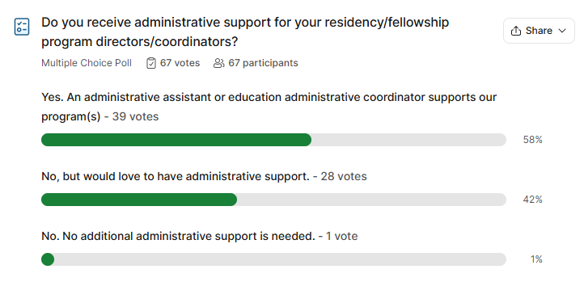
RFESIG Membership Meeting Slido Poll Questions at 2026 CSM - Anaheim

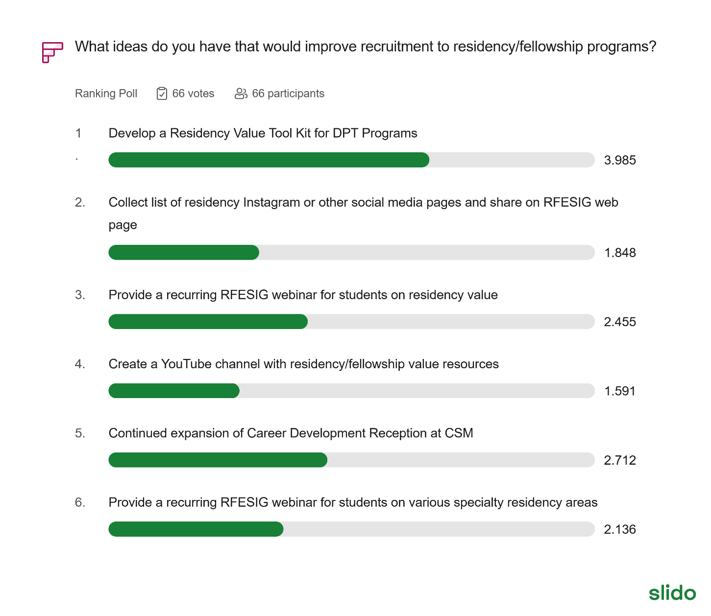

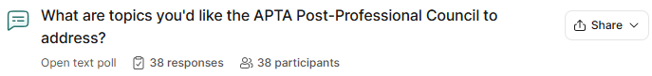

1. Recruitment & Marketing Strategy
This is the most prominent theme, with respondents seeking more aggressive and polished ways to attract DPT students to residency programs.
- Targeted Outreach: Getting in front of 2nd and 3rd-year DPT students to introduce residency early.
- Media & Content: Creating videos of recent graduates to showcase the value of residency and utilizing an "intro to residency" video to filter applicants before events like CSM.
- Unified Messaging: Collaborating with DPT programs to ensure consistent messaging and clear distinctions between the residency and fellowship continuum.

2. Standardization & Administrative Support
Many participants expressed a desire for a more streamlined, less fragmented experience for both programs and applicants.
- Admissions Reform: Suggestions include a "match" system for all specialty areas and a more standardized application/admissions process.
- Streamlining Accreditation: Simplifying annual reporting, accreditation processes, and form/assessment sharing.
- Consistent Quality: Developing a "best practices" framework for curriculum development and residency education consistency.

3. Resource Sharing & Development
There is a clear call for a centralized hub of information to help programs improve their offerings.
- Educational Repository: Compiling resources for mentoring development, lectures, and faculty modules.
- Peer-to-Peer Learning: Knowing what specific programs are doing well to allow for better resource sharing across institutions.
- Advocacy Groups: Creating a council of residency graduates to advocate for these programs and the profession.

4. Financial & Professional Incentives
Participants highlighted the need to address the "ROI" of residencies to remain competitive.
- Compensation: Quantifying program value and advocating for "PT equivalent" salaries for residents to attract higher-quality applicants.
- Funding: Finding funding opportunities for faculty seeking specialist certifications when institutional support is lacking.
- Specialty Growth: Specific mentions of addressing the Acute Care board certification and exam.

2026 RFESIG Goals
AoE SIG | Board Position Goals | Strategic Plan Goal Being Addressed (Name and Letter) | Time Frame for Meeting Goal | Catalyst(s) to Achieving Goals | Barrier(s) to Achieving Goals
RFESIG | Further develop research groups, plans, created from Residency/fellowship symposium. | Elevate AB; Lead A | 12 months | Symposium planning group; RFESIG leadership; connect with scholarship goal Scholarship of Education | Coordination and communication; follow-up action steps.
RFESIG | Futher curate web-site content, focus on recruitment, mentor training, educator training. | Lead B; Advance B & C | 12 months | Residency & Fellowship Specialty SIG leaders; RFESIG leaders | Development of and vetting recruitment and mentor training content. Disseminating, communication updates to members.

Academy of Education Goals
ADVANCE: Inspiring physical therapists and physical therapist assistants in their roles as educators.
- A. Pathways – Creating pathways to inspire emerging educators.
- B. Advancing – Developing professionals through contemporary educational opportunities using innovative and accessible methods.
- C. Sharing - Disseminate best practices and resources to physical therapy educators.
CONNECT: Leading physical therapy education through organizational collaboration and member engagement.
- A. Partnerships - Create and strengthen interactive partnerships among education stakeholders.
- B. Members - Increase member involvement in the Academy to promote a diverse and inclusive environment.
- C. Representation - Ensure strategic representation of the Academy in every relevant forum
ELEVATE: Elevating the profession by furthering physical therapy educational research.
- A. Research Agenda – Prioritize research based on the gaps in evidence to support best practices in teaching and learning in physical therapy education.
- B. Collaboration – Support the development and collaboration of education researchers.
- C. Strengthen – Strengthen education research initiatives.
LEAD: Exhibiting strong leadership to advance the Academy.
- A. Members - Engage members to contribute to achieving the vision of the Academy.
- B. Communications – Maintain a strong Academy presence through branding, clear messaging, publications, and visibility.
- C. Leadership and Management – Maintain excellence in governance and management with a dedicated team and pipeline of future leaders.
- D. Resources – Supplement revenue streams to advance the mission and serve the membership.

