RFESIG Leadership Meeting
Agenda

Date: January 9, 2026
Time Zone: 3:00 pm CT
Location: Zoom Meeting
Time | Topic |  |  |  |  | Purpose | Proponent(s)
3:00 pm | Welcome |  |  |  |  | Introduction | All
3:05 pm | Officer Reports  - Chair – Darren Calley  - RFESIG Initiatives  - Discuss Creating Resident/Fellow RFESIG Leadership Positions. Students and active residents/fellows can be members of Education Section for free.  - Create 2 Liaison roles  - Advertise, hold elections  - Serve 1 year terms  - Create student/resident resources how to be a strong applicant, why residency/fellowship, post-residency career pathways.  - Potential role description  Consider developing a workgroup, need to identify scope. Poll attendees at CSM to gain input.  - CSM RFESIG Meeting – content to cover Thur Feb 12 4-530pm. Mention journal clubs and work group proposal. Will raffle 10 gift cards, $60 each.  - APTA Post-Professional Education Council questions  - How are other stakeholders addressing the demand for specialty and subspecialty education?  Value point for residency education  Research for res-fel showing the value  - What strategies or resources could be developed to better support specialty and subspecialty areas of practice?  - What types of marketing efforts and communication platforms would be most effective for sharing this information?  DPT Faculty education on value of residency. Create faculty toolkit? Youtube video?  Need a better understanding of number of programs that is not able to fill their spots. Which academic programs are applicants attending? Any trends?  RF-PTCAS: ask them to include question in application: How did you hear about residency/fellowship training?  - Interest from RFESIG in holding an annual meeting with other AoE SIG Committee members? No  - Vice Chair – Dave Nolan  - Distinguished Mentor in Residency/Fellowship Education Award – 2026 award selected. 2 nominees, unanimous decision for 1 who has been made aware.  - Membership Secretary – Martha Bloyer  - Membership updates  - Treasurer Secretary – Kristel Maes  - 2026 budget: CSM food $1,780, $720 left. |  |  |  |  | Update & Discussion | Officers
3:15 pm | Committee Reports  - Nominating Committee Chair – Kristina Stein  Nominations for 2026:  - Vice Chair  - Nominating Committee  - Communications Chair – Kris Neelon  - Program Committee  - Laura Zajac-Cox (ELC) –  - Christina Bentrewicz (CSM) – February 12-14, 2026 Anaheim  - Scholarly Research Chair – Raine Osborne  - RFESIG Journal Club Webinar – next date March 10, 2026  - Quarterly future dates (2nd Tuesday):  - March 10, 2026. Financial value article-John DeWitt?  - June 9, 2026  - Sept 8, 2026  - Dec 8, 2026  Planning pre-conference symposium either at CSM 2027 |  |  |  |  | Update | Committee Chairs
3:40 pm | Ongoing Items  - RFESIG Community Discussion board – increased engagement  - Recruiting resources – RFESIG website  - Should we develop content for students/residents?  - Why residency  - How to prepare a competitive application  - Pathway to clinical education or academic teaching |  |  |  |  | Discussion | all
 | Upcoming meetings  - RFESIG Leadership Meeting pattern: 2nd Friday of Jan, March, May, July, Sept, Nov @ 3:00 pm CT |  |  |  |  | Information | all
Initiatives
- Collaboration & Networking with ResFel SIGs
  - The RFESIG is engaged in connecting other residency and fellowship education SIGs and leaders by collaborating on projects, sharing resources, providing networking opportunities, and creating innovative strategies to promote excellence in RFE.
- Mentoring, Recruiting, and Education resources & videos
  - The collaborative initiatives among and Residency & Fellowship SIGs strive to provide faculty and mentor development resources and build connections to support residency and fellowship SIG's
- RF Research Collaborative – ongoing research projects
Action items and Upcoming Dates
Action items:
- Darren to bring back idea of student-resident-fellow liaison workgroup
- Darren to create poll at CSM for work group proposal
- Raine check with John DeWitt if he can present at next journal club
- Darren to f/u on $300 gift card
Next RFE SIG Executive Committee Meeting: Friday, March 13th, 2026 3:00 pm CT

RFESIG Roles
- Darren Calley Chair
- David Nolan Vice Chair
- Kristel Maes Secretary/Treasurer
- Martha Bloyer Membership Secretary
- Kristina Stein Nominating Committee Chair
- Caitlyn Lang Nominating Committee
- Jodie Rush Nominating Committee
- Kris Neelon Communications Committee Chair
- Laura Zajac-Cox & Christina Bentrewicz Program Committee Chairs
- Raine Osborne Scholarly Research Committee Chair
Attendance
Darren Calley |  | x | Kristel Maes | x | Jodie Rush |  |  | x
Christina Bentrewicz |  |  | Kris Neelon |  | Kristina Stein |  |  | x
Martha Bloyer |  | x | Dave Nolan | x | Laura Zajac-Cox
Caitlyn Lang |  |  | Raine Osborne | x
X = Attending; NA = Not Attending

RFESIG Membership Meeting Slido Poll Questions at 2025 ELC – Kansas City
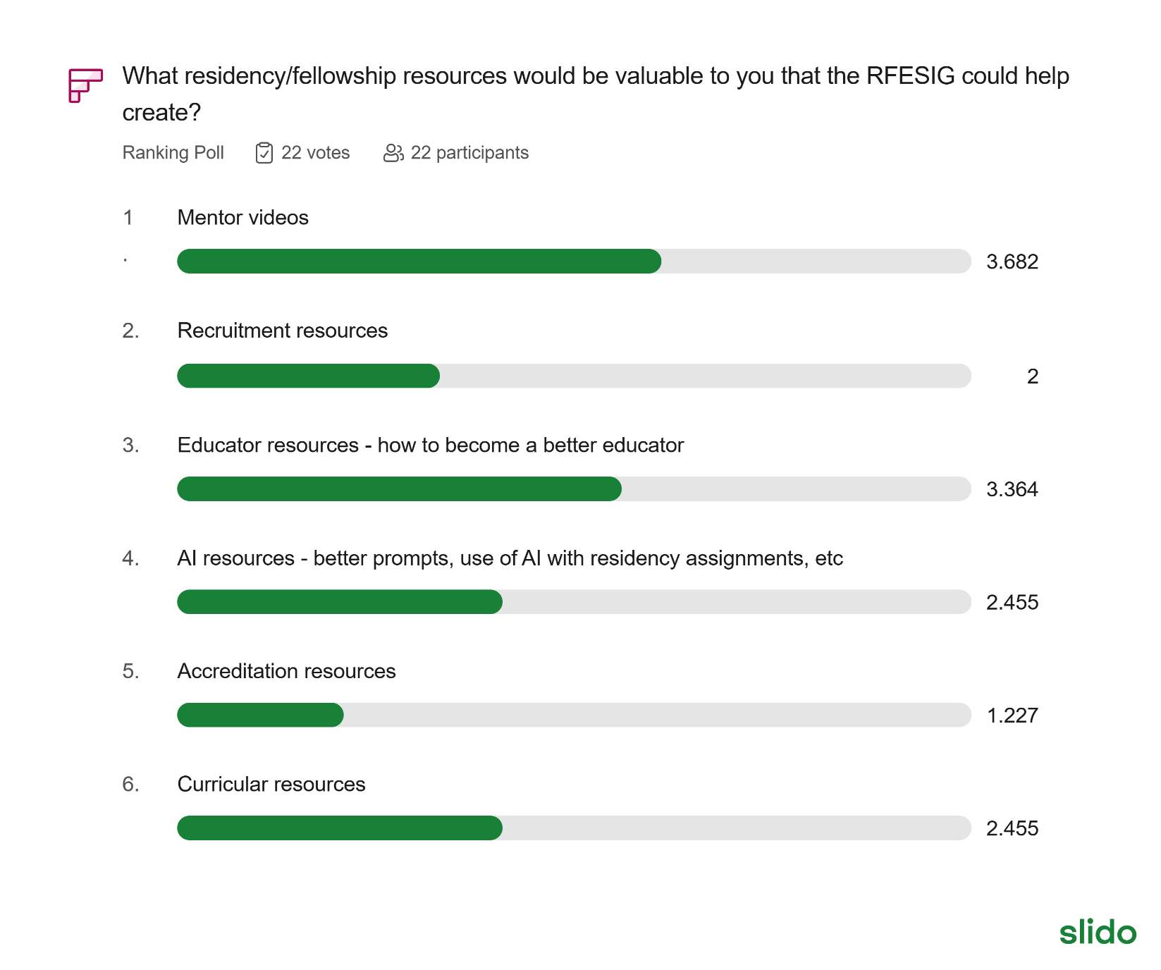
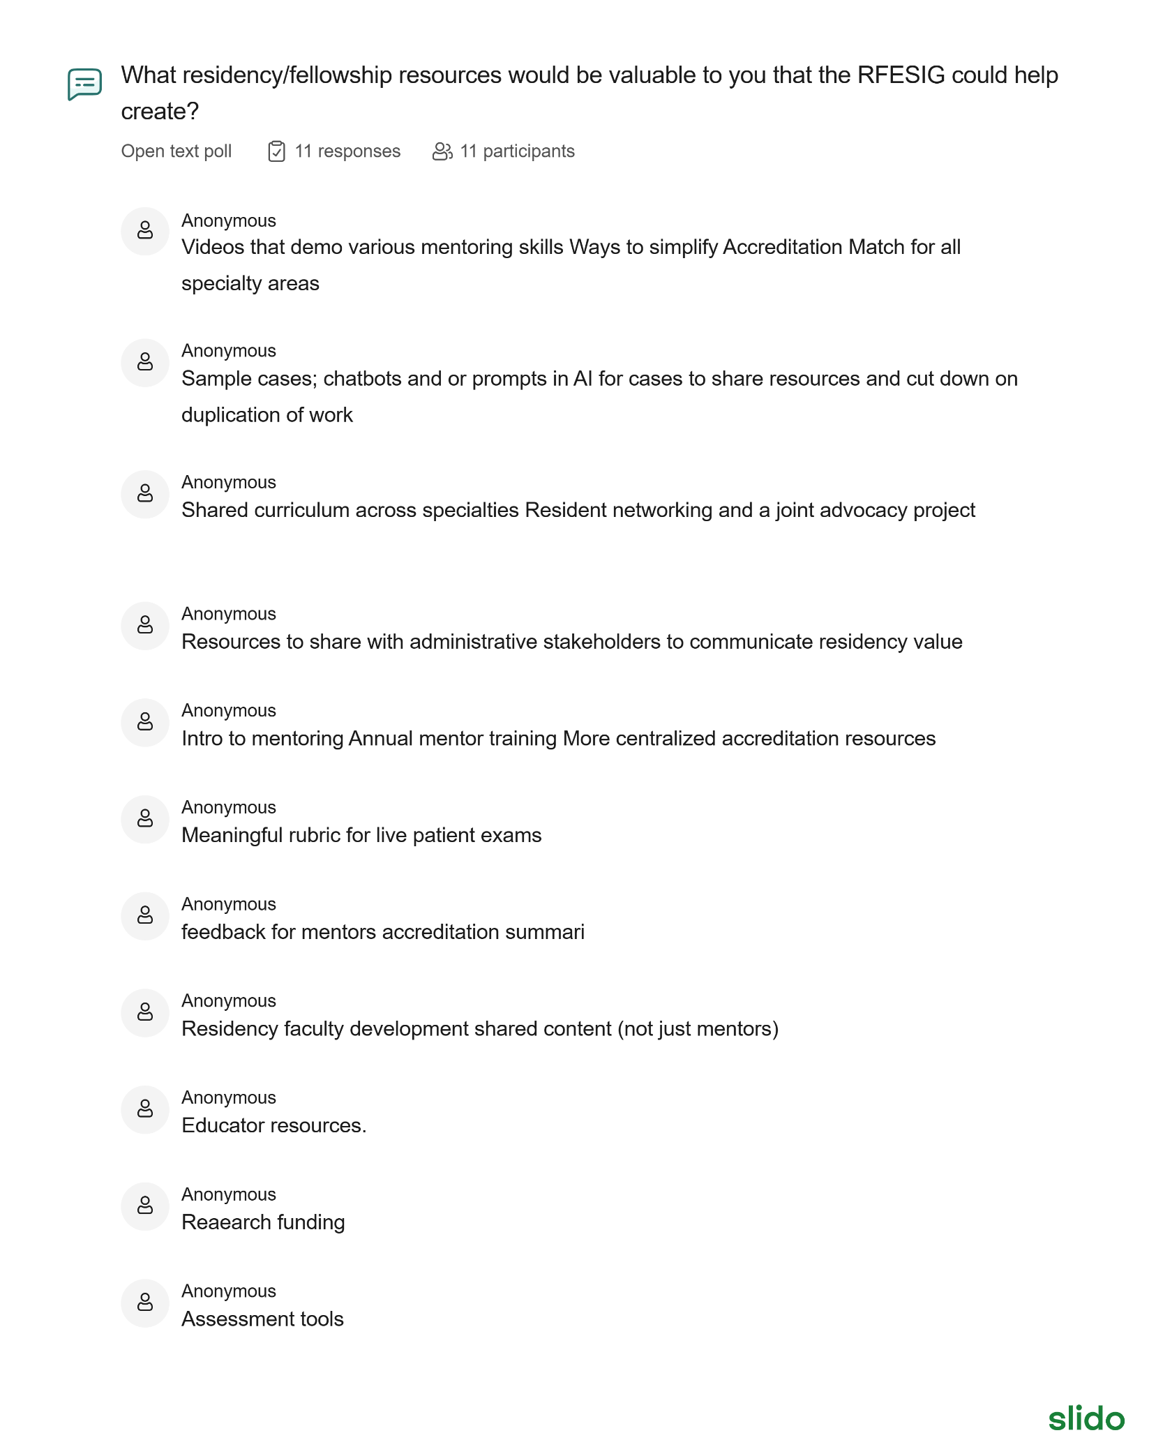
2026 RFESIG Goals
AoE SIG | Board Position Goals | Strategic Plan Goal Being Addressed (Name and Letter) | Time Frame for Meeting Goal | Catalyst(s) to Achieving Goals | Barrier(s) to Achieving Goals
RFESIG | Further develop research groups, plans, created from Residency/fellowship symposium. | Elevate AB; Lead A | 12 months | Symposium planning group; RFESIG leadership; connect with scholarship goal Scholarship of Education | Coordination and communication; follow-up action steps.
RFESIG | Futher curate web-site content, focus on recruitment, mentor training, educator training. | Lead B; Advance B & C | 12 months | Residency & Fellowship Specialty SIG leaders; RFESIG leaders | Development of and vetting recruitment and mentor training content. Disseminating, communication updates to members.

Academy of Education Goals
ADVANCE: Inspiring physical therapists and physical therapist assistants in their roles as educators.
- A. Pathways – Creating pathways to inspire emerging educators.
- B. Advancing – Developing professionals through contemporary educational opportunities using innovative and accessible methods.
- C. Sharing - Disseminate best practices and resources to physical therapy educators.
CONNECT: Leading physical therapy education through organizational collaboration and member engagement.
- A. Partnerships - Create and strengthen interactive partnerships among education stakeholders.
- B. Members - Increase member involvement in the Academy to promote a diverse and inclusive environment.
- C. Representation - Ensure strategic representation of the Academy in every relevant forum
ELEVATE: Elevating the profession by furthering physical therapy educational research.
- A. Research Agenda – Prioritize research based on the gaps in evidence to support best practices in teaching and learning in physical therapy education.
- B. Collaboration – Support the development and collaboration of education researchers.
- C. Strengthen – Strengthen education research initiatives.
LEAD: Exhibiting strong leadership to advance the Academy.
- A. Members - Engage members to contribute to achieving the vision of the Academy.
- B. Communications – Maintain a strong Academy presence through branding, clear messaging, publications, and visibility.
- C. Leadership and Management – Maintain excellence in governance and management with a dedicated team and pipeline of future leaders.
- D. Resources – Supplement revenue streams to advance the mission and serve the membership.

