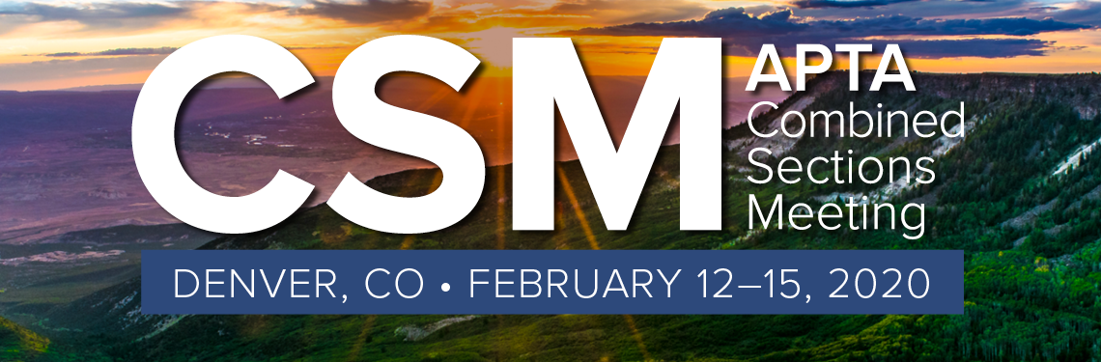
Clinical Education Special Interest Group Business Meeting
Combined Sections Meeting - Denver, CO
February 13, 2020 5:00 - 7:00 p.m. MST
Colorado Convention Center-109/111/113
Board Reports
Introductions
- Co-Chairs: Carol Beckel (Academic) and Karen Bock (Clinical)
- Recording Secretary: Elsa Drevyn
- Membership Secretary: Lisa Harrison
- Nominating Committee: Susan Tomlinson and Laurie Neely

Membership Chair - Lisa Harrison
- Please sign into the link for attendance

PT PAC – Paul Hildreth
Discussed the importance of contributing to PAC. This is the only fundraising organization that influences federal legislators to work for Physical Therapy legislative interests.

Placement Process task force – Cindy Flom-Meland and Christine McCallum
Members of the taskforce were introduced. The taskforce has been working on the placement process for about two years. They have done extensive literature review and distributed surveys to different stakeholders, receiving thousands of responses.
Findings:
- The main finding is that the curricular models are variable.
- The training for DCEs and SCCEs is also variable.
- The academic programs’ goal is to figure out a model that will ensure that each program will fulfill the requirements.
- The clinical sites want students that are prepared for their clinical experiences, and they also want to fill out available spots.
- In January they surveyed the students with over 2000 responses. The students’ response showed that they were most concerned in getting placed in a site that would provide the best experience.
The taskforce is putting together a manuscript to submit to the CE SIG and the NCCE for them to decide on how to proceed. She encouraged members to share ideas and provided contact information.

Co-Chair Report – Carol Beckel and Karen Bock
- CESIG Survey from CSM 2019
  - Initiated data collection at CSM 2019 during CESIG Business Meeting; extended for 2 weeks
  - 873 usable responses reviewed by CESIG Board for themes
  - Final data shared with APTA, NCCE, and PTAESIG leadership

- Updates on ELC Initiatives – Carol Beckel
- See Liaison International slides for technical improvements including adjustments to sign-off
- No updates on Advisory Panel for CPI/CSIF (see APTA Education slides)
  - There has been ongoing communication and they have started the framework for the panel.
- No updates regarding data management plan

- Update on Clinical Education and Residency Discussion (ELC 2018)
  - Conversations with Residency Directors at CSM 2019
  - Plan to restart discussions again
  - The concern is still there regarding the amount of time that the students are taking to do residency interviews

- Use of APTE Discussion Boards (https://forums.aptaeducation.org/)
  - CESIG will start using to better track discussions
  - Continue to check The Hub Clinical Education Community for documents
  - The benefit of using this avenue for discussion is that it is trackable

- Recognition of Outgoing Board Members
o Carol Beckel – Academic Co-Chair
  - Susan Tomlinson - Nominating Committee
  - Lisa Harrison – Membership Secretary

Membership Chair Report – Lisa Harrison
- Please register attendance, link provided.

Recording Secretary Report – Elsa Drevyn
- ELC 2019 Minutes to be posted on The Hub

Nominating Committee Report – Susan Tomlinson and Laurie Neely
- Introduced the slate for the candidates, starting with the academic co-chair, membership secretary candidates, nominating committee candidates.
- The ballots go out March 1st and voting will end April 1st. Positions start on July 1st.

Standing Reports

CSM 2020 Program Report – Carol Beckel reporting on behalf of Skye Donovan and Rebecca McKnight
- CSM 2021 will be in Orlando, Florida and It will be the centennial celebration.
- Poster submissions deadline is July 13th and Education Session submission deadline is March 18th.

ELC 2020 Preview – Cynthia Utley
- The theme for ELC is: “The Key to Unlocking the Quadruple Aim”, the dates are October 16-18.
- Abstract submission March 9th - March 27th.
- Registration will be earlier this year. Scholarship application for clinicians will open 5/21, 40 scholarships available.

APTE Update – Pam Levangie, APTE President
- Academy members received an email with a link to the annual report.
- The academy has accomplished a lot this year through its SIGs.
- Some priorities for this year was providing more support for the JOPTE. They are restructuring the editorial leadership to provide better support for the journal and the members.
- The academy is looking into developing a PTA summit. There is a need to strategize for the future of PTA education and to address current issues. She is encouraging anyone who is passionate about PTA education and has expertise in this area, to assist with planning the summit and to please contact her.

ELP Update – Steven Chesbro, Vice President, Education – APTA
- In 2015 the presidents of APTE, ACAPT, APTA came together to collaborate and prioritize regarding PT education. The ELP partnership was created with the three major stakeholders, and other partners were added afterwards.
- The taskforce for best practice provided recommendations to the boards, providing a long-term strategic plan for long term excellence in PT education.
- The ELP created four categories that needed to be prioritized. Clinical education crosses multiple modes of education.
- Strategy meetings have been taking place and this will continue.
- The partners will be discussing the long-term education strategy during an October 2020 meeting. This is expected to be a 6 months process. All the reports are posted.

New Business (6:15)

Colorado CESIG - Jenny Rodriquez
- They are a relatively new SIG. They evolved out of a CE forum in the ‘90s. Three years ago, they became a SIG of the state chapter. This has worked very well for them and has promoted more collaboration.
- The chair of the Florida consortium described their model.
- Illinois CE SIG reported on their newly developed model.

Dissemination of the Common Terminology Glossary – Vicki LaFay & Kim Snyder
- The PTAE SIG task force was developed to address the use of the terminology by PTAs. They developed a document that was submitted to ACAPT and APTE.
- In January the document was posted on the APTA website.
- There are similarities and differences between the PTA and PT terminology.
- They included the term “Intraprofessional” to represent the relationship between PT and PTA.
- They encouraged for all to continue to incorporate this terminology in their documentation and share it with all stakeholders.

Updates on CCIP Level 1 or 2 Courses - Cyndi Robinson
- She is a member of the committee to update the Level 1 course. The revisions have been finalized and piloted.
- They are now working on publications through the APTA and expect to have the updated course available at the end of the year.
- The APTA has approved the hybrid course which includes one day online and one ‘live’.
- The fee structure for the program is being simplified for both courses.

Academic-Clinical Partnership - Donna Applebaum
The Academic-Clinical partnership meeting will be in three weeks.
They want to discuss:
- “culture” – values and conventions or social practices
- “partnership” – legal agreement. Will also look at rights and responsibilities for both partners.
- The recommendations for partnerships from the “Best Practices for PT Education Taskforce”.
- The CE strategy meeting proposed a recommendation for the ‘marketing for a clinical education culture shift.”
Donna posted a link to a survey for members to submit responses to questions regarding ‘culture’. The survey will be open for two weeks.
HTTPS://WWW.SURVEYMONKEY.COM/R/WX5D5JH

Attendance:
PT 98 vs PTA 9
Academic Faculty:94
Clinical Faculty: 10
Both: 3
Total: 107

