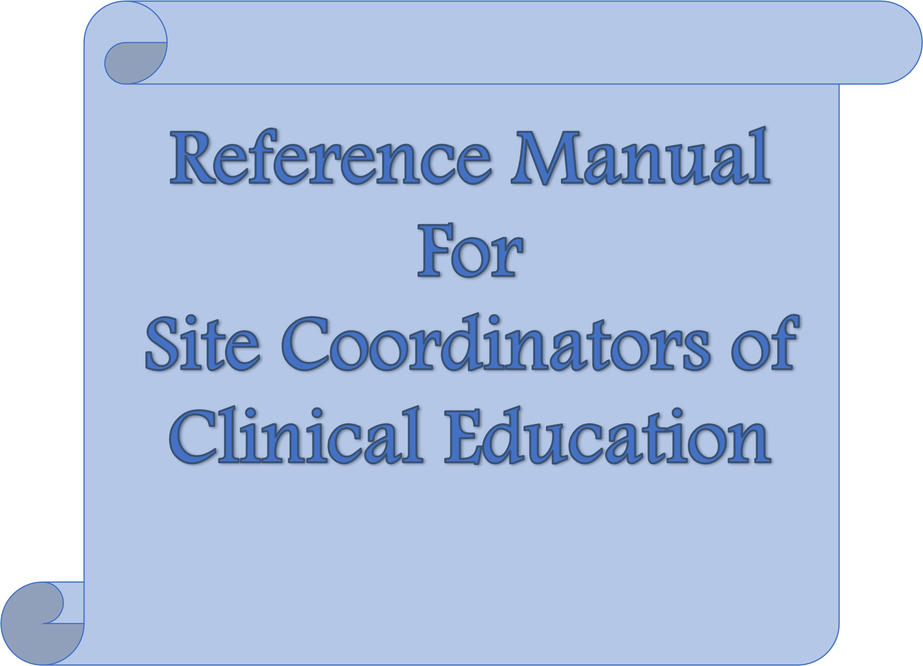

© 2018, 2012, 2002. American Physical Therapy Association. All rights reserved. Visit APTA’s online store at [http://www.apta.org](http://www.apta.org/) to access this publication.

Updated 2024.

Previous publications with title: *Reference Manual for Center Coordinators of Clinical Education*

Clinical Education Special Interest Group (CESIG)

American Physical Therapy Association, Academy of Physical Therapy Education

# *Table of Contents*

PAGE

Letter to Site Coordinator of Clinical Education (SCCE) from CESIG Leadership 3

|  |  |
| --- | --- |
| Definition of Terms | 5 |
| Supplemental Glossary of Terms | 6 |
| Administrative Duties of the SCCE  Scheduling of Students  Student On-boarding & Orientation  Clinical Education Agreements | 8 |
| SCCE Communications  Communication with Academic Programs and DCE/ACCE  Communication with Clinic Staff  Communication with Clinical Instructor (CI)  Communication with Student  Communication with CI/Student | 11 |
| Mentorship/Staff Development  General Staff Education  Tips for Preparing a Novice Clinician to Become a CI  Tips Prior to a Clinical Experience  Tips During a Clinical Experience  Tips Following a Clinical Experience  Mentorship Resources | 12 |
| Conflict Management for SCCEs | 15 |
| Introduction to Clinical Education Objectives  Sample Objectives for Physical Therapist (PT) Students  Sample Objectives for Physical Therapist Assistant (PTA) Students | 16 |
| APTA Core Documents  APTA Professionalism Documents  APTA Ethics Documents  Additional Resources | 18 |
| Additional Thoughts for the Novice SCCE  Guidelines Regarding Timelines  Expectations: Student  Expectations: CI  Expectations: Patients  Expectations: DCE/ACCE, ADCE  Expectations: Administrators  Expectations: Clinical Staff  Unmet Expectations  Expectations for the SCCE | 19 |
| Appendix A: Administration Templates and Resources  A1: The Clinical Education Special Interest Group Voluntary Uniform Mailing Date  A2: CESIG Common Request Form Blank Template for March 1 Mailing  A3: CESIG Common Request Form March 1 Mailing Completed Example  A4: Students Contacting Clinical Facilities to Request Clinical Experiences  A5: Sample Letter/Email to Student  A6: Orientation Checklist  A7: Memorandum of Agreement  A8: Example SCCE Memorandum Soliciting Clinician Preceptors  A9. Student Clinical Education Manual Example | 30 |
| Appendix B: Forms Used During a Clinical Experience  B1: Anecdotal Record  B2: Critical Incident Report  B3: Weekly Planning Form  B4: CPI Anchor Definitions  B5. Example Student Program Feedback Form | 49 |

# *Letter to Site Coordinators of Clinical Education (SCCE)*

Congratulations on becoming an SCCE. You already know how rewarding it can be to work with students; now you have taken on the responsibility of coordinating this experience for your coworkers. Whether you work in a large site with many therapists or a small practice with only a few co-workers, the basics are the same.

**Here is a checklist to help you get started with the process of hosting students at your clinical Site:**

* Consider reaching out to the SCCE Mentorship group of the APTA Clinical Education Special Interest Group as well as your local Consortia
* Prepare a student manual
  + Student Handbook
  + University/Clinic site Contacts
  + Welcome emails/flyers for students
  + Student documentation guidelines for electronic medical records
  + Exit Interview Survey/questionnaire to assess clinical
  + Student perks/incentives
  + Trip Advisor type info for area
    - Restaurants
    - Things-to-do
* Prepare a CI manual and additional helpful resources

(i.e., documentation guidelines, etc.)

* Collate lists of clinical sites and clinical instructors in your enterprise (include physical addresses, contact info – phone/email, operational days and hours, clinic description, specialties offered, additional opportunities available (e.g. observation of surgeries, etc.)
* Prepare your staff for being a clinical instructor; consider the APTA Credentialed Clinical Instructor Program (CCIP); determine lists of clinicians, specialties, working hours, student preference, vacations, etc.
* Market the benefit of precepting students to management and administrators
* Send the student the information about your site including: parking, hours, lodging if any, cafeteria, and any other things they need to know particular to your site

*Timeline for the SCCE:*

**Dec to Feb – Scheduling of Students: Planning for March 1 Mailer (see page 8 for details**)

* Determine student volume
* Determine process for student->CI assignment
* Determine and implement strategy for clinical experience schedule/calendar
* Determine CI availability from staff
* CI’s willing to perform 2:1 model

# March to May - Scheduling of Students: March 1 Mailer (see page 8 for details)

* March 1 receive requests from schools
* Plan the student calendar for the following year
* Confirm student schedule with staff and schools
* Complete interviews if required/desired by site

# May through January: After commitments are made and sent to DCE/ADCE

* Prepare / update student handbook
* Prepare Orientation checklist for student
* Prepare CIs for their role

## **6 months before student scheduled**

* Schools should supply SCCE with name of the student

# 6-8 weeks prior to student start date

* Student should contact SCCE/CI
* SCCE should send student particular information about site: location, public transportation, parking, dress code, hours, patient population, any suggestion of information for student to study, contact information
* SCCE speaks with CI for any questions or concerns
* Contact the student and get them in touch with the CI

## **2 weeks prior to student start date**

* Touch base with CI to make sure they have been in contact with student
* Coordinate who will give which part of the student orientation

# Day of student arrival

* Welcome sign/note for student so staff can see it to remind staff of student’s name
* Student orientation / tour of site, identification of role of CI, SCCE and the relationship with the school

# On-going throughout each student’s clinical experience

* Be present for questions
* Touch base with CI for progress, concerns
* Touch base separately with student for progress, concerns

Congratulations again and good luck on this journey in clinical education. We hope this manual will help you and the clinicians you work with meet all of your clinical education goals.

Sincerely,

CESIG Leadership and Task Force

## **Definition of Terms**

In 2014 stakeholders within physical therapy education came together for the 2014 Clinical Education Summit. Following this meeting 3 strategic initiative panels were formed to work on recommendations determined at the Summit: Common Terminology Panel, Integrated Clinical Experience Panel, and Student Readiness Panel.

A common theme discussed at the 2014 Summit was the need for a common language to be used by all stakeholders within PT Education. This would reduce the risk of confusion and allow efficient and effective communication between the academic and clinical settings. To meet this initiative, the Common Terminology Panel presented their recommendations for a glossary of terms to be used by all stakeholders during the Education Leadership Conference in 2017. A motion of the terms was presented to American Council of Physical Therapy Education (ACAPT) and adopted. You can obtain the full motion document of accepted terms at:

<http://acapt.org/docs/default-source/motions/2017-Motions/common-terminology-motion.docx?sfvrsn=0>

You can read the published article: [Recommendations from ACAPT's Common Terminology Panel (2018)](https://academic.oup.com/ptj/article-abstract/98/9/754/5040253?redirectedFrom=fulltext) if you would like to learn more. This glossary is updated on a regular basis based on feedback of those within the clinical education community. In addition, a supplemental glossary of terms that may be helpful to you as a SCCE is included in this manual. Some glossary terms have a hyperlink attached that you may use for additional information. Please note that some hyperlinks require APTA or Academy of Physical Therapy Education membership log in information for access.

## **Supplemental Glossary of Terms**

**Academic Faculty Special Interest Group (AFSIG):** A special interest group within the Education Section of the APTA, serving as a resource for academic faculty. The AFSIG has general membership meetings twice a year at both the Education Leadership Conference and Combined Sections Meeting.

<http://aptaeducation.org/members/special-interest-group/academic-faculty-sig/index.cfm>

**Academy of Physical Therapy Education of the APTA: Section** with the APTA devoted to the development of PT and PT assistant students. The education section has their own publication, the Journal of PT Education (JOPTE) that is available to section members through their website. <https://aptaeducation.org/home-page.cfm>

**American Council of Academic Physical Therapy (ACAPT):** A component of the APTA with the purpose to advance academic physical therapist (PT) education. Institutional membership is required for voting rights within ACAPT. [www.acapt.org](http://www.acapt.org/)

**Assistant Director of Clinical Education (ADCE): The** appointed PT faculty member who assists the DCE in carrying out all aspects of the clinical education curriculum.

**Clinical Education Consortium:** A regional group of members including clinical education academic faculty, clinical faculty and/or other members who support the clinical education of students. The regional consortia advance physical therapy clinical education in their region and promotes excellence in physical therapy through the partnership of its academic and clinical members. [www.apta.org/ClinicalEducationConsortia](http://www.apta.org/ClinicalEducationConsortia)

**Clinical Education Site:** An approved health care site that maintains a clinical education agreement (contract) with an academic institution to provide clinical experiences to students.

**Clinical Education Special Interest Group (CESIG):** The Clinical Education SIG shall serve as a resource and forum for individuals who have professional concerns for the coordination, implementation, and evaluation of clinical education for physical therapists and physical therapist assistants. This includes academic and clinical faculty.

<http://aptaeducation.org/members/special-interest-group/clinical-education-faculty-sig/index.cfm>

**Clinical Site Information Form (CSIF): A** uniform document developed by the APTA that is completed by the SCCE to provide information about the clinical education site. Serves as an aide in selection and student placements. Used to assess the available learning experiences and opportunities for students. [www.apta.org/CSIF](http://www.apta.org/CSIF)

**Credentialed Clinical Instructor Program (CCIP):** An APTA course intended for health care providers who work primarily in a clinical setting designed to develop/advance teaching abilities when providing clinical instruction to students. The CCIP and Advanced CCIP (ACCIP) courses are both available to health care providers and course schedules can be found on the APTA website. [www.apta.org/CCIP](http://www.apta.org/CCIP)

**Clinical Performance Instrument (CPI):** A standardized online evaluation tool developed by the APTA to assess student performance a clinical experience. [www.apta.org/PTCPI](http://www.apta.org/PTCPI)

**Commission on Accreditation in Physical Therapy Education (CAPTE):**  Accrediting body of physical therapist (PT) and physical therapist assistant (PTA) education programs, as recognized by the US Department of Education as well as the Council for Higher Education Accreditation. [www.capteonline.org/home.aspx](http://www.capteonline.org/home.aspx)

**Education Leadership Conference (ELC):** Education Section Sponsored Conference held every October. Conference participation is encouraged for both academic and clinical faculty. In addition, scholarships are available to clinicians/clinical faculty through the education section as well as various regional consortia for funds related to travel and registration at ELC. <https://aptaeducation.org/events/>

**Education Leadership Partnership:** A leadership committee including representatives from the APTA, Education Section of the APTA, and ACAPT whose purpose is to reduce unwarranted variation in PT and PTA education. [www.apta.org/ELP](http://www.apta.org/ELP)

**First Come First Served (FCFS):** Some clinical facilities decide not to hold spots specifically for any physical therapy program. In this situation, the site may offer a FCFS clinical experience. Spots with these identified facilities are filled as stated- on a First Come First Served basis.

**Physical Therapist Assistant Educator Special Interest Group (PTAESIG):** A special interest group within the Education Section of the APTA, serving as a resource for both academic and clinical faculty in PTA programs. The PTAESIG has general membership meetings twice a year at both the Education Leadership Conference and Combined Sections Meeting. <http://aptaeducation.org/members/special-interest-group/pta-educator-sig/>

***Administrative Duties of the SCCE***

**Scheduling of Students: March 1 Mailer**

**Planning for March 1**

* Determine the number of students that your site can accommodate both at one time and throughout the year.
  + Key considerations: CI availability*, space, staffing, resources (i.e. desks, computers), level of clinical experience, length of clinical experience, CI: student ratio, * managerial/administration support/ approval, policies, affiliation agreements etc.
  + *CI availability: may consider survey to CIs (purpose: gauge interest, preferences, availability)
  + Appendix/Link:
  + CI Survey Exemplar 1: PT/PTA only, 1 site location, multi-setting

(add at end of document or add a link to document)

* + CI Survey Exemplar 2: multidisciplinary, multi-site locations, multi-setting
* Determine process for how students will be assigned to CIs (immediate vs. delayed matching, student vs CI preferences/characteristics)
* Determine and implement a strategy to map out clinical experience schedule (i.e. calendar, excel spreadsheet, database system [Exxat One])
* Appendix/Link:
* Clinical Experience Scheule Map Exemplar 1: multidisciplinary, multi-site locations, multi-setting

**March 1 Mailer**

* Date - The March 1st ‘mailing’ date was established in 1999 by the Clinical Education Special Interest Group (CESIG) of the Education Section of the APTA. The purpose of this mailing is to plan clinical experiences for the following year; more information regarding this date is available in Appendix A1.
* Common form – in 2016 the CESIG developed a ‘Common Form’ for academic programs to use for the March 1st mailing so facilities would receive a similar form from each program to increase ease of use. Please see Appendix A2 and A3 for the form and a sample completed form. Most academic programs send this communication electronically. Some programs use other database systems (i.e. Exxat) for scheduling.
* Students should NOT be contacting facilities to set up a clinical experience. The CESIG has established a position on this as outlined in Appendix A4. If this occurs, please kindly guide the student back to their DCE. Please reach out to DCE (if known) to let them know the student has reached out. (Often students will reach out despite being instructed not to.)
* Considerations for successful SCCE/CI partnership:
* Be mindful of volume - consider breaks from students as/if needed (length and quantity of clinical experiences)
* Assign students who vary in skill level
* Student: CI ratio, 1:1, 2:1, 1:2 model*

*Student: CI ratio: 1:1, 2:1, 1:2 (need to assign primary CI for 1:2 model; this model should be considered for new CIs to gain experience

# Student On-boarding & Orientation (see checklist in Appendix A5)

* Confirm site and CI are a good fit for hosting a student
  + Consider desire to host students
    - Are future employees aware of the company’s culture and expectations related to precepting students?
    - Does staff express desire to provide clinical education to students?
    - Is hosting students voluntary or a job requirement?
    - Is there a site/staff commitment to educating future professionals?
  + Create plan for CI/staff absenteeism during clinical experiences to best facilitate student learning of job duties but ensuring students are not treated as replacement staff for patient care
  + Ensure all staff are familiar with state practice act requirements relative to supervision of students
  + Ensure all staff are familiar with company expectations relative to supervision of students.
  + Recognize that schools may have stringent/clear expectations for supervision, but whichever is most strict is what is required to be followed
  + Review clinical reasoning of staff in determining students are ready for less direct supervision
* Obtain/confirm affiliation agreement
  + SCCE to be made aware of the purpose of affiliation agreement and what information is included (CAPTE minimum requirements vs school-specific)
  + Legal information is included in requirements (i.e. background check, vaccines, site’s specific policies, who can provide clinical instruction)
  + SCCE to be made aware of how to locate affiliation agreement
    - Possible areas that assist with agreements may include human resources, education department, or PT department at site
  + It is important to know when the date expires on the affiliation agreement. Sites should not have a student without an affiliation agreement or with an expired contract.
    - Contracts can be 1-5 years, up to open-ended, and are agreed upon by both educational programs and healthcare site
  + Obtain Memorandum of Understanding (MOU)
    - Determine where MOU form is found, maybe human resources, education department or PT department at side
    - Parties involved need to sign.
    - For some sites/programs, MOUs and affiliation agreements are not separate documents.
* The SCCE should receive the name of the student or confirmation of use no later than 3 months before the start date from the academic program. (Recommendation from Placement Process Work Group/Slot Release Study and vote from the CE SIG at ELC 2024.)
* The academic program or student should reach out to the clinical site 8-10 weeks prior to the start date to provide program and student information.
* The site should provide the following information to students prior to their arrival (see example letter to students at Appendix A6):
  + General information about the site including a map of the site with directions (if needed)
  + General information about the staff and CIs, including contact information for questions
  + Most common patient diagnoses that the student will be exposed to during the clinical experience
  + Name and contact information of the clinical instructor(s) the student will be paired with during the clinical experience
  + Hours/schedule the student will be expected to follow in the clinical site

o Where and what time to arrive on day one of the clinical experience

o Required dress code

o Site parking

* + Food storage/cafeteria at or near the site

# Clinical Education Agreements

* A legally binding document that will generally be reviewed and negotiated between legal counsel or other authorized individual(s) which must be in place prior to a student beginning a clinical experience.
* It is the responsibility of the clinical site, academic program, and students to be informed of the content of the agreement; all parties must read and remain in compliance with the conditions specified within the agreement.
* Either the academic program or the clinical site may initiate the agreement.
* Initiation of the agreement may take weeks to month until completed
* General components of an agreement:
  + Purpose of the agreement
  + Objectives of the program and the clinical education site in establishing the agreement
  + The rights and responsibilities of the program and the clinical education site (including those related to responsibility for patient/client care and to responsibilities for supervision and evaluation of students) o Procedures to be followed in reviewing, revising, and terminating the agreement.

***SCCE Communications***

# Communication with Academic Programs and DCE/ADCE

* Maintain communication regarding availability of clinical experiences, scheduling of students, and site-specific requirements.
* Maintain communication with DCE, program faculty, CI, and students during the clinical experience.
* Provide regular feedback to the program about student performance and perceived strengths and weaknesses of the academic program.
* Provide regular assessment of the effectiveness of the DCE and program faculty involved in clinical education supervision.
* Introduce the new SCCE if/when changes are made.
* Complete and update the Clinical Site Information Form (CSIF). See additional resources.

# Communication with Clinic Staff

* Communicate information to the staff when students are coming, who they will work with, how long they will be at the site, and any other pertinent information.
* Review guidelines/regulations specific to educating students in your clinical setting.
* Consider developing an annual report regarding clinical education to inform clinical staff at your site. It will also assist in updating the CSIF. Potential topics:
  + Clinical education agreement
  + Clinical education that occurred that year (e.g. # of students & CIs, summary of student clinical evaluations)
  + Number of APTA Credentialed CIs in the site

# Communication with CI

* Provide the CI information about the student (including student biography/resume and clinical education syllabus and/or course expectations sent by the academic program) prior to student arrival so they can prepare for the clinical experience.
* Check-in with the CI and student early on, at midterm, and near the ends of the clinical experience.

# Communication with Student

* Ensure orientation is completed at the beginning of the clinical experience.
* Discuss that you are a resource/guide during this clinical experience if needed.
* Provide expectations for clinical experience.

# Communication with CI/Student

* Be an impartial third party during crucial conversations.
* Facilitate open dialogue.

***Mentorship/Staff Development***

# General Staff Education

The SCCE can keep the staff informed of local, state and national clinical education opportunities. This can be done in staff meetings or by posting information. It is helpful for the SCCE to be actively involved in clinical education special interest groups or consortia.

Consider contacting the ADCEs/DCEs to provide an in-service. They enjoy visiting clinics and helping clinicians have a better understanding of evaluation tools, learning styles, curriculum, expectations, and more. This provides an opportunity for the staff to meet the ADCE/DCE and strengthens the relationship between the clinical site and the academic program.

# Tips For Preparing a Novice Clinician to Become a CI

* Create a binder with resources for the CI. Example of resources listed below.
* Have the clinician take a student for a day or during an integrated clinical experience (ICE).
* Pair the novice CI with a seasoned CI for a full-time clinical experience.
* Review and discuss the clinical objectives for your clinical site and the objectives from the academic program.
* Support the CI throughout the clinical experience by providing feedback.
* Have the CI reflect on the clinical experience each week (what went well, what they would like to improve upon, goals for the next week).

# Tips Prior to a Clinical Experience

* Find out the needs of CIs during the clinical experiences. For example, some CIs can remember when the midterm evaluation is due and can complete it on their own. Other CIs may need reminders.
* Discuss the SCCE role with the CIs and develop an effective working relationship. For example, it is helpful to decide how problem situations will be handled and when the CI feels they would like a third person (SCCE) to be involved.
* Some CIs may want to meet with the SCCE to discuss the teaching experience, brainstorming, problem solving, etc. It may be necessary to set time aside to meet.

# Tips During a Clinical Experience

* Check-in/meet with the CI and student at the beginning, midterm, and final weeks of the clinical experience.
* Provide Weekly Planning form to CI and promote for weekly use
* Assist with challenging situations. Contact the ACCE/DCE to provide support and assistance.

# Tips Following a Clinical Experience

* Review the CI and Site Evaluations completed by the student. You may need to specifically ask the student and/or DCEs for these forms. These evaluations are a helpful teaching tool in the development of the education program and CIs.
* Meet with the CI to discuss the clinical experience and the feedback from the students and others.
* It is helpful to assess the strengths and weaknesses of Cls to enhance their teaching abilities. A check-off sheet detailing the specific teaching skills that you want to assess is a good way to meet this objective.
* Have the CI complete the APTA CI Self-Assessment and create a professional development plan.

# Mentorship Resources

* The APTA Credentialed Clinical Instructor Program (CCIP) level 1 and

Credentialed Clinical Instructor Program level 2 are offered throughout the country both in-person and in virtual formats and are an excellent opportunity for SCCEs and CIs to gain the expertise to design an effective learning environment. Refer to the additional resources for links to these programs.

* PT programs and consortia may sponsor additional clinical instructor training for the new and experienced CI. Contact your ADCE/DCE about upcoming programs.
* A mentorship module is available on the APTA Resource Center. Currently the module is geared toward residency and fellowship education but is being modified for general mentorship. [American Physical Therapy Association: Successful Mentorship for Residency and Fellowship Education](https://learningcenter.apta.org/products/successful-mentorship-for-residency-and-fellowship-education)
* Research articles about effective clinical teaching (CI characteristics, communication & feedback):
  + Ozga KL, Kenyon LK, Engel AJ. Physical Therapist Students’ Perceptions of Effective Clinical Instructor Behaviors: A Pilot Study. J Phys Ther Educ. 2016;30(4):35-43.
  + Recker-Hughes C, Wetherbee E, Buccieri KM, Fitzpatrick-Timmerberg J, Stolfi AM. Essential characteristics of quality clinical education experiences: standards to facilitate student learning. J Phys Ther Educ. 2014;28(1):48–55.
  + McCallum CA, Reed R, Bachman S. A Systematic Review of Physical Therapist Clinical Instructor Demographics and Key Characteristics: Impact on Student Clinical Education Experiences. J Phys Ther Educ. 2016;30(3):11-20.
  + Rindflish A, Hoversten K, Patterson B, Thomas L, Dunfee H. Students description of factors contributing to a meaningful clinical experience in entry-level physical therapist professional education. Work [serial online]. March 2013;44(3):265274.
  + Buccieri KM, Pivko S, Olzenak DL. Development of an Expert Clinical Instructor: A theoretical Model for Clinical Teaching in Physical Therapy. J Phys Ther Educ. 2013;27(1):48-59.
  + Greenfield B, Bridges PH, Hoy S, Metzger R, Obuaya G, Resutek L. Exploring Experienced Clinical Instructors’ Experiences in Physical Therapist Clinical

Education: A Phenomenological Study. J Phys Ther Educ. 2012;26(3):40-47.

* + Buccieri KM, Pivko SE, Olzenak DL. How Does a Physical Therapist Acquire the

Skills of an Expert Clinical Instructor? J Phys Ther Educ. 2011;25(2):17–23

o Kelly S. The exemplary clinical instructor: a qualitative case study. J Phys Ther Educ. 2007;21(1):63–69.

o Robert W Jarski, Kornelia Kulig, Ronald E Olson. Clinical Teaching in Physical Therapy: Student and Teacher Perceptions. Phys Ther.1990;70(3):173–178.

* Research articles about clinical reasoning/decision making & learning theories:
  + Atkinson HL, Nixon-Cave K. A Tool for Clinical Reasoning and Reflection Using the International Classification of Functioning, Disability and Health (ICF) Framework and Patient Management Model. Phys Ther. 2011;91(3):416–430.
  + Wainwright SF, Shepard KF, Harman BL, Stephens J. Factors That Influence the Clinical Decision Making of Novice and Experienced Physical Therapists. Phys Ther. 2011;91(1):87–101.
  + Patton N, Higg J, Smith M. Using theories of learning in workplaces to enhance physiotherapy clinical education. Phys Theor Pract. 2013;29(7):493-503.
  + Carraccio CL, Denson BJ, Nixon LJ, Derstine PL. From the Educational Bench to the Clinical Bedside: Translating the Dreyfus Developmental Model to the Learning of Clinical Skills. Acad Med. 2008;83(8):761-767.

## **Conflict Management for SCCEs**

SCCEs frequently need to manage conflict that arises during clinical experiences. Both students and CIs may feel stressed, due to a variety of reasons, during a clinical experience, which can result in ineffective communication, and lead to a suboptimal clinical experience. Two strategies that can be used during conflict management are assertive communication and reflection.

**Tips for effective communication:**

* Identify who “owns” the problem.
* Paraphrase the student’s words.
* Respond to the student’s emotional state or feelings.
* Obtain clarification using open-ended questions.
* Listen, allowing time and possibly some awkward silence.
* Avoid judgment.
* Acknowledge any gender or cultural differences.
* Have a congruent, authentic response (what you say matches what you feel).
* Use “I” statements, such as “I feel frustrated when…” or “I feel confused…”.
* Provide feedback, while being aware of non-verbal communication (eye-contact, facial expression, personal space between you and the student, tone of voice).

**Tips for reflection:**

* Keep a journal.
* Ask “why” questions to analyze the challenge.
* Recognize when the student was surprised or unprepared.
* List how the student reacted and what he/she felt.
* What could CI have done to have made the situation better?
* How did the CI make sense of the situation?
* What was good and bad about the situation?
* If this happens again, what can the CI/SCCE do differently?

There may be a need to facilitate a meeting to discuss the conflict. It is important to create the right atmosphere for these high stakes conversations. Generally, these conversations include stating the situation as you see it, how you feel about the situation, what is needed to correct the situation, and the consequences if there is not a resolution of the situation.

*Adapted from Davis, CM, Musolino, GM. Patient Practitioner Interaction: An Experiential Manual for Developing the Art of Health Care, Sixth Edition. Thorofare, NJ: Slack Incorporated; 2016.*

**Tips for an Open, Respectful, and Supportive Conversation:**

* Find a private location.
* State the purpose of the meeting.
* Encourage free flow of relevant information (objective observations, open & honest opinions & feelings) and view of the situation.
* Ensure understanding of differing perspectives/meanings of all involved.
* During the conversation, keep focused on the objective of the discussion. Do not get sidetracked into other topics.
* Keep conversation going by making it safe for others to share.
* Ask to hear their opinion/thoughts/their “story”.
* Confirm their feelings by what you hear or observe.
* Paraphrase what was said with active listening techniques.
* Control your emotions.
* Maintain unconditional positive regard.
* Focus on the end goal.
* Commit to a mutual purpose.
* Separate facts from the story.
* Identify that there can be different points of view and maintain that no one person’s view is wrong.
* Seek agreement on a clear action plan to improve the situation.

**References:**

*Davis C, Musolino GM. Patient Practitioner Interaction: An Experiential Manual for Developing the Art of Health Care. 6th Edition. Thorofare, NJ: Slack Incorporated; 2016.*

*Patterson K, Grenny J, McMillan R, Switzler A. Crucial Conversations Tools for Talking When Stakes Are High. Second Edition.2012.*

## **Introduction to Clinical Education Objectives**

Generally, the PT /PTA school has a list of learning objectives that the student must achieve by the end of the clinical experience. Frequently, these are based on CPI criteria. Some clinical facilities have developed additional site-specific objectives which may be based on enhanced learning opportunities at their location (i.e. specialty clinics, observations, etc.).

Learning objectives fit into one of three domains (categories):

1. Cognitive, which covers knowledge of material
2. Psychomotor, which addresses performance of a skill
3. Affective, which includes (but is not limited to) professional behaviors and empathy

Below are some examples of objectives your site may decide to add to those already required by the school. Well written objectives need to be measurable and specific. Additionally, DCEs at your partnering institutions will be willing to assist you with writing site specific objectives. Please reach out as needed for assistance.

**Sample Objectives for PT students**

*Cognitive Domain:*

* Develop short and long-term goals
* Educate the patient/client in examination, evaluation, intervention, and plan of

care

* Participate in re-examination and plan of care modification *Psychomotor Domain:*
* Demonstrate ability to collect data from patient/client interview
* Collect objective data
* Accurately document patient/client encounters in a clear, concise manner
* Apply manual therapy techniques
* Apply therapeutic modalities
* Demonstrate efficient time management skills
* Educate patient/client and their caregivers in home exercise programs

*Affective Domain:*

* Demonstrate ability to build patient/client rapport
* Effectively communicate with patient/client, CI, and other health care

professionals

* Interact with patients/clients in a culturally sensitive manner
* Demonstrate appropriate verbal and non-verbal communication techniques

**Sample Objectives for PTA students**

*Cognitive Domain:*

* Recognize when to inform PT of change in patient/client condition

*Psychomotor Domain:*

* Demonstrate ability to collect data from patient/client interview
* Collect objective data
* Explain and apply therapeutic modalities
* Accurately document patient/client care in clear, concise manner
* Teach home exercise programs to patient/client and their caregivers
* Administer manual therapy techniques

*Affective Domain:*

* Demonstrate ability to build patient/client rapport
* Demonstrate efficient time management skills
* Effectively communicate with patient/client, CI and other disciplines
* Communicate in a culturally sensitive manner

*Anticipate that most PT/PTA students during their first clinical experience will require moderate supervision and guidance to safely, effectively and consistently perform these objectives. During second and third clinical experiences, they should require less supervision and guidance. **Contact the DCE as soon as it appears that the student is not progressing.**

**References:**

*A Normative Model of Physical Therapist Professional Education: Version 2004. American Physical Therapy Association, Alexandria, VA; 2004.*

## **APTA Core Documents**

The following references are provided by the APTA and available for members and nonmembers. Documents can be used to assist you as a SCCE and/or to refer CIs or students to while preparing for or during a clinical experience.

**APTA Professionalism Documents**: All documents can be found on the APTA website under

“Professionalism”. <http://www.apta.org/Professionalism/>

* *Professionalism: Physical Therapy Core Values*: Definitions and Sample Indicators of the core values approved by the APTA are listed.

[www.apta.org/uploadedFiles/APTAorg/About_Us/Policies/Judicial_Legal/ProfessionalismCoreValues.pdf](http://www.apta.org/uploadedFiles/APTAorg/About_Us/Policies/Judicial_Legal/ProfessionalismCoreValues.pdf)

* *APTA Core Values Self-Assessment*: A self-assessment resource that can be used to measure professionalism in PTs and PT students. [www.apta.org/CoreValuesSelfAssessment](http://www.apta.org/CoreValuesSelfAssessment)
* *Values-Based Behaviors for the PTA*: Definitions and Sample Indicators of the values-based behaviors for the PTA as approved by the APTA BOD are listed.

[www.apta.org/uploadedFiles/APTAorg/PTAs/Careers/Values/ValuesBasedBehaviorsforPTA.pdf](http://www.apta.org/uploadedFiles/APTAorg/PTAs/Careers/Values/ValuesBasedBehaviorsforPTA.pdf)

* *Values-Based Behaviors Self-Assessment*: A self-assessment resource that can be used to measure professionalism in PTAs and PTA students. [www.apta.org/uploadedFiles/APTAorg/PTAs/Careers/Values/VBB_SelfAssessment.doc](http://www.apta.org/uploadedFiles/APTAorg/PTAs/Careers/Values/VBB_SelfAssessment.doc)

**APTA Ethics Documents:** All documents can be referenced on the APTA website under “Core

Ethics Documents”. <http://www.apta.org/Ethics/Core/>

* *Code of Ethics for the Physical Therapist*: Ethical obligations for all PTs are defined.

[www.apta.org/uploadedFiles/APTAorg/About_Us/Policies/Ethics/CodeofEthics.pdf](http://www.apta.org/uploadedFiles/APTAorg/About_Us/Policies/Ethics/CodeofEthics.pdf)

* *Guide for Professional Conduct*: Document used to assist in interpreting the “Code of Ethics for the Physical Therapist”. www.apta.org/uploadedFiles/APTAorg/Practice_and_Patient_Care/Ethics/GuideforProfessionalConduct.pdf
* *Standards of Ethical Conduct for the Physical Therapist Assistant*: Ethical obligations for all PTAs are defined.

[www.apta.org/uploadedFiles/APTAorg/About_Us/Policies/Ethics/StandardsEthicalConductPTA.pdf](http://www.apta.org/uploadedFiles/APTAorg/About_Us/Policies/Ethics/StandardsEthicalConductPTA.pdf)

* *Guide for Conduct of the Physical Therapist Assistant*: Document used to assist in interpreting the “Code of Ethics for the Physical Therapist Assistant”. [www.apta.org/uploadedFiles/APTAorg/Practice_and_Patient_Care/Ethics/GuideforConductofthePTA.pdf](http://www.apta.org/uploadedFiles/APTAorg/Practice_and_Patient_Care/Ethics/GuideforConductofthePTA.pdf) *Additional Resources*

# Clinical Performance Instrument (CPI):<http://www.apta.org/PTCPI/Web/>

* *CPI Web Login*: <https://cpi2.amsapps.com/user_session/new>
* *CPI Training Course Quick Click Guide*: Detailed information on how to access the CPI web Training Course on the APTA Learning Center [www.apta.org/uploadedFiles/APTAorg/Educators/Assessments/PT_CPI/CPI_QuickStartGuide.pdf](http://www.apta.org/uploadedFiles/APTAorg/Educators/Assessments/PT_CPI/CPI_QuickStartGuide.pdf)
* *PT CPI Training course on the APTA Learning Center:* Required for all new PT CIs and CPI users.<http://learningcenter.apta.org/AdvancedSearch.aspx?KeyWord=CPI>
* *PTA CPI Training Course on the APTA Learning Center:* Required for all new PTA CIs and CPI users.<http://learningcenter.apta.org/AdvancedSearch.aspx?KeyWord=CPI>
* *Anchor CPI Definitions*: (Appendix B4) Defined levels of clinical practice based on the CPI.

**Clinical Site Information Form (CSIF):**

* Basic CSIF information can be found at <http://www.apta.org/CSIF/>• CSIF Web Login: <https://csifweb.amsapps.com/user_session/new>

**APTA Clinical Instructor Training Courses:**

* *Credentialed Clinical Instructor Program Information*: <http://www.apta.org/CCIP/>• *Credentialed Clinical Instructor Course Schedule*: <http://www.apta.org/CCIP/BecomingaTrainer/CICredentialingCoursesSchedule/>• *Advanced Credentialed Clinical Instructor Course Schedule*: <http://www.apta.org/ACCIP/CourseSchedule/>

**Clinical Education Assessments:**

* *PT Student Evaluation*: Clinical Experience and Clinical Instruction: An assessment that can be completed by PT students as part of the clinical experience course. Different academic institutions may have their own version of a similar evaluation, or use an evaluation developed by their database management system.

[www.apta.org/uploadedFiles/APTAorg/Educators/Assessments/StudentPTEvaluationForm.doc](http://www.apta.org/uploadedFiles/APTAorg/Educators/Assessments/StudentPTEvaluationForm.doc)

* *PTA Student Evaluation*: Clinical Experience and Clinical Instruction: An assessment that can be completed by PTA students as part of the clinical experience course. Different academic institutions may have their own version of a similar evaluation, or use an evaluation provided by their database management system.

[www.apta.org/uploadedFiles/APTAorg/Educators/Assessments/StudentPTAEvaluationForm.doc](http://www.apta.org/uploadedFiles/APTAorg/Educators/Assessments/StudentPTAEvaluationForm.doc)

* *Guidelines and Self-Assessments for Clinical Education*: provides basic guidelines on how to create a quality clinical education program as well as provides individual assessments for CIs, SCCE’s, and the clinical site. **APTA Members Only Content

[www.apta.org/Educators/Assessments/ACCE/DCE/GuidelinesandAssessmentsforClinEd](http://www.apta.org/Educators/Assessments/ACCE/DCE/GuidelinesandAssessmentsforClinEd)

* Additional clinical education assessment may be used by various PT/PTA programs. Please refer to the ACCE/DCE for additional information.

***Additional Thoughts for the Novice SCCE***

**Guidelines Regarding Timelines**

* Building and supporting academic relationships: a first step
  + Learn about what schools have contracts already established with your facility. Look up information about each program to understand variations in academic content and clinical education requirements. Reach out to all DCE’s to introduce yourself and begin communication about your new role. It is helpful for staff to have concise information about programs and program expectations. Begin to develop resources for your staff related to all programs.
* Building new programs and contracts
  + If you are looking to grow your academic partnerships, look for programs that have similar strengths that support your site. For example, if your staff utilize a lot of manual therapy, look for programs that emphasize manual therapy skills. Conversely, if your site has pelvic health therapists, reach out to schools that have pelvic health electives. You are more likely to fill offered slots with programs that are in your region, so start with programs closer to your clinical site. However, creating nationwide relationships can also be helpful to improve the diversity of your student population and expand horizons towards other institutions. You will also want to look at the length of clinicals and timelines within a year for clinical experiences to determine if that fits the need of your site. Your site may want to fill gaps in student experiences and that could direct your decision about what school will be a good partner for you. Ask about how students are evaluated (ex: CPI, CIET other). There is also the need to ensure that programs have had successful outcomes, and that communication is timely so that you have a positive start to a relationship.
* Understanding contracts
  + Each clinical site may have different contracts with academic programs. Some sites will only offer their own contract to an academic program, while some academic programs may wish to have certain information within a contract. Work with your legal team, if necessary, to develop appropriate contracts with schools. Know that sometimes, developing contracts is a slow process and thus you may not be able to respond quickly to a school that has a request for student placement if a contract is not already in place. Having a general understanding of the typical timeline to get a new contract implemented at your site is advised.
* Understanding your employer and coworkers needs
  + Employer
    - When you become the SCCE, it will be important for you to establish expectations of the job. Topics that you should discuss with your employer could include: goals in the new position, ideal number of students per year, how students impact performance reviews for staff, benefits that can be offered to staff who take students, what went well in the past and what can improve, productivity expectations given new administrative work, and visions for student programming.
  + Co-workers
    - Take time to communicate with each coworker to learn about their feelings for clinical education. Learn what has worked well in the past and what can improve for each of them. Discuss if they have taken the CI credentialing course and their level of comfort working with students/history of students. Ask about the upcoming year and their desires to have students. If a staff member does not wish to work with a student, learn why and determine if you can encourage staff to take students or provide support that was not there in the past. Ask about CI preferences ex: level of student, length of clinical, time of year for clinical, student from a specific program.
* Building blocks for program development (APTA (2004). [Guidelines and Self-Assessments for Clinical Education](https://www.apta.org/contentassets/7736d47f2ec642a3962276d9b02503d2/guidelinesandselfassessmentsforclined.pdf). Revision)
  + Create a philosophy/mission/vision for your clinical education program
  + Create organizational tools that will support your success
    - Structure to collect and maintain contracts, liability forms
    - Resources for staff and yourself about each academic program and an easy to get to list of contacts
    - A location to store all student requirements (ex: HIPAA forms, immunization records, CPR expiration dates, student contact information, and emergency contacts for students)
    - A schedule for the year that has information about school, CE number, CI name, student name, dates of experiences, etc. that is accessible to yourself and staff
    - Orientation checklists and materials. Within this, it may be good to develop a list of expectations for both students and CIs to sign. This will assist in establishing a paper trail for student/CI performance and to review in the event that expectations are not being met.
    - Intentional learning opportunities - Consider how students can grow and improve at your clinical site, being mindful of areas that students struggle in. This may also include any educational or in-service requirements your site has, along with research projects.
    - Take the APTA CI credentialing course 1 and 2 and make sure that you have done all the training for evaluation tools academic partners use.
    - Consider developing a clinical experience curriculum specific to your site with learning objectives and strategies to address each.
  + The “March Mailer” slot selection time period
    - Understand that schools will send out slot requests on March 1st of each calendar year.
    - Be sure you have communicated with staff and employer about expectations and goals for the year.
    - Build a master template of all your academic program slot offers that you receive via email and all of your available CIs.
    - Match each student to CI and document all plans, confirm with staff, save your offers, respond to schools as requested by school timeline.
  + Preparing for a student prior to arrival
    - As an SCCE you will have the initial communication contact with the student. You will give the first items of orientation i.e. address of clinic, time and date to arrive, where to park, dress code/name badge and name/email of CI.
    - You will be responsible for getting all paperwork and documentation of requirements i.e. affiliation verification form, vaccinations, HIPAA, etc. completed prior to the start of the clinical experience.
    - You will provide the CI with all student information and clinic specific required forms.
  + Orientation week with a student
    - Depending on your site, some SCCEs will do all basic orientation with the students prior to being set up with the CI. Some sites will have the CI do all the orientation. Determine the degree to which you want direct involvement with the orientation process and clearly articulate roles and expectations of the SCCE, CI, and student. Include these items in writing to document these expectations.
    - You will introduce yourself to the student, explain your role/expectations and provide the student with your contact information if they don’t already have it.
  + Expectations to fulfill while a student is in the clinic and end of clinical experience needs
    - The SCCE is the conduit/mediator/facilitator between the clinic and the academic institution. If a clinical experience is not going as planned, the CI should communicate with the SCCE as soon as an issue arises to facilitate the appropriate and most timely course of action. The SCCE/CI will then also communicate with the DCE as soon as possible. It is important that the SCCE is part of this communication, and not just between the CI and DCE, so that the SCCE can also help identify the source of the problem. This may include mentoring the CI as much as the student. The early timing of this communication with all parties is critical to success and resolution of any problems.
  + Ending a clinical experience early
    - A clinical experience may need to be ended early for a variety of reasons which may include: illness, unplanned leave of absence, legal violation, patient safety, or code of ethics violation. If the CI develops an extended illness or unplanned leave of absence, the SCCE should try to place the student with another CI for the remainder of the clinical rotation. If there is a need to end the clinical experience early the DCE should be notified immediately. The DCE is an excellent resource for you to discuss concerns and assist in developing alternatives and action plans.
  + Collaboration with academic partners
    - Learn what benefits academic partners can offer. For example, they may be able to defer the cost of some continuing education for CI’s or give you access to the institution’s library.

**Expectations: Student (SPT)**

* Communication
  + Call vs text vs email
    - Email is recommended for official communication, so all involved parties have the date, time, and content of the communication.
    - For communication with students about issues such as expectations, assignments, clinical performance, evaluation, etc. it is recommended you use your official “work” email address and the student’s school email address.
  + When communicating with the student via email, consider whether others should receive a courtesy copy (“cc”). For example, the SCCE may consider including the CI on messages to students that relate to logistics and performance expectations. The SCCE may wish to include the DCE/ACCE on messages that address on-boarding and orientation, so the school is aware of your organization's expectations and policies. and procedures, and any issues that may arise related to the student’s adherence
    - Initiative & follow through (Professionalism)
  + Engage your team of CIs in a discussion regarding expectations for students’ professional behavior. Rather than just relying on traits or characteristics, describe examples of how the student’s actions would (or would not) represent those characteristics. Such a discussion would inform the development of a document describing your practice/department’s expectations for professional behaviors. This document may then be shared with the student prior to or during orientation.
  + Consider reviewing APTA core values for the PT and PTA, Ethical standards for PT and PTA, and [Professional Behaviors for the 21st Century](https://www.marquette.edu/physical-therapy/documents/professional-behaviors.pdf). All are good resources when outlining facility professionalism expectations.
    - Self-Assessment / Goal Setting
  + Many PT/PTA programs will have students complete a self-assessment and set goals to be shared with the SCCE/CI prior to the clinical experience. You may develop your own format for self-assessment and goal setting in case a school does not provide this information. You may also consider developing your own format that is specific to your practice/department in case self-assessment and goals provided by the school or student are more general.
* Reflection
  + Encourage CIs and students to build in time for reflection and discussion. Consider using a Weekly Planning Form that asks the student to reflect on their experiences and performance over the past week, provides space for the CI to provide written formative feedback, and a space for both to develop short-term goals and plans for progression of the experience. Use of such forms helps make the process more streamlined and efficient. These forms are also good prompts for both students and CIs to set aside time for feedback and discussion alongside hectic patient care schedules. The APTA Credentialed Clinical Instructor Program - Level 1 includes sample Weekly Planning Forms if the academic program or clinical site do not have their own.
    - Problem-solving/strategies for self
  + Not sure that this means - problem solving for the CI or for the student?
    - Feedback See above under “Reflection”
    - Intentional learning
      * Academic programs may have required assignments students must complete during the clinical experience (i.e. in-service presentation, Process Improvement project, self-reflections, etc.). Consider any assignments or required reading you want to include to augment the overall clinical experience for the student.
      * Work with your team of CIs to develop a list of common potential learning activities or readings they may want to assign besides practice with patient care. Examples include having students review a clinical practice guideline germane to your patient population, complete guided observations of other health disciplines, or present an in-service to your staff. Once potential assignments have been identified, determine how and when these learning activities may be assigned. Develop written handouts that include learning objectives, instructions and other details that can be emailed or given to students when appropriate. Of course, CIs may develop their own assignments for specific students, but having samples created in advance will help give CIs ideas and a starting point.
    - Students are often reluctant to share personal information with SCCEs and CIs. Consider ways to make it “safe” for students to discuss life circumstances that may impact their learning, as well as feedback and recommendations they may have received from CIs upon completion of previous clinical experiences.
    - Disclosure of disabilities and requests for accommodation must be done through the academic PT/PTA program. If a student makes such a disclosure or request to the SCCE, inform them that you will need to consult with the DCE/ACCE and follow the proper university/college policies according to the Americans with Disabilities Act.
    - Inquire about student preferred feedback format and timing and student learning styles/preferences at the beginning of the clinical experience. Students may have previously completed formal learning style inventories which may also be helpful for CIs and SCCEs to be aware of.

**Expectations: Clinical Instructor (CI)**

* + - Communication
      * Your communication as the SCCE with various CI’s may be site dependent. For example, you may be able to informally chat in the hallway or over lunch in a small setting. Conversely, in a large setting email may be preferred to both stay organized and to have a record of the exchange.
      * A formal, recurring meeting may be necessary to keep in contact with your CI’s and understand their needs. Are they having a significant life event that precludes them from having a student? Or are they simply burned out and want a break from students?
    - Reliability/Dependability/Follow Through
      * It is critically important to the relationship between the site and the school that if a CI offers to take a student, the CI follows through with that agreement. Furthermore, the CI must be ready, willing and prepared to have and teach a student.
    - Education
      * You may decide to implement certain education requirements to become a CI for your organization. One example of this is requiring all CI’s to be CI credentialed through the APTA or state organization.
    - Feedback
      * Feedback is critically important for the success of the student, CI, and system as a whole. It may be helpful to have the student give the CI written feedback regarding the learning experience weekly as well. The SCCE may want to conduct exit interviews or surveys with students to get feedback about the CI.
    - Mentorship
      * Mentorship is vital for new CIs or CIs working with an exceptional student. Scheduled checkpoints or pairing new CIs with experienced ones can improve the experience for everyone.
    - Mediation
      * Mediation between the CI and the student may be necessary during a clinical experience.
      * Checking in with CI and student throughout the experience may allow you to catch areas of conflict early.
      * Observation, taking the student yourself for a day, or having another CI take the student briefly can help you get a better understanding of the situation.
      * The school may also contact you for information regarding a situation as you may better understand the environment, CI, and team dynamics.
      * There are tools you may use to assist with conflict negotiation, but the school is a good resource.
    - Intentional learning
      * Assignments out of clinic (See above)
      * Directing learning opportunities in the clinic
        + CI assessment of student, student’s self-assessment, and clear learning objectives will lead you to student specific learning needs.
        + Having a list of special learning opportunities available at your facility will allow students to select educational activities of interest.

**Expectations: Patient**

* Acknowledgment as primary team member
  + Patients have the right to refuse care by a student. It is important to have a clear policy regarding student identification while in the clinic and the introduction of the student into patient care. Patients must be aware if a student is part of their care and students must be introduced as a student physical therapist.
* High quality/safe care
  + The CI maintains responsibility for patient safety and quality of care during the entire clinical experience. The goal is for the student to work with patients but if it compromises patient safety or care, student issues need to be addressed. Contact the academic program early if you need guidance or a student is performing below expectations.
* Understanding of CI’s role in care
  + CI maintains responsibility for patient care, but their role will progress from primary clinician to a coach/mentor to student.
* Understanding of student role in care
  + A student’s role will progress from observation to mentored independence as they progress or move from early to terminal clinical experiences.
* Feedback
  + Patients can give the student valuable feedback regarding the care they provide. It is also important to consider how your student program is impacting the patient’s general satisfaction. If a student's performance is negatively impacting patient satisfaction, student issues should be addressed.

**Expectations: DCE/ADCE**

* Timely requests for placements & release of placements
  + Most schools will send placement requests March 1 for the following calendar year with the expectation that you will respond by May 1.
  + Inform the academic program of the date that student information must be submitted for placement.
  + Inform the academic program of your release of placement policy. The APTA Clinical Education Special Interest Group recently completed a survey of clinical site preferences and recommends at least 3 months advance notice if they will not be utilizing the clinical placement at your site.
  + Notify school ASAP if you must cancel a placement or are changing a placement location.
* Timely & Clear communication
  + It is helpful to cc school when emailing students regarding onboarding requirements and deadlines.
  + Contact school immediately if you identify persistent safety concerns or if a student is in danger of not meeting clinical experience expectations/objectives.
  + Notify the academic program if the SCCE is changing.
* Education
  + School objectives, paperwork, assessment tools
* Clinical Faculty development
  + Schools may offer or host clinical faculty development programs and may be willing to develop special educational units according to your CI needs
* Updates regarding APTA, regulations, consortium - schools should provide
* Resources - Schools can offer different resources for CI development, clinician continuing education, or for working with exceptional students.
* Support & prompt intervention/mediation
  + Notify and request assistance when a student is experiencing difficulties.
  + School will assist with learning or remediation contracts and mediation.
* Feedback - DCE will request feedback from CI and possibly SCCE regarding the effectiveness of their clinical education/academic preparation of students.

**Relevant Stakeholders and Expectations: Administrators**

* Support of clinical education (positive, understanding of impact of students on productivity, student friendly culture, etc.)
* Communication - changes that impact student program
* Support of continuing education for SCCE & CIs
* Feedback
* Online modules
* Update SCCE on new updated expectations
* Department budget support

**Expectations: Clinical Staff**

* Support/Welcoming
* Mentorship/Role Modeling

**Unmet Expectations**

* + Establish clear check-in time points (may be the same as below) to determine if expectations are being met. If not, then why
  + Establish explicit ways in which documented feedback can be offered to each stakeholder when expectations are not being met
    - Student- if not meeting expectations during any of the below time points, email communication should be relayed immediately to DCE/ADCE.
      * “The earlier the better”
      * Establish a common goal → “we want you to succeed”
      * Use mental health resources as needed
* Consider completing a critical incident form for specific incidents (safety, professionalism)
  + Weekly Planning Forms / Self reflection
  + Midterm Assessment
  + Final Assessment
  + Sharing Feedback to the Site/SCCE regarding the Site – maintain anonymity of students.
* CI
  + Weekly Planning Forms- Formative feedback
  + Midterm Assessment
  + Final Assessment -summative feedback
  + DCE/ADCE/ACCE
    - Opportunities provided to the SCCE/CI to offer feedback to the University at varying time points specific to that school
      * i.e.3-week email “check-in”
      * Midterm phone call/site visits
      * Review of Midterm/Final Assessment
      * Survey of Academic Clinical Faculty to SCCE/CI for feedback
  + Coordinate SCCE and/or CI with DCE
  + Ascertain why the expectation is not being met

**Expectations for the SCCE**

* Student preparation:
  + Pre-clinical “interview” to establish expectations and get to know the student, may help with “matching” to CI if indicated
  + Onboarding information, assistance
  + Orientation
  + Mediation if issue with CI or experience
* CI preparation:
  + Pre-clinical reading assignments and/or survey to establish groundwork for creating safe and effective learning environment for student
  + Mentorship
  + Mediation or second pair of eyes on situation
  + Scheduling assistance if issues arise
* DCE
  + Clear, timely communication if any problems arise
  + It is very important to keep all the stakeholders aware and informed during times of difficulty or adversity
  + Feedback on DCE/school
  + Guidance/intervention if CI is the problem in a CI/student issue or CI is not fulfilling role regarding assessment/paperwork
  + Clear coordination and communication regarding student placements and change of SCCE or rehab management company
  + Assistance with contract completion or maintenance
  + Initiate communication if there are educational needs or student coordination needs that DCE/school may assist with

**Ending a Clinical Rotation Early**

* Behaviors
  + Patient Safety
  + Legal violation
  + Code of Ethics violation
  + Professionalism - i.e excessive tardiness, disrespect
* Documentation
  + Anecdotal Reports
  + Critical Incident Reports
* Communication
  + Accountability conversation with student
  + Notifying Academic Institution

**Ending a Relationship with a School**

* There may be circumstances in which termination of the contract with the school is required. Consult the contract currently in place.

## Appendix

### A1: The Clinical Education Special Interest Group Voluntary Uniform Mailing Date

The Clinical Education Special Interest Group (CESIG) of the Education Section of the APTA serves the interests of individuals from academic programs and clinical facilities. The CESIG conducts meetings at the APTA national conferences in February and June.

The voluntary uniform mail-out date was implemented in 1999.

Background:

At the February 1998 CESIG meeting, both the Department of Education and the CESIG presented data from surveys of ACCEs and CCCEs. There was a discussion regarding the condition of clinical education and ways of easing the load for the CCCE. A motion was made to consider the concept of a voluntary uniform mailing date for requesting clinical slots. The motion included mailing dates of January 1 through January 15, the preferred dates noted in a poll conducted by the APTA Division of Education. Discussion indicated some schools might have difficulty with those dates, as many schools are not in session during that time and a window of dates could not be agreed to. The motion containing the January dates was defeated. A second motion was made "that we voluntarily agree to a date for a national mailing request for sites by PT and PTA programs". That motion was deferred until the Scientific Meeting and Exposition in June 1998. Clinical educators in the room were encouraged to return to their consortia, clinical facilities and academic program and discuss the motion. The group recognized the impact of establishing a set of voluntary mailing dates and understood that significant compromises would be necessary in order for all programs to eventually accept the dates.

During the June 1998 CESIG business meeting in Orlando, clinical education representatives from across the country reported widespread acceptance of the concept of a uniform mailing date. The motion deferred from the February meeting "that we voluntarily agree to a date for a national mailing request for sites by PT and PTA programs" was passed unanimously.

In 2009, results of a similar survey of clinical educators indicated a strong preference to continue with the March Uniform Mailing Date between March 1 and 15 with a requested return date of April 30. The requests for slots should be for the following calendar year only.

Recent discussions among CESIG members indicate SCCEs are receiving requests and awarding placements when a clinical education course extends into the subsequent year. This is associated with longer terminal internship periods during the academic calendar that typically spans two calendar years.

In 2015, outcomes of another similar survey of clinical educators verified continued preference for the uniform March mailing date and for the requests to be for the following calendar year as noted above.

Another outcome of the survey was a strong preference for a common form for programs to use when sending out their requests. A task force developed a common form based upon sample forms received and this was unveiled at the CESIG Business meeting at CSM in 2016. A handful of programs did use this form for their March 1st mailing requesting slots for 2017. Follow-up at ELC 2016 was positive concerning use of the form.

Updated January 2017 Available at http://aptaeducation.org/members/special-interest-group/clinicaleducation-faculty-sig/pdfs/CESIG%20Update%20on%20Voluntary%20Uniform%20Mailing%20Date.pdf

A2 **CESIG Common Request Form Blank Template for March 1 Mailing**

http://aptaeducation.org/members/special-interest-group/clinical-education-faculty-sig/pdfs/CE SIG common request form 2016 - completed example.docx **Must copy and paste entire link for access

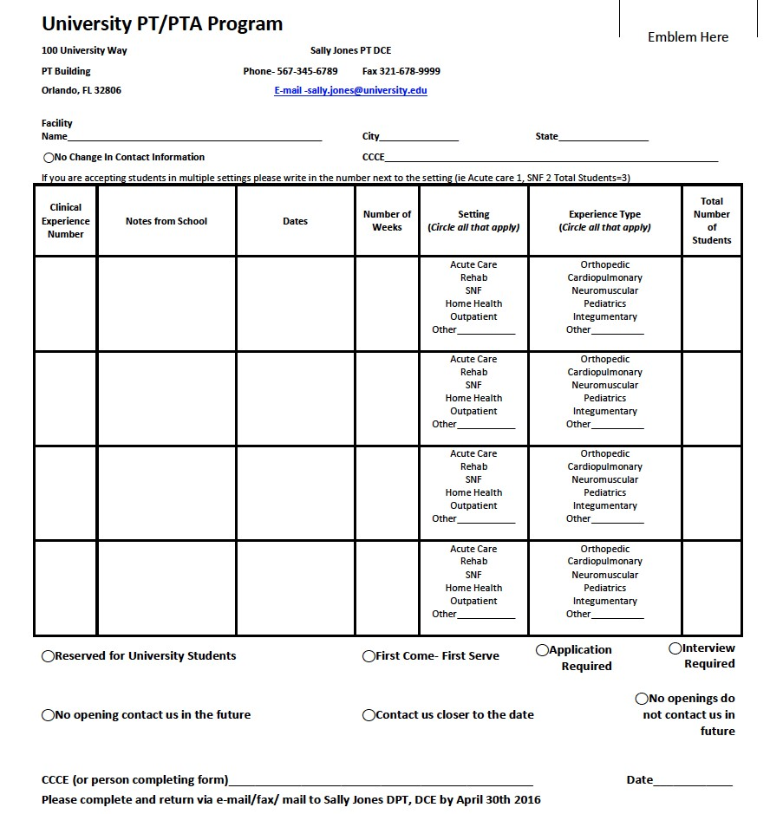

A3 **CESIG Common Request Form March 1 Mailing Completed Example**

http://aptaeducation.org/members/special-interest-group/clinical-education-faculty-sig/pdfs/CE SIG common request form 2016.docx **Must copy and paste entire link for access

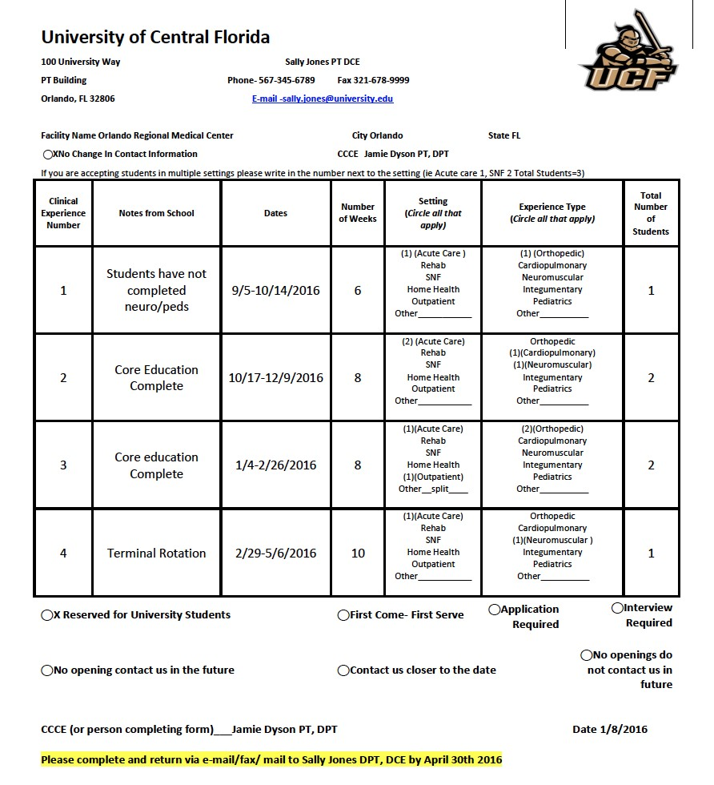

A4 **Students Contacting Clinical Sites to Request Clinical Experiences**

POSITION STATEMENT: Students Contacting Clinical Sites to Request Clinical Experiences *posted: March 03, 2017*

**The Clinical Education Special Interest Group**

**Students Contacting Clinical Sites to Request Clinical Experiences**

The Clinical Education Special Interest Group (CESIG) of the Education Section of the APTA serves the interests of individuals from academic programs and clinical facilities. The CESIG conducts meetings at CSM in February and at ELC in October.

At the October 2016 CESIG meeting there was discussion amongst members related to students contacting clinical sites requesting clinical experiences and the challenges this presents. During this meeting in Phoenix, clinical education representatives from across the country reported widespread acceptance of the position that students would be instructed to not contact clinical sites requesting clinical experiences. The request for clinical placements is to come from DCEs/ACCEs. This position is for accredited and developing physical therapy and physical therapist assistant programs.

<http://aptaeducation.org/?qvd7ii>

A5 **Sample Introduction Letter/Email to student**

|  |
| --- |
| *Re: Clinical experience at "Site Name"*Dear:  This letter is to provide you with some information prior to your clinical experience starting on  Our site has had an established clinical education program since 1992. We have 10 physical therapists employed at this clinical site. You will be paired with one or two therapist(s) and you may have the opportunity to work with various staff members while at our site. Three therapists at this site have received APTA Clinical Instructor Credentialing. Please see the below details for your upcoming clinical experience:  Our site has had an established clinical education program since 1992. We have 10 physical therapists employed at this clinical site. You will be paired with one or two therapist(s) and you may have the opportunity to work with various staff members while at our site. Three therapists at this site have received APTA Clinical Instructor Credentialing. Please see the below details for your upcoming clinical experience:  CI (s) Name: CI (s) Email:  CI (s) Phone Number: Clinic Phone Number:  Your schedule:  Monday  Tuesday  Wednesday  Thursday  Friday  Saturday  Sunday  I have enclosed information about our location, parking, dress code, etc. You will need to wear a name tag. I would encourage you to bring lunch. Kitchen facilities are available. There is a cafeteria available to buy food.  Please complete the enclosed Learning Style Inventory and return it to this clinic on or before the first day of your clinical experience.  You may want to bring your notes regarding treatment of patients/clients with spine, knee, shoulder and ankle conditions. You may have patients with conditions in other areas, but these are the most common injury sites that we generally manage.  If you have any questions or concerns, please call me at or e-mail me at. We look forward to meeting you and working with you.  Sincerely,  SCCE Name, PT, SCCE |

A6: **Orientation Checklist**

|  |
| --- |
| *"Site Name"*  *PT/PTA STUDENT ORIENTATION*  Student Name:  Date of Orientation:  Initial Introduction: Letter is sent to student(s) including clinical site information, student responsibilities, and learning style inventory. A copy of the letter is in the student file. Date Sent: First Day of Clinical Experience  Tour of Site  Orientation to clinic: general review of equipment, supplies, and workspace  Assign personal/professional space use areas  Emergency procedures of the clinical site/hospital reviewed  Student Clinical Education Manual is shown to the student Discussion of Learning  Conflict Resolution Procedures  Site Confidentiality Policies  Objectives and Responsibilities Reviewed:  Learning Objectives: Program objectives (CPI/Blue Macs/Alternative tool)  Clinic objectives (See handbook put together by clinic)  Student Scheduling procedures: sick time, snow days, personal days off  Documentation: written/dictation; initial/daily/discharge procedures  Billing procedures/insurance authorization procedures  Required Clinical Education Forms  Meetings: Weekly meeting with CI, Weekly staff meeting, team meetings, etc  Required Staff Presentation/Project Requirements  The above information has been explained to me, and I agree to comply with the requirements of the clinical site.  Student Signature: Date: SCCE Signature: Date: |

A7: **Memorandum of Agreement to Site Documentation**

|  |
| --- |
| Site Name  *Memorandum of Agreement*  I, Student Printed Name, have read and understand the site materials below and agree to abide by all policies, procedures, and objectives described in these documents.  Clinical Education Manual  Site Policies and Procedures  Site and/or Clinical Experience Learning Objectives  Student Signature: Date:  Clinical Instructor Signature: Date:  Site Coordinator of Clinical Education Signature: Date: |

A8: **Example SCCE Memorandum Soliciting Clinician Preceptors**

|  |
| --- |
|  |

**A9. Student Clinical Education Manual Example** *used with permission from Upstate NY

|  |
| --- |
|  |

|  |
| --- |
|  |

B1: **Anecdotal Record**- Used with permission from CCIP/APTA

|  |
| --- |
| **Anecdotal Record**  **Student: Date:**  **Evaluator/Observer:**  **Setting (place, people involved, atmosphere, etc.) Student’s Actions or Behavior:**  **Evaluator’s Interpretations:**  **Student’s Signature _________________ Evaluator’s Signature ________________**  **Student’s Comments:** |

Format adapted from: Shea ML, Boyum PG, Spanke MM. Health Occupations Clinical Teacher Education Series for Secondary and Post Secondary Educators. Urbana, IL: Department of Vocational and Technical Education, University of Illinois at UrbanaChampaign; 1985.

B2: **Critical Incident Report via CPI Web**- Reprinted with permission. 2006 American Physical Therapy Association. All rights reserved.

Step 1:

Step 2:

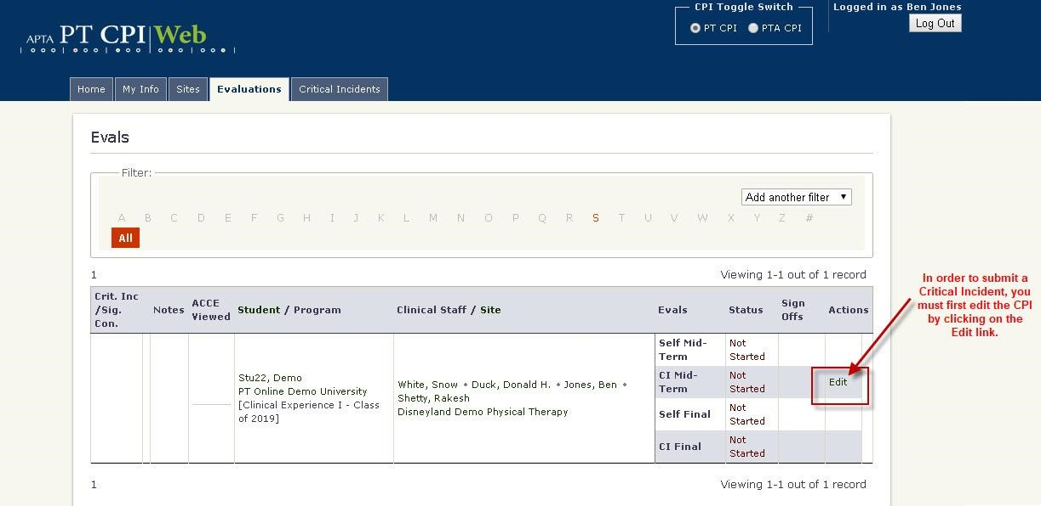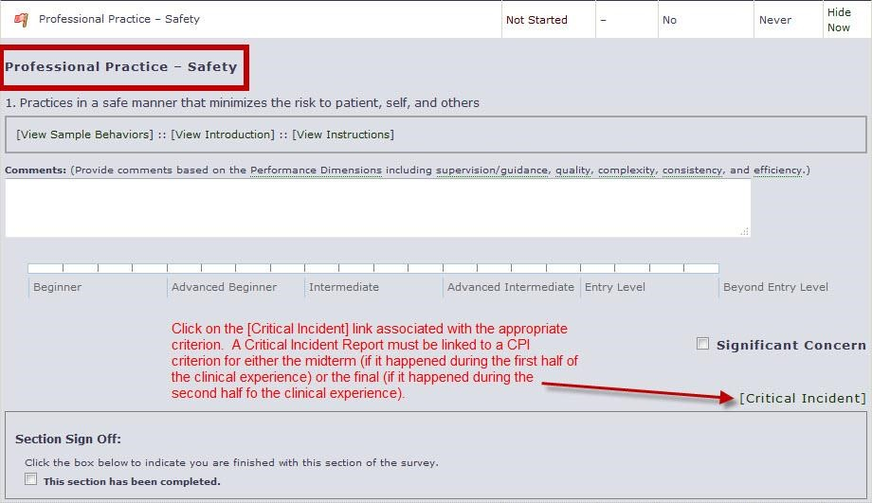

Step 3:

Step 4:

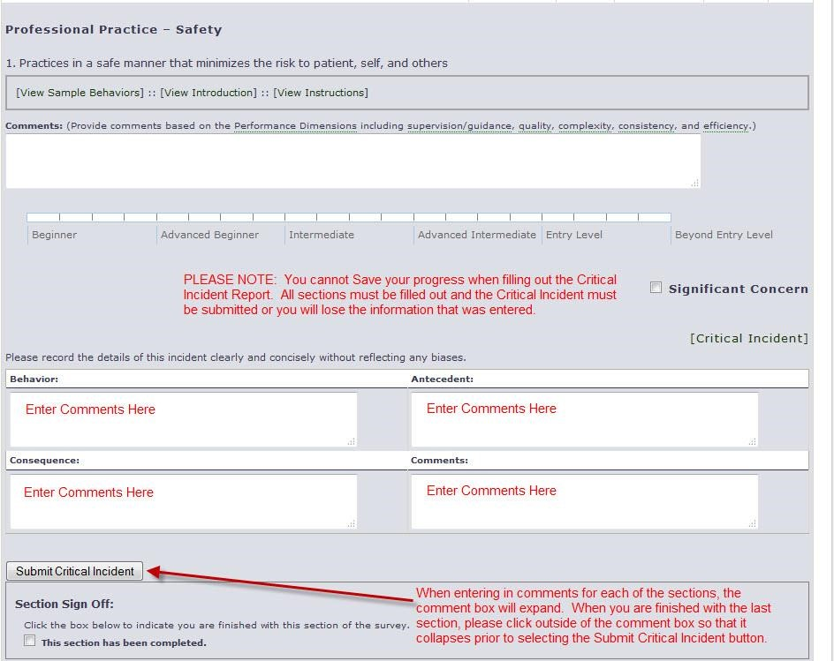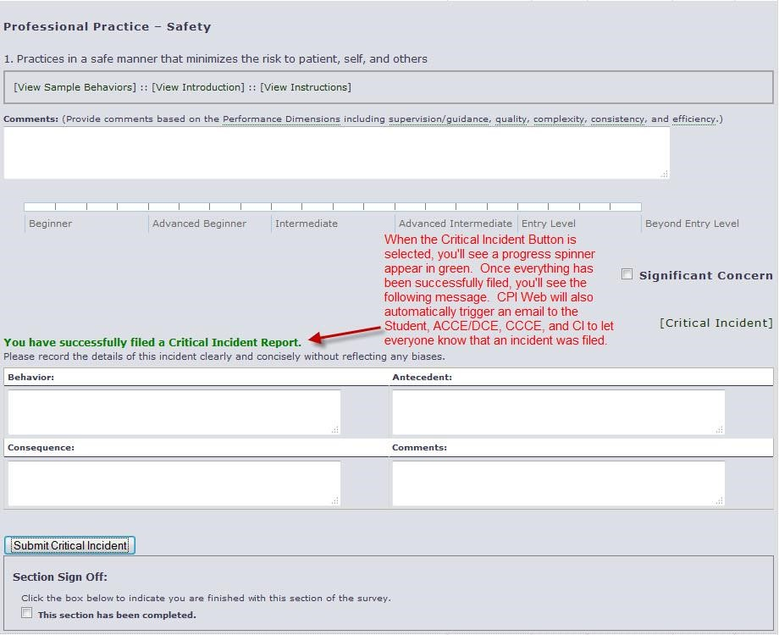

B3: **Weekly Planning Form**- Used with permission from CCIP/APTA

# SAMPLE

WEEKLY PLANNING FORM

Dates: ______________________________Week Number: ____________

## **Student’s Review of the Week**

When completing this form consider the five (5) performance dimensions: quality of care, supervision/guidance required, consistency, complexity of tasks/ environments, and efficiency of performance.

## **CI’s Review of the Week**

When completing this form consider the five (5) performance dimensions: quality of care, supervision/guidance required, consistency, complexity of tasks/ environments, and efficiency of performance.

## **Goals for the Upcoming Week of ______________________**

Student’s Signature _______________________

CI Signature _______________________

B4: **Clinical Performance Instrument Anchor Definitions**- Reprinted with permission. 2006 American Physical Therapy Association. All rights reserved.

|  |
| --- |
| Anchor Definitions  **Beginning performance:**   * A student who requires close supervision 100% of the time managing patients with constant monitoring and feedback, even with patients with simple conditions. * At this level, performance is inconsistent and clinical reasoning* is performed in an inefficient manner. * Performance reflects little or no experience. • The student does not carry a caseload.   **Advanced beginner performance:**   * A student who requires clinical supervision 75%-90% of the time managing patients with simple conditions, and 100% of the time managing with complex conditions. * At this level, the student demonstrates consistency in developing proficiency with simple tasks (eg, medical record review, goniometry, muscle testing, and simple interventions). * The student may begin to share a caseload with the clinical instructor.   **Intermediate performance:**   * A student who requires clinical supervision less than 50% of the time managing patients with simple conditions, and 75% of the time managing patients with complex conditions. * At this level, the student is proficient with simple tasks and is developing the ability to consistently perform skilled examinations, interventions, and clinical reasoning. * The student is **capable of** maintaining 50% of a full-time physical therapist’s caseload.   **Advanced intermediate performance:**   * A student who requires clinical supervision less than 25% of the time managing new patients or patients with complex conditions and is independent managing patients with simple conditions. * At this level, the student is consistent and proficient in simple tasks and requires only occasional cueing for skilled examinations, interventions, and clinical reasoning. * The student is **capable of** maintaining 75% of a full-time physical therapist’s caseload.   **Entry-level performance:**   * A student who is **capable of** functioning without guidance or clinical supervision managing patients with simple or complex conditions. * At this level, the student is consistently proficient and skilled in simple and complex tasks for skilled examinations, interventions, and clinical reasoning. * Consults with others and resolves unfamiliar or ambiguous situations. * The student is **capable of** maintaining 100% of a full-time physical therapist’s caseload in a cost-effective manner.   **Beyond entry-level performance:**   * A student who is **capable of** functioning without clinical supervision or guidance in managing patients with simple or highly complex conditions and is able to function in unfamiliar or ambiguous situations. * At this level, the student is consistently proficient at highly skilled examinations, interventions, and clinical reasoning, and is capable of serving as a consultant or resource for others. * The student is **capable of** maintaining 100% of a full-time physical therapist’s caseload and seeks to assist others where needed. * The student is capable of supervising others. * The student willingly assumes a leadership* role for managing patients with more difficult or complex conditions. |

**B5. Example Student Program Feedback Form**

|  |
| --- |
|  |