Location: APTA CSM (Hilton Bayfront – Indigo AE Level Two)
Date: Thursday February 23rd, 2023
Time: 6-7:15a PST

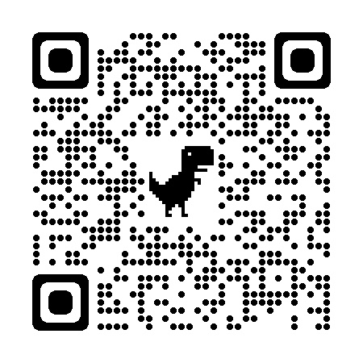
- Call to Order/Attendance – Kimeran Evans, AF SIG Chair
- AF SIG Business Meeting (6-6:20a)
  - Academy of Education Updates - President (Pam Levangie) and President Elect (Chalee Engelhard)
    - Fellowship in Higher Education Leadership
    - Academy of Education CSM Business Meeting – Friday Feb 24th – 6:30-9:30p
    - Other News and Announcements
  - AF SIG Announcements and Updates
    - AF SIG 2023-24 Open Leadership Position Updates – Derek Liuzzo, AF SIG Nom Com Chair
      - Chair
      - Nominating Committee Member
    - AF SIG Quarterly Podcast “Office Hours with a Physio” – Episodes 1 and 2 now live! Click here to listen on your favorite podcast platform: https://linktr.ee/officehourswithaphysio
    - Upcoming Events and Opportunities
      - APTA Academy of Education New Faculty Development Workshop – July 20-22nd in Chicago, IL
      - ACAPT The Future of Clinical Reasoning – April 14th and 15th in Phoenix, AZ
- Round Table Discussions - New Faculty and Mid-Career Faculty (6:20-7:15a)
  - Introduction of Facilitators (New Faculty Development Workshop Faculty for 2023)
    - Steven G. Lesh, PhD, PT, AT Ret, Board-Certified Sports Clinical Specialist Emeritus, Associate Clinical Professor, Bowling Green State University, Bowling Green, OH
    - Kirsten Potter, PT, DPT, MS, Professor, Director of Curriculum & Assessment, Doctor of Physical Therapy Program - Seattle, Tufts University, School of Medicine
  - Breakout Discussion and Networking Sessions

