

Crisis Connections
Emergency Response Handbook
2025
Index
List of Emergency numbers ………………………………………….2
First Aid Actions …………………………………………………………..2
Fire Safety …………………………………………………………………...3
Power Outage & Generator ………………………………………….5
Telephone Threats ………………………………………………………..6
Earthquake ……………………………………………………………………7
Suspicious Package ……………………………………………………….7
Active Shooter/Lock Down ……………………………………………8
Environmental Hazard/Shelter in Place ………………………8-9
Evacuations ……………………………………………………………………9
Floor Plan & Escape Routes ………………………………………9-12
Incident Response Team ………………………………………………14
Safety Drills………………………..…………………………………………15
Post Disaster Employee Mental Health Tools ……………….16

Important Numbers for Emergencies
Poison Control: 1-800-222-1222
Public Health Emergency: 1-800-556-8744

Location of First aid supplies:
At front desk, back cabinet, second drawer. In the kitchen below the microwave, and at the printer station below the mailbox cubbies. All clearly labeled “First Aid Kit.”
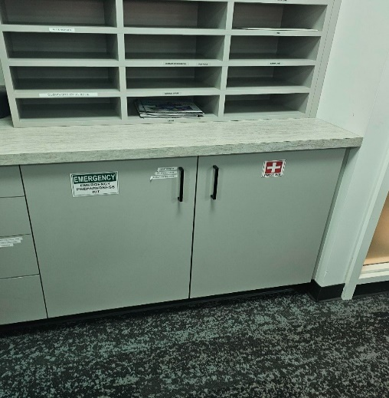
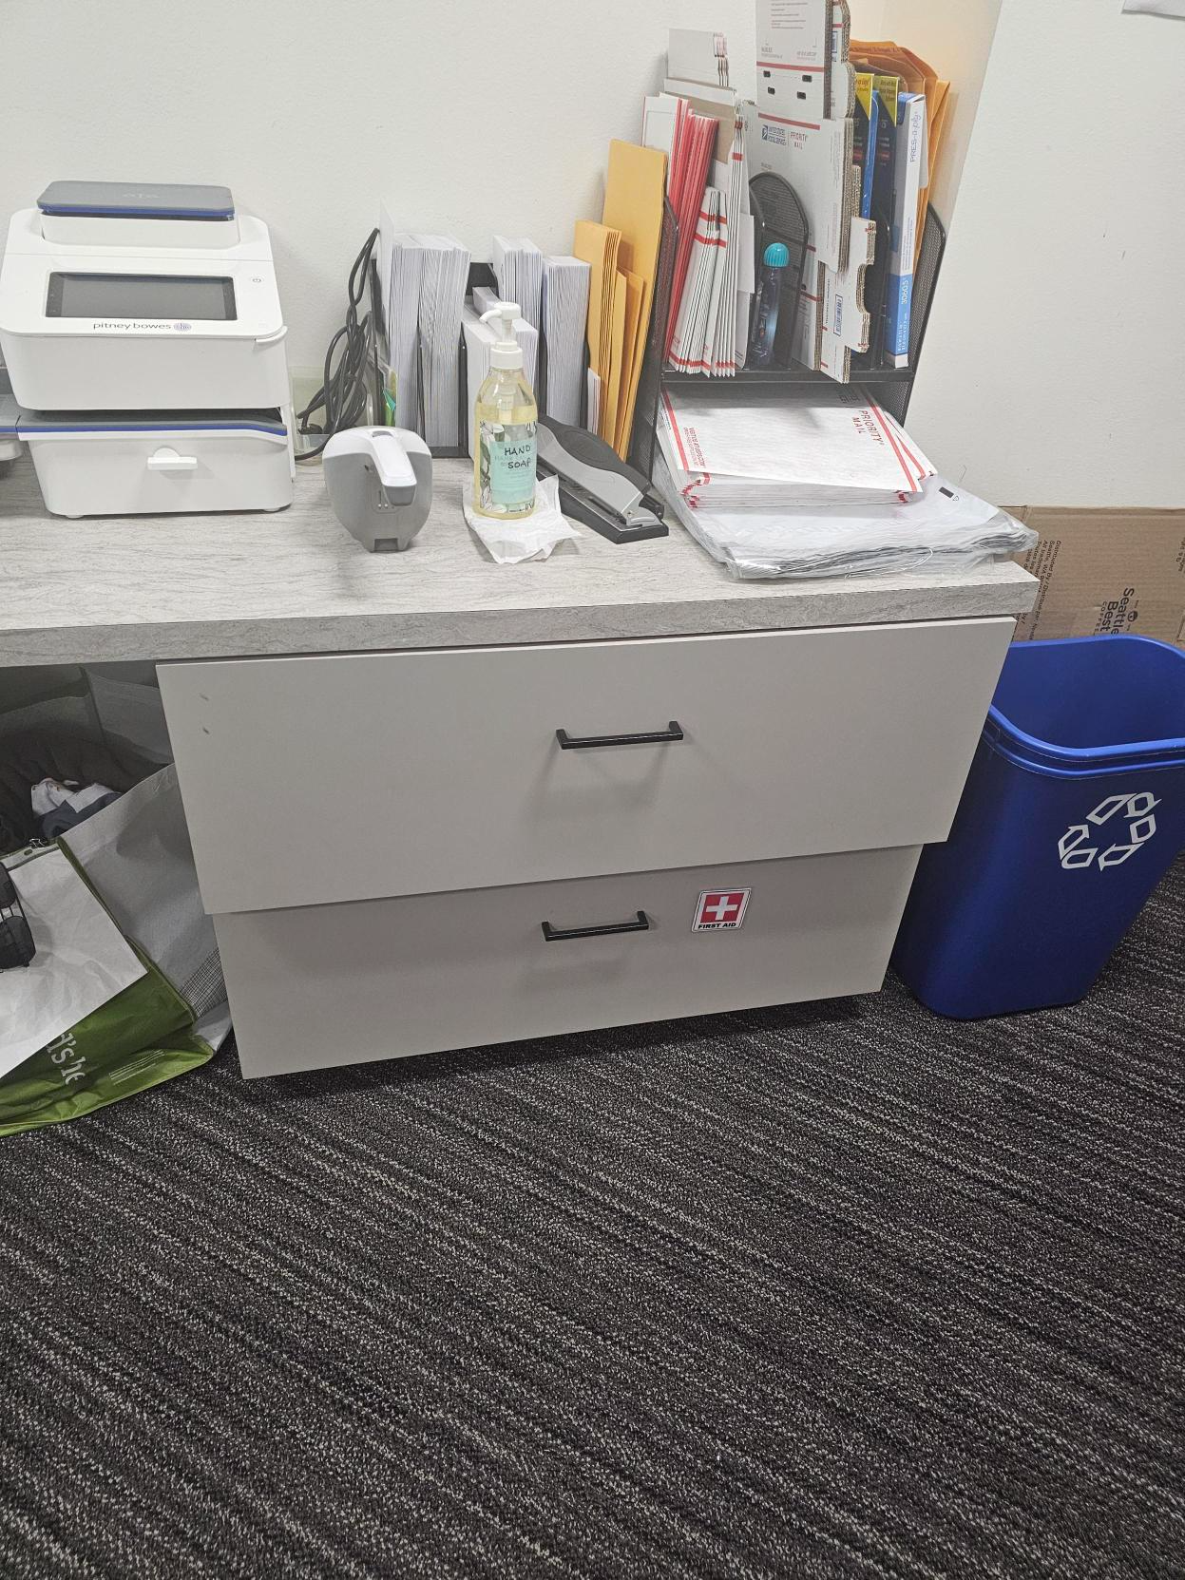
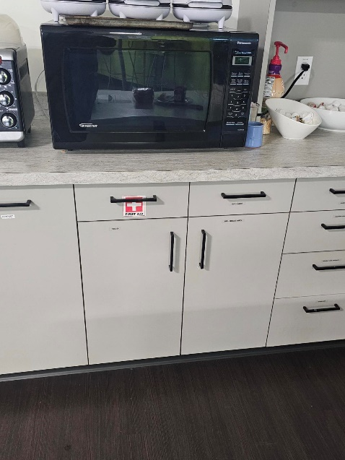
Front Desk: Back Cabinet Kitchen: drawer under Microwave Printer area: below mail cubbies

Location of Emergency Kits:
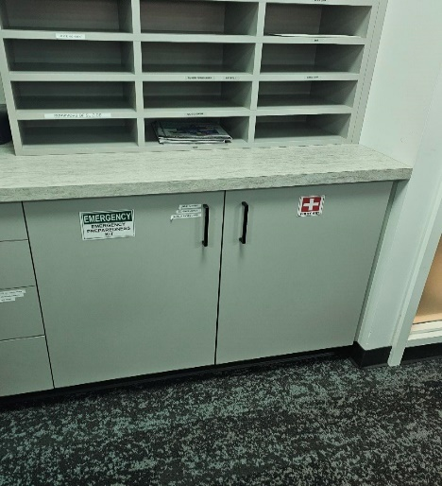
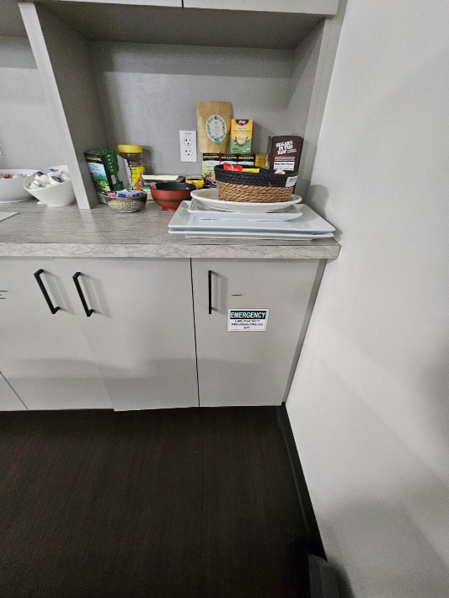
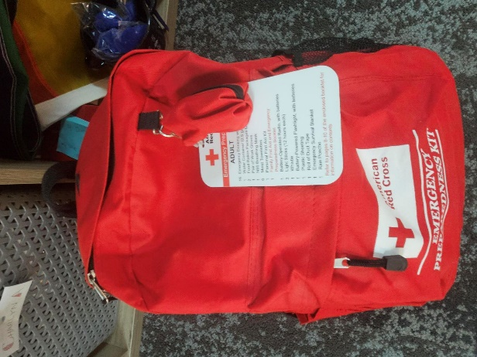
Printer area: below mail cubbies Kitchen: back corner Admin Hallway: Emergency Kit at top of cubbies

Location of AED Defibrillator
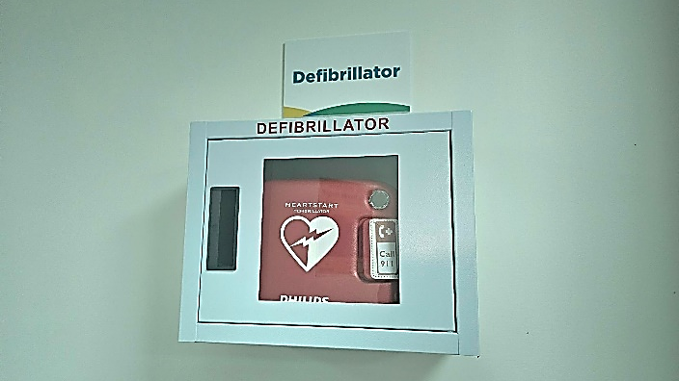
Printer Area: Above workspace

FIRST AID ACTIONS
Call 911 and administer appropriate care to restoring breathing, treating for shock and controlling bleeding. Perform CPR if trained to do so.

Unconscious victim:
1. Open airway and check for breathing
2. Check circulation
3. Start rescue breathing or CPR if needed

Shock:
1. Maintain body temperature by placing a blanket over the victim
2. Monitor airway and breathing
3. Observe skin color to monitor circulation
4. Check for bleeding
5. If you do NOT suspect head, neck, or spine injury, elevate legs 8-12 inches

Chemical burns:
- Remove contaminated articles of clothing.
- Flush area with large amounts of water for 20-30 minutes
- Cover area with sterile dressing.
Bleeding:
- Wash your hands with soap and water, wear gloves if possible.
- Prepare a clean place to administer first aid.
- Apply pressure dressing to the wound.
- If the wound is on an extremity, raise limb above the heart.
- Add more bandages as needed, do not remove old bandages.

Fainting:
- Lay victim on back
- Elevate feet 8-12 inches.
- Loosen restrictive clothing.
- Place cool cloth on victim’s forehead.
- If the victim vomits, roll victim onto side to let fluids drain from mouth.
- DO NOT give the victim anything to drink or eat.

Poisoning:
- Maintain airway.
- Read label for ingested material and follow treatment recommendations.
- If the victim has breathed noxious gasses, move victim into fresh air if safe to move.

Seizures:
- DO NOT attempt to restrain the victim or put anything in the victim’s mouth.
- Protect the head from injury.
- After the seizure has passed, check for breathing problems.
- The victim may appear sleepy afterwards.

Unconscious victim:
- Do not move the victim or allow victim to move.
- Control heavy bleeding with direct pressure.
- To control shock, keep the victim warm and elevate feet 8-12 inches.
FIRE SAFETY
Procedures:
- If you see a fire, yell for someone to call 911.
- Pull nearest fire alarm, located throughout office.
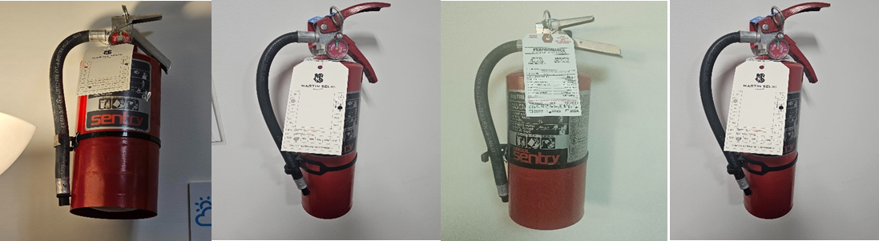
- Use fire extinguishers for small fires.

To use: Pull, Aim, Squeeze and Sweep (PASS)
P = PULL and twist the pin which is retained by a plastic tie.
A = AIM the nozzle at the base of the fire, standing back about at least 6-10 feet.
S= SQUEEZE the handle or trigger to activate the extinguisher
S = SWEEP the fire from side to side

- For larger fires EVACUATE, close doors as you leave.
- If clothing catches on fire, STOP ~ DROP ~ ROLL.

WHEN FIRE ALARM RINGS:
- Evacuate the building to the designated meeting area in the Wells Fargo Parking Lot, at the intersection of Broad Street and Denny Way unless directed otherwise, listen for instructions from emergency responders.
- Grab an emergency kit from Printer area, admin hallway or Kitchen in case of injuries, marked “Emergency Kit.”

WHEN FIRE EVACUATION IS ORDERED OR DEEMED NECESSARY:
- Proceed to nearest exit following Evacuation Plans and Routes, do not take personal belongings or re-enter building.
- Feel top of door with back of hand, if hot or smoke is visible DO NOT USE
- DO NOT break windows.
- DO NOT use elevators.
- Stay low while moving through smoke.
- Follow Evacuation plans and meet at Assembly location.

IF TRAPPED IN ROOM:
- Close doors and windows do not open or break unless to escape.
- Place cloth (wet if possible) under/around door to block smoke.
- Signal your location to rescue personnel by phone or through Window.

IF CAUGHT IN SMOKE OR FIRE:
- Drop to knees and crawl, breathing through shirt.
- Protect head and hair from flames.

POWER OUTAGE
Call Seattle City Light if we have an outage: (206) 684-3000.
Inform IT Team that they need to turn on our generator.
Flashlights and lanterns are inside the emergency kits located in the office, at the printer station below the mailbox cubbies, and in the Kitchen below the plates and cups cupboard. Both are clearly marked “Emergency Kit.”

The Generator is located outside near the Fire Exit on Second Avenue, at the back of the phone room.
The Generator is started as follows:
- Obtain keys that lock the cage from server room plus a key is needed for the generator to start it (also on back of door in server room)
- Obtain yellow power cord that is connected to 220V output from generator to the input electrical feed to the circuit breaker in the storage room.
- Make sure the gas shutoff switch is in the “on” setting pull out the choke on left side of generator and make sure ignition key is set to “on.”
- Ensure there is enough fresh gas in the tank.
- Pull the starter and let run for 5 mins.
- Flip the upper breaker switch to kill the street power in the storage room, wait 1 minute then flip the switch to run on the generator power (UPS should stop beeping)
- Let the generator run until testing or if needed longer.

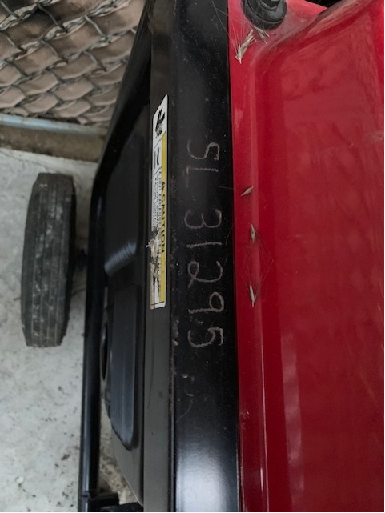
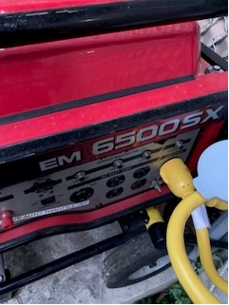

TELEPHONE THREATS
During the Call:
- DO NOT hang up, quietly get someone else to call 911.
- Caller ID name/number: _____________________________________
- Remain calm.
- Determine if threat is a bomb, a shooter, or other.
- Attempt to obtain as much information as possible by asking these questions:
- When is the bomb going to explode/shooting to take place?
- Where is the bomb/shooter right now?
- What does the bomb/shooter look like?
- What kind of bomb/gun is it?
- What will cause the bomb to explode?
- Did you place the bomb? Are you the shooter?
- Why?
- What is your address?
- What is your name?

Caller’s gender ____ Caller’s Race/Accent __________ Caller’s Age _____

Circle all appropriate descriptors.
Caller’s voice: Calm, Angry, Excited, Slow, Fast, Soft, Loud, Laughing, Crying, Normal, Distinct, Slurred, Nasal, Stutter, Lisp, Raspy, Deep, Ragged, Accent, Clearing Throat, Muffled, Disguised, Cracked, Breathing heavily, Familiar? Who: ___________

Background Noise: Street sounds, Animal Sounds, Clear, Static, Music, Motors, Household noises, Factory machinery, Voices, PA System, Office noises.

Threat Language: Well-spoken, Foul, Irrational, Incoherent, Taped, Read by Threat Maker, Read by another person.
Give necessary information to law enforcement.

EARTHQUAKES
DURING AN EARTHQUAKE:
- Instruct everyone to DROP, COVER AND HOLD, protecting head and neck.
- Stay away from windows and objects which could fall on you.
- DO NOT USE ELEVATORS.
- If outdoors, stay in an open area. DO NOT enter the building.

AFTER AN EARTHQUAKE:
- Remain calm.
- Be prepared for aftershocks.
- DO NOT leave your evacuation area unless directed to do so.
- Administer First Aid if needed.
- DO NOT USE THE PHONE except to report fire or medical emergencies.
- Alert Incident Command to anything needing attention.
- If you are not attending to an injured person, move to a safe interior location, avoiding glass and equipment.
- Wait for and follow instructions from Emergency Personnel.
- Be prepared to evacuate if necessary. (See Evacuation Procedures)

DROP COVER AND HOLD INSTRUCTIONS:
In offices:
- Move away from windows.
- Drop and take cover under desk or table, positioning as much of the body as possible under cover.
- Cover head, neck and eyes by resting on elbows, hands clasped behind the neck, face down.
- Hold onto table legs or side of the desk.
- Remain in this position until you receive further instructions.

In open locations:
- Find a safe location along interior wall away from windows or objects that may fall.
- DROP to knees and curl into ball on floor or ground.
- COVER head and neck with hands.
- HOLD onto any stable object.

SUSPICIOUS PACKAGES
Signs
- Leaking of liquid or powder, strange sounds or smells emitting from the package
- Poorly packaged with scribbled writing
- Incorrect postage and/or incorrectly addressed.
- Unidentified package sitting in an unlikely place.

Procedure
- Do not touch the package.
- Move as far away as possible and warn others to stay out of the area.
- Call 911 for a possible HazMat response.
- If you touched the substance, do not touch mouth, eyes or nose, wash as soon as possible.
- Follow instructions from law enforcement.

ACTIVE SHOOTER
If shots are heard
- If a safe route is available, attempt to escape the building as quickly as possible and take refuge behind any large object.
- If escape is not possible, take refuge in an enclosed room, close and lock the door, move heavy objects in front of the door if possible.
- Sit with back toward an outside wall, remain quiet.
- Only engage shooter if there are no escape or shelter options.
- Silence cell phones, call 911 when it’s safe to do so.
- Follow law enforcement instructions, keeping hands up and moving slowly.
- Everyone is a suspect until cleared by law enforcement.

Prevention
- Take all threats seriously and report them to the police.
- If individual staff is threatened because of work of a domestic dispute, notify CC management so precautions can be taken.
- Attending annual training held by Office of Emergency Management.

LOCK DOWN
- Always escape, if possible, but if it is not possible, the safest alternative may be to go into lock-down.
- Secure the space; lock all doors, close windows, pull shades.
- Make sure all visitors are secured in rooms and accounted for
- If lock-down is for an external environmental hazard, place jackets, sweaters, or any other available items along the bottom of doorways where there is a space.
- If lock-down is for a shooter in the building, huddle on the floor near a solid wall and away from the door. If there is time, stack desks and chairs against the door.
- Do not use cell phones, keep lines open for emergency responders.
- Evacuate the room only when told to do so by emergency responders or law enforcement.
ENVIRONMENTAL HAZARD
- Environmental Hazards which may require lockdown include, external use of pepper spray during a civil disturbance, anthrax or other chemicals entering the building in the mail, chemical spill on the roadway outside the building.
- When encountering an environmental hazard, the safest course of action is to move as far away from the source as possible, if that is not possible, follow the instructions for lock-down.
- Hold a cloth over your nose and mouth to avoid breathing the substance.
- Assist others to leave the area, if they are unable to move, direct emergency responders to their location.
- If substance has contacted your skin, remove contaminated clothing and wash skin as soon as possible with cool water and a gentle soap.
- If a substance has entered your eyes, rinse with an eye wash for at least 15 minutes.
- Follow instructions of emergency responders and law enforcement
SHELTER IN PLACE
Procedures:
- Stay inside.
- Close all windows and doors.
- Turn off ventilation systems (heating and air-conditioning).
- Go into a room/office with the fewest doors and windows and seal the room.
- Stay in the room/office until told by the emergency responders that it is safe to come out.
- Dampen towels and place them over the cracks under doors.
- Cut plastic sheeting to fit over the windows and vents. Secure the plastic with duct tape.
- Tape around the door.
- Turn on the radio located in an emergency kit in Printer Area and Kitchen area. Labeled “Emergency Kit”
- Don't air out or leave your sealed shelter until you are told to do so.
EVACUATIONS
Evacuation notice may be a fire alarm or a verbal announcement to staff.

Procedures:
- Remain Calm
- When the alarm sounds, grab equipment and evacuate as quickly as possible following assigned route.
- Take your cellphone and coat, leave other personal belongings.
- If main route is blocked, follow building perimeter to Designated Meeting Area if safe.
- Staff assigned to Incident Management duties will conduct roll call and assign duties as needed.
- DO NOT return to the building until the “all-clear” has been given.
- DO NOT use elevators.
- DO NOT lock doors.
- DO NOT use cell phones, leave lines open for emergency use.

EVACUATION OF DISABLED PERSONS:
Mobility Impaired
- We’ll need to ensure that the person and wheelchair together may need to be carried by two or more people in the event of an emergency.

Sight Impaired
- Assign another person to act as guide
- Guide will describe situation, obstacles and plan for evacuating.

Hearing Impaired
- Use gestures or write information to indicate situation and needed actions.

INCIDENT COMMAND TEAM

Incident Commander:
• Overall responsibility and direction
• Liaison with First Responders

Operations Lead:
• Oversee Team Leaders/Floor Wardens
• Collect roll sheets, noting missing personnel
• Ensure all personnel are evacuated and/or accounted for
• Share information with Incident Commander, noting any missing persons
• Determine need to move to alternate facility or virtual work
• Oversee transition to new location

Logistics Lead:
Transportation
• Arrange safe passage to parking area for displaced staff
• Arrange for equipment to be moved to new location
Resources
• Arrange for food, water, shelter if needed

Public Information Officer:
• Ensure clients and public are informed of situation
• Respond to media requests
• Monitor social media and correct misinformation

Safety Officer:
• Monitor and assess hazards and unsafe situations
• Develop measures for ensuring personnel safety
• Identify safety problems and implement solutions to minimize risk
• Keep Incident Commander informed of present and potential problems

SAFETY DRILLS
Crisis Connections conducts annual drills for fire drills and earthquake drills.
- Build Management holds quarterly fire drills with active lights and alarm bells during day shift and graveyard shift hours. This includes staff evacuation for our suite to our designated meeting location.
- We hold annual fire drills at our Seattle facility with the assistance of the Building Manager.
- The Health & Safety Committee plans the date and time of fire drills, and earthquake drills providing advanced notice to staff.
Staff are required to complete our annual trainings in Relias covering safety including:
- Fire Safety: The Basics
- Workplace Violence Prevention
Remote employee safety is encouraged by:
- Creating an emergency safety kit including water, flashlight, nonperishable food, fire extinguisher, batteries, extra blankets, first aid supplies, cell phone with extra charger and backup battery, AM radio or NOAA Weather radio, etc.
- Encouraging staff to participate in safety drills in their own homes (for example earthquake, fire, and flood).
- Encouraging staff to be cautious about fire hazards (electrical circuits, etc) and tripping hazards.
- Emergency weather conditions are communicated out to staff via email when necessary.

POST DISASTER EMPLOYEE MENTAL HEALTH TOOLS
- Supervisors will remain mindful of the stress and emotional toll of their staff and volunteers and provide coping tool mechanisms.
- Red Cross Emotional Recovery website: https://www.redcross.org/get-help/disaster-relief-and-recovery-services/recovering-emotionally.html
- Red Cross Disaster Distress Helpline: available 24/7 for support at 1-800-985-5990.

Employee Assistance Plan: Canopy
- EAP resources will be made available to staff via https://my.canopywell.com/
- HR can also arrange for therapist led debriefing sessions for staff and volunteers.

