***YOUR "MAGIC MINUTE"!***

***Tips To Create a Magical Customer Experience Even During This Crisis!***

***TIP # 1- First Impressions***

*I hope you are safe, healthy and staying positive.  Many people have reached out to me for advice on what to do during the crisis regarding their business, leadership and dealing with their staff and teams. Unfortunately, many businesses are on hold or very limited at this time. We are all hoping things will return to normal soon.*

*For those businesses that are fortunate to remain open it is very important to create a magical customer experience now more than ever. Now is not the time to let down your guard. In fact, because many businesses are very limited and have fewer customers, we need to truly appreciate what customers we do have and continue to deliver a positive and magical experience so they will come back. Now and again when the crisis is over.*

*One way to demonstrate a magical customer experience is to make sure you and your staff are providing a great first impression.  In this "Magic Minute", I share an experience that I received from a local restaurant that my wife and I visited for take out.*

*While watching the video, you will see that it was not a magical experience. This restaurant just doesn't get it. Based on my first impression, instead of this business truly appreciating having a customer during these challenging times, my perception was mostly that there staff could care less. I wonder why the business owner would tolerate such a bad first impression, not only from the entrance of their store, as well as from their staff, if they really wanted to stay in business.*

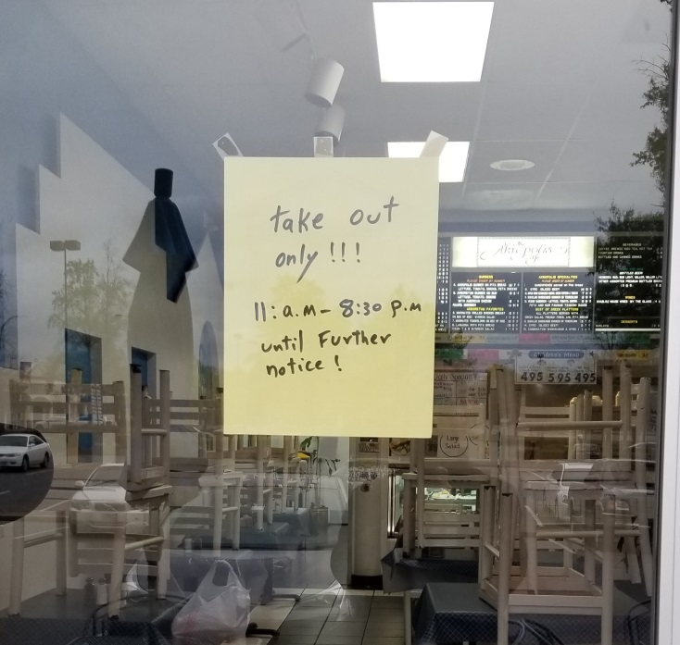

*Now is not the time to let down your guard. Go overboard to make sure every contact point with the customer experience is a magical one. Once this pandemic is over, people are going to be telling stories for a long time about these incredible times in our lives. The stories you want them to tell about your business during this time are the good things not the bad things.*

*Need help? Contact me today!*

[**https://www.youtube.com/watch?v=QbDa5-pW9Gk&feature=youtu.be**](https://www.youtube.com/watch?v=QbDa5-pW9Gk&feature=youtu.be) ***- To Watch Your "Magic Minute"***

*(By the way, I am over delivering so it is longer than a minute.)*

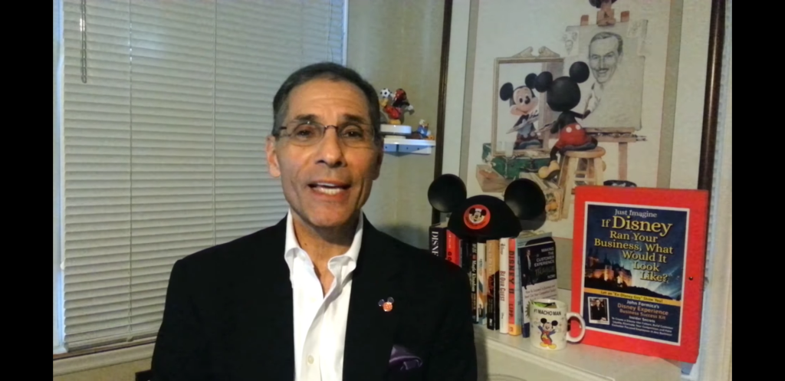

*Stay Safe, Stay Healthy, Stay Positive and Stay Magical!*

*John Formica…The “Ex-Disney Guy”*