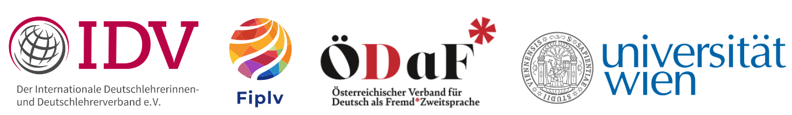

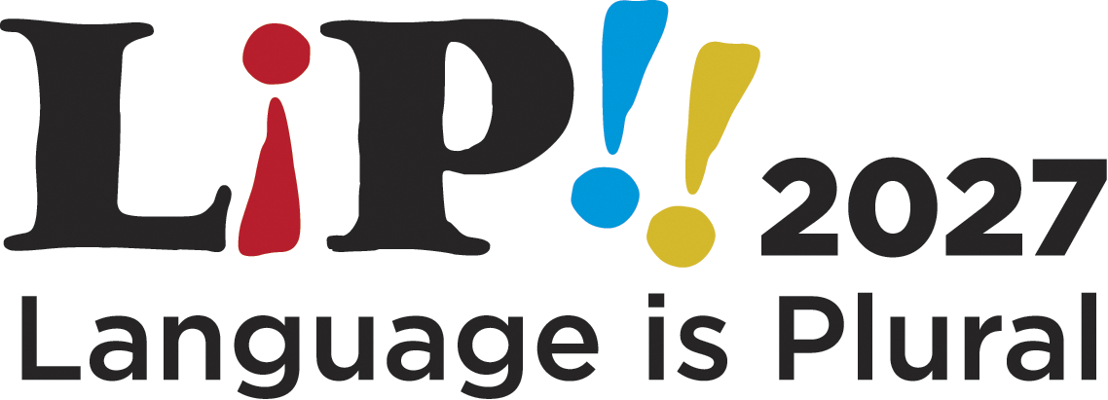
Celebrating Multilingualism in Language Education

University of Vienna, 26.–29. July 2027

LiP 2027 brings together the World Congress of the Fédération Internationale des Professeurs de Langues Vivantes (FIPLV) and the International Delegates’ Conference (IDK) of the International Association of Teachers of German (IDV).
It is organised by the Austrian Association for German as a Foreign and Second Language (ÖDaF) in cooperation with the University of Vienna.
Call for Papers  
LiP 2027 invites contributions that explore multilingualism and language education from research, practice, policy, and teacher-education perspectives. Building on the conference theme and mission, LiP 2027 welcomes work that examines multilingual repertoires, equitable and inclusive pedagogies, language learning as an empowering practice, and the design of open, participatory, and emancipatory learning environments.
The conference provides a platform for scholars, educators, practitioners, and students to exchange expertise, present current work, and build networks across disciplines and educational contexts. The conference is conceived as a genuinely multilingual event in which a wide range of languages serve as media of communication, shaped by the participants and their chosen languages of presentation. Unlike most language conferences, this edition is envisioned as a fully multilingual, multimodal, and multiliterate experience - one in which multilingualism is not merely addressed as a topic, but actively practised, valued, and institutionally legitimised within the academic space.

Important Dates:
Submission deadline: 31 December 2026
Notification of acceptance: 28 February 2027
Conference dates: 26–29 July 2027
Location: University of Vienna, Austria

Conference Languages:
LiP 2027 is a multilingual, multimodal and multiliteral event. Participants are encouraged to present in the languages that best reflect their research, practice, or linguistic identities. Contributions in multiple languages are welcome; English, German, and other languages of participants may serve as media of communication. Abstracts can be in English, German or any other language. Please specify in which language you would like to do your presentation. Please be aware that presenters are expected to contribute to the conference’s multilingual ethos by ensuring accessibility across languages. This includes providing translations or multilingual support (e.g. multilingual slides, summaries, handouts, QR codes, or other formats) in English or German so that audiences can meaningfully engage with the presentation. The conference organisation will support and facilitate multilingual practices wherever possible.

Submission Formats:
Individual Paper in a Session
20-minute presentation + 10-minute discussion (30 minutes in total). Papers are submitted to one of the thematic sessions (listed below).
Poster Presentation
Posters may present empirical findings, didactic innovations, classroom projects, or concept papers. Contributors will present their posters in dedicated poster sessions.
Thematic Panel
Panels consist of a maximum of four contributions and last for 90–120 minutes. Panel organisers are responsible for selecting, coordinating, and structuring the contributions. Panels may include empirical studies, theoretical inputs, practitioner-oriented contributions, or mixed formats.

Submission Guidelines
Please submit your proposal via the following links:

Individual Poster or Poster Presentation: https://univie.eventsair.com/lip2027/lipsub
In your abstract of no more than 300 words, please clearly outline the following points:
- the focus and aim of your contribution
- the methodology and/or theoretical framework
- the relevance of your contribution to the conference theme

Thematic Panel: https://univie.eventsair.com/lip2027/lippanelsub
Panel proposals should include an overarching panel description of no more than 500 words as well as individual abstracts for each contribution, maximum 250 words per contribution including the title, with a maximum of four contributions per panel.

Thematic Sessions

LiP 2027 encourages submissions related to the following themes.

1) Multilingual Pedagogies, Repertoires & Translanguaging
2) Voices, Agency & Identity in Multilingual Learning and Teaching
3) Language Policy & Educational Environments
4) Language, Power, Social Justice & Decolonisation of Language Education
5) Minority, Heritage & Indigenous Languages
6) Inclusive Language Teaching, Learning and Assessment
7) Technology, Digital Spaces & AI in Multilingual Learning
8) Creative, Literary and Arts-based approaches to Multilingual Learning and Teaching

Session Chairs

Session Chairs will be announced in due course.

Session Descriptions

Multilingual Pedagogies, Repertoires & Translanguaging
This session focuses on learning and teaching approaches, educational concepts, empirical research, and classroom practices that recognise, value, and purposefully mobilise learners’ multilingual and multimodal repertoires. It invites contributions that explore how learners draw on their full linguistic and semiotic resources when making meaning and participating in learning. We are particularly interested in approaches that create open, participatory and empowering learning environments, that challenge monolingual norms, and that view multilingualism as a pedagogical resource at the centre of teaching and learning.
- research on multilingualism, including sign language; empirical cases of multilingual learning
- experiences with multilingual pedagogies and translanguaging
- educational concepts that support multilingual learning
- cooperation across institutions and learners
- Language for specific purposes (LSP) and supporting multilingual competence
- informal learning, learning beyond the classroom
- bridging formal and informal language learning spaces

Voices, Agency & Identity in Multilingual Learning and Teaching
This session focuses on perspectives, attitudes, and experiences that shape multilingual language learning and teaching. We invite contributions that examine how teachers, learners, and other educational actors understand and navigate linguistic diversity, how their beliefs and expectations influence classroom practices, and how learner voice, identity and agency become (in-)visible in multilingual learning environments. We are particularly interested in work that highlights the role of professional knowledge, (self-)reflection, positioning, and motivation in fostering inclusive and multilingual pedagogies. We also welcome contributions that address teacher well-being, workload, emotional labour, and sustainability in multilingual educational contexts, recognising that inclusive and multilingual pedagogies depend on supported and resilient teachers.
- teachers’ views, beliefs, attitudes, and professional decision-making
- learners’ perspectives, voice, identity work, motivation, and agency
- interactions between teachers’ and learners’ beliefs and practices
- (self-)reflection, positioning, and professional knowledge in multilingual pedagogy
- professionalisation and teacher education for multilingual pedagogies

Language Policy & Educational Environments
This session examines language policies and the institutional conditions that shape teaching and learning language in schools and beyond. We invite contributions that explore how policy is created, negotiated, and enacted at different levels, classroom, school, community, and system, and how these processes influence opportunities for participation, equity, and multilingual learning. Particular interest lies in bottom-up approaches, curricular developments, assessment practices, and the institutional structures that support or hinder multilingual education.
- language policies for teaching and learning in various contexts
- bottom-up, participatory language policy practices
- language policy making through networks and associations
- rationales for supporting language learning and multilingualism
- curricular development
- school development and institutional support for multilingualism
- assessment of multilingual learning and teaching
- evaluation and impact of multilingual practices and policies

Language, Power, Social Justice & Decolonisation of Language Education
This session offers critical perspectives on inequality, discrimination, power relations, othering, and decolonising approaches in language education. We invite contributions that examine how linguistic practices and ideologies shape access, participation, and agency, and how racism, linguicism, and prestige hierarchies manifest in educational contexts. Of particular interest are approaches that foreground positionality, challenge dominant narratives, and work towards more equitable, decolonial and socially just language education.
- racism, linguicism, prestige hierarchies
- language mandates, language bans, standard language ideologies
- performativity of language; discourse, framing, manipulation
- responsibility, agency, positionality in educational contexts

Minority, Heritage & Indigenous Languages
This session focuses on valuing, supporting, and sustaining minoritised languages across educational and community contexts through diverse and multilingual approaches. We welcome contributions that explore minoritised, non-dominant languages as well as languages with fewer speaker numbers in public schools and informal sectors, indigenous and minority language teaching, and community-based practices that foster linguistic continuity, recognition, and participation.
- community/heritage/home languages in formal and informal education
- Sign language and signing in formal and informal education
- minority and indigenous language strengthening, learning and teaching
- experiences from minority and immersion schooling worldwide
- community-led language projects and practices

Inclusive Language Teaching, Learning and Assessment
This session focuses on approaches that enable full participation, equitable learning opportunities, and meaningful access for all learners. We welcome contributions that explore how inclusion can be fostered in multilingual classrooms, how multilingual materials and/or assessment practices can support equity, and how linguistic diversity can be recognised as a resource for democratic participation.
- inclusivity in the language classroom, learning resources, and textbooks
- inclusivity in sign language education and deaf–hearing learning contexts
- addressing diverse learning needs, biographies, and learning trajectories
- assessment and evaluation practices that promote fairness and access
- removing linguistic barriers to participation
- multilingualism as a pathway to equity, belonging, and democratic culture

Technology, Digital Spaces & AI in Multilingual Learning
This session explores the role of technology in transforming multilingual practices and language education. We invite contributions that critically examine how digital tools and AI reshape language learning, teaching, and assessment across spoken and sign language contexts, and how technological innovation can support or challenge equitable and multilingual educational environments.
- Innovation and AI as an integral component in language teaching and learning
- AI-driven transformations in language education, learning and teaching processes
- Digitally mediated practices, multimodality, and online learning spaces
- priming and framing effects of AI-generated content and strategies to detect and counteract these effects
- Ethical aspects and digital citizenship

Creative, Literary and Arts-based approaches to Multilingual Learning and Teaching
This session focuses on learning and teaching approaches, educational concepts and methods for arts-based approaches in language learning. Literature, music or art offer possibilities for promoting multilingual learning on a cognitive as well as emotional level. They enhance learners’ competence to understand and participate in processes of meaning-making in globalised, multilingual and superdiverse societies. We welcome contributions which present educational concepts, discuss teaching and learning material or provide empirical evidence for multilingual learning processes initiated by arts-based approaches.
- Educational concepts for promoting creativity in language learning
- literary multilingualism and multilingual literature in language learning
- aesthetic education and language learning
- empirical research on arts-based approaches

